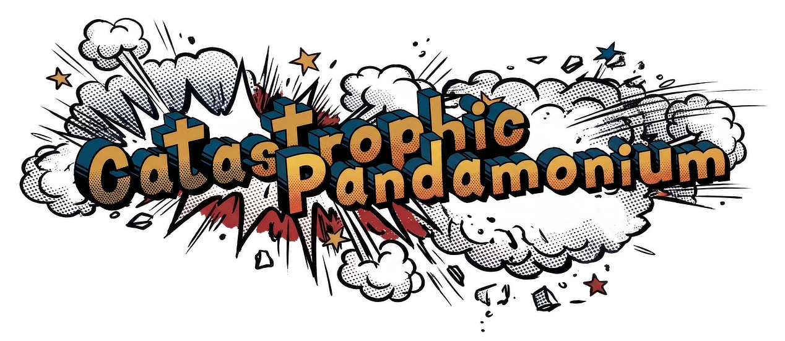

Project Brief
Catastrophic Pandamonium (CataPanda)
SheBuilds Season 04 (Lovable) · Social Good: Civic Engagement · 15–17 October 2026

At a glance
Field | Detail
Product | Catastrophic Pandamonium (nickname: CataPanda)
One-liner | The cool uncle who helps you prep for the worst, with a smile and a plan, in under 3 minutes.
Category | Civic tech made by the public, for the public: consumer disaster preparedness
Hackathon | SheBuilds Season 04, hosted by Lovable
Category (submission) | Social Good: Civic Engagement (no sponsor challenges)
Team | Alex Hana, Builder
Timeline | 15–17 October 2026
Platform | Mobile-first web app, built with Lovable (version 2026-09-11)
MVP region | Taiwan: earthquake, flood and typhoon

The problem
Disaster-preparedness information is often fragmented, incomplete, outdated, one-size-fits-all, hard to find and not action-oriented. It’s either oversimplified or overly complex.
- Many government websites don’t offer public checklists, or they split guidance by disaster type, so people click through five pages to piece together one plan.
- Generic lists don’t fit real households, from a toddler with allergies to a grandparent with a cane.
- Fear-based messaging overwhelms people, so they put it off.
- General AI chatbots are quick, but their advice isn’t traceable, and made-up safety advice is a real risk.
CataPanda reduces the mental load: clear, concise, personalized answers that cut the logistics of disaster prep and help people get it done.

The solution
A friendly, fast app that builds a personalized disaster-prep checklist in under 3 minutes:
- Pick the disasters you’re preparing for and describe your household in a sentence.
- Answer up to 5 quick questions the AI asks so it doesn’t have to guess.
- Get a Top 10, a full personalized list and a list for each disaster, built from government-vetted guidance plus items specific to your household.
- Share your Top 10 with family by email, text message, WhatsApp, Signal or Instagram.
Every item shows where it came from: Gov-vetted, CataPanda Tip or AI.

Who it’s for

Primary: the general public
- People living where natural disasters recur every year or more (the MVP starts with Taiwan)
- People moving to a disaster-prone area
- People who need tailored plans because of disability, age, pregnancy, pets or medical needs
- People proactively packing a go-bag ahead of disaster season
- People who need to prepare quickly for an impending disaster

Secondary
- Disaster-response advocates and relief professionals, who can use the app as an educational tool
All on their phones, with no sign-up.

Why us
Alex lives in Taiwan, on the Pacific Ring of Fire and in the Western Pacific typhoon belt, among the world’s highest-risk zones for earthquakes and typhoons, and has prepared for disasters firsthand. Taiwan’s strong building codes and early-warning systems model good preparedness. Alex is connected to local technologists and experts passionate about disaster readiness, including a close friend who is a Director at FEMA, and brings the drive to launch a public tech product and the skills to innovate with AI.

What makes it different
- Vetted first. A hand-curated catalog researched from 7 government and civil-defense agencies (Taiwan, Singapore, Hong Kong, South Korea, the Philippines, Brunei, Indonesia) is the source of truth.
- AI that’s core, but constrained. AI understands free-text households, asks clarifying questions, adds household-specific items, removes duplicates and ranks the Top 10. It never edits vetted items, labels everything it adds, flags medical items “Check with your doctor”, and only searches government, health-authority and manufacturer sites.
- Private by design. No sign-up. Household descriptions are used only to build the lists and are never stored or reshared.
- Always works. If AI or search fails, users still get complete gov-vetted lists. Never an empty screen.
- Calm, joyful brand. Comic-book energy and cute mascots instead of fear and urgency.

How the AI works
Tier | Role
1. Vetted catalog | Always used: government-sourced items for the selected disasters.
2. AI reasoning | Common needs (pets, diets, sensitive skin, pregnancy): the AI suggests items from its own knowledge.
3. Live web search | Niche needs only (medical devices, rare allergies): searches official sites and links each item to its source.

Three AI steps run in order: Clarify (questions), Suggest (household items) and Review (removes duplicates and ranks the Top 10). Plain logic handles everything that doesn’t need AI, such as combining lists and calculating overlap between disasters.

MVP scope

In
- Disaster selection, household description and clarifying questions
- Top 10, Personalized (Custom, Combo, Core) and single-disaster lists
- Source labels on every item; About page with a Sources section
- Sharing the Top 10
- Mobile-first design with the existing logo and mascots

Stretch
- Taiwan educational page about the country and its disasters

Out
- Accounts and saved lists, checkboxes, online shopping, other countries, other languages, PDF export

Tech stack
Type | Technology / service | Purpose
App builder and frontend | Lovable (version 2026-09-11) | Builds and hosts the mobile-first web app
Backend | Lovable Cloud (Supabase) | Server functions for AI and search calls
AI model | Lovable AI | Clarify, Suggest and Review steps; swappable for another provider
Search | Perplexity Search, via Lovable’s managed connector | Live web search for niche needs, restricted to official sites
Data | Plain data files in the project | The vetted catalog and sources, editable without code changes
Code hosting | GitHub | Source code, synced from Lovable
Sponsor tech | None

The app is built to scale with multiple AI solutions: AI, search, data and hosting each sit behind one replaceable piece, so services can change in later versions without a rebuild.

Timeline
Date | Focus
15 October | Product decisions: flow, catalog, AI guardrails, design
16 October | Documents (brief, PRD, design guidelines, Lovable prompts) and start the build: setup, catalog, core flow
17 October | AI steps and search, sharing, About page, polish, security check, screenshots and submission

Deliverables
SheBuilds Season 04 submission (Hub form):
- Required: project name; a working, published .lovable.app URL; a short description; the problem and intended user; final category; up to 3 screenshots.
- Optional: additional context, testing instructions, known limitations. (Demo access isn’t needed: there’s no login.)
- No demo video is required or reviewed. A GitHub or custom-domain link doesn’t replace the required .lovable.app URL.
- Before submitting: test the published link and resolve any security errors.
Also kept for the team: the GitHub repository synced from Lovable. License: none. Draft answers for each form field are in submission-checklist.md.

Risks and mitigations
Risk | Mitigation
AI or search is slow or fails during the demo | Fallback to vetted lists after 20–30 seconds; search has an on/off switch
AI gives unsafe or invented advice | Vetted catalog is the source of truth; labels, medical warnings, official-site-only search, and a Review step
Short timeline | Staged build prompts; stretch goal only after everything else works
Security errors block a clean submission | Run Lovable’s security check in the polish stage and resolve errors before submitting
Users skip questions or write very little | Clarifying questions, two always-included CataPanda Tips, and complete vetted lists

Success looks like
- A personalized list in under 3 minutes on a phone
- Every item’s source is visible and explained
- Visibly different lists for different households
- A smooth, reliable demo, even if AI is unavailable

