PIT Mutation Testing Final Report
GitHub Repository: https://github.com/notlokii/jsoup_Mutation_Parsed

OVERVIEW
This project focused on mutation testing with PIT for a Java-based codebase and on building supporting scripts to parse mutation reports and recreate mutated source files. The assigned project used jsoup as the Java project under test. In addition to configuring PIT in pom.xml, the work also included Python tooling to process mutations.xml and generate mutated source outputs.
The main objective was to understand how mutation testing evaluates the effectiveness of an existing test suite and how extra automation can make the resulting mutation reports more useful for analysis.

PROJECT SETUP
The repository was organized into a compact layout with the Java project placed under Test/jsoup and the supporting automation stored in scripts/. The key scripts are parsePitXml.py, mutationApplier.py, run_pit.sh, and run_pipeline.sh.
Before running mutation testing, the project was built and tested with Maven to confirm that the baseline test suite passed successfully.
mvn test
The final successful test run reported 7967 tests with 0 failures, 0 errors, and BUILD SUCCESS.
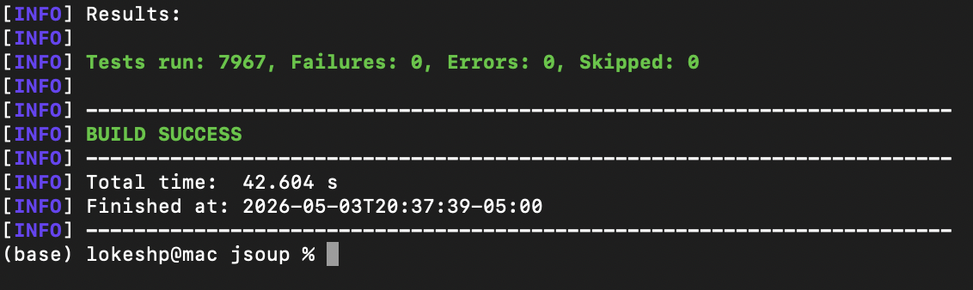
Figure 1. Maven test run showing all tests passing and BUILD SUCCESS.

RUNNING PIT MUTATION TESTING
PIT was configured in Test/jsoup/pom.xml with a custom mutator list, XML output enabled, and line coverage export enabled. The plugin configuration also includes target class and target test settings for the generated EvoSuite tests.
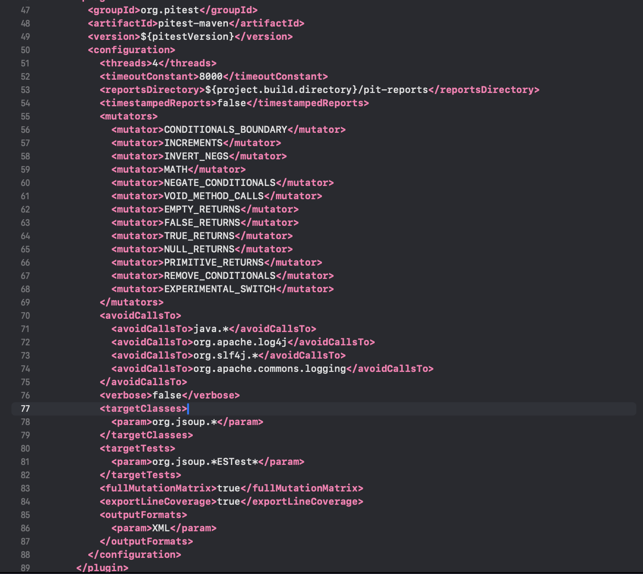
Figure 2. PIT plugin configuration in pom.xml.
The general PIT command for the project is shown below:
mvn test-compile org.pitest:pitest-maven:mutationCoverage
A full-project PIT run produced worker RUN_ERROR instability for some EvoSuite-generated tests. To complete a stable end-to-end demonstration, a targeted PIT execution was performed on org.jsoup.parser.ParseError using a single PIT thread.
mvn clean test-compile org.pitest:pitest-maven:mutationCoverage \
-DtargetClasses=org.jsoup.parser.ParseError \
-DtargetTests='org.jsoup.parser.ParseError_ESTest*' \
-Dthreads=1
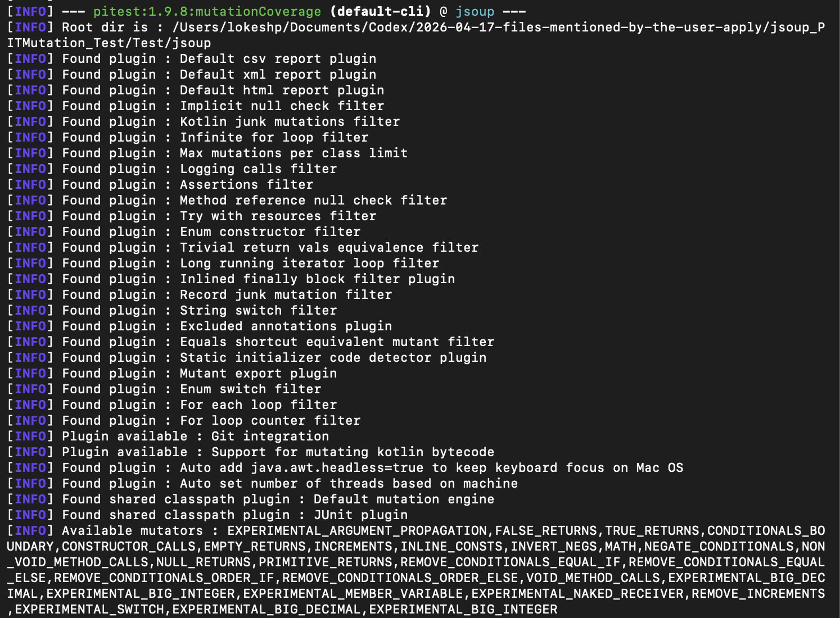
Figure 3. PIT mutationCoverage execution in progress.
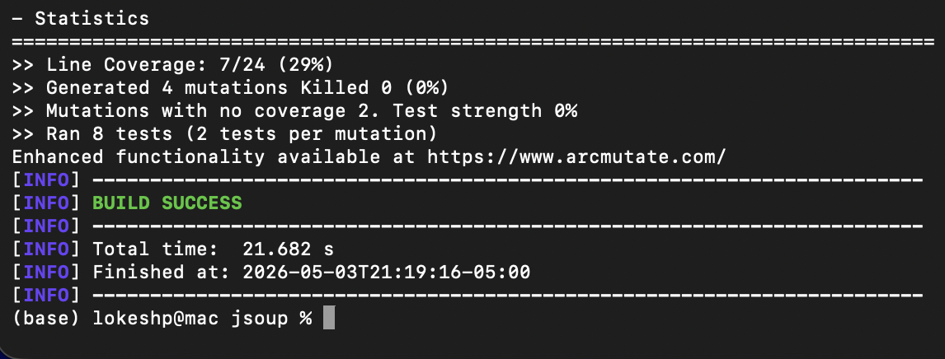
Figure 4. Final PIT statistics for the successful targeted run.

PIT RESULTS
The successful targeted PIT run reported the following final statistics:
- Line Coverage: 7/24 (29%)
- Generated mutations: 4
- Killed mutations: 0
- Mutations with no coverage: 2
- Test strength: 0%
- Tests executed: 8
Although the mutation score for this targeted run was low, the run successfully generated valid XML reports and confirmed that the PIT configuration and downstream tooling worked end to end.

MUTATION REPORTS
After execution, PIT generated reports in Test/jsoup/target/pit-reports/. The key files were mutations.xml and linecoverage.xml. The mutations.xml file stores the source file, mutated class, mutated method, line number, mutator type, and status for each mutation. These files served as the input for the custom Python tooling.

APPLYING MUTATIONS TO SOURCE CODE
The Python script scripts/mutationApplier.py was implemented to recreate mutations directly in the Java source files. Instead of relying only on string replacement, the script uses javalang to parse Java source into an AST and then validates node types and source locations before applying each mutation.
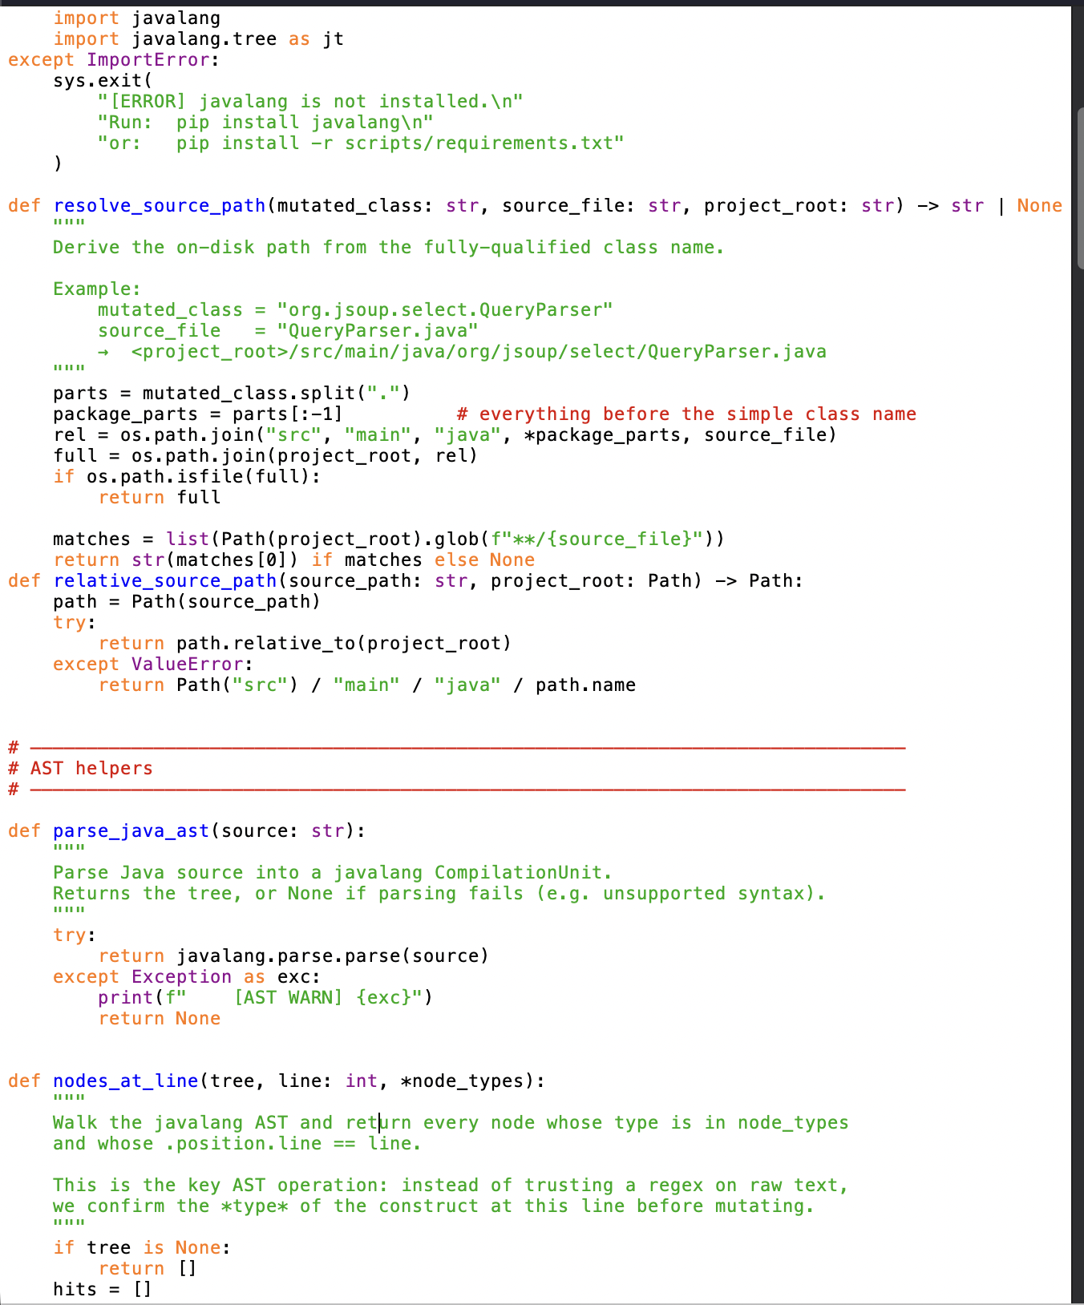
Figure 5. AST-aware logic inside mutationApplier.py.
The script performs the following operations:
- Reads mutation entries from mutations.xml
- Locates the corresponding source file in Test/jsoup/src/main/java/
- Parses the Java source file with javalang
- Applies a mutation-specific transformation
- Writes the mutated source to the mutants/ directory
python3 scripts/mutationApplier.py \
--mutations Test/jsoup/target/pit-reports/mutations.xml \
--project Test/jsoup \
--output mutants
The final script execution created 4 mutant files with 0 skipped files and 0 errors.
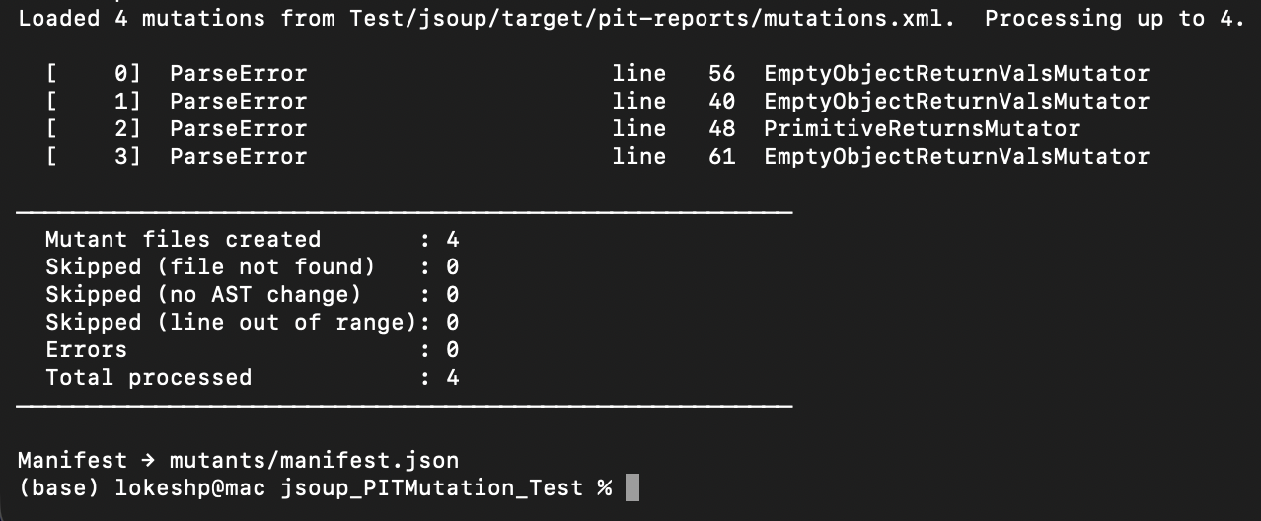
Figure 6. mutationApplier.py execution summary.

PROGRESS
The following work was completed during the project:
- Restructured the repository into a clear Test/jsoup plus scripts layout
- Configured PIT in pom.xml with XML export and line coverage export
- Verified that mvn test passes successfully
- Executed PIT and generated mutation report artifacts
- Implemented Python tooling for mutation parsing and mutation application
- Generated mutated source files from PIT output
- Pushed the deliverables and documentation to GitHub

WHAT I LEARNED
This project strengthened my understanding of mutation testing as a measure of test quality rather than simple code coverage. I learned how PIT creates mutants, how the test suite is run against each mutant, and how mutation statistics can reveal weaknesses that are not obvious from standard test results alone.
I also learned more about practical Maven plugin configuration and about the value of AST-based automation. Using javalang in the Python tooling showed why syntax-aware transformations are more reliable than plain text replacement when working with Java source code.

HOW THIS PROJECT WAS BENEFICIAL
This project was beneficial because it combined several practical software engineering skills in one workflow: Java project setup, Maven configuration, automated testing, mutation testing, debugging tool/runtime issues, Python-based automation, and repository documentation. Working through these steps felt like a realistic engineering task that required both implementation and troubleshooting.

DELIVERABLES
All project deliverables are available in the GitHub repository: https://github.com/notlokii/jsoup_Mutation_Parsed
- Java project under test: Test/jsoup/
- PIT configuration: Test/jsoup/pom.xml
- Mutation parsing script: scripts/parsePitXml.py
- Mutation recreation script: scripts/mutationApplier.py
- Pipeline scripts: scripts/run_pit.sh and scripts/run_pipeline.sh
- Generated mutant outputs: mutants/
- Repository documentation: README.md
- Final report document: deliverables/jsoup_final_report.docx

CONCLUSION
This project demonstrated how mutation testing can be used to evaluate the strength of a test suite and how additional tooling can make PIT reports more actionable. PIT provided mutation and coverage data, while the Python scripts extended the workflow by parsing XML reports and recreating mutated source files for inspection.
Overall, the project reinforced the importance of testing quality, automation, and tool-building in software engineering. It also showed that even when a full mutation run is unstable, a carefully scoped and documented workflow can still validate the tooling pipeline and produce meaningful results.

