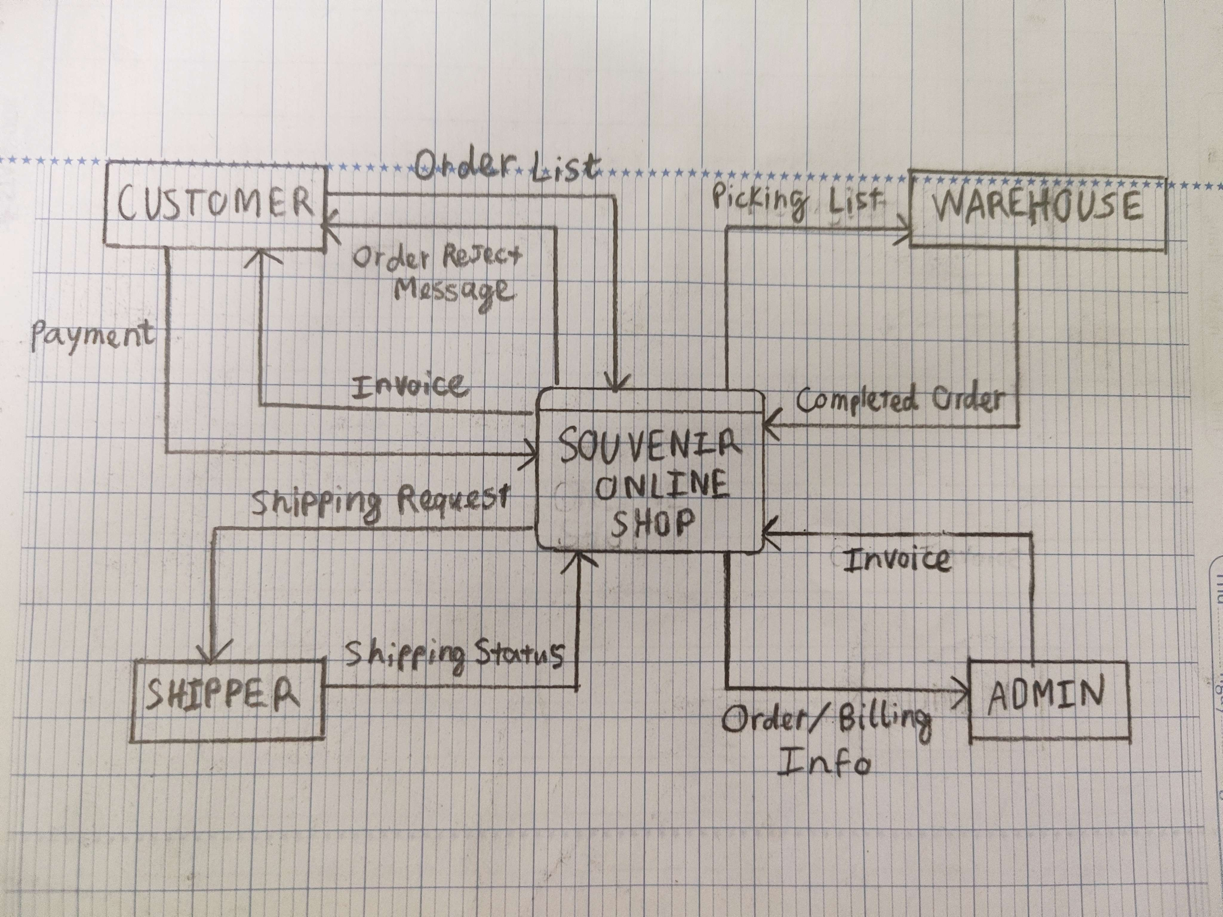
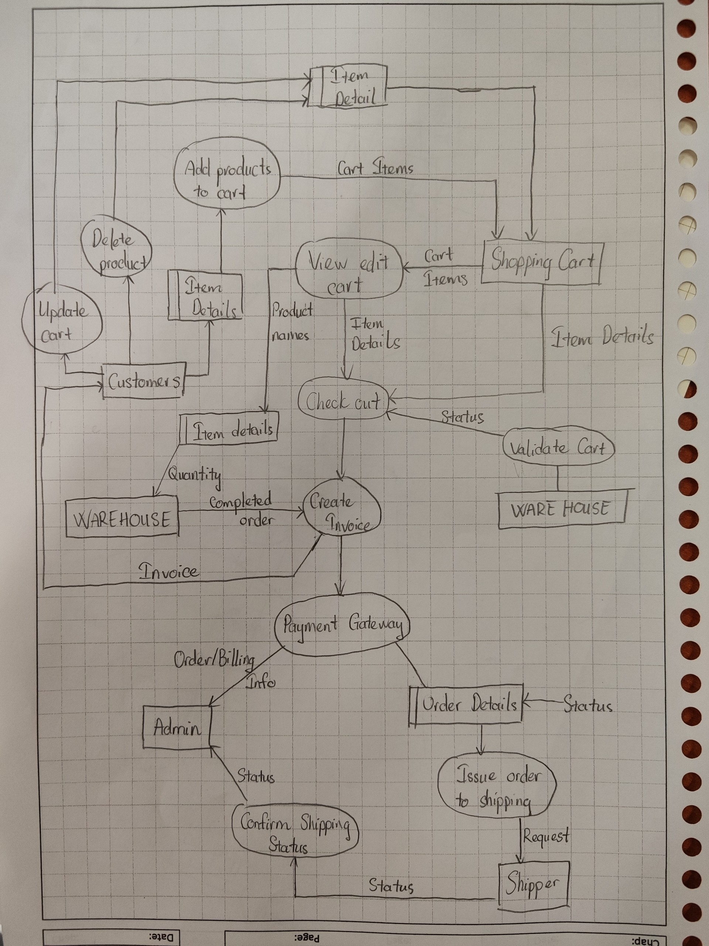
https://app.diagrams.net/#G1dBnofAoDNlTmqZP8l0B8ffRvZSJGXLg_#%7B%22pageId%22%3A%22fFSSvAEFyGOQvYFbmD-n%22%7D

