ROYGBIV Earth User Manual

Written and coded by Mauro Chavez

1. Working with ROYGBIV Earth user interface

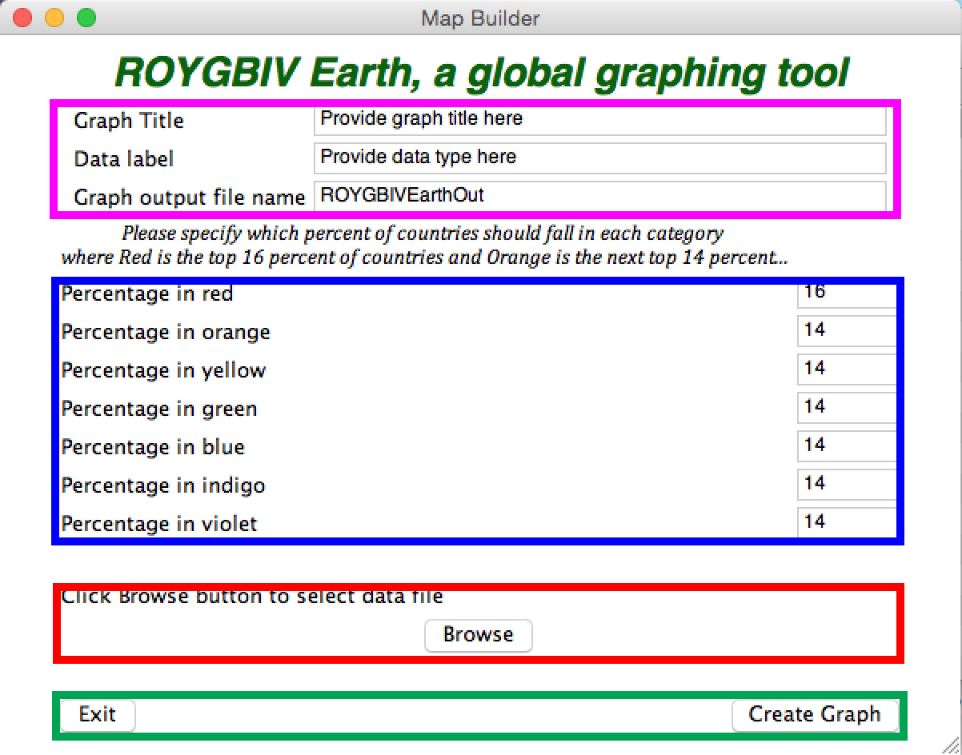

After starting the program ROYGBIV_Earth.app, this window will pop up. The following describes what each field is used for and how to set up the parameters that direct the creation of your graph.

**Pink Box:**

In the first row of the section highlighted by the pink box you can enter the title of your graph that will appear above the map of the world.

The second row allows you to provide a key word or phrase that describes the data being graphed. This will appear above the ROYGBIV color key.

The third row is where you should write the name of the graph file itself that is created by the app. This file will have “.html” added to it and will automatically open after you click create graph.

**Blue Box:**

In this field you can define the percentages of countries that will occupy each of the ROYGBIV color categories. For example, 14 in the “Percentage in organge” box means that 14 % of countries will show up in orange where the orange countries are the second highest grouping of values in the data set. In this setting, the top 16 % of values would show up as red and the next 14% would show up as orange…

**Red Box:**

Click “Browse” to open up a file browser. Find the .csv file that you have created that contains county names (saved as a Windows Comma Separated file) and their corresponding values to be graphed. See part 2 and part 3 for more details on how the .csv file should look.

**Green Box:**

Clicking “Create Graph” will use all the currently showing/entered parameters in the window and create your graph as an HTML file. This file will be automatically opened by your default internet browser but does not require an internet connection to be functional.

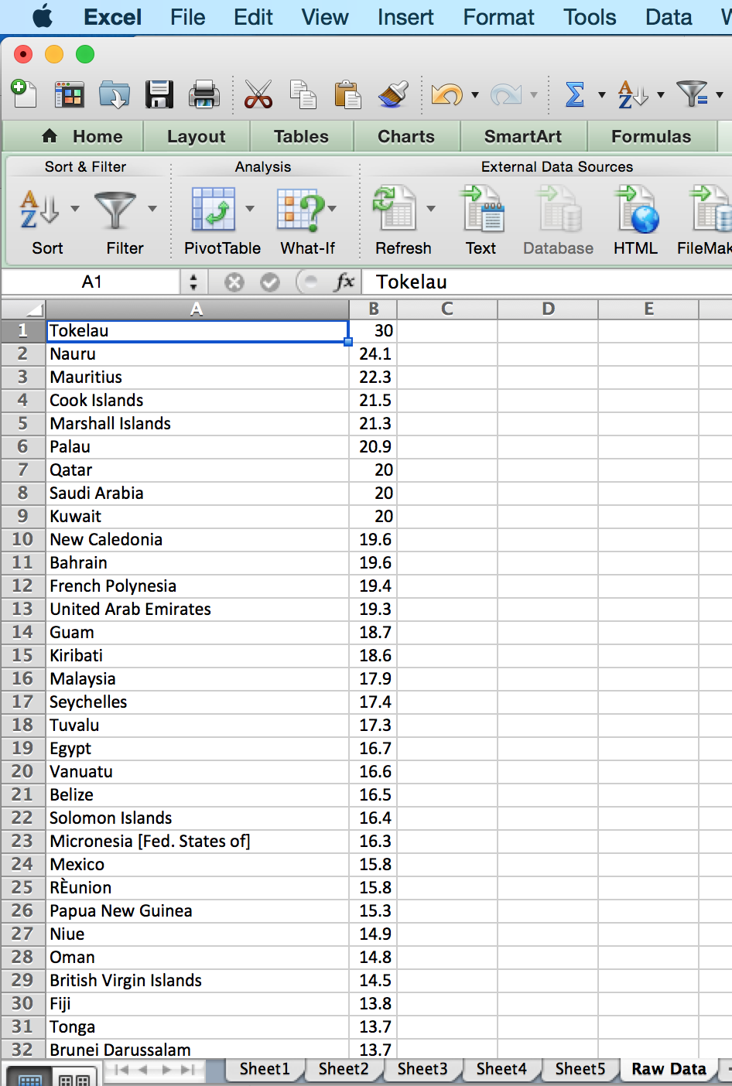2. Setting up your data

The image on the left shows how you should format your data so that it can be read by ROYGBIV_Earth. You can use any spreadsheet program capable of saving .csv files. In the example I use Excel. The first column should contain country names. The app is fitted with an extensive dictionary so local, official and common versions of a county’s name should be picked up. To ensure accuracy in readying country names, capitalize them appropriately. The second column should contain the value of whatever data you wish to graph that corresponds to the country on the same row in the left column.

The countries and corresponding values do not need to be in any particular order and no column labels are required.

3. Saving your data

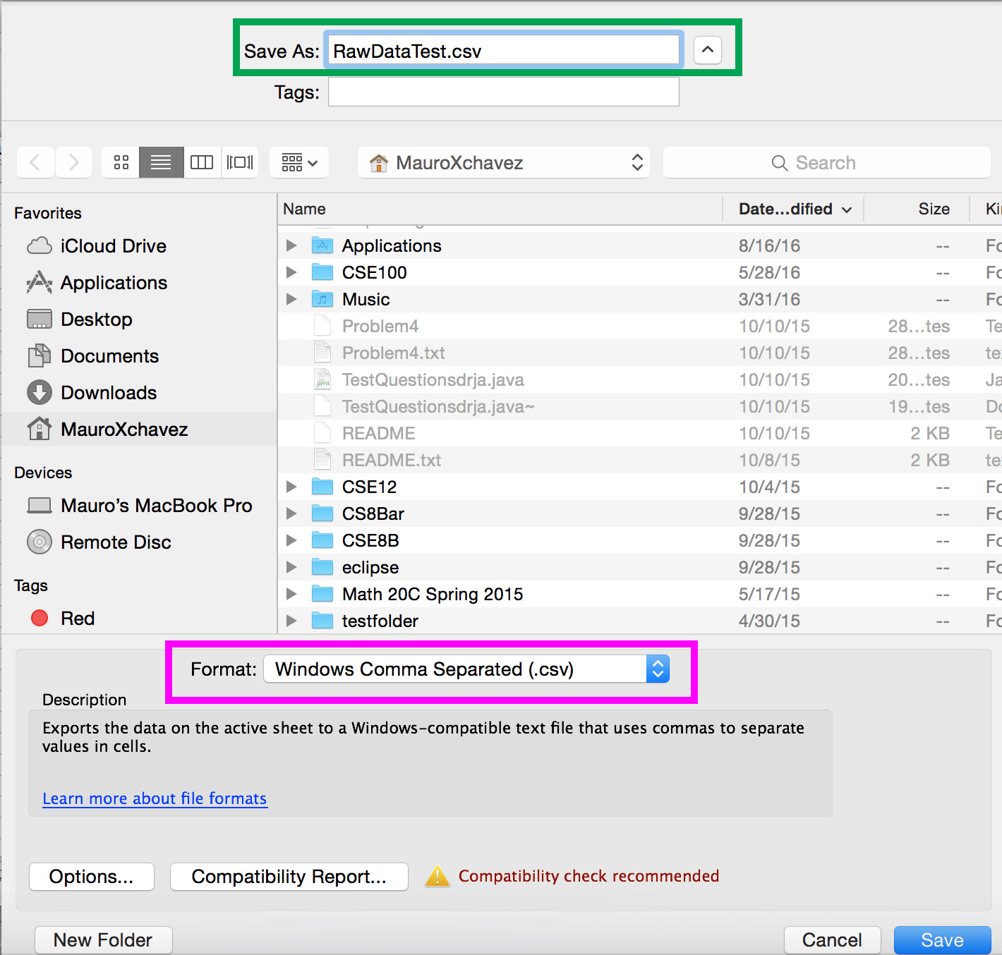Once your data is formatted as described above, save it as a .csv file. The green box on the image to the right shows where you can enter the name of the file. The pink box shows HOW you should save your data file. **Make sure to save your data as a Windows Comma Separated (.csv) file to ensure that it works with ROYGBIV_Earth.app**

4. Getting Images of your graph

Below is an example of a filled out ROYGBIV_Earth window.

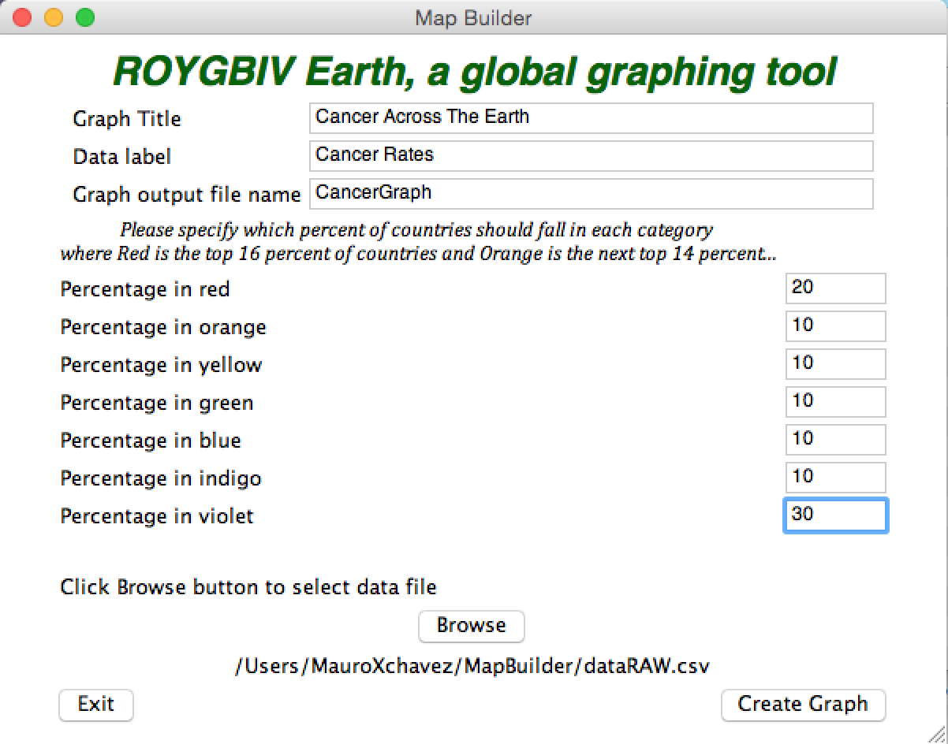

The above window will create the below graph. There are a few things to notice here.

* The URL of this webpage shows where on your computer the output file was stored
* In the top right you can save the graph as a Mac image file

While it is possible to download the graph as a .png image, I recommend using your mac’s screen shot feature to snap a picture of the graph. This allows for a higher quality image.

**To screen shot your graph hold command + left shift + 4 and drag the box over the area of the graph. Make sure to include the name and color key. This image by default gets put on your desktop as a .png file.**

