Case 1

A 30-year-old male presents with history of difficulty swallowing both solids and liquids for two years. He notices that his symptom gets worse with 10-kg weight loss in the last 6 months. Rapid eating also aggravates his symptom. Occasionally, when he is supine or is exercising, he regurgitates food particles from previous meals and complains of halitosis (bad breath). He denies history of heartburn.

Physical examination
Vital signs: BT 37 ºc, BP 130/90 mmHg, HR 90/min, RR 16/min
Abdomen: soft, normoactive bowel sound, non-tender, no hepatosplenomegaly.
Other examination: unremarkable

Upper endoscopy: dilated and tortuous esophagus, tight esophagogastric junction

Barium swallow: dilated lower esophagus with air-barium level
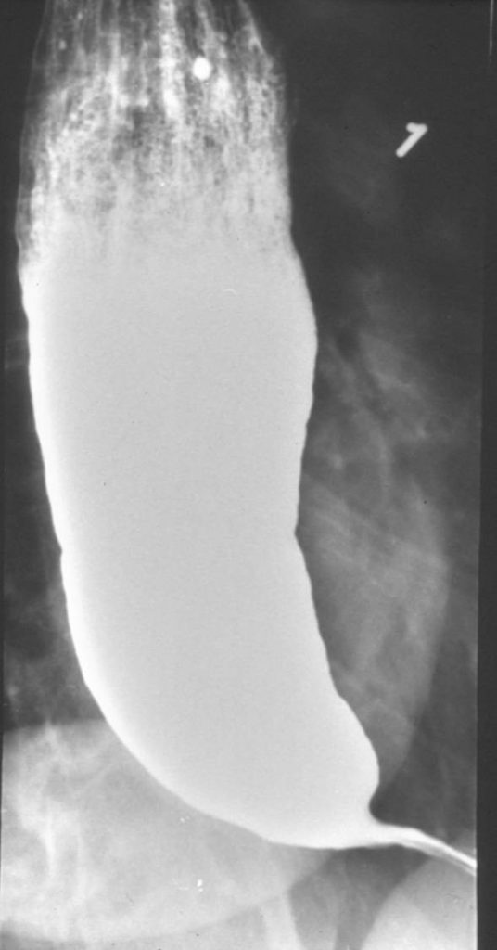

Questions:
- How can food regurgitation be differentiated from vomiting?
- What are the clinical differences between mechanical obstruction and esophageal motility disorder?
- What is the most likely diagnosis and the pathophysiology of the disease?

Case 2
A 25-year-old woman is evaluated for nausea and vomiting with three partly digested yellowish vomiting contents and four loose stools for 3 hours. She has not had fever, abdominal pain or blood in the stool. She is otherwise healthy and takes no medication. She just ate left-over fried rice 6 hours ago.
Physical examination:
Body temperature 37° C Blood pressure 100/60 mmHg Pulse rate 120 beat/min
HEENT: Dry lips, dry tongue and sunken eye ball
Abdomen: hyperactive bowel sound, no distension, soft without tenderness on palpation
Questions
- What is the most likely diagnosis and pathophysiology of vomiting?
- What is the most likely etiology of her symptoms?
- What medication can be given to relieve her symptoms and what are their mechanisms?

Case 3
A 70-year-old female is evaluated for vomiting. She has intermittent vomiting and abdominal pain for one week. Her symptoms are getting worse today with more abdominal distension and crampy pain. She vomits almost every 10-30 minutes with bilious emesis. She also has constipation and unable to pass gas during this week. Her underlying disease is asymptomatic gallstone 2 cm without history of acute cholecystitis or other stone-related complications. She denies previous surgery.

Physical examination:
Body temperature 36.7° C Blood pressure 100/50 mmHg Pulse rate 110 beat/min Respiratory rate 22/min
HEENT: Dry lips, Dry tongue and sunken eye ball, anicteric sclera
Abdomen: Moderately distended, tympanic and high-pitched bowel sounds, soft without tenderness on palpation
Rectal examination: normal
Questions
- What is the most likely pathophysiology of vomiting?
- Where is the abnormality occur?
- What is the differential diagnosis in this patient?

