BottleOps plan
Oct 20, 2026 · @Noel A P
BottleOps has two agents. Line Watcher guards the lines and raises red alerts. Data Explorer answers your questions. Both use only Bottle Co data and show every number they used. You decide the choices in section 2. Then we build.

1. At a glance
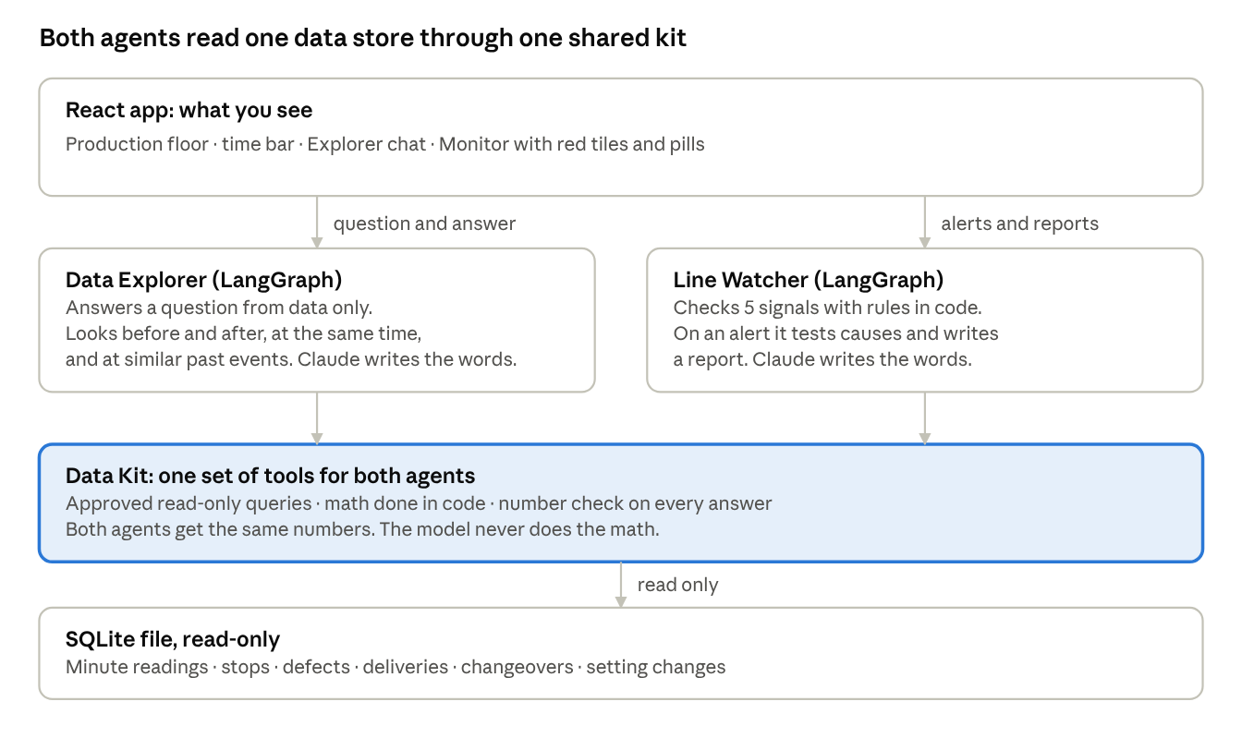
Both agents read one data store through one shared kit.
Two agents share one Data Kit. The kit does all the math and checks every number. The model writes only the words.

2. Architecture choices: you decide
I recommend React, Python, SQLite and Claude. Each row gives the options, my pick and the reason. D1, D3 and D4 are hard to change later. The others are easy to change.
# | Choice | Options | My pick | Why
D1 | Front end (what you see) | A. React + Vite · B. Streamlit · C. Plain HTML + HTMX | A. React | The time drawer, the moving bottles and the iMessage look need full control of the screen. Streamlit redraws the page on each click. It cannot do these well.
D2 | Back end (the engine) | A. Python + FastAPI · B. Node + LangChain.js · C. No back end (Streamlit only) | A. Python + FastAPI | LangGraph is strongest in Python. The data code is also Python.
D3 | Data store | A. SQLite · B. DuckDB · C. Postgres | A. SQLite | One file. No server. It opens read-only, so an agent cannot change data. Enough for 40,000 to 1 million rows. Move to DuckDB if the data grows.
D4 | Brain (the AI model) | A. Claude (Haiku, Sonnet, Opus) · B. OpenAI · C. Local model | A. Claude | Strong at using tools and at "answer only from data". The Brain slider picks the size.
D5 | Agent shape | A. Two graphs + one shared Data Kit · B. One supervisor graph · C. One basic loop | A. Two graphs + shared kit | The agents start from different triggers: a clock and a question. A shared kit gives both the same numbers. A custom graph makes the number check a step the agent cannot skip.
D6 | Alert engine | A. Rules in code · B. LLM watches the numbers · C. ML detector | A. Rules in code | Same result every time. No LLM cost each minute. It cannot invent an alert. The LLM only writes the report from the evidence.
D7 | Time clock | A. App holds the clock · B. Server streams the clock · C. Pre-built static files | A. App holds the clock | Scrubbing back and forth is easy. A report is written once per alert and saved. A replay costs nothing and repeats exactly.
D8 | Live updates | A. Plain requests + Server-Sent Events · B. WebSocket | A. Plain requests + SSE | Simpler. We need a push only for "report ready".
D9 | Data for v1 | A. Bottle Co synthetic data · B. PIADE real data · C. Both | A. Bottle Co synthetic | The causes are known, so we can test every cause finding. PIADE has no defect names and no stock data. Add PIADE later as a second dataset.
D10 | Hosting | A. React on Cloudflare Pages + API on a small host with rate limit and spend cap · B. One container · C. Hugging Face Space | A. Pages + small API host | It fits your noel.sg plan. The limits protect your API credit.
If you choose Streamlit (D1-B), the build is faster but the app is smaller. You lose the time drawer, the live floor and the iMessage look. I do not recommend it for this goal.

3. Use-cases and 5 KPIs
Five KPIs cover the three stories in your notes: downtime, quality and supply shock. They also cover the three OEE losses and give one look-ahead.
# | KPI (plain name) | What it shows | Warn when | Story it catches | Why this KPI
1 | Overall score (OEE) | Share of ideal output you got, last 60 min | Below 55% | Any large loss | One number that sums up the line.
2 | Stopped time | Minutes stopped by faults, last 60 min | Above 20 min | Filler jam bursts, preform shortage | Shows downtime as plain minutes.
3 | Speed | Running speed against ideal, last 15 min | Below 75% | Slow running, tiny stops | Hidden loss. A line can run but run slow.
4 | Rejects | Share of bottles rejected, last 30 min | Above 3% | Rejects after changeover, capper drift | Quality loss. It shows up early here.
5 | Preforms left | Minutes of preforms left at the current pace | Below 45 min | Preform shortage, about 45 min before the stop | The only look-ahead KPI. It warns before the line stops.
I left out energy, MTBF and changeover time. Each adds a number but no new story. We can add them later. Every warning level is a slider (section 6).

4. How the two agents work
Each agent is a LangGraph flow. Code runs the queries, the math, the cause tests and the number check. Claude reads your question and writes the words.

Data Explorer: runs when you ask
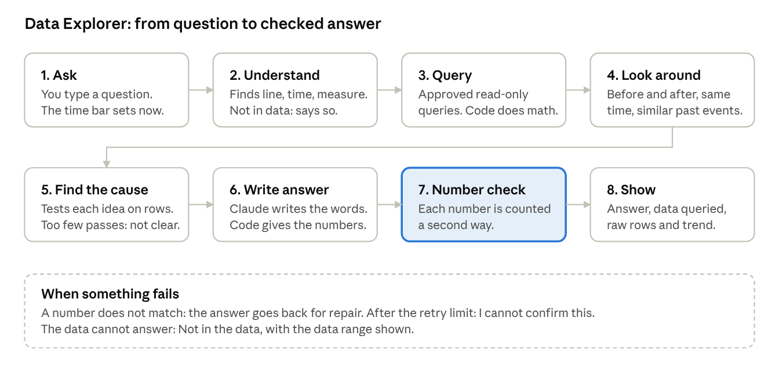
Data Explorer flow.

Line Watcher: runs on the clock
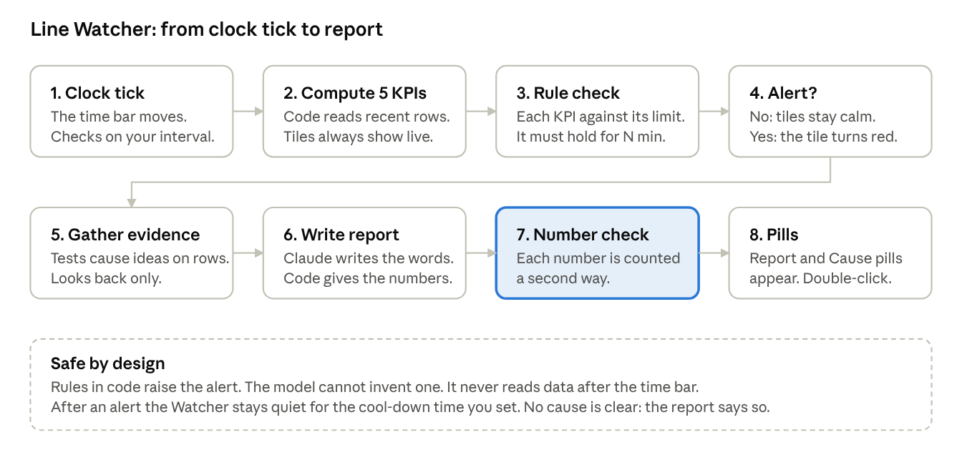
Line Watcher flow.
The number check is a step the agent cannot skip.

5. No-guess rules
A model writes a wrong number only when it writes numbers itself. In BottleOps, code writes every number. The model writes the words around the numbers. A check proves they match.
- Data only. The agent has no other source. It reads rows with approved tools and writes only from those rows.
- Code does the math. Totals, rates and OEE come from code, never from the model.
- Every number has a source. Tap a number in an answer to see its rows in the data table.
- Number check (always on). Code compares each number and date in the answer with the rows. One mismatch sends the answer back for repair. After the retry limit, the agent says "I cannot confirm this".
- "Not in the data" is a valid answer. An empty result, or a date outside the data, gives that answer and shows the data range.
- A cause needs proof. The agent names a cause only if enough checks pass on the data. If not, it says "the cause is not clear from the data" and lists what it checked.
- No peek at the future. Line Watcher sees only data up to the playhead time.
- Read-only data. The database opens read-only. The agent can run only approved queries, with a row limit.
- Wording sliders never change numbers. "How free is my wording?" changes words only. The number check stays on at every setting.

6. Sliders in plain English
Every setting is a slider with plain words. The app shows no technical term. The last column is for the build only. One setting is not a slider: the number check. It is always on.
Slider (text in the app) | Left | Right | Default | Used by | Under the hood (build only)
How free is my wording? | Same words every time | More variety | Left | Both | Temperature, 0 to 1
How long are my answers? | Short | Long | Short | Both | Max answer length, 150 to 1,200 tokens
Brain | Fast | Deep | Balanced | Both | Model size: Haiku, Sonnet, Opus
How hard do I try? | Quick look | Dig deep | 6 steps | Both | Max graph steps, 3 to 20
How long may I think? | 10 sec | 2 min | 45 sec | Both | Time limit per run
If my number check fails, how often do I try again? | Never | 3 times | 2 times | Both | Repair retries, 0 to 3
How far around the moment do I look? | 15 min | 12 hours | 2 hours | Both | Look-around window
How many past events do I compare? | 1 | 10 | 3 | Explorer | Similar events (k)
How alike must a past event be? | Loosely alike | Nearly the same | Middle | Explorer | Similarity cut-off
How much data may I read? | 100 rows | 5,000 rows | 1,000 rows | Explorer | Row limit per query
How sure must I be before I answer? | Answer fast | Be very sure | High | Explorer | Min share of passed checks
How much of our chat do I remember? | 2 messages | 30 messages | 10 | Explorer | Chat memory window
Overall score: warn me below | 30% | 80% | 55% | Watcher | OEE limit
Stopped time: warn me above | 5 min | 45 min | 20 min | Watcher | Stop-minutes limit
Speed: warn me below | 50% | 95% | 75% | Watcher | Speed limit
Rejects: warn me above | 1% | 8% | 3% | Watcher | Reject-rate limit
Preforms left: warn me below | 10 min | 120 min | 45 min | Watcher | Stock-cover limit
How often do I check? | Every minute | Every 15 min | Every minute | Watcher | Check interval
How long must a problem last before I warn? | 1 min | 30 min | 5 min | Watcher | Hold time
How long do I stay quiet after a warning? | 0 min | 2 hours | 30 min | Watcher | Cool-down
How many days of normal do I compare with? | 1 | 14 | 7 | Watcher | Baseline window
How many causes do I check? | 1 | 8 | 5 | Watcher | Cause ideas to test
How long is a report? | Brief | Full | Brief | Watcher | Report detail
I set the defaults to favor facts over style: same words, 2 retries, high certainty. Each agent has its own settings sheet. "Reset" puts the safe defaults back.

7. Data
The data is sample data, shaped like your MES file. It covers 14 days (1 to 15 Sep 2026), 2 lines and 20,160 minutes per line. A fixed seed gives the same data every time. The preview builds it in the browser. The real build keeps it in one SQLite file.
Table | What it holds
lines | Line 1 and Line 2
products | Bottle types and their ideal speed
shifts | Shifts A, B and C, with hours
minute_readings | One row per line per minute: state, speed, good and rejected bottles, preforms in stock (40,320 rows)
hourly_production | Totals per line per hour
downtime_events | Each stop, with start, end and reason
defects | Rejects by defect type
deliveries | Preform trucks: planned and actual arrival
changeovers | Product changes, with start and end
setpoint_changes | Machine setting changes, with time
event_features | Size, hour and shift of each past event. It is used to find similar past events
The data holds 8 story events. Each has a known cause. They are the answer key for every cause test.
# | Line | When | What happens | Known cause
1 | L1 | Thu 3 Sep 10:12 | 4 filler jams in 45 min after a clean | Start-up after a clean
2 | L2 | Sat 5 Sep 14:20 | Bad labels after a product change | Changeover
3 | L1 | Mon 7 Sep 00:30 | Cap torque slides for 2 h. Rejects rise | Capper drift
4 | L2 | Tue 8 Sep 22:02 | Many 1 to 2 min slowdowns after the 22:00 handover | Shift handover
5 | L2 | Wed 9 Sep 15:10 | Ran at 70% speed for 3.5 h | Speed set lower
6 | L1 | Thu 10 Sep 05:00 | Truck about 14 h 40 min late. The line ran dry. Daily OEE 51.0% | Late preform delivery
7 | Both | Fri 11 Sep 13:10 | Both lines stop for more than 20 min | Site-wide stop (power dip)
8 | L2 | Sun 13 Sep 02:20 | The score dips for 80 min | None. The answer must be "not clear"
PIADE data comes later as a second dataset. No G1, SAP or HMGICS data enters the app.

8. Screens and look
The live preview shows the full design: open the preview. Press play. The clock stops at the first warning. Then click the red RCA pill.
Layout
- Top: the production floor. Two lanes, bottles move left to right. A fault lights the station.
- Left: Data Explorer, an iMessage-style chat. Each answer has cards for Data queried, Raw data and Trend observed.
- Right: Line Watcher. 5 live tiles per line. A tile turns red on a trigger. A list of RCA pills appears below. Click one to see the full analysis and the triangulation.
- Bottom: the time drawer. A scrub bar, play/pause, jump buttons, and speed chips (Real, 1×, 2×, 3×, 5×, 10×, 30×, 60×, 360×, Custom). The header shows date, time and shift. Bottles move on each line at that line's real rate.
- Phone: the Explorer and the Watcher become two tabs.
Apple rules
- Colors, sizes and radii come from tokens. Dark mode with Liquid Glass is the default. Light and auto mode also work.
- Font: the system font (SF on Apple devices). Large, calm text. Red only for a real trigger.
- Sliders look like iOS sliders, with plain words at both ends.
- Pills and sheets use soft glass and rounded corners. A sheet opens in front of the Watcher panel.
- Chat bubbles follow iMessage: blue for you, grey for the Explorer.
- Keyboard works: Space plays, arrows jump, Enter opens a pill.

9. Build phases
Each phase ends with a check. We move on only when the check passes. I build. You review at each gate.
- Check the basics. Run one model call with your settings. Confirm the key, the budget, and that the wording slider works on the chosen model. Done when: a test call runs with the values set.
- Build the data. Extend your MES generator with minute tables and the 8 story events. Save one SQLite file. Done when: totals match plain SQL checks, for example the 10 Sep daily OEE of Line 1.
- Build the Data Kit and the alert engine. Tools, the 5 KPIs and the alert rules, in code, with tests. Done when: the 8 story events raise the expected alerts and nothing else raises at the default sliders.
- Build Line Watcher. The LangGraph flow, the report, the cause tests and the number check. Done when: all reports pass the number check, the top cause matches the known cause for 7 events, and event 8 gives "not clear".
- Build Data Explorer. The LangGraph flow and the three look-around lenses. Done when: 30 golden questions pass and 10 trick questions get "not in the data".
- Build the app. React screens from the approved preview, linked to the API. Done when: scrub, speed, pills, chat and sliders work and match the preview.
- Polish and QA. Tokens only, keyboard, dark mode, phone width, screenshot tests. Done when: no screen differs from the approved design.
- Publish. Deploy, add the rate limit and the spend cap, add the page to noel.sg/opsagent/bottleops. Done when: a stranger can use it and the spend cap holds.

10. Tests
Tests prove that the agents do not guess. Every test has a known right answer from plain SQL or from the story events.
- Data: totals from plain SQL match the numbers in the app.
- Alerts: each of the 8 story events raises its alert. No other alert shows at the default sliders.
- Golden questions (30): each has a known answer. The agent must match every number.
- Trick questions (10): missing date, unknown machine, forecast, opinion, date outside the data. The agent must say "not in the data".
- Number check: we inject a wrong number on purpose. The check must catch it every time.
- Causes: the top cause must match the known cause. Event 8 has none, so the agent must say "not clear".
- Repeat test: with wording at "Same words every time", the same question gives the same numbers twice.
- UI: compare a screenshot of each screen with the approved design. Check contrast, keyboard use and dark mode.

11. Risks and open points
Check the first two points before any build work.
- Model settings. Some new models may not accept a wording setting. I check this in phase 1. If a model does not accept it, the slider changes the style through the prompt. Numbers stay safe.
- Cost on a public site. Strangers use your API credit. We add a rate limit, a spend cap and saved answers for the sample questions.
- Preview limits. The preview chat answers 5 sample question types. The real app answers any question from the data.
- One click on touch screens. One click or tap opens a pill on any device. The preview has both.
- "Open before the monitoring agent." I read this as "open in front of the monitoring panel". Tell me if you meant something else.
- Synthetic data is too clean. The preview has vague comments and odd hours, as in your sample. It has no time gaps yet. I add them in phase 2.
- No real company data. Data from G1, SAP and HMGICS stays out of any public demo.

