Git

**Git basic requirements:**

1. **Push the code from working copy to GitHub repo.**

**Working area->Staging area or Staging area-> Working area**

**Add file from working area->staging area**

With file name: git add filename1.txt, filename2.txt……

For all files: git add * or git add .

**Remove file from staging area->working area**

With file name: git add filename1.txt, filename2.txt……

For all files: git add * or git add .

NOTE: if we change any single line and save it on git then it will create a separate copy of it. Basically, it manages the history of it.

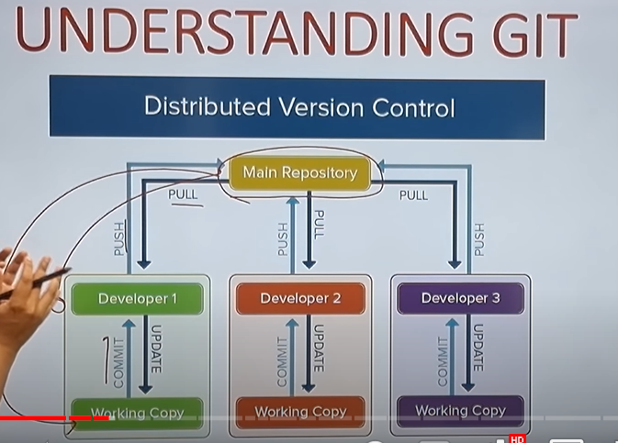

Here, **update** and **commit** are using for local repository to save and get the data. And **push** and **pull** are using for master/main repo on github.

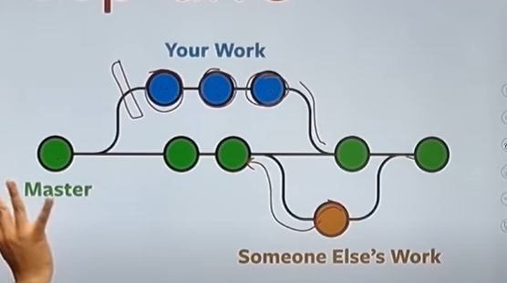

Here, for new module developer will create new branch and after finish it they will push it in master/main branch where all developers will push the final code.

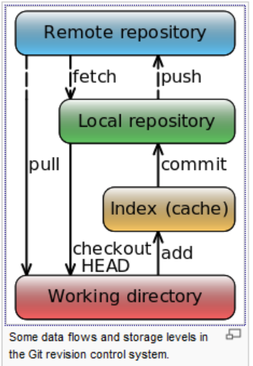

Suppose, I created 10 different class/file and out of 10 I want to save only 6. Then move this 6 files form working area to staging index using add command. So, add will add the file in staging area.

Commands:

**git status:** to get the status like how many files are modified, not committed etc.

**git clone:** to get the GitHub repo copy in our local system.

**git diff:** to show the difference between working area and local repo.

**git add:** to add the file in staging area.

For single file: **git add filename.txt**

For 2 or 3 files: **git add filename.txt filename1.txt**

For all file: **git add \***

**git rm –cached:** to remove it from staging area.

For single file: **git rm –cached filename.txt**

For 2 or 3 files: **git rm –cached filename.txt filename1.txt**

For all file: **git rm –cached \***

**git commit -m "commit message":** to commit the file in local repo.

**git push:** to push the code from local repo to git repo.

git log: to show the log/history.

**git checkout -b branch_name:** to create new branch and switch in new branch.(-b means new branch).

**git checkout branch_name**: to switch from current branch to new branch.

**git branch:** to get all the branch.