Q1 . Create “Hello World “ Application. That will display “Hello World “ in middle of the Screen in blue color with white background with a border to Android Layout. [10]
//activity_main.xml
<?xml version="1.0" encoding="utf-8"?>
<RelativeLayout xmlns:android="http://schemas.android.com/apk/res/android"
xmlns:app="http://schemas.android.com/apk/res-auto"
xmlns:tools="http://schemas.android.com/tools"
android:layout_width="match_parent"
android:layout_height="match_parent"
android:background="#000000"
android:padding="10dp"
tools:context=".MainActivity">
<LinearLayout
android:layout_width="match_parent"
android:layout_height="match_parent"
android:orientation="horizontal"
android:background="@drawable/border">
<TextView
android:layout_width="fill_parent"
android:layout_height="fill_parent"
android:gravity="center_vertical|center_horizontal"
android:text="Hello World!"
android:background="#A00000FF"
android:textColor="#ffffff"
android:textSize="40sp" />
</LinearLayout>
</RelativeLayout>

//border.xml
<?xml version="1.0" encoding="utf-8"?>
<shape xmlns:android="http://schemas.android.com/apk/res/android"
android:shape="rectangle">
<stroke
android:width="20dp"
android:color="#ffffff"></stroke>
</shape>

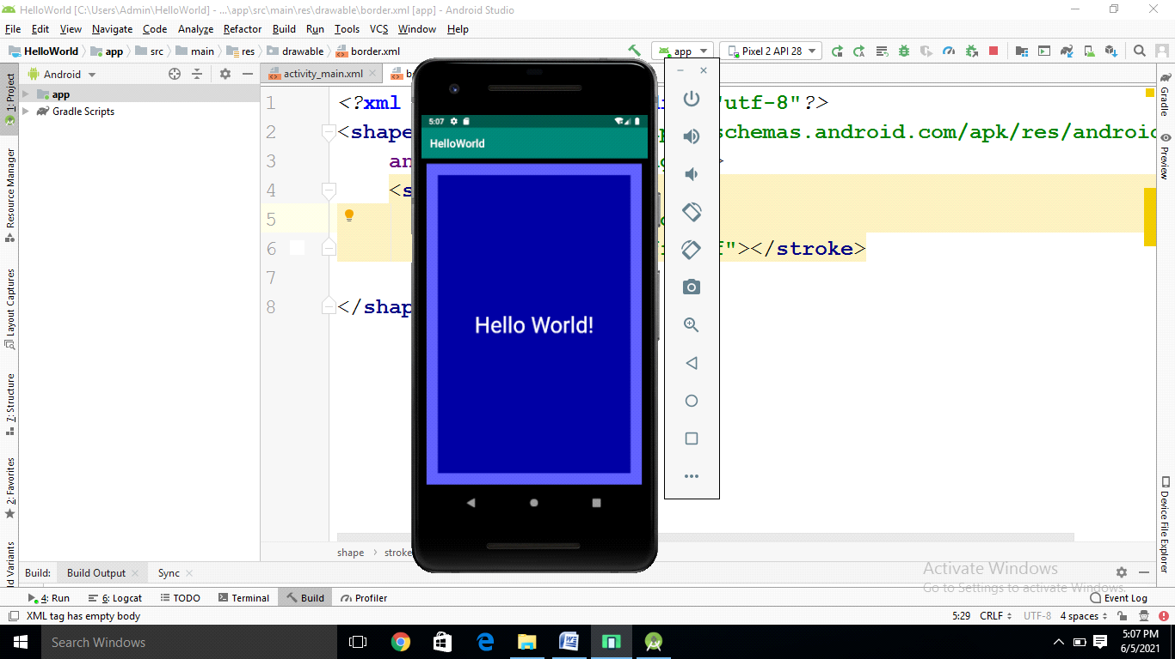

Q2. Create a simple Application which shows Life Cycle of activity.
package com.example.activitylifecycle;

import android.support.v7.app.AppCompatActivity;
import android.os.Bundle;
import android.support.v7.view.menu.ShowableListMenu;
import android.util.Log;
import android.widget.Toast;

public class MainActivity extends AppCompatActivity {
String t="event";

@Override
protected void onCreate(Bundle savedInstanceState) {
super.onCreate(savedInstanceState);
setContentView(R.layout.activity_main);
Toast.makeText(getApplicationContext(),"hello all",Toast.LENGTH_SHORT).show();
}

@Override
protected void onStart() {
super.onStart();
Log.d(t,"on start");
}

protected void onStop(){
super.onStop();
Log.d(t, "on Stop");
}

@Override
protected void onPause() {
super.onPause();
Log.d(t,"on pause");
}

@Override
protected void onResume() {
super.onResume();
Log.d(t, "onResume: ");
}
}

.XML
<?xml version="1.0" encoding="utf-8"?>
<android.support.constraint.ConstraintLayout xmlns:android="http://schemas.android.com/apk/res/android"
xmlns:app="http://schemas.android.com/apk/res-auto"
xmlns:tools="http://schemas.android.com/tools"
android:layout_width="match_parent"
android:layout_height="match_parent"
tools:context=".MainActivity">

<TextView
android:layout_width="wrap_content"
android:layout_height="wrap_content"
android:text="Hello World!"
app:layout_constraintBottom_toBottomOf="parent"
app:layout_constraintLeft_toLeftOf="parent"
app:layout_constraintRight_toRightOf="parent"
app:layout_constraintTop_toTopOf="parent" />

</android.support.constraint.ConstraintLayout>
Q3. Create following Vertical Scroll View Creation in Android [10]
Main.xml
<?xml version="1.0" encoding="utf-8"?>
<android.support.constraint.ConstraintLayout xmlns:android="http://schemas.android.com/apk/res/android"
xmlns:app="http://schemas.android.com/apk/res-auto"
xmlns:tools="http://schemas.android.com/tools"
android:layout_width="match_parent"
android:layout_height="match_parent"
tools:context=".MainActivity">

<ScrollView
android:layout_width="match_parent"
android:layout_height="match_parent">

<LinearLayout
android:layout_width="match_parent"
android:layout_height="wrap_content"
android:orientation="vertical" >

<Button
android:layout_width="match_parent"
android:layout_height="wrap_content"
android:gravity="center"
android:text="Button1"/>

<Button
android:layout_width="match_parent"
android:layout_height="wrap_content"
android:gravity="center"
android:text="Button2"/>

<Button
android:layout_width="match_parent"
android:layout_height="wrap_content"
android:gravity="center"
android:text="Button3"/>

<Button
android:layout_width="match_parent"
android:layout_height="wrap_content"
android:gravity="center"
android:text="Button4"/>

<Button
android:layout_width="match_parent"
android:layout_height="wrap_content"
android:gravity="center"
android:text="Button5"/>

<Button
android:layout_width="match_parent"
android:layout_height="wrap_content"
android:gravity="center"
android:text="Button6"/>

<Button
android:layout_width="match_parent"
android:layout_height="wrap_content"
android:gravity="center"
android:text="Button7"/>

<Button
android:layout_width="match_parent"
android:layout_height="wrap_content"
android:gravity="center"
android:text="Button8"/>

<Button
android:layout_width="match_parent"
android:layout_height="wrap_content"
android:gravity="center"
android:text="Button9"/>

<Button
android:layout_width="match_parent"
android:layout_height="wrap_content"
android:gravity="center"
android:text="Button10"/>

<Button
android:layout_width="match_parent"
android:layout_height="wrap_content"
android:gravity="center"
android:text="Button11"/>

<Button
android:layout_width="match_parent"
android:layout_height="wrap_content"
android:gravity="center"
android:text="Button12"/>

<Button
android:layout_width="match_parent"
android:layout_height="wrap_content"
android:gravity="center"
android:text="Button13"/>

<Button
android:layout_width="match_parent"
android:layout_height="wrap_content"
android:gravity="center"
android:text="Button14"/>

<Button
android:layout_width="match_parent"
android:layout_height="wrap_content"
android:gravity="center"
android:text="Button15"/>

<Button
android:layout_width="match_parent"
android:layout_height="wrap_content"
android:gravity="center"
android:text="Button16"/>

</LinearLayout>
</ScrollView>

</android.support.constraint.ConstraintLayout>
Q4. Create android application to change Font Size, Color and Font Family of String.
[10]
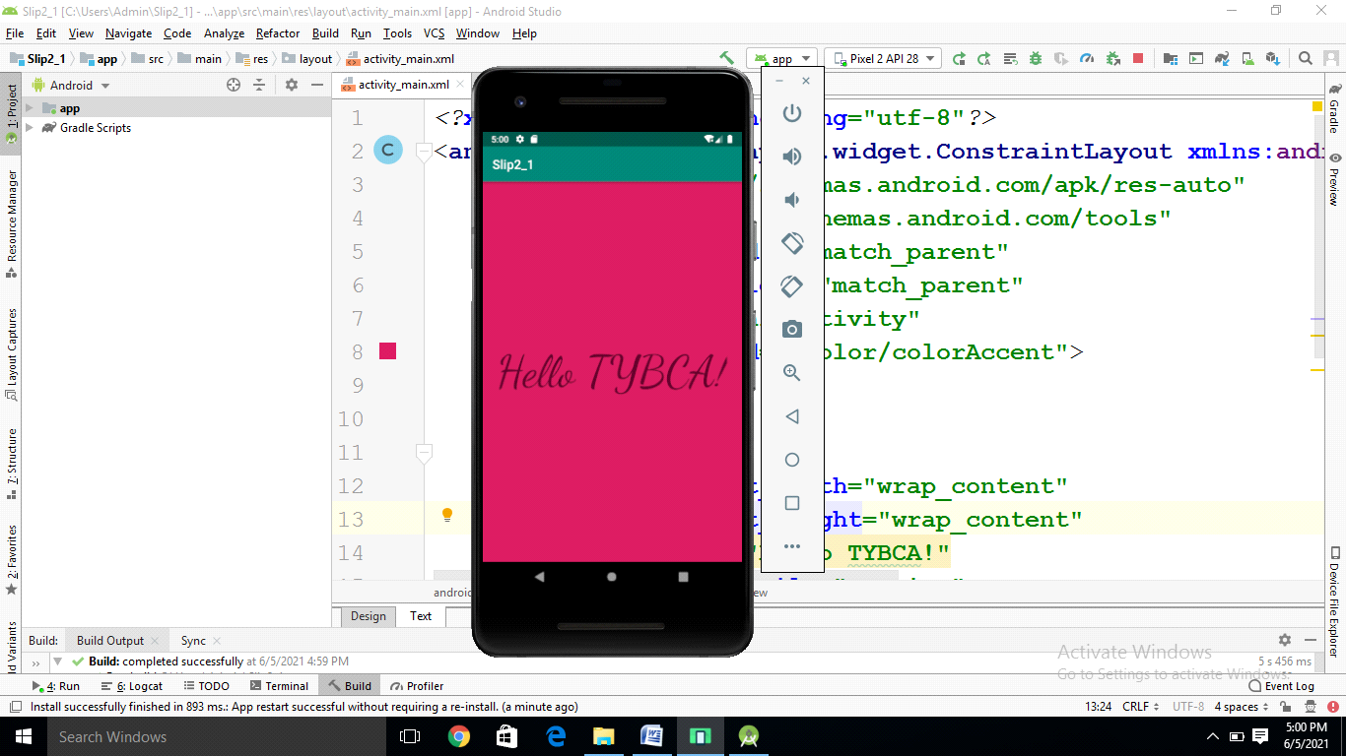
<?xml version="1.0" encoding="utf-8"?>
<androidx.constraintlayout.widget.ConstraintLayout xmlns:android="http://schemas.android.com/apk/res/android"
xmlns:app="http://schemas.android.com/apk/res-auto"
xmlns:tools="http://schemas.android.com/tools"
android:layout_width="match_parent"
android:layout_height="match_parent"
tools:context=".MainActivity"
android:background="@color/colorAccent">
<TextView
android:layout_width="wrap_content"
android:layout_height="wrap_content"
android:text="Hello TYBCA!"
android:fontFamily="cursive"
android:textSize="70dp"
app:layout_constraintBottom_toBottomOf="parent"
app:layout_constraintLeft_toLeftOf="parent"
app:layout_constraintRight_toRightOf="parent"
app:layout_constraintTop_toTopOf="parent" />
</androidx.constraintlayout.widget.ConstraintLayout>
Q5. Construct an app that toggles a light bulb on and off when the user clicks on toggle
button. [10]
Main.java
package com.example.tooglebutton;

import android.support.v7.app.AppCompatActivity;
import android.os.Bundle;
import android.view.View;
import android.widget.Toast;
import android.widget.ToggleButton;

public class MainActivity extends AppCompatActivity {

@Override
protected void onCreate(Bundle savedInstanceState) {
super.onCreate(savedInstanceState);
setContentView(R.layout.activity_main);
ToggleButton tb=(ToggleButton)findViewById(R.id.toggle1);
tb.setOnClickListener(new View.OnClickListener() {
@Override
public void onClick(View v) {

if (((ToggleButton)v).isChecked())
{
Toast.makeText(getBaseContext(),"Light is is On", Toast.LENGTH_LONG).show();
}
else
{
Toast.makeText(getBaseContext(),"Light is Off", Toast.LENGTH_LONG).show();
}
}
});

}

}

Main.java
<?xml version="1.0" encoding="utf-8"?>
<LinearLayout xmlns:android="http://schemas.android.com/apk/res/android"
xmlns:app="http://schemas.android.com/apk/res-auto"
xmlns:tools="http://schemas.android.com/tools"
android:layout_width="match_parent"
android:layout_height="match_parent"
tools:context=".MainActivity">

<ToggleButton
android:layout_width="wrap_content"
android:layout_height="wrap_content"
android:id="@+id/toggle1"/>

</LinearLayout>

