Q1. Create an application to accept Movie details like Name, Release Year, Collection and display the same information on the next activity. [20]
//ActivityMain.java
package com.example.slip29_2;
import
androidx.appcompat.app.AppCompatActivity;
import android.content.Intent;
import android.os.Bundle;
import android.view.View;
import android.widget.Button;
import android.widget.EditText;
public class MainActivity extends
AppCompatActivity {
@Override
protected void onCreate(Bundle
savedInstanceState) {

super.onCreate(savedInstanceState);

setContentView(R.layout.activity_main);
final EditText editText =
findViewById(R.id.mname);
final EditText
text2=findViewById(R.id.ryr);
final EditText
text3=findViewById(R.id.collection);
//final EditText editry = findViewById(R.id.ryr);
// final EditText editcoll =
findViewById(R.id.collection);
Button button = findViewById(R.id.button);
button.setOnClickListener(new
View.OnClickListener() {
@Override
public void onClick(View v) {
String name =
editText.getText().toString().trim();
String
releseyr=text2.getText().toString().trim(
);
String collection =
text3.getText().toString().trim();
Bundle bundle = new
Bundle();

bundle.putString("value1",name);

bundle.putString("value2",releseyr);

bundle.putString("value3",collection);
Intent intent = new
Intent(MainActivity.this, SecondActivirt.class);
intent.putExtras(bundle);
startActivity(intent);
}
});
}
}
//main_activity.xml
<?xml version="1.0" encoding="utf-8"?>
<LinearLayout
xmlns:android="http://schemas.android.com
/apk/res/android"

xmlns:app="http://schemas.android.com/apk
/res-auto"

xmlns:tools="http://schemas.android.com/t
ools"
android:layout_width="match_parent"
android:layout_height="match_parent"
android:orientation="vertical"
tools:context=".MainActivity">
<EditText
android:id = "@+id/mname"
android:layout_width = "match_parent"
android:layout_height = "wrap_content"
android:layout_gravity = "center"
android:hint = "Enter movie name"
android:inputType = "text" />
<EditText
android:id = "@+id/ryr"
android:layout_width = "match_parent"
android:layout_height = "wrap_content"
android:layout_gravity = "center"
android:hint = "Enter movie release year"
android:inputType = "text" />
<EditText
android:id = "@+id/collection"
android:layout_width = "match_parent"
android:layout_height = "wrap_content"
android:layout_gravity = "center"
android:hint = "Enter movie collection"
android:inputType = "text" />
<Button
android:id = "@+id/button"
android:layout_width = "wrap_content"
android:layout_height = "wrap_content"
android:layout_gravity = "center"
android:layout_marginTop = "16dp"
android:text = "Next" />
</LinearLayout>
//SecondActivity.java
package com.example.slip29_2;
import android.content.Intent;
import android.os.Bundle;
import android.widget.TextView;
import
androidx.appcompat.app.AppCompatActivity;
public class SecondActivirt extends
AppCompatActivity {
@Override
protected void onCreate(Bundle
savedInstanceState) {

super.onCreate(savedInstanceState);

setContentView(R.layout.activity_second);
Bundle bundle = getIntent().getExtras();
if (bundle!= null) {
String value = bundle.getString("value1");
String value2 = bundle.getString("value2");
String value3 = bundle.getString("value3");
TextView textView =findViewById(R.id.text_view);
TextView textView2 = findViewById(R.id.textryr);
TextView textView3 =
findViewById(R.id.textcollection);
textView.setText(value);
textView2.setText(value2);
textView3.setText(value3);
}
}
}
//activity_second.xml
<?xml version="1.0" encoding="utf-8"?>
<LinearLayout
xmlns:android="http://schemas.android.com
/apk/res/android"
android:orientation="vertical"
android:layout_width="match_parent"
android:layout_height="match_parent">
<TextView
android:id = "@+id/text_view"
android:layout_width = "match_parent"
android:layout_height = "wrap_content"
android:layout_gravity = "center"
/>
<TextView
android:id = "@+id/textryr"
android:layout_width = "match_parent"
android:layout_height = "wrap_content"
android:layout_gravity = "center"
/>
<TextView
android:id = "@+id/textcollection"
android:layout_width = "match_parent"
android:layout_height = "wrap_content"
android:layout_gravity = "center"
/>
</LinearLayout>
Q2. Display 15 images in 2-Dimensional scrolling grid. Information of selected with
position will be displayed using Toast message. [20]
//activity_main.xml
<?xml version="1.0" encoding="utf-8"?>
<ScrollView xmlns:android="http://schemas.android.com/apk/res/android"
xmlns:app="http://schemas.android.com/apk/res-auto"
xmlns:tools="http://schemas.android.com/tools"
android:layout_width="match_parent"
android:layout_height="match_parent">
<LinearLayout
android:layout_width="match_parent"
android:layout_height="wrap_content"
android:orientation="vertical" >
<GridView
android:id="@+id/gridview"
android:layout_width="fill_parent"
android:layout_height="fill_parent"
android:numColumns="3"
android:verticalSpacing="10dp"
android:horizontalSpacing="10dp"
android:columnWidth="90dp"
android:stretchMode="columnWidth"
android:gravity="center"
>
</GridView>
</LinearLayout>
</ScrollView>
//Activity_Main.java

package com.example.slip10_2;
import androidx.appcompat.app.AppCompatActivity;
import android.content.Intent;
import android.os.Bundle;
import android.view.View;
import android.widget.AdapterView;
import android.widget.GridView;
import android.widget.ImageView;
import android.widget.Toast;
public class MainActivity extends AppCompatActivity {
Integer[] imageIDs = {
R.drawable.pic1,
R.drawable.pic2,
R.drawable.pic3,
R.drawable.india,
R.drawable.china,
R.drawable.us
};
@Override
public void onCreate(Bundle savedInstanceState) {
super.onCreate(savedInstanceState);
setContentView(R.layout.activity_main);
GridView gridView = (GridView) findViewById(R.id.gridview);
gridView.setAdapter(new ImageAdapter(this));
gridView.setOnItemClickListener(new AdapterView.OnItemClickListener() {
public void onItemClick(AdapterView<?> parent,
View v, int position, long id) {
Toast.makeText(getBaseContext(),
"pic" + (position + 1) + " selected",
Toast.LENGTH_SHORT).show();
}
});
}
}

//ImageAdapter.java
package com.example.slip10_2;
import android.content.Context;
import android.view.View;
import android.view.ViewGroup;
import android.widget.BaseAdapter;
import android.widget.GridView;
import android.widget.ImageView;
import android.widget.ListAdapter;
class ImageAdapter extends BaseAdapter {
private Context context;
public ImageAdapter(Context c)
{
context = c;
}
public int getCount() {
return imageIDs.length;
}
public Object getItem(int position) {
return position;
}
public long getItemId(int position) {
return position;
}
//---returns an ImageView view---
public View getView(int position, View convertView, ViewGroup parent)
{
ImageView imageView;
if (convertView == null) {
imageView = new ImageView(context);
imageView.setLayoutParams(new GridView.LayoutParams(185, 185));
imageView.setScaleType(ImageView.ScaleType.CENTER_CROP);
imageView.setPadding(5, 5, 5, 5);
} else {
imageView = (ImageView) convertView;
}
imageView.setImageResource(imageIDs[position]);
return imageView;
}
Integer[] imageIDs = {
R.drawable.pic1,
R.drawable.pic2,
R.drawable.pic3,
R.drawable.india,
R.drawable.china,
R.drawable.us
};
}
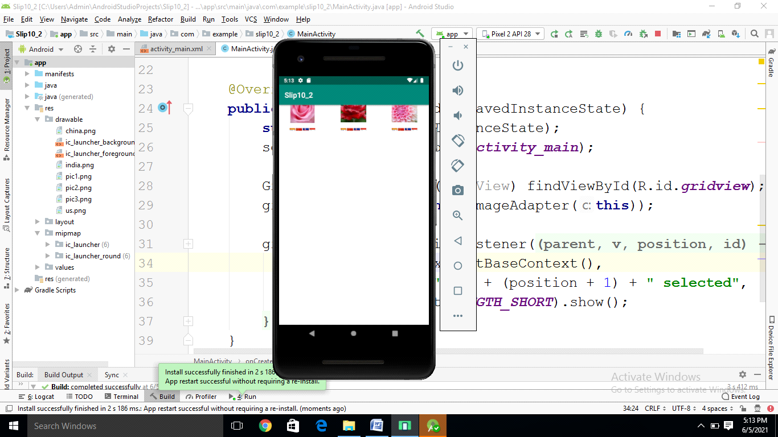
Q3. Create Application to demonstrate date and time picker [20]
TimeDemo(TimePicker DatePicker)
//MainActivity.java
package com.example.timedemo;
import
androidx.appcompat.app.AppCompatActivity;
import android.os.Bundle;
import android.view.View;
import android.widget.DatePicker;
import android.widget.TimePicker;
import android.widget.Toast;
public class MainActivity extends
AppCompatActivity {
TimePicker tp;
DatePicker dp;
@Override
protected void onCreate(Bundle
savedInstanceState) {

super.onCreate(savedInstanceState);

setContentView(R.layout.activity_main);

tp=(TimePicker)findViewById(R.id.timePicker);
// tp.setIs24HourView(true);

dp=(DatePicker)findViewById(R.id.datePicker);
}
public void onClick(View view) {
Toast.makeText(getBaseContext(),
"Time Selected"+tp.getHour()+":"+tp.getMinute(),

Toast.LENGTH_SHORT).show();
}
public void showDate(View view) {
Toast.makeText(getBaseContext(),
"date selected"+(dp.getMonth()+1)+

"/"+dp.getDayOfMonth()+
"/"+dp.getYear(),

Toast.LENGTH_SHORT).show();
}
}
//activity_main.xml
<?xml version="1.0" encoding="utf-8"?>
<LinearLayout
xmlns:android="http://schemas.android.com
/apk/res/android"

xmlns:app="http://schemas.android.com/apk
/res-auto"

xmlns:tools="http://schemas.android.com/t
ools"
android:layout_width="match_parent"
android:layout_height="match_parent"
android:orientation="vertical"
tools:context=".MainActivity">
<TimePicker
android:id="@+id/timePicker"

android:layout_width="wrap_content"
android:layout_height="238dp" />
<Button
android:id="@+id/btnSet"
android:layout_width="70dp"
android:layout_height="31dp"
android:onClick="onClick"

tools:layout_editor_absoluteX="174dp"

tools:layout_editor_absoluteY="193dp" />
<DatePicker
android:id="@+id/datePicker"

android:layout_width="wrap_content"
android:layout_height="238dp" />
<Button
android:id="@+id/btndt"
android:layout_width="70dp"
android:layout_height="31dp"
android:onClick="showDate"

tools:layout_editor_absoluteX="174dp"

tools:layout_editor_absoluteY="193dp" />
</LinearLayout>
Q4. Create the simple calculator shown below also perform appropriate operation [20]

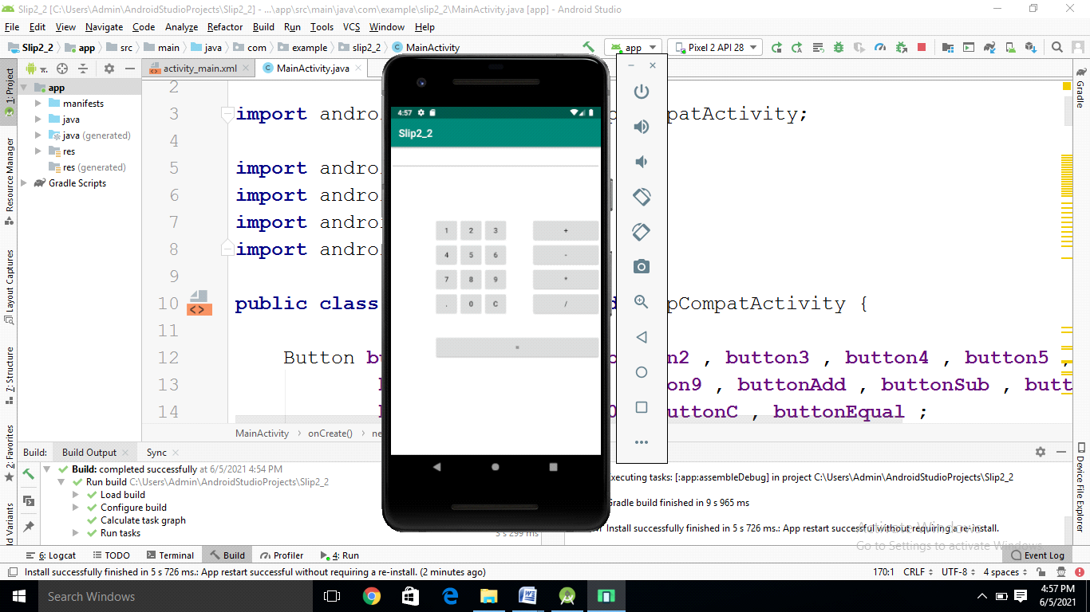

<?xml version="1.0" encoding="utf-8"?>
<RelativeLayout xmlns:android="http://schemas.android.com/apk/res/android"
xmlns:app="http://schemas.android.com/apk/res-auto"
xmlns:tools="http://schemas.android.com/tools"
android:layout_width="match_parent"
android:layout_height="match_parent"
tools:context=".MainActivity">
<EditText
android:layout_width="match_parent"
android:layout_height="wrap_content"
android:id="@+id/edt1"/>
<Button
style="?android:attr/buttonStyleSmall"
android:layout_width="wrap_content"
android:layout_height="wrap_content"
android:text="1"
android:id="@+id/button1"
android:layout_marginTop="94dp"
android:layout_below="@+id/edt1"
android:layout_toStartOf="@+id/button4"
android:layout_alignRight="@+id/button4"
android:layout_alignEnd="@+id/button4" />
<Button
style="?android:attr/buttonStyleSmall"
android:layout_width="wrap_content"
android:layout_height="wrap_content"
android:text="2"
android:id="@+id/button2"
android:layout_alignTop="@+id/button1"
android:layout_toLeftOf="@+id/button3"
android:layout_toStartOf="@+id/button3" />
<Button
style="?android:attr/buttonStyleSmall"
android:layout_width="wrap_content"
android:layout_height="wrap_content"
android:text="3"
android:id="@+id/button3"
android:layout_alignTop="@+id/button2"
android:layout_centerHorizontal="true" />
<Button
style="?android:attr/buttonStyleSmall"
android:layout_width="wrap_content"
android:layout_height="wrap_content"
android:text="4"
android:id="@+id/button4"
android:layout_below="@+id/button1"
android:layout_toLeftOf="@+id/button2" />
<Button
style="?android:attr/buttonStyleSmall"
android:layout_width="wrap_content"
android:layout_height="wrap_content"
android:text="5"
android:id="@+id/button5"
android:layout_alignBottom="@+id/button4"
android:layout_alignLeft="@+id/button2"
android:layout_alignStart="@+id/button2" />
<Button
style="?android:attr/buttonStyleSmall"
android:layout_width="wrap_content"
android:layout_height="wrap_content"
android:text="6"
android:id="@+id/button6"
android:layout_below="@+id/button3"
android:layout_alignLeft="@+id/button3"
android:layout_alignStart="@+id/button3" />
<Button
style="?android:attr/buttonStyleSmall"
android:layout_width="wrap_content"
android:layout_height="wrap_content"
android:text="7"
android:id="@+id/button7"
android:layout_below="@+id/button4"
android:layout_toLeftOf="@+id/button2" />
<Button
style="?android:attr/buttonStyleSmall"
android:layout_width="wrap_content"
android:layout_height="wrap_content"
android:text="8"
android:id="@+id/button8"
android:layout_below="@+id/button5"
android:layout_alignLeft="@+id/button5"
android:layout_alignStart="@+id/button5" />
<Button
style="?android:attr/buttonStyleSmall"
android:layout_width="wrap_content"
android:layout_height="wrap_content"
android:text="9"
android:id="@+id/button9"
android:layout_below="@+id/button6"
android:layout_alignLeft="@+id/button6"
android:layout_alignStart="@+id/button6" />
<Button
style="?android:attr/buttonStyleSmall"
android:layout_width="wrap_content"
android:layout_height="wrap_content"
android:text="+"
android:id="@+id/buttonadd"
android:layout_alignTop="@+id/button3"
android:layout_toRightOf="@+id/button3"
android:layout_marginLeft="46dp"
android:layout_marginStart="46dp"
android:layout_alignRight="@+id/edt1"
android:layout_alignEnd="@+id/edt1" />
<Button
style="?android:attr/buttonStyleSmall"
android:layout_width="wrap_content"
android:layout_height="wrap_content"
android:text="-"
android:id="@+id/buttonsub"
android:layout_below="@+id/buttonadd"
android:layout_alignLeft="@+id/buttonadd"
android:layout_alignStart="@+id/buttonadd"
android:layout_alignRight="@+id/buttonadd"
android:layout_alignEnd="@+id/buttonadd" />
<Button
style="?android:attr/buttonStyleSmall"
android:layout_width="wrap_content"
android:layout_height="wrap_content"
android:text="*"
android:id="@+id/buttonmul"
android:layout_below="@+id/buttonsub"
android:layout_alignLeft="@+id/buttonsub"
android:layout_alignStart="@+id/buttonsub"
android:layout_alignParentRight="true"
android:layout_alignParentEnd="true" />
<Button
style="?android:attr/buttonStyleSmall"
android:layout_width="wrap_content"
android:layout_height="wrap_content"
android:text="."
android:id="@+id/button10"
android:layout_below="@+id/button7"
android:layout_toLeftOf="@+id/button2" />
<Button
style="?android:attr/buttonStyleSmall"
android:layout_width="wrap_content"
android:layout_height="wrap_content"
android:text="0"
android:id="@+id/button0"
android:layout_below="@+id/button8"
android:layout_alignLeft="@+id/button8"
android:layout_alignStart="@+id/button8" />
<Button
style="?android:attr/buttonStyleSmall"
android:layout_width="wrap_content"
android:layout_height="wrap_content"
android:text="C"
android:id="@+id/buttonC"
android:layout_below="@+id/button9"
android:layout_alignLeft="@+id/button9"
android:layout_alignStart="@+id/button9" />
<Button
style="?android:attr/buttonStyleSmall"
android:layout_width="wrap_content"
android:layout_height="wrap_content"
android:text="/"
android:id="@+id/buttondiv"
android:layout_below="@+id/buttonmul"
android:layout_alignLeft="@+id/buttonmul"
android:layout_alignStart="@+id/buttonmul"
android:layout_alignRight="@+id/buttonmul"
android:layout_alignEnd="@+id/buttonmul" />
<Button
android:layout_width="wrap_content"
android:layout_height="wrap_content"
android:text="="
android:id="@+id/buttoneql"
android:layout_below="@+id/button0"
android:layout_marginTop="37dp"
android:layout_alignRight="@+id/buttondiv"
android:layout_alignEnd="@+id/buttondiv"
android:layout_alignLeft="@+id/button10"
android:layout_alignStart="@+id/button10" />
</RelativeLayout>

//MainAcivity.java
package com.example.slip2_2;
import androidx.appcompat.app.AppCompatActivity;
import android.os.Bundle;
import android.view.View;
import android.widget.Button;
import android.widget.EditText;
public class MainActivity extends AppCompatActivity {
Button button0 , button1 , button2 , button3 , button4 , button5 , button6 ,
button7 , button8 , button9 , buttonAdd , buttonSub , buttonDivision ,
buttonMul , button10 , buttonC , buttonEqual ;
EditText edt1 ;
float mValueOne , mValueTwo ;
boolean mAddition , mSubtract ,mMultiplication ,mDivision ;
@Override
protected void onCreate(Bundle savedInstanceState) {
super.onCreate(savedInstanceState);
setContentView(R.layout.activity_main);
button0 = (Button) findViewById(R.id.button0);
button1 = (Button) findViewById(R.id.button1);
button2 = (Button) findViewById(R.id.button2);
button3 = (Button) findViewById(R.id.button3);
button4 = (Button) findViewById(R.id.button4);
button5 = (Button) findViewById(R.id.button5);
button6 = (Button) findViewById(R.id.button6);
button7 = (Button) findViewById(R.id.button7);
button8 = (Button) findViewById(R.id.button8);
button9 = (Button) findViewById(R.id.button9);
button10 = (Button) findViewById(R.id.button10);
buttonAdd = (Button) findViewById(R.id.buttonadd);
buttonSub = (Button) findViewById(R.id.buttonsub);
buttonMul = (Button) findViewById(R.id.buttonmul);
buttonDivision = (Button) findViewById(R.id.buttondiv);
buttonC = (Button) findViewById(R.id.buttonC);
buttonEqual = (Button) findViewById(R.id.buttoneql);
edt1 = (EditText) findViewById(R.id.edt1);
button1.setOnClickListener(new View.OnClickListener() {
@Override
public void onClick(View v) {
edt1.setText(edt1.getText()+"1");
}
});
button2.setOnClickListener(new View.OnClickListener() {
@Override
public void onClick(View v) {
edt1.setText(edt1.getText()+"2");
}
});
button3.setOnClickListener(new View.OnClickListener() {
@Override
public void onClick(View v) {
edt1.setText(edt1.getText()+"3");
}
});
button4.setOnClickListener(new View.OnClickListener() {
@Override
public void onClick(View v) {
edt1.setText(edt1.getText()+"4");
}
});
button5.setOnClickListener(new View.OnClickListener() {
@Override
public void onClick(View v) {
edt1.setText(edt1.getText()+"5");
}
});
button6.setOnClickListener(new View.OnClickListener() {
@Override
public void onClick(View v) {
edt1.setText(edt1.getText()+"6");
}
});
button7.setOnClickListener(new View.OnClickListener() {
@Override
public void onClick(View v) {
edt1.setText(edt1.getText()+"7");
}
});
button8.setOnClickListener(new View.OnClickListener() {
@Override
public void onClick(View v) {
edt1.setText(edt1.getText()+"8");
}
});
button9.setOnClickListener(new View.OnClickListener() {
@Override
public void onClick(View v) {
edt1.setText(edt1.getText()+"9");
}
});
button0.setOnClickListener(new View.OnClickListener() {
@Override
public void onClick(View v) {
edt1.setText(edt1.getText()+"0");
}
});
buttonAdd.setOnClickListener(new View.OnClickListener() {
@Override
public void onClick(View v) {
if (edt1 == null){
edt1.setText("");
}else {
mValueOne = Float.parseFloat(edt1.getText() + "");
mAddition = true;
edt1.setText(null);
}
}
});
buttonSub.setOnClickListener(new View.OnClickListener() {
@Override
public void onClick(View v) {
mValueOne = Float.parseFloat(edt1.getText() + "");
mSubtract = true ;
edt1.setText(null);
}
});
buttonMul.setOnClickListener(new View.OnClickListener() {
@Override
public void onClick(View v) {
mValueOne = Float.parseFloat(edt1.getText() + "");
mMultiplication = true ;
edt1.setText(null);
}
});
buttonDivision.setOnClickListener(new View.OnClickListener() {
@Override
public void onClick(View v) {
mValueOne = Float.parseFloat(edt1.getText()+"");
mDivision = true ;
edt1.setText(null);
}
});
buttonEqual.setOnClickListener(new View.OnClickListener() {
@Override
public void onClick(View v) {
mValueTwo = Float.parseFloat(edt1.getText() + "");
if (mAddition == true){
edt1.setText(mValueOne + mValueTwo +"");
mAddition=false;
}
if (mSubtract == true){
edt1.setText(mValueOne - mValueTwo+"");
mSubtract=false;
}
if (mMultiplication == true){
edt1.setText(mValueOne * mValueTwo+"");
mMultiplication=false;
}
if (mDivision == true){
edt1.setText(mValueOne / mValueTwo+"");
mDivision=false;
}
}
});
buttonC.setOnClickListener(new View.OnClickListener() {
@Override
public void onClick(View v) {
edt1.setText("");
}
});
button10.setOnClickListener(
new View.OnClickListener() {
@Override
public void onClick(View v) {
edt1.setText(edt1.getText()+".");
}
});
}
}

Q5)Write a andriod prog to send hello msg from activiy to another with the use of button
acivity main.xml
<?xml version="1.0" encoding="utf-8"?>
<LinearLayout xmlns:android="http://schemas.android.com/apk/res/android"
xmlns:app="http://schemas.android.com/apk/res-auto"
xmlns:tools="http://schemas.android.com/tools"
android:layout_width="match_parent"
android:layout_height="match_parent"
android:orientation="vertical"
tools:context=".MainActivity">

<EditText
android:layout_width="wrap_content"
android:layout_height="wrap_content"

android:id="@+id/t1"
/>
<Button
android:id="@+id/b1"
android:layout_width="wrap_content"
android:layout_height="wrap_content" />

</LinearLayout>

MAIN ACTIVITY.JAVA
package com.example.intenttext;

import android.content.Intent;
import android.support.v7.app.AppCompatActivity;
import android.os.Bundle;
import android.view.View;
import android.widget.Button;
import android.widget.EditText;

public class MainActivity extends AppCompatActivity {
EditText t1;
Button b1;

@Override
protected void onCreate(Bundle savedInstanceState) {
super.onCreate(savedInstanceState);
setContentView(R.layout.activity_main);
t1=(EditText) findViewById(R.id.t1);
b1=(Button)findViewById(R.id.b1);
b1.setOnClickListener(new View.OnClickListener() {
@Override
public void onClick(View v) {
String str= t1.getText().toString();
Intent intent= new Intent(getApplicationContext(),SecondActivity.class);
intent.putExtra("msg_key", str);
startActivity(intent);
}
});
}
}

ACITVITYSECOND.XML
<?xml version="1.0" encoding="utf-8"?>
<LinearLayout xmlns:android="http://schemas.android.com/apk/res/android"
xmlns:app="http://schemas.android.com/apk/res-auto"
xmlns:tools="http://schemas.android.com/tools"
android:layout_width="match_parent"
android:layout_height="match_parent"
tools:context=".SecondActivity">
<TextView
android:id="@+id/t1"
android:layout_width="match_parent"
android:layout_height="match_parent" />

</LinearLayout>

SECONDEACTIVITY.JAVA
package com.example.intenttext;

import android.content.Intent;
import android.support.v7.app.AppCompatActivity;
import android.os.Bundle;
import android.widget.TextView;

public class SecondActivity extends AppCompatActivity {

@Override
protected void onCreate(Bundle savedInstanceState) {
super.onCreate(savedInstanceState);
setContentView(R.layout.activity_second);
TextView msg=(TextView) findViewById(R.id.t1);
Intent intent= getIntent();
String str= intent.getStringExtra("msg_key");
msg.setText(str);
}
}
Q6) Write a program to perform Zoom In, Zoom Out operation on Google Map. [20]
//MapsActivity.java

package com.example.mygps;
import androidx.fragment.app.FragmentActivity;
import android.os.Bundle;
import android.view.KeyEvent;
import com.google.android.gms.maps.CameraUpdateFactory;
import com.google.android.gms.maps.GoogleMap;
import com.google.android.gms.maps.OnMapReadyCallback;
import com.google.android.gms.maps.SupportMapFragment;
import com.google.android.gms.maps.model.LatLng;
import com.google.android.gms.maps.model.MarkerOptions;
public class MapsActivity<onMapReady> extends FragmentActivity implements OnMapReadyCallback {
private GoogleMap mMap;
@Override
protected void onCreate(Bundle savedInstanceState) {
super.onCreate(savedInstanceState);
setContentView(R.layout.activity_maps);
// Obtain the SupportMapFragment and get notified when the map is ready to be used.
SupportMapFragment mapFragment = (SupportMapFragment) getSupportFragmentManager()
.findFragmentById(R.id.map);
mapFragment.getMapAsync(this);
}
/**
* Manipulates the map once available.
* This callback is triggered when the map is ready to be used.
* This is where we can add markers or lines, add listeners or move the camera. In this case,
* we just add a marker near Sydney, Australia.
* If Google Play services is not installed on the device, the user will be prompted to install
* it inside the SupportMapFragment. This method will only be triggered once the user has
* installed Google Play services and returned to the app.
*/
@Override
public void onMapReady(GoogleMap googleMap) {
mMap = googleMap;
// Add a marker in Sydney and move the camera
LatLng sydney = new LatLng(21, 78);
mMap.addMarker(new MarkerOptions().position(sydney).title("Marker in Sydney"));
mMap.moveCamera(CameraUpdateFactory.newLatLng(sydney));
}
@Override
public boolean onKeyDown(int keyCode, KeyEvent event) {
switch (keyCode)
{ case KeyEvent.KEYCODE_3:mMap.animateCamera(CameraUpdateFactory.zoomIn());
break;
case KeyEvent.KEYCODE_1 :mMap.animateCamera(CameraUpdateFactory.zoomOut());
break;}
return super.onKeyDown(keyCode, event);
}
}

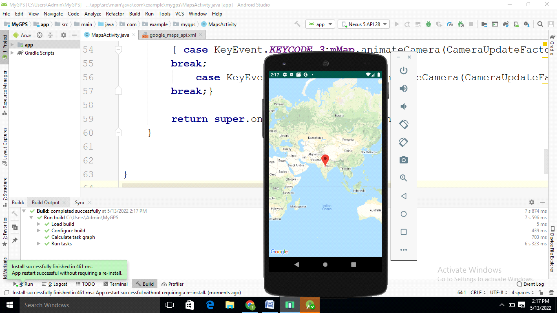

Q7) Create application to send email. [20]
//Activity_main.xml

<?xml version="1.0" encoding="utf-8"?>
<RelativeLayout xmlns:android="http://schemas.android.com/apk/res/android"
xmlns:app="http://schemas.android.com/apk/res-auto"
xmlns:tools="http://schemas.android.com/tools"
android:layout_width="match_parent"
android:layout_height="match_parent"
tools:context=".MainActivity" >
<EditText
android:id="@+id/editText1"
android:layout_width="wrap_content"
android:layout_height="wrap_content"
android:layout_alignParentRight="true"
android:layout_alignParentTop="true"
android:layout_marginRight="22dp"
android:layout_marginTop="16dp"
android:ems="10" >
</EditText>
<EditText
android:id="@+id/editText2"
android:layout_width="wrap_content"
android:layout_height="wrap_content"
android:layout_alignLeft="@+id/editText1"
android:layout_below="@+id/editText1"
android:layout_marginTop="18dp"
android:ems="10" >
<requestFocus />
</EditText>
<EditText
android:id="@+id/editText3"
android:layout_width="wrap_content"
android:layout_height="wrap_content"
android:layout_alignLeft="@+id/editText2"
android:layout_below="@+id/editText2"
android:layout_marginTop="28dp"
android:ems="10"
android:inputType="textMultiLine" />
<TextView
android:id="@+id/textView1"
android:layout_width="wrap_content"
android:layout_height="wrap_content"
android:layout_alignBaseline="@+id/editText1"
android:layout_alignBottom="@+id/editText1"
android:layout_alignParentLeft="true"
android:text="To:" />
<TextView
android:id="@+id/textView2"
android:layout_width="wrap_content"
android:layout_height="wrap_content"
android:layout_alignBaseline="@+id/editText2"
android:layout_alignBottom="@+id/editText2"
android:layout_alignParentLeft="true"
android:text="Subject:" />
<TextView
android:id="@+id/textView3"
android:layout_width="wrap_content"
android:layout_height="wrap_content"
android:layout_alignBaseline="@+id/editText3"
android:layout_alignBottom="@+id/editText3"
android:layout_alignParentLeft="true"
android:text="Message:" />
<Button
android:id="@+id/button1"
android:layout_width="wrap_content"
android:layout_height="wrap_content"
android:layout_alignLeft="@+id/editText3"
android:layout_below="@+id/editText3"
android:layout_marginLeft="76dp"
android:layout_marginTop="20dp"
android:text="Send" />
</RelativeLayout>

//MainActivity.java

package com.example.sendsms;
import androidx.appcompat.app.AppCompatActivity;
import androidx.core.app.ActivityCompat;
import androidx.core.content.ContextCompat;
import android.os.Bundle;
import android.app.Activity;
import android.content.Intent;
import android.view.Menu;
import android.view.View;
import android.view.View.OnClickListener;
import android.widget.Button;
import android.widget.EditText;
public class MainActivity extends AppCompatActivity {
EditText editTextTo, editTextSubject, editTextMessage;
Button send;
@Override
protected void onCreate(Bundle savedInstanceState) {
super.onCreate(savedInstanceState);
setContentView(R.layout.activity_main);
editTextTo = (EditText) findViewById(R.id.editText1);
editTextSubject = (EditText) findViewById(R.id.editText2);
editTextMessage = (EditText) findViewById(R.id.editText3);
send = (Button) findViewById(R.id.button1);
send.setOnClickListener(new OnClickListener() {
@Override
public void onClick(View arg0) {
String to = editTextTo.getText().toString();
String subject = editTextSubject.getText().toString();
String message = editTextMessage.getText().toString();
Intent email = new Intent(Intent.ACTION_SEND);
email.putExtra(Intent.EXTRA_EMAIL, new String[]{to});
email.putExtra(Intent.EXTRA_SUBJECT, subject);
//need this to prompts email client only
email.setType("message/rfc822");
startActivity(Intent.createChooser(email, "Choose an Email client :"));
}
});
}
}

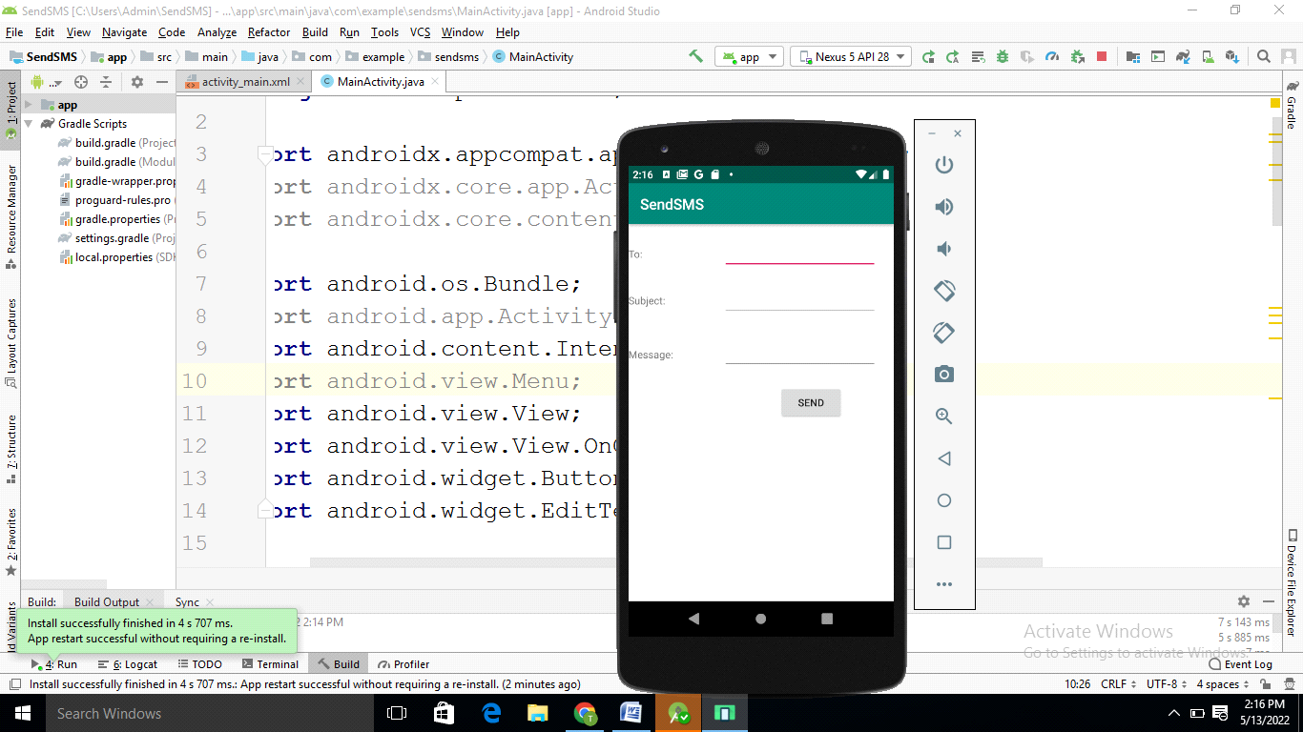

Q2. Create simple application with Login Screen. On successful login, gives message go to next Activity (Without Using Database).
main.java
package com.example.intent;

import androidx.appcompat.app.AppCompatActivity;

import android.content.DialogInterface;
import android.content.Intent;
import android.os.Bundle;
import android.view.View;
import android.widget.Button;
import android.widget.EditText;

public class MainActivity extends AppCompatActivity {
Button b1;
EditText e1, e2;

@Override
protected void onCreate(Bundle savedInstanceState) {
super.onCreate(savedInstanceState);
setContentView(R.layout.activity_main);
e1=(EditText) findViewById(R.id.edtEmail);
e2=(EditText) findViewById(R.id.edtPass);
b1= (Button) findViewById(R.id.button1);

b1.setOnClickListener(new View.OnClickListener() {
@Override
public void onClick(View view) {
String uname = "Admin";
String password = "Admin123";
if ((e1.getText().toString().equals(uname)) && (e2.getText().toString().equals(password))){
Intent intent = new Intent(getApplicationContext(),second.class);
intent.putExtra("SUCCESS","Success");
startActivity(intent);
}
else
{Intent intent = new Intent(getApplicationContext(),second.class);
intent.putExtra("SUCCESS","Invalid");
startActivity(intent);
}}
});

}
}

xml
<?xml version="1.0" encoding="utf-8"?>
<LinearLayout xmlns:android="http://schemas.android.com/apk/res/android"
xmlns:app="http://schemas.android.com/apk/res-auto"
xmlns:tools="http://schemas.android.com/tools"
android:layout_width="match_parent"
android:layout_height="match_parent"
android:orientation="vertical"
tools:context=".MainActivity">

<EditText
android:id="@+id/edtEmail"
android:layout_width="fill_parent"
android:layout_height="wrap_content"
android:ems="10"
android:hint="Email"
android:inputType="text"
tools:layout_editor_absoluteX="77dp"
tools:layout_editor_absoluteY="100dp" />

<EditText
android:id="@+id/edtPass"
android:layout_width="fill_parent"
android:layout_height="wrap_content"
android:ems="10"
android:hint="Password"
android:inputType="text"
tools:layout_editor_absoluteX="84dp"
tools:layout_editor_absoluteY="201dp" />

<Button
android:id="@+id/button1"
android:layout_width="match_parent"
android:layout_height="wrap_content"
android:text="Button" />

</LinearLayout>

second java
package com.example.intent;

import androidx.appcompat.app.AppCompatActivity;

import android.content.Intent;
import android.os.Bundle;
import android.widget.EditText;
import android.widget.TextView;

public class second extends AppCompatActivity {
TextView t1;
@Override
protected void onCreate(Bundle savedInstanceState) {
super.onCreate(savedInstanceState);
setContentView(R.layout.activity_second);

setContentView(R.layout.activity_second);
t1=findViewById(R.id.t1);
Intent intent=getIntent();
String str=intent.getStringExtra("SUCCESS");
t1.setText(str);

}
}

second xml
<?xml version="1.0" encoding="utf-8"?>
<LinearLayout xmlns:android="http://schemas.android.com/apk/res/android"
xmlns:app="http://schemas.android.com/apk/res-auto"
xmlns:tools="http://schemas.android.com/tools"
android:layout_width="match_parent"
android:layout_height="match_parent"
tools:context=".second">

<TextView
android:id="@+id/t1"
android:layout_width="wrap_content"
android:layout_height="wrap_content"
android:text="TextView"
tools:layout_editor_absoluteX="125dp"
tools:layout_editor_absoluteY="120dp" />
</LinearLayout>

