Biomarker Visualizations

Jordan Lo

2022-11-30

# Enables us to read excel files  
library("readxl")  
# Allows us to do data processing and clean-up  
library("tidyverse")

## ── Attaching packages ─────────────────────────────────────── tidyverse 1.3.2 ──  
## ✔ ggplot2 3.4.0 ✔ purrr 0.3.5   
## ✔ tibble 3.1.8 ✔ dplyr 1.0.10  
## ✔ tidyr 1.2.1 ✔ stringr 1.4.1   
## ✔ readr 2.1.3 ✔ forcats 0.5.2   
## ── Conflicts ────────────────────────────────────────── tidyverse_conflicts() ──  
## ✖ dplyr::filter() masks stats::filter()  
## ✖ dplyr::lag() masks stats::lag()

# Enables us to write to an excel file  
library("writexl")  
# GGally alows us to use their pairs funtion  
library("GGally")

## Registered S3 method overwritten by 'GGally':  
## method from   
## +.gg ggplot2

# ggplot2 lets us make pretty graphs  
library("ggplot2")  
# ggpubr   
library("ggpubr")

bio_clinical <- read_excel("C:\\Users\\notjello\\Documents\\Github\\Biomarker-Master-Sheet\\Biomarker_Assays_and_Clinical_Data_20221122.xlsx")  
  
# creates new columns for the log transformations of the biomarker concentrations   
bio_clinical$log_ang2 <- log(bio_clinical$`urine_ang-2_V1 (pg/mL)`)  
bio_clinical$log_il18 <- log(bio_clinical$`urine_il18_V1 (pg/mL)`)  
bio_clinical$log_ngal <- log(bio_clinical$`urine_ngal_V1 (pg/mL)`)  
bio_clinical$log_sfas <- log(bio_clinical$`urine_sfas_V1 (pg/mL)`)  
  
# converts covid19 diagnosis to 0 for neg and 1 for pos  
bio_clinical['COVID19'][bio_clinical['COVID19'] == 'pos'] <- "1"  
bio_clinical['COVID19'][bio_clinical['COVID19'] == 'Pos'] <- "1"  
bio_clinical['COVID19'][bio_clinical['COVID19'] == 'neg'] <- "0"  
  
bio_clinical$COVID19<- as.numeric(as.character(bio_clinical$COVID19))  
  
# converts aki_hosp from numeric into a character for better visualization  
bio_clinical$aki_hosp <- as.character(bio_clinical$aki_hosp)  
  
  
# view(bio_clinical)

# creates a pairs plot of the biomarker concentration data using ggpairs  
bio_clinical %>%  
 select(c(`log_ang2`, `log_il18`, `log_ngal`, `log_sfas`, )) %>% # selects the data used  
 ggpairs(labels = letters[1:ncol(bio_clinical)], # creates the actual plot  
 lower = list(continuous=wrap("smooth"))) +   
 theme_bw() + # color scheme of plot  
 ggtitle("Correlation Data of Biomarker Concentrations") + # creates a title  
 theme(plot.title = element_text(hjust = 0.5)) # centers titel

## Warning in warn_if_args_exist(list(...)): Extra arguments: "labels" are being  
## ignored. If these are meant to be aesthetics, submit them using the 'mapping'  
## variable within ggpairs with ggplot2::aes or ggplot2::aes_string.

## Warning: Removed 50 rows containing non-finite values (`stat_density()`).

## Warning in ggally_statistic(data = data, mapping = mapping, na.rm = na.rm, :  
## Removed 50 rows containing missing values  
  
## Warning in ggally_statistic(data = data, mapping = mapping, na.rm = na.rm, :  
## Removed 50 rows containing missing values  
  
## Warning in ggally_statistic(data = data, mapping = mapping, na.rm = na.rm, :  
## Removed 50 rows containing missing values

## Warning: Removed 50 rows containing non-finite values (`stat_smooth()`).

## Warning: Removed 50 rows containing missing values (`geom_point()`).

## Warning: Removed 50 rows containing non-finite values (`stat_smooth()`).

## Warning: Removed 50 rows containing missing values (`geom_point()`).

## Warning: Removed 50 rows containing non-finite values (`stat_smooth()`).

## Warning: Removed 50 rows containing missing values (`geom_point()`).

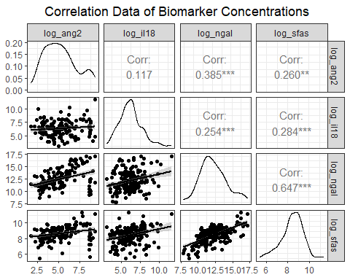

bio_clinical_NA <- bio_clinical %>%  
 filter(aki_hosp != "NA")  
  
# creates a jitter plot of the ang 2 levels and the presence of incident aki  
ang2_jitter <-  
 ggplot(data = bio_clinical_NA, # selects dataframe  
 mapping = (aes(x = log_ang2, y = aki_hosp))) + # maps variables to x and y  
 geom_jitter(width = 0, # sets parameters for the jitter  
 height = 0.2) +  
 labs(x = "[Ang-2]", # labels axes  
 y = " ")  
  
il18_jitter <-  
 ggplot(data = bio_clinical_NA,   
 mapping = (aes(x = log_il18, y = aki_hosp))) +  
 geom_jitter(width = 0,   
 height = 0.2) +  
 labs(x = "[IL-18]",  
 y = " ")  
  
sfas_jitter <-  
 ggplot(data = bio_clinical_NA,   
 mapping = (aes(x = log_sfas, y = aki_hosp))) +  
 geom_jitter(width = 0,   
 height = 0.2) +  
 labs(x = "[sFas]",  
 y = " ")  
  
ngal_jitter <-  
 ggplot(data = bio_clinical_NA,   
 mapping = (aes(x = log_ngal, y = aki_hosp))) +  
 geom_jitter(width = 0,   
 height = 0.2) +  
 labs(x = "[NGAL]",  
 y = " ")

# creates a 2x2 matrix of the four plots  
figure <- ggarrange(ang2_jitter, il18_jitter, ngal_jitter, sfas_jitter,  
 ncol = 2,   
 nrow = 2)

## Warning: Removed 50 rows containing missing values (`geom_point()`).

# annotates the figure with a title and description  
annotate_figure(figure,  
 top = text_grob("Biomarker Concentrations and Rates of Incident AKI   
in CHROME Participants",  
 size = 12,  
 face = "bold"),  
 bottom = text_grob("Concentrations are log transformed and taken from the first visit   
0 = No AKI | 1 = AKI",  
 size = 10,  
 face = "bold"))

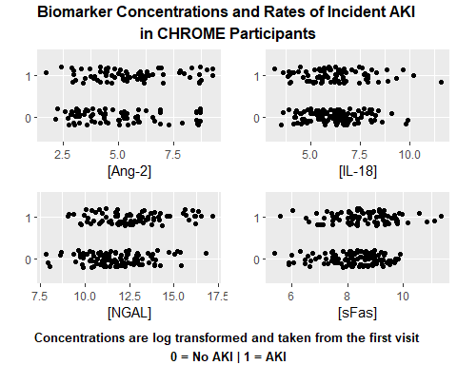

ang2_box <- ggplot(data = bio_clinical_NA, aes(x = log_ang2, y = aki_hosp)) +  
 geom_boxplot()+  
 labs(x = "[Ang-2]",  
 y = " ")  
  
il18_box <- ggplot(data = bio_clinical_NA, aes(x = log_il18, y = aki_hosp)) +  
 geom_boxplot()+  
 labs(x = "[IL-18]",  
 y = " ")  
  
sfas_box <- ggplot(data = bio_clinical_NA, aes(x = log_sfas, y = aki_hosp)) +  
 geom_boxplot() +  
 labs(x = "[sFas]",  
 y = " ")  
  
ngal_box <- ggplot(data = bio_clinical_NA, aes(x = log_ngal, y = aki_hosp)) +  
 geom_boxplot()+  
 labs(x = "[NGAL]",  
 y = " ")  
  
figure <- ggarrange(ang2_box, il18_box, ngal_box, sfas_box,  
 ncol = 2,   
 nrow = 2)

## Warning: Removed 50 rows containing non-finite values (`stat_boxplot()`).

annotate_figure(figure,  
 top = text_grob("Biomarker Concentrations and Rates of Incident AKI   
in CHROME Participants",  
 size = 12,  
 face = "bold"),  
 bottom = text_grob("Concentrations are log transformed and taken from the first visit   
0 = No AKI | 1 = AKI",  
 size = 10,  
 face = "bold"))

