R-PLEX Human EGF

Ran on: 5/16/23

Ran by: Zoie Bailey

# Purpose

Run **KRI Urine samples** on a Singleplex R-Plex EGF plate to determine the concentrations:

* **Dilutions: 1:250**
* Replicates: 1
* Number of Plates: 2

# Samples

* **KRI Urine** (KRI US)samples:

**-** n = 118

- SubAliquots’ initial volume: 1mL-4mL

- Stored in a sterile, tightly cap-sealed, 96-well V-bottom plate at -80°C

* **QC** Samples: CIT US V1 2/16/22

# Procedure—run in one day

1. Prepare Samples, QC and Reagents
2. Locate samples, QCs & reagents:

* **Samples**
* Location: Serena Williams, Shelf 1, Rack 6
* **QC**
* Location: Road Runner, Rack 81, Box Label: *CIT US V1 QC 2/16/23*
* **Calibrators (20x)**: -80°C
* **Diluent 100**: 4°C.
* **Diluent 37:** -20°C
* **MSD GOLD 96 Small Spot SA SECTOR Plate**: 4°C

1. Thaw on ice**:**

* Samples’
* Bring to RT 30 min prior to use

1. Thaw **Diluent 37** at room temperature (RT), bring **Diluent 100** to RT.
2. Thaw calibrator on ice. Bring to RT 30 min prior to use
3. Bring MSD plate and Capture Antibodies from 4°C to RT. Just prior to use, remove plate from pouch to prevent dryness
4. Print 96-well MSD Plate layouts in color:

B:\KRI\ICICLE\ICICLE_Plate _Layout.xlsx

1. Prepare R-Plex MSD Plate

**Step 1: Coat Plate**

1. Add 200uL of biotinylated capture antibody to 3.3mL of coating diluent (Diluent 100). Mix by vortexing.
2. Add 25uL of the above solution to each well of the plate. Seal the plate and shake at RT for 1hour.
3. Wash the plate 3x with 200uL of Wash Buffer.

*Notes:*

* *Coating diluents can be simple diluents containing 0.5% BSA in PBS, or use 0.5% MSD Blocker A or MSD Diluent 100.*

1. Prepare Calibrator Curve in Matrix tubes
   1. Thaw calibrator on ice.
   2. Transfer **285** **μL** of **Diluent 37** into 1 eppendorf tube, and **300** **μL into the other 7 tubes.**
   3. Gently vortex the calibrator stock vial (**20x**), pipette **15 μL** into STD 1 tube.Vortex.
   4. Serially add **100 μL** of the prior standard to make each consecutive standard.
   5. Use Diluent 37 for STD 8 (Blank)

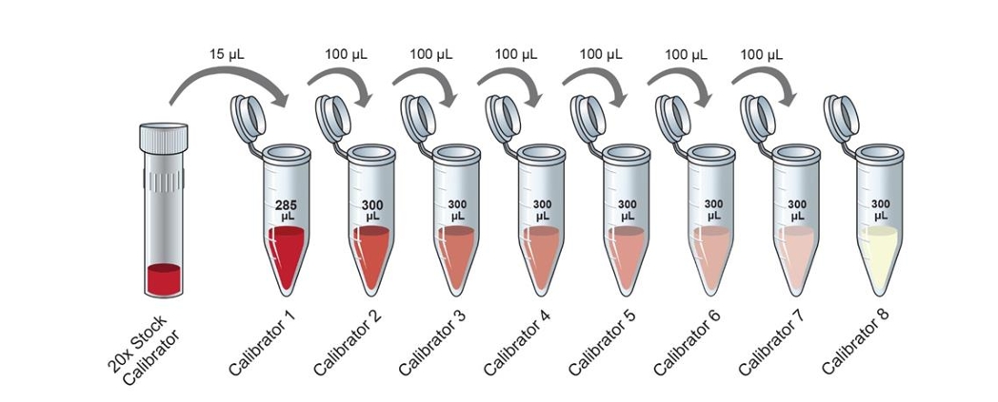

*Dilution Scheme for Standards*

1. Dilute Samples and QCs

30 min prior to use, bring the samples and QCs to RT. Pipette up/down 3x, without making bubbles.

1. **Dilution 1 = 1:25**

* Add **120 μL Diluent 100** per well
* Add **5 μL sample** into diluent wells
* Pipette up/down 3x

1. **Dilution 2 = 1:250**

* Add **90 μL Diluent 37** per well
* Add **10 μL sample** into diluent wells
* Pipette up/down 3x

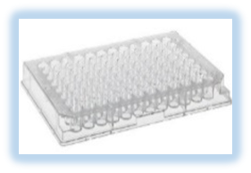

**50-µL/well Subaliquots Vials**

**Dilution 2, 1:250**

**90 µL Diluent 37**

**10 µL samples**

**120 µL Diluent 100**

**5 µL samples**

**Dilution 1, 1:25**

***Dilution Plate Layout***



***MSD Plate Layout***

1. Incubate Samples and Standards with Capture Antibody
2. Wash the plate **3x** with **200 μL/well** Wash Buffer
3. Add **25 μL/well Diluent 37** in all wells
4. Add **25 μL/well STD and diluted samples** in duplicate.
5. Seal the plate with foil. **Shake for 1 hr at RT at 700 rpm.** After the 1st 30 min, rotate the plate 180°C
6. Incubate with Detection Antibody
   1. Prepare detection Ab solution:
7. **Immediately prior to use**, transfer **5,940 μL Diluent 37** to a 15-ml sterile conical tube at RT
8. Transfer **60 μL** of both 100x detection antibodies.
9. Invert tube 5x
   1. Wash the plate 3x with **200 μL/well** 1x Wash Buffer. Do not let the wells dry
   2. Add **50 μL/well** detection Ab solution
   3. Seal the plate. **Shake for 1 hr at RT at 700 rpm.** After the 1st 30 min, rotate the plate 180°C.
10. Read the Plate: R&T 613
    1. Wash 3x with 200 μL/well 1x Wash Buffer. Do not let the wells dry
    2. Add 150 μL/well MSD Gold Read Buffer B
    3. Read the plate immediately on MSD Instrument

# Material

1. MSD Reagents:
2. U-Plex 2-Assay Plate: Cat#L45SA-1; Lot: Z0022072

*Plate Barcodes* 1: 23M2JAH772

2: 23M2JA4819

1. Diluent 37: Cat# R50AF-6; Lot: M0370037
2. Diluent 100: Cat# R50AA-4; Lot: Y0270325
3. EGF Calibrator: Cat# C015F-2; Lot: A00R1001
4. EGF Antibody Set: Cat# B215F-3; Lot: RSET00830
5. Wash Buffer:

* PBS 1x: Gibco (-) Ca2+, (-) Mg2+ Cat# 10010-023, Lot
* Tween-20
* Pipette slowly 250 μL Tween-20. Dispense in 500 ml 1x PBS. Rinse tips multiple time with PBS until tip becomes completely clear → 0.05% Tween-20/PBS

1. MSD Gold Read Buffer B:

* Cat# R60AM-2; Lot Y0800033. 90 ml. Store at RT.

1. Supplies:
2. 96-well Plate Caps
3. U-bottom 96-well plates (dilution plates)
4. Plate seals
5. Matrix tubes
6. Matrix rack
7. 1000 uL, 200 uL and 20 uL sterile filter tips
8. Manual Pipettes: P1000, P200, P20, 8-channel
9. 8-channel Electric Repeater (for washes)
10. Plastic reservoirs: thin groove and large V bottom
11. Sterile 15-ml conical tubes
12. Shaker
13. Ice bucket + ice
14. Room temperature water bath