R-PLEX Human KIM-1 US Protocol

Ran by: Jordan Lo & Zoie Bailey

Ran on:

# Adopted from Past KIM-1 Experiment: R:\Eliza\Protocols\MSD\CFA Urine\Protocol_KIM-1_CFA_Urine_MSD_Expt02_20201215.docx

# Purpose

Run **ICICLE/SUGAR/PROCLAIM urine samples** on a R-Plex KIM-1 plate to determine analyte concentrations:

* **Dilution: 1:10**
* Number of Plates: 2

# Samples Description and Location

* **CFA Urine** (CFA US)samples:
  + n = 117 on two plates (n = 69 and n = 68)
  + Stored in vials from KRI
  + Pipetted into plates from vials
* **QC**
  + 1:10 dilution
  + Stored in
  + Inventory:

# Procedure—run in one day

1. **Prepare Samples, QC and Reagents**
2. Locate samples & reagents:

* **Samples**
* **Calibrator KIM-1** : -80°C
* **Diluent 37 :** -20°C
* **U-Plex 96-Well SECTOR Plate**: 4°C
* **Capture and Detection Antibodies:** 4°C
* **MSD GOLD Read Buffer T (4x)**: RT

1. Thaw **Diluents** at room temperature (RT)

* The day prior to the assay, transfer diluents from -20°C to 4°C. Bring to RT the day of the assay.

1. Bring MSD plate and Capture Antibodies from 4°C to RT. Just prior to use, remove plate from pouch to prevent dryness
2. Prepare Wash Buffer (PBS + 0.05% Tween-20): slowly pipette 0.25 ml Tween-20, add to 500 ml PBS, and rinse the tip slowly and multiple times with PBS to dissolve the tween.
3. Thaw on ice**:**

* Samples, calibrator
* Bring to RT 30 min prior to use

1. Print 96-well dilution plate and MSD Plate layouts

**Prepare 5% Blocker A in PBS**

* + Take out one 250 ml bottle of Blocker A
  + Add 200 mL diH2O
  + Soak for 2h; add a stir bar and stir for 2h
  + Add 50 mL 5x MSD Phosphate Buffer (whole bottle); stir 10 min
  + Filter with a 0.2 uM filter into a 500 mL bottle, Label
  + Store at 4C for up to 5 weeks

**Prepare 2x Read Buffer T**

* + 10mL Read Buffer T (4x) + 10mL diH2O

1. **Block U-Plex MSD Plate**

**Add Blocker A Solution**

* 1. Add 150uL of **Blocker A** solution to each well. Seal the plate with an adhesive plate seal, and incubate for 30 minutes on a shaker.

1. **Calibrator Curve in Matrix tubes**

**STEP 1: Prepare a 4-fold serial dilution for standards**

* 1. Thaw the assay calibrator on wet ice for at least 30 minutes and keep on ice.
  2. Add 15uL of stock calibrator into an Eppendorf tube. Add 285uL of Diluent 37 to bring volume up to 300uL.
  3. Prepare the next calibrator solution by transferring 60uL of the most concentrated calibrator to 180uL of assay diluent. Mix by vortex. Repeat 4-fold serial dilution to generate 7 calibrator solutions.
  4. Use 180uL of Diluent 37 as Calibrator Standard 8

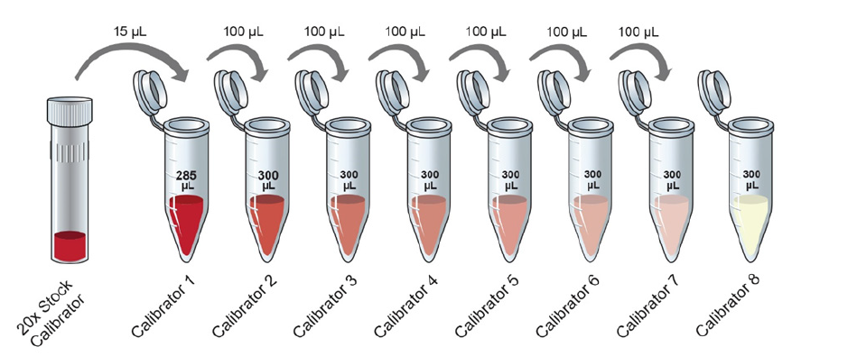

60uL

180uL

1. **Dilute Samples**

30 mins prior to use, bring the samples and QC’s to RT.

* 1. Dilute samples and QC’s 1:10
  2. Add **72uL of Diluent 37** per well
  3. Add **8uL of sample/ QC’s** into diluent wells

**72 µL Diluent 37**

**8 µL samples**

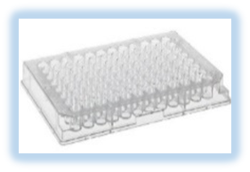

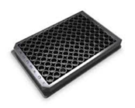

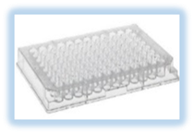

**Sample Dilution 1:10**

**25µL/well Subaliquot Plate**

**Dilution Plate**

**MSD Plate**

1. **Incubate Samples and Standards**
2. Wash the plate **3x** with **300 μL/well** Wash Buffer
3. Add **50 μL/well STD, QC’s and diluted samples in** duplicate.
4. Seal the plate. **Shake for 2 hr at RT at 700 rpm.** After the 1st hr, rotate the plate 180°C

***Subaliquot & Dilution Plate Layout***

1. **Incubate with Detection Antibody**
   1. Prepare detection Ab solution:
      1. Immediately prior to use, transfer **2.94 mL Diluent 37** to a 15-ml sterile conical tube
      2. Transfer **60 μL** of 50X SULFO-TAG Anti-hu KIM-1 Antibody.
      3. Invert tube 5x
   2. Wash the plate 3x with **300 μL/well** of 1x Wash Buffer. Do not let the wells dry
   3. Add 2**5 μL/well** detection Ab solution
   4. Seal the plate with foil or a foil plate seal. **Shake for 2 hr at RT at 700 rpm.** After the 1st hr min, rotate the plate 180°C.
2. **Read the Plate: R&T 613**
   1. Wash 3x with **300 μL/well 1x Wash Buffer**. Do not let the wells dry
   2. Add **150 μL/well of 2X Read Buffer T**
   3. Read the plate immediately on MSD Instrument

# Materials

1. MSD Reagents:
2. U-Plex Human KIM-1 Plate: Cat#L; Lot:Z

*Plate Barcodes* 1:

1. Diluent 37: Cat#: R; Lot#:
2. Calibrator KIM-1: Cat#: Lot#:
3. KIM-1 Antibody: Cat#:; Lot:
4. Wash Buffer:

* PBS 1x: Gibco (-) Ca2+, (-) Mg2+ Cat# 10010-023, Lot
* Tween-20
* Pipette slowly 250 μL Tween-20. Dispense in 500 ml 1x PBS. Rinse tips multiple time with PBS until tip becomes completely clear → 0.05% Tween-20/PBS

1. MSD Gold Read Buffer T (4x): Cat#: ; Lot#
2. Supplies:
3. 96-well Plate Caps
4. U-bottom 96-well plates (dilution plates)
5. Plate seals
6. Matrix tubes
7. Matrix rack
8. 1000 uL, 200 uL and 20 uL sterile filter tips
9. Manual Pipettes: P1000, P200, P20, 8-channel
10. 8-channel Electric Repeater (for washes)
11. Plastic reservoirs: thin groove and large V bottom
12. Sterile 15-ml conical tubes
13. Shaker
14. Ice bucket + ice
15. Room temperature water bath