CLOVERS_PE_Ang1Ang2_Redo

Jordan Lo

2023-10-02

# finds number of occurrences where values stayed the same  
length(  
 which(  
 combined$`PE_Ang-1_V1_Redo` == combined$`PE_Ang-1_V1`  
 )  
 )

## [1] 29

length(  
 which(  
 combined$`PE_Ang-1_V1` == -89  
 )  
)

## [1] 43

There were originally 43 Ang-1 and 8 Ang-2 samples that were below fit curve range in the original 18-plate run of CLOVERS. The question is are they actually below fit curve range or is there perhaps something wrong with the assay, protocol, or technique that is causing them to have no values. We re-ran a plate containing the out of range samples along with several In Detection Range controls for a total of n = 76. One sample vial didn’t contain enough volume to run the assay, so the total dropped to 75 samples; it was a control sample.

29 of the Ang-1 samples that were below fit curve range are still below fit curve range which means 14 samples have a concentration value after re-assaying. All 8 samples of Ang-2 that were out of detection range received a concentration in the rerun.

# Correlation of Control Samples

# creates a new file of just in detection range samples  
idr <- combined %>%  
 filter(`PE_Ang-1_V1` != -89)  
  
# creates a scatter plot looking at the ang-1_idr controls and how well they correlate between the original and redo  
idr_ang1 <- ggplot(data = idr,  
 mapping = aes(x = `PE_Ang-1_V1`,  
 y = `PE_Ang-1_V1_Redo`))  
  
idr_ang1 +   
 geom_smooth(method = "lm",  
 se = FALSE) +   
 geom_point() +  
 stat_cor(method = "pearson") +  
 theme_classic()

## `geom_smooth()` using formula = 'y ~ x'

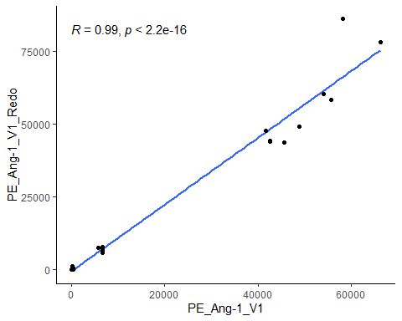

# creates a scatter plot looking at the ang-2_idr controls and how well they correlate between the original and redo  
idr_ang2 <- ggplot(data = idr,  
 mapping = aes(x = `PE_Ang-2_V1`,  
 y = `PE_Ang-2_V1_Redo`))  
  
idr_ang2 +   
 geom_smooth(method = "lm",  
 se = FALSE) +   
 geom_point() +  
 stat_cor(method = "pearson") +  
 theme_classic()

## `geom_smooth()` using formula = 'y ~ x'

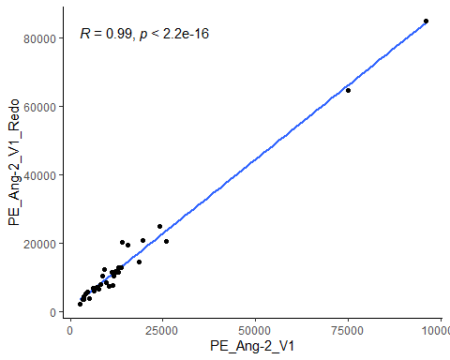 We see high correlation between the control samples in the original run and redo run in both Ang-1 and Ang-2 (R = 0.99).

# QCs

|  |  |  |
| --- | --- | --- |
| Assay | Average Intraplate CV | Interplate CV |
| Ang-1 | 5.4 | 11.6 |
| Ang-2 | 5.2 | 14.9 |

These are the CVs for the QCs in the original eighteen plate run of CLOVERS

|  |  |  |
| --- | --- | --- |
| Assay | Average Intraplate CV | Interplate CV |
| Ang-1 | 5.6 | 11.3 |
| Ang-2 | 5.6 | 15.0 |

These are the CVs for the QCs in the original eighteen plates after inclusion of the redo plate.

# Samples with New Values

new <- combined %>%  
 filter(`PE_Ang-1_V1` == -89) %>%  
 filter(`PE_Ang-1_V1` != `PE_Ang-1_V1_Redo`)  
  
new_ang1 <- new %>%  
 dplyr::select(c("Sample",  
 "PE_Ang-1_V1",  
 "PE_Ang-1_V1_Redo"))  
new_ang1

## Sample PE_Ang-1_V1 PE_Ang-1_V1_Redo  
## 1 CLV_18019131-03 -89 134.9981  
## 2 CLV_18020574-03 -89 10587.4691  
## 3 CLV_18020604-02 -89 194.3529  
## 4 CLV_18021078-03 -89 779.2418  
## 5 CLV_18036758-03 -89 11298.8090  
## 6 CLV_18057951-02 -89 3449.0643  
## 7 CLV_18065846-02 -89 3785.6823  
## 8 CLV_18077399-03 -89 437.1578  
## 9 CLV_18088102-02 -89 12006.4395  
## 10 CLV_18095435-02 -89 4806.3433  
## 11 CLV_19028284-03 -89 1855.9630  
## 12 CLV_19043360-02 -89 1276.0444  
## 13 CLV_19076668-02 -89 277.0577  
## 14 CLV_19076674-05 -89 217.0620

new_ang2 <- new %>%  
 filter(`PE_Ang-2_V1` == -89) %>%  
 filter(`PE_Ang-2_V1` != `PE_Ang-2_V1_Redo`) %>%  
 dplyr::select(c("Sample",  
 "PE_Ang-2_V1",  
 "PE_Ang-2_V1_Redo"))  
new_ang2

## Sample PE_Ang-2_V1 PE_Ang-2_V1_Redo  
## 1 CLV_18020604-02 -89 5065.413  
## 2 CLV_18036758-03 -89 12291.061  
## 3 CLV_18057951-02 -89 14777.377  
## 4 CLV_18065846-02 -89 7314.682  
## 5 CLV_18077399-03 -89 21522.607  
## 6 CLV_18088102-02 -89 7128.800  
## 7 CLV_18095435-02 -89 5102.636  
## 8 CLV_19028284-03 -89 12523.393