|  |  |  |  |  |
| --- | --- | --- | --- | --- |
|  | **Tertile 1 (N = 87)** | **Tertile 2 (N = 86)** | **Tertile 3 (N = 86)** | **Total (N = 259)** |
| **Demographics** |  |  |  |  |
| Age, mean (± SD) | 49 (14.4) | 53 (13.5) | 50 (14.2) | 51 (14.1) |
| Male, N (%) | 64 (73.5) | 54 (62.8) | 52 (60.5) | 172 (66.4) |
| Body mass index, mean (± SD) | 32.8 (12.1) | 30.4 (9.9) | 32.0 (12.7) | 31.8 (11.7) |
| **Race, N (%)** |  |  |  |  |
| White/Caucasian | 72 (82.8) | 71 (82.6) | 65 (75.6) | 208 (80.3) |
| Asian | 3 (3.4) | 1 (1.2) | 5 (5.8) | 9 (3.5) |
| Black | 6 (6.9) | 5 (5.8) | 8 (9.3) | 19 (7.3) |
| Native American | 1 (1.1) | 7 (8.1) | 5 (5.8) | 13 (5.0) |
| Pacific Islander | 2 (2.3) | 1 (1.2) | 2 (2.3) | 5 (1.9) |
| Other/Unknown | 3 (3.4) | 1 (1.2) | 1 (1.2) | 5 (1.9) |
| **Comorbidities, N (%)** |  |  |  |  |
| Diabetes mellitus | 25 (28.8) | 25 (29.1) | 35 (40.7) | 85 (32.8) |
| Hypertension | 36 (41.3) | 35 (40.7) | 33 (38.4) | 104 (40.2) |
| Congestive heart failure | 7 (8.0) | 10 (11.6) | 9 (10.5) | 26 (10.0) |
| **ICU Characteristics on Enrollment** |  |  |  |  |
| Invasive mechanical ventilation, N (%) | 49 (56.3) | 51 (59.3) | 62 (72.1) | 162 (62.5) |
| SOFA Score, mean (± SD) | 4.9 (3.5) | 5.8 (3.8) | 7.8 (4.4) | 6.1 (4.1) |

**Table 1.** Cohort Characteristics

**Table 2.** Outcomes

|  |  |  |  |  |
| --- | --- | --- | --- | --- |
| **Outcomes, n (%)** |  |  |  |  |
| Acute kidney injury | 21 (24.1) | 25 (29.0) | 46 (53.4) | 92 (35.5) |
| Stage 1 | 11 (12.6) | 14 (11.6) | 21 (24.4) | 46 (17.8) |
| Stage 2 | 2 (2.2) | 5 (5.8) | 5 (5.8) | 12 (4.6) |
| Stage 3 | 8 (9.2) | 6 (7.0) | 20 (23.2) | 34 (13.1) |
| Dialysis | 1 (0.4) | 4 (1.5) | 7 (2.7) | 12 (4.6) |
| Death | 5 (5.7) | 5 (5.8) | 8 (9.3) | 18 (6.9) |

**Table 3:** Risk exposures for AKI status at 28 days in creatinine-normalized uAng-2 Tertiles (N = 259)

|  |  |  |  |  |  |
| --- | --- | --- | --- | --- | --- |
| Normalized uAng-2 | n | Adjusted In-Hospital AKI Risk | p-value | Unadjusted In-Hospital AKI Risk | p-value |
| Low Tertile (95% CI)  **Baseline Risk** | 21/87 | 1 | N/A | 1 | N/A |
| Intermediate Tertile (95% CI) | 25/86 | 1.05 (0.94 - 1.17) | 0.424 | 1.04 (0.94 - 1.16) | 0.434 |
| High Tertile  (95% CI) | 40/86 | 1.24 (1.11 - 1.38) | < 0.001 | 1.24 (1.12 - 1.37) | < 0.001 |

**Table 4**: Risk exposures for dialysis in creatinine-normalized uAng-2 Tertiles (N = 259)

|  |  |  |  |  |  |
| --- | --- | --- | --- | --- | --- |
| Normalized uAng-2 | n | Adjusted Dialysis Risk | p-value | Unadjusted Dialysis Risk | p-value |
| Low Tertile (95% CI)  **Baseline Risk** | 1/86 | 1 | N/A | 1 | N/A |
| Intermediate Tertile (95% CI) | 4/86 | 1.03 (0.98 - 1.08) | 0.258 | 1.03 (0.99 - 1.09) | 0.164 |
| High Tertile  (95% CI) | 7/86 | 1.08 (1.01 – 1.15) | 0.027 | 1.07 (1.01 – 1.13) | 0.024 |

**Table 5**: Risk exposures for in-hospital mortality in creatinine-normalized uAng-2 Tertiles (N = 259)

|  |  |  |  |  |  |
| --- | --- | --- | --- | --- | --- |
| Normalized uAng-2 | n | Adjusted In-Hospital Death Risk | p-value | Unadjusted In-Hospital Death Risk | p-value |
| Low Tertile (95% CI)  **Baseline Risk** | 5/87 | 1 | N/A | 1 | N/A |
| Intermediate Tertile (95% CI) | 5/86 | 0.99 (0.92 – 1.06) | 0.703 | 1.00 (0.94 – 1.07) | 0.985 |
| High Tertile  (95% CI) | 8/86 | 1.03 (0.95 – 1.12) | 0.425 | 1.62 (0.96 – 1.11) | 0.373 |

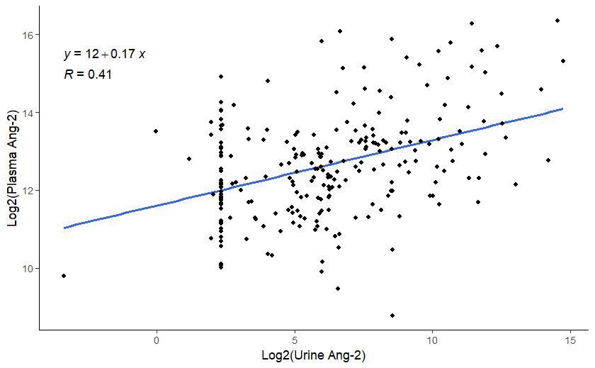**Plasma Ang-2 vs. Urine Ang-2 (Log2)**

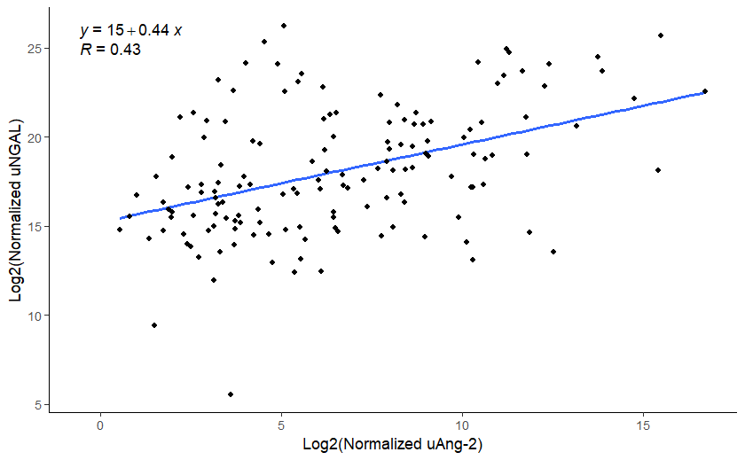**Urine Ang-2 vs. Urine NGAL**

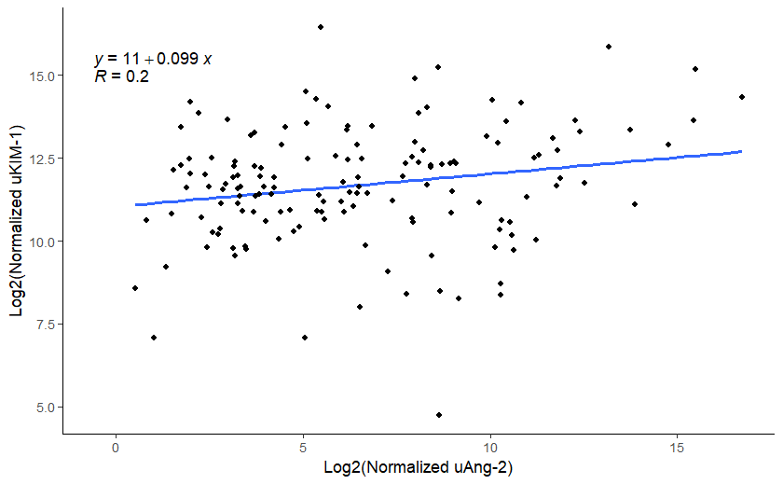**Urine Ang-2 vs. Urine KIM-1**