Untitled

Jordan Lo

2023-11-15

# tidyverse allows us to do our data processing  
library("tidyverse")

## ── Attaching packages ─────────────────────────────────────── tidyverse 1.3.2 ──  
## ✔ ggplot2 3.4.0 ✔ purrr 0.3.5   
## ✔ tibble 3.1.8 ✔ dplyr 1.0.10  
## ✔ tidyr 1.2.1 ✔ stringr 1.4.1   
## ✔ readr 2.1.3 ✔ forcats 0.5.2   
## ── Conflicts ────────────────────────────────────────── tidyverse_conflicts() ──  
## ✖ dplyr::filter() masks stats::filter()  
## ✖ dplyr::lag() masks stats::lag()

# readxl allows us to read excel files  
library("readxl")  
# writexl allows us to write to excel files  
library("writexl")

raw <- read_excel("B:/CITRC/Plasma Biomarker August 2022/AngPTL4/2023_03_30/AngPTL4_All_Plates_Data.xlsx",  
 sheet = "RawData")  
  
raw$`Conc. (ng/mL)` <- as.numeric(raw$`Conc. (ng/mL)`)

## Warning: NAs introduced by coercion

raw <- raw %>%  
 drop_na(`Conc. (ng/mL)`)  
  
colnames(raw)[3] ="Concentration"  
  
raw <- raw %>%  
 group_by(Sample) %>%  
 filter(n()>1)  
  
plot <- ggplot(data = raw,  
 mapping = aes(x = Visit,  
 y = Concentration,  
 group = Sample))  
plot +  
 geom_point() +  
 geom_line() +  
 theme_classic()

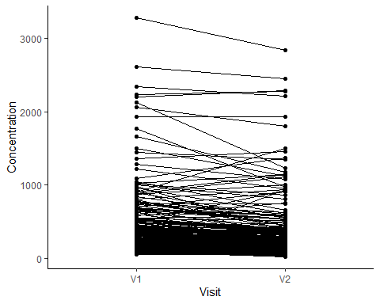

plot <- ggplot(data = raw,  
 mapping = aes(x = Visit,  
 y = log2(Concentration)))  
plot + geom_boxplot() +  
 theme_classic() +  
 labs(y = "Log2(AngPTL4 Conc. ng/mL)")

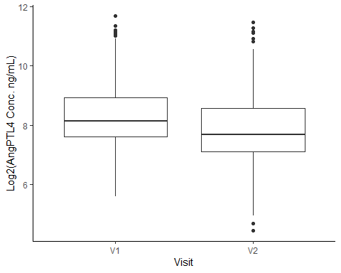

plot <- ggplot(data = raw,  
 mapping = aes(x = Visit,  
 y = Concentration))  
plot + geom_boxplot() +  
 theme_classic() +  
 labs(y = "AngPTL4 Conc. (ng/mL)")

