ChargeFlow
Field findings from Varanasi
What nine e-rickshaw drivers told us, with the charts behind it. SHIFT Hackathon, IIT (BHU) Varanasi. · [Team name] · [Member names]
How to read this document
FIELD DATA is what drivers told us. DERIVED is calculated from that data. SIMULATED comes from our ChargeFlow model and is not a field measurement. Figures from drivers are approximate and were collected in one visit.
9  drivers, A to I, in Varanasi | 7 of 9  rent the vehicle by the day | ₹380–400  daily rent, charging included | 8 at once  vehicles charging between 12 am and 8 am

The short version
• The customer is the garage owner. Seven of nine drivers rent by the day and the rent includes charging, so the owner pays the electricity bill.
• Charging overlaps. Six of eight drivers who gave a window start between 11 pm and 1 am and run until 8 to 11 am.
• Electricity and batteries take a large share of the rent: about ₹125 to ₹195 of every ₹400 (a third to a half), derived from the drivers' figures.
• Batteries age fast and no one tracks health. Driver E's pack gives 60 km now against 150 km when new.

1. The drivers we spoke to
FIELD DATA · What each driver reported
Driver | Vehicle | Battery | Full charge | Range | Charging window | Cost to driver / owner
A | Rented | Lead-acid | 10 h | 90 km | 8 pm–10 am | ₹400 rent incl. charging; battery ₹48,000 / 2 yr
B | Rented | Lithium (LFP) | 3–4 h | 100 km | 12 am–11 am | ₹300 rent + ₹80 charging; battery ₹70,000 / 2 yr
C | Rented | Lithium (to confirm) | 3.5 h | 100 km | 12 am–10 am; 3–7 pm | ₹400 incl. charging; battery every 1.5 yr
D | Rented | Lead-acid | 8 h | 100 km | 12 am–10 am | ₹400 incl. charging; takes home ₹400–500
E | Own | Lead-acid | 3 h (12 h new) | 60 km (150 new) | At home | ₹40–50 per charge; battery ₹50,000 / 2 yr
F | Rented | Lithium (LFP) | 5–6 h | 100 km | 12 am–11 am | ₹400 rent; takes home ₹600; owner pays ₹50,000 battery
G | Rented | Lead-acid | 8 h | 120 km | 11 pm–8 am | ₹300 rent + ₹100 charging; battery ₹48,000
H | Own | Lead-acid | 10 h | 100 km | 11 pm–10 am | ₹70–80 per day at home (7–8 units); battery every 1.5 yr
I | Rented | Lithium (LFP) | 5 h | 100 km | 10 pm–10 am | ₹400 rent

2. When they charge
FIELD DATA · Charging windows as reported
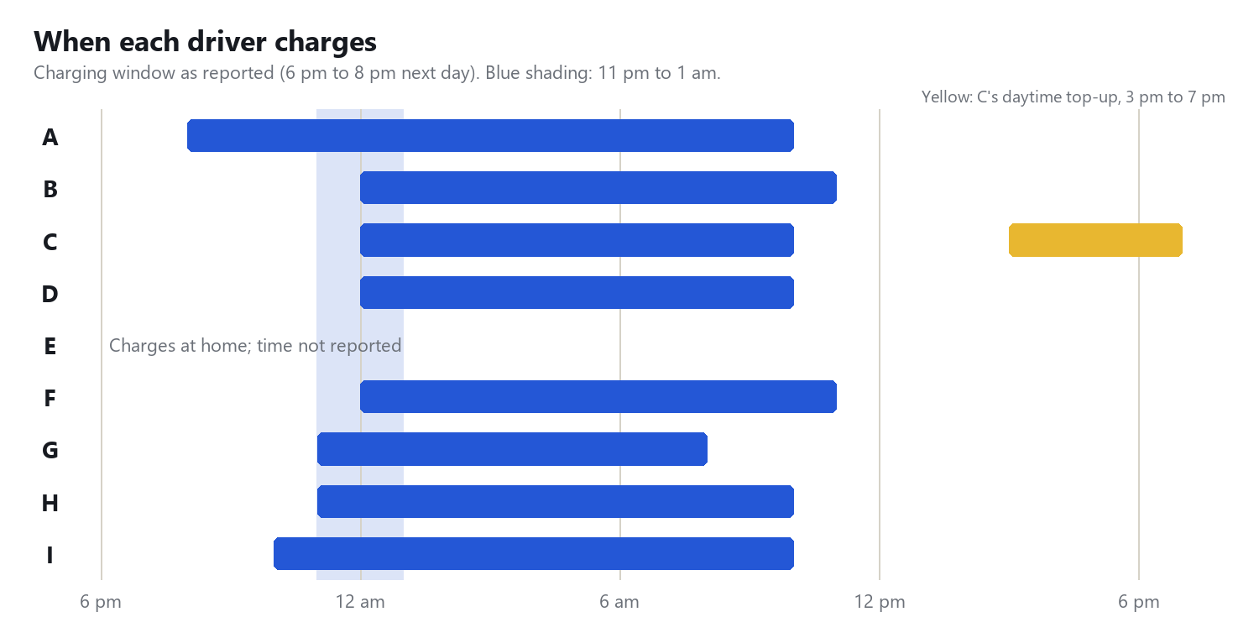
Chart 1. Six of eight drivers start charging between 11 pm and 1 am. A and I gave a second window that is not drawn; E charges at home and gave no time.
DERIVED · Counted from the windows above
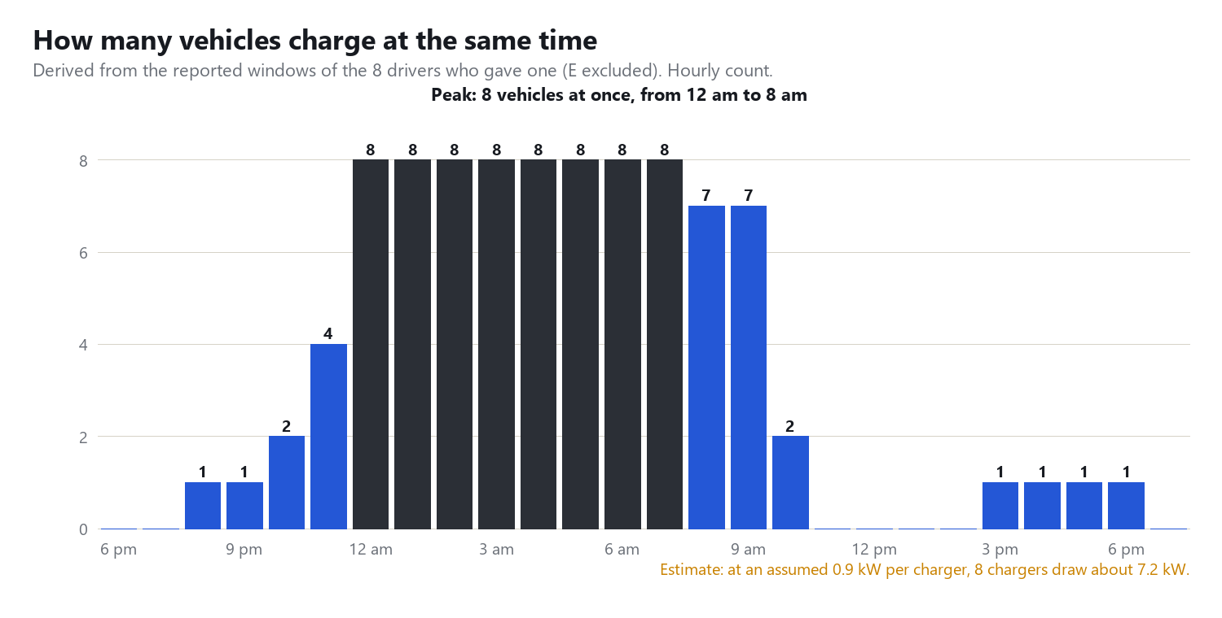
Chart 2. All eight drivers who gave a window are charging between 12 am and 8 am. The kW figure uses an assumed 0.9 kW per charger, which we still need to confirm.

3. Batteries and range
FIELD DATA · Charge time and range as reported
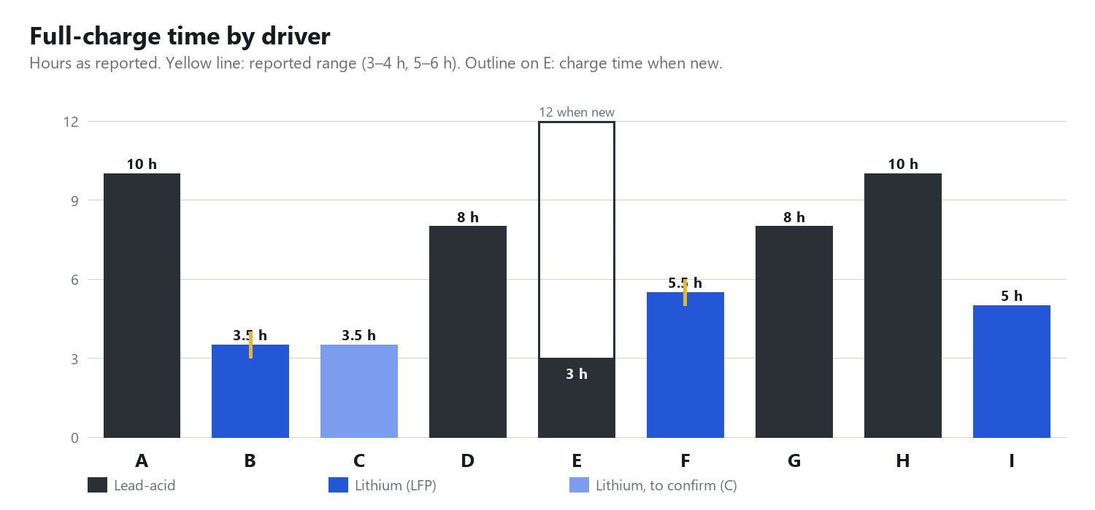
Chart 3. Lead-acid packs take 8 to 10 hours, which leaves little room to shift charging. Lithium takes 3 to 6 hours. E's lead-acid pack now charges in 3 hours because there is far less battery left.
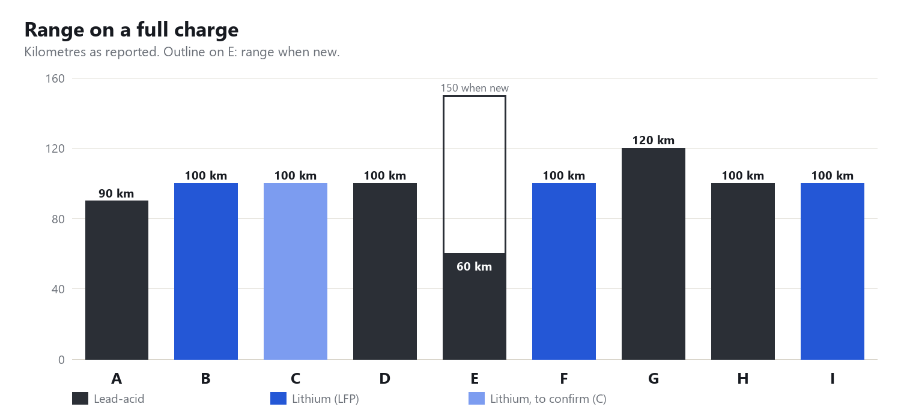
Chart 4. Most vehicles report about 100 km. E's range has fallen from 150 km to 60 km, 40% of the original.
FIELD DATA · Replacement cost and interval
Driver | Battery | Replacement cost | Replaced every | Derived ₹ per day
A | Lead-acid | ₹48,000 | 2 years | ₹66
B | Lithium | ₹70,000 | 2 years | ₹96
E | Lead-acid | ₹50,000 | 2 years (company asks yearly) | ₹68 (₹137 if yearly)
F | Lithium | ₹50,000 | 3 years | ₹46
G | Lead-acid | ₹48,000 (₹12,000 each) | not stated | ₹66 if 2 years
H | Lead-acid | not stated | 1.5 years (1 year guarantee) | n/a

₹ per day = replacement cost ÷ (years × 365). Derived by us, not reported by drivers.

4. Where the rent goes
DERIVED · Derived from the drivers' figures
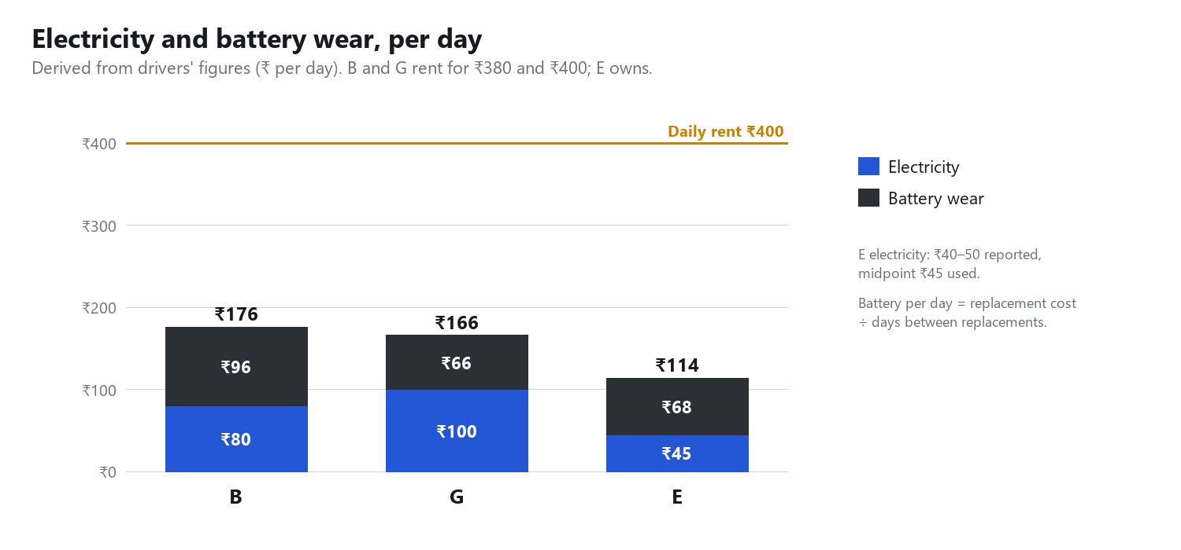
Chart 5. For B and G, electricity plus battery wear is about ₹165 to ₹175 a day, around 40% of the rent. These are the owner's costs. Not the owners' accounts: a margin and other costs are not measured.

5. What ChargeFlow does with this
SIMULATED · ChargeFlow simulator results
Measure (10 rickshaws, 7 kW limit assumed) | Plug-in-and-charge | ChargeFlow
Peak grid demand | 10.5 kW | 6.6 kW
Time over the sanctioned load | 4 h 15 min | 0
Rickshaws ready (95%) by departure | 10 of 10 | 10 of 10
Charger-hours on already-full packs | 7.8 h | 0
At a 6 kW limit: ready by departure | grid only: 5 of 10 | with solar + second-life pack: 10 of 10

Plug-in-and-charge also reaches 10 of 10 at 7 kW, but only by running 4 hours 15 minutes over the limit. Arrival times in the simulator are generated, and the 7 kW limit is a placeholder.

6. What we have not verified yet
Open question | Why it matters
Sanctioned load and breaker trips at a garage | Our central claim is that ten chargers exceed the connection. The visit did not ask this.
Charger rating, and whether it cuts off when full | Sets the real load per vehicle and how much energy float charging wastes.
Energy per charge: 7–8 units from H, one driver | Our simulator assumes about 5 kWh per vehicle, so it may understate the load.
Whether the garage connection is residential | Decides if PM Surya Ghar rooftop solar can apply. A 3 kW system gives about 12 kWh a day against 70–80 kWh of nightly charging.
The 'morning charging' subsidy we heard about | Unclear whether it is a tariff or a purchase subsidy.

7. Suggested 5-minute pitch
Time | Show | Say
0:10 | Title | A day with e-rickshaw drivers in Varanasi.
0:30 | Key numbers | 7 of 9 rent; rent includes charging; the owner pays the bill.
0:35 | Chart 1 and 2 | Most start charging at the same hours: 8 vehicles at once.
0:40 | Chart 5 | A third to a half of the rent is electricity and battery wear.
0:25 | Chart 4 | E's range fell from 150 km to 60 km; nobody tracks battery health.
1:30 | Section 5 + live app | At 6 kW, grid only gets 5 of 10 ready; with solar and storage, 10 of 10.
0:40 | Section 6 | What we have not verified, and the one-week garage test.

