ChargeFlow
Unit economics and feasibility
Garage owner and company, using our Varanasi field data plus published prices and subsidy rules. All figures in ₹, per year unless stated.
Bottom line
• The owner's business is already profitable: about ₹76,058 margin per vehicle a year on ₹1.6 lakh of vehicle cost (payback 2.1 years; 4.6 years in a conservative case).
• Electricity plus batteries are about 29% of the rent, so cost savings help but cannot be the whole story.
• The strongest owner investment is a 3 kW rooftop system with subsidy and net metering: payback about 4.3 years (range 2.7 to 6.0), and still about 5.2 years with no subsidy.
• A standalone smart-charging controller is only profitable for the owner if it also extends battery life; the pilot must measure that. At ₹800 a month the base case nets the owner ₹9,200 a year; the conservative case is ₹-400.
• For the company, breakeven is about 162 garages (base), range 92 to 417, with about ₹17.84 lakh of upfront cash.
• Best design: lead with solar plus net metering and the controller together, sold through solar installers and e-rickshaw dealers. Second-life storage is optional, not the profit engine.

Correction to our earlier material
• We earlier treated the ₹80–100 charging fee as the owner's electricity cost. That is what B and G are billed. At 6.5 kWh a day and a ₹6.5 tariff the owner's own cost is about ₹42 a day, so electricity plus batteries are about 30% of the rent, not a third to a half. Update the pitch slide and the Word summary.

1. Data used
FIELD = our nine drivers. PUBLISHED = found in sources (listed at the end). ASSUMPTION = our estimate, to be replaced by pilot data.
Input | Value | Source
Daily rent, charging included | ₹380–400 | FIELD (7 of 9 drivers rent)
Vehicles per garage | about 10 | FIELD
Battery set cost and life | ₹48,000–70,000 every 1.5–3 years (≈ ₹46–137 a day) | FIELD (A, B, E, F, G, H)
Energy per vehicle per night | 5–8 kWh (H: 7–8 units); base 6.5 | FIELD (one driver) + simulator
Vehicle cost | ₹1.45–2.0 lakh; base ₹1.6 lakh | FIELD (E, H)
Operating days a year | 330 base (280–340) | ASSUMPTION
Electricity tariff | Domestic average ₹5.82; LMV-11 charging ₹7.70; non-domestic average ₹9.87 per kWh | PUBLISHED (UPERC FY27 reports)
Rooftop solar price, 3 kW | ₹2.1–2.3 lakh gross; ₹1.0–1.2 lakh after subsidy in Varanasi and Lucknow | PUBLISHED (installer quotes)
Solar yield, Varanasi | 1,400–1,800 kWh per kW a year; seasonal 3.7–6.3 kWh per kW a day | PUBLISHED (NASA POWER model, UNI)
Varanasi e-rickshaw registrations | 4,026 (2022), 7,238 (2023), 5,752 (2024) | PUBLISHED (Down To Earth)
UP e-rickshaws registered | 8,60,054 | PUBLISHED (Rajya Sabha reply, Mar 2025)
Battery prices | LFP ₹20,000–35,000 and lead-acid ₹8,000–15,000 per kWh (general solar-storage guide) | PUBLISHED, indicative

2. Subsidies and incentives: what applies to a garage
The garages are small quarters, so the key question is the electricity connection type. PM Surya Ghar is for residential consumers; charging schemes are for public stations.
Scheme | What it gives | Applies to our garage? | In the model
PM Surya Ghar (central) | ₹30,000 per kW for the first 2 kW and ₹18,000 for the third: ₹78,000 maximum, paid after inspection into the owner's bank account | Yes, if the connection is domestic, the owner owns the roof and the meter is in the owner's name. Verify. | Yes: ₹78,000
UP state top-up for rooftop solar | Reported at ₹30,000 (older report: ₹15,000 per kW up to ₹30,000); installers say it is often not filed in western UP | Same eligibility. Amount not confirmed by an official notice found. | Base yes, conservative no
Net metering (UP) | Export by day, import at night; annual settlement reported. A ₹3.00 surplus rate was reported without a citation. | Yes, once solar is installed. Banking terms must be confirmed with the DISCOM. | Assumed full retail offset
PM E-DRIVE: e-rickshaw purchase | Extended to March 2028 for e-rickshaws and carts; reported ₹5,000 per kWh capped at ₹25,000, halved from April 2025, funding cut. Sources conflict. | Only for new vehicle purchases, not for charging. Helps owners buying vehicles. | No
PM E-DRIVE: public charging | ₹2,000 crore for 72,300 public chargers; 80% of upstream infrastructure, 70% of charger cost at some sites. Eligible bodies are government ministries, state governments and public-sector bodies. | No. A private garage is not an eligible applicant. | No
UP EV policy 2022: charging stations | 20% capital subsidy up to ₹10 lakh per station, with a minimum ₹25 lakh investment | No. Far above a garage's investment. | No
UP purchase subsidy and tax waiver | 3-wheeler purchase subsidy (15%, up to ₹12,000) reported ended in October 2023; road-tax and registration rules changed in 2025 | Not for charging. Unclear. | No
'Morning charging' subsidy from our notes | We could not find a UP time-of-day or morning subsidy for EV charging | Unknown. Ask UPPCL or the owner. | No

Only PM Surya Ghar, its UP top-up and net metering are counted. Everything else is excluded rather than assumed.

3. Garage owner: unit economics per vehicle
₹ per vehicle per year | Conservative | Base | Optimistic
Rent income (₹400 × days) | ₹112,000 | ₹132,000 | ₹136,000
Days rented a year | 280 | 330 | 340
Electricity (kWh × tariff × days) | ₹22,109 (8.0 kWh × ₹9.87) | ₹13,942 (6.5 × ₹6.50) | ₹11,220 (5.5 × ₹6.00)
Battery replacement | ₹32,000 | ₹24,000 | ₹18,000
Maintenance and repairs | ₹15,000 | ₹12,000 | ₹10,000
Insurance, permits, other | ₹8,000 | ₹6,000 | ₹5,000
Margin before vehicle cost | ₹34,891 | ₹76,058 | ₹91,780
Payback on ₹1.6 lakh vehicle | 4.6 years | 2.1 years | 1.7 years
Electricity + battery share of rent | 48% | 29% | 21%

Maintenance and 'other' are assumptions, kept modest because we have no field data. A garage of 10 vehicles earns about ten times these figures. Driver take-home (₹400–700 after rent) is unaffected.
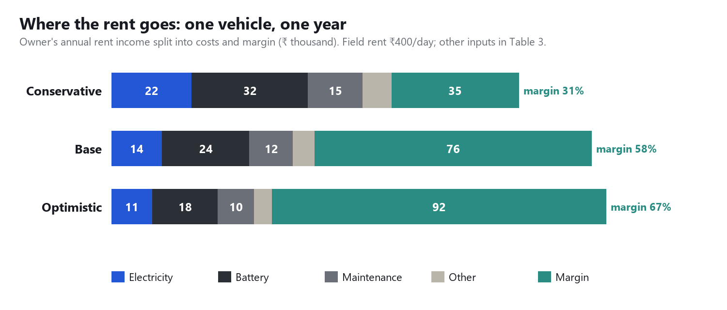
Chart 1. The owner keeps about 31% of the rent as margin even in the conservative case. Electricity plus batteries take 29% in the base case and 48% in the conservative case (higher tariff, yearly lead-acid swaps).

4. Garage owner: the solar investment (3 kW)
Case | Net cost | Yearly saving, year 1 | Payback | 25-year net cash
Optimistic (central + UP top-up, high yield) | ₹108,000 | ₹41,580 | 2.7 years | ₹7.66 lakh
Base (central + UP top-up) | ₹120,000 | ₹29,250 | 4.3 years | ₹4.80 lakh
Conservative (central only) | ₹142,000 | ₹25,200 | 6.0 years | ₹3.68 lakh
No subsidy (commercial connection) | ₹220,000 | ₹44,415 | 5.2 years | ₹7.17 lakh

Saving = kWh a year × tariff offset through net metering. Yield falls 1% a year, O&M ₹1,000 a year, inverter replaced at ₹25,000 in year 12, no future tariff rise (installers assume 3%, so this is conservative).
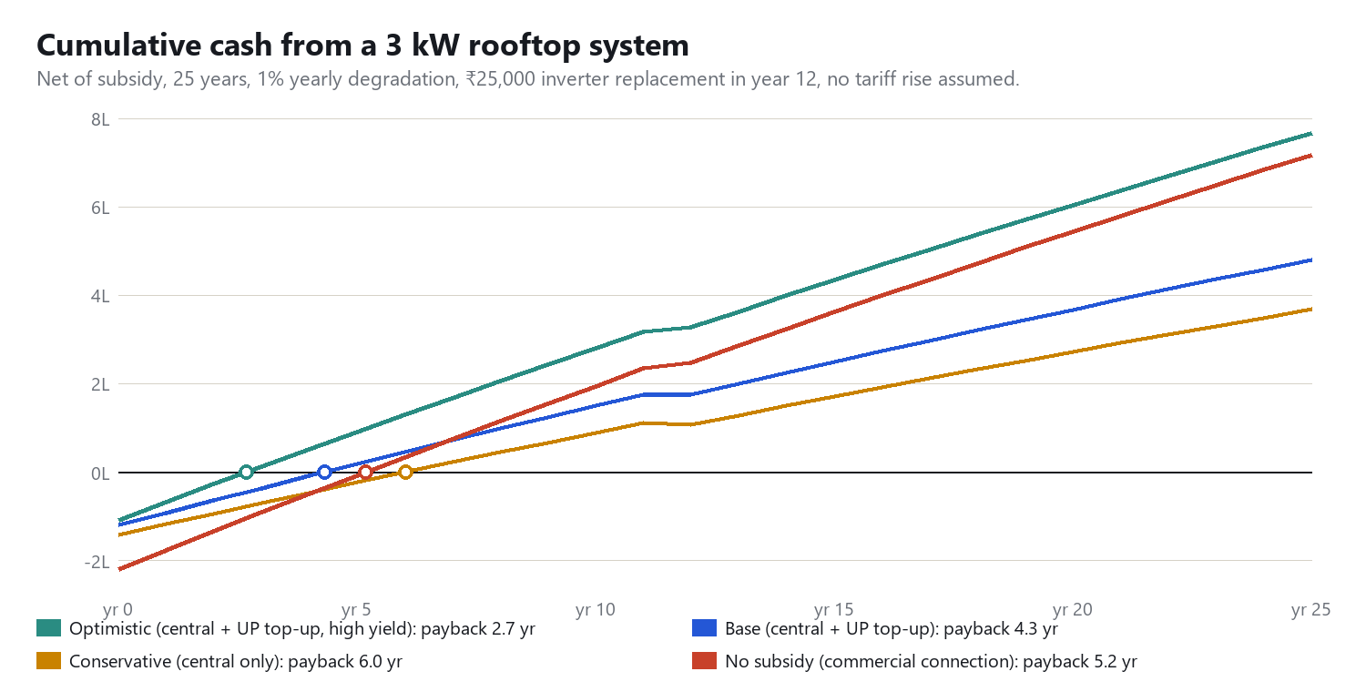
Chart 2. Subsidised solar pays back in 3 to 6 years and earns for 25. Without subsidy it still pays back in about 5 years, but only if the higher commercial tariff applies and net metering works.
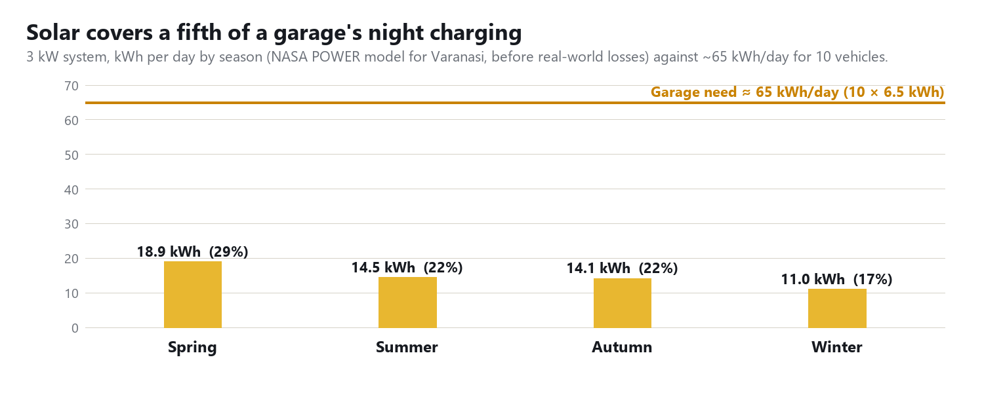
Chart 3. A 3 kW roof covers 17 to 29% of a garage's charging energy depending on season. Solar is a supplement, which is why the pitch should not oversell it.
Why net metering matters more than storage
• The vehicles are out by day and charge at night. With net metering, daytime solar is banked with the DISCOM and offsets the night load, so no battery is needed.
• A second-life storage unit (15 kWh, assumed about ₹10,000 per kWh plus a ₹50,000 hybrid inverter, about ₹2 lakh) would roughly triple the solar investment for energy the grid already banks for free: payback beyond 10 years. We have no India price for second-life packs, so this is our assumption.
• Storage makes sense only where net metering is unavailable or the connection limit is binding, for example the 6 kW garage in our simulation (5 of 10 ready on grid only, 10 of 10 with storage).

5. What ChargeFlow adds for the owner (per garage of 10)
Benefit | Conservative | Base | Optimistic | Evidence
Lower peak: ~4 kW less contracted load (simulated 10.5 → 6.6 kW), at about ₹100/kW/month | ₹4,800 | ₹4,800 | ₹4,800 | Simulation; fixed charge assumed
Less float charging and better timing | ₹2,000 | ₹2,000 | ₹2,000 | Small; simulation
Battery life gain on ₹2.4 lakh a year of batteries | 0% = ₹0 | 5% = ₹12,000 | 10% = ₹24,000 | Unproven: pilot must measure
Total yearly value | ₹6,800 | ₹18,800 | ₹30,800
Subscription (₹600 / ₹800 / ₹1,000 a month; hardware included) | ₹7,200 | ₹9,600 | ₹12,000 | Our price
Owner's net gain | ₹-400 | ₹9,200 | ₹18,800

We left out avoided breaker trips, downtime and fire risk because we have no data on them. They would only add to the value. We could not confirm the fixed charge per kW; check a bill.

6. Our company: unit economics and breakeven
Assumption / result | Conservative | Base | Optimistic
Subscription per garage per month | ₹600 | ₹800 | ₹1,000
Hardware per garage (controller, relays, meters, install) | ₹10,000 | ₹8,000 | ₹6,000
Variable cost per garage per year (data, cloud, remote support) | ₹4,000 | ₹3,000 | ₹2,500
Solar partner commission per install; share of garages that buy | ₹6,000; 20% | ₹8,000; 30% | ₹10,000; 40%
Acquisition cost per garage (one visit, demo) | ₹4,000 | ₹3,000 | ₹2,000
Fixed team and tools per year (2 staff, travel, cloud) | ₹15 lakh | ₹12 lakh | ₹10 lakh
Contribution per garage per month | ₹300 | ₹617 | ₹903
Payback of hardware + acquisition per garage | 3.9 years | 1.5 years | 0.7 years
Breakeven garages (vehicles) | 417 (4,167) | 162 (1,622) | 92 (923)
Upfront cash to reach breakeven | ₹58.33 lakh | ₹17.84 lakh | ₹7.38 lakh

Management is kept lean: founders unpaid in the pilot year, remote support, no sales team. Hardware and variable costs are our estimates from typical component prices, not quotes. Founders' pay would add to fixed cost.
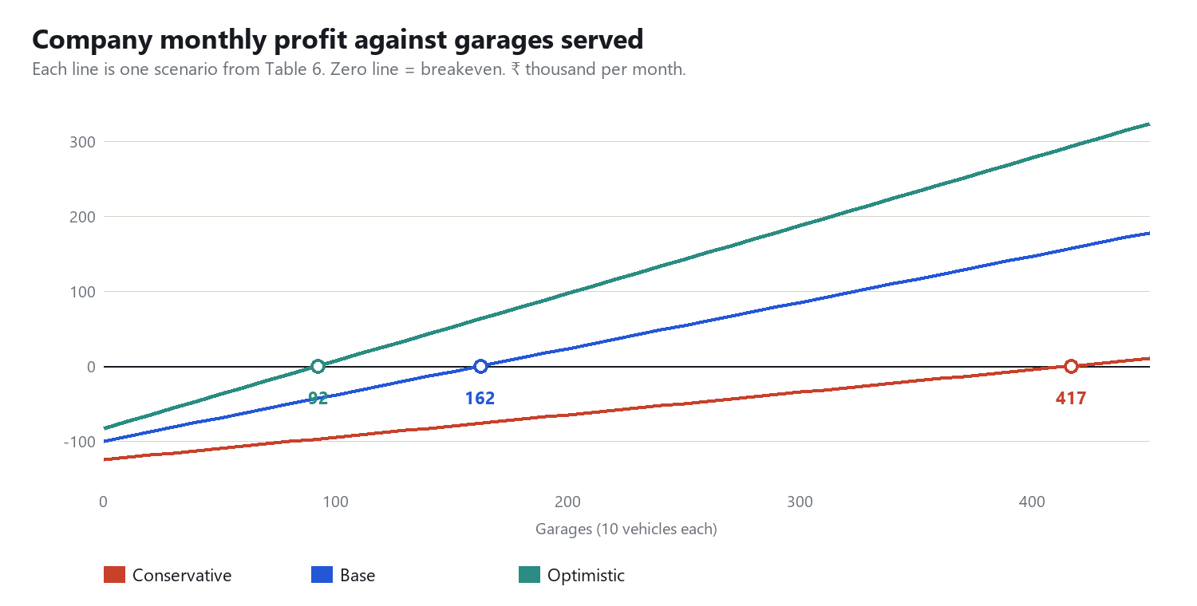
Chart 4. Base case breaks even at about 160 garages. Varanasi added about 17,000 e-rickshaws in 2022–24 alone, roughly 1,700 garages of ten, so breakeven needs under a tenth of that growth, though the market is unsurveyed.
Market check. Counting only new registrations from 2022 to 2024, Varanasi has at least 17,000 e-rickshaws. If half work from garages of ten, that is about 850 garages in Varanasi, so breakeven (base) is under a fifth of the reachable market and Uttar Pradesh as a whole (860,000 e-rickshaws) leaves room to grow. These counts are not yet verified for Varanasi's total fleet.

7. Sustainability
• Solar: a 3 kW system generates about 4,500 kWh a year, avoiding about 3.1 tonnes of CO2 per garage a year (assumed grid factor 0.7 kg per kWh; verify).
• Lead-acid batteries are replaced every 1 to 2 years. Any gain in life, and routing retired lithium packs to second use, reduces the battery waste that these garages generate. We have not measured the gain.
• Peak shaving avoids upgrading the electricity connection for a charging load.

8. Risks and what would change the answer
Risk | Effect | How we handle it
Connection is domestic but used commercially | The DISCOM could reclassify it to non-domestic or EV-charging (₹7.70 to ₹9.87 per kWh), and subsidy eligibility is at risk | Check connection type with each owner; use the commercial-case numbers (payback about 5 years) as the floor
Net metering banking terms | A low surplus buy-back (₹3.00 reported) would cut solar savings by about half | Confirm banking with UPPCL before quoting; size solar to the night load
Battery-life benefit not proven | Controller value falls to about ₹7,000 a year; owner nets about zero | Pilot with metered batteries and range logs; price so the owner pays only if it saves
Subsidy rules change or delay | Payback lengthens by about 2 years without the UP top-up | Quote conservative (central only) numbers
Field data is small | Nine drivers, one visit, approximate answers | Measure one garage for a week and re-run this model

9. The most optimised idea
• Sell one bundle, not three products: a small controller (load limit plus charge scheduling) plus a PM Surya Ghar 3 kW system with net metering. The controller makes the system safe on a small connection; solar produces most of the savings.
• Do the solar through local installers who already file the subsidy, and take a partner commission. This avoids our carrying installation staff and inventory.
• Reach owners through e-rickshaw dealers and manufacturers. Our notes show the vehicle company already helps owners set up charging points at home, which is a ready channel.
• Price the controller as a subscription with hardware included and a 'pay only if it saves' guarantee in the pilot. This removes the owner's risk while the battery-life benefit is measured.
• Offer battery health tracking (range per full charge) and a discounted lithium upgrade or second-use pack later. Batteries are the owner's largest controllable cost (₹24,000 a vehicle a year).
• Keep second-life storage as an option for garages that cannot use net metering or are limited by their connection.
• Prove it first: one garage, one week of metered data, then update the model. That one pilot answers the three biggest unknowns.

Sources
PM E-DRIVE e-rickshaw extension and rates: electrive.com/2026/03/30/india-extends-subsidies-for-electric-two-wheelers-and-rickshaws ; autocarpro.in (Anish Shah on subsidies) ; inc42.com/?p=553418
PM E-DRIVE public charging guidelines: autocarpro.in/news/government-releases-guidelines-for-ev-public-charging-infra-under-pm-e-drive-128940 ; mercomindia.com/government-notifies-guidelines-for-charging-stations-under-pm-e-drive
PM Surya Ghar subsidy slabs: businesstoday.in (28 Jul 2026) ; zbotic.in ; quickestimate.co/blog/pm-surya-ghar-subsidy-slabs
UP top-up and system prices: solarsquare.in/blog/3-kw-solar-panel-price-in-uttar-pradesh-with-subsidy ; bridgewaypower.in/blog/solar-subsidy-up-2026-guide ; iamrenew.com (UP top-up report)
UP tariffs FY 2026-27: powerpeakdigest.com/uperc-retains-fy27-power-tariffs-raises-subsidy-and-expands-ev-benefits ; desiutility.com/electricity/tariffs/uppcl (unverified slab table)
UP EV policy 2022: invest.up.gov.in/uttar-pradesh-electric-vehicle-manufacturing-policy-2022 ; evreporter.com ; bolt.earth/blog/uttar-pradesh-ev-policy
E-rickshaw numbers: Rajya Sabha reply PQ 267 of 12 Mar 2025 (rsdebate.nic.in) ; downtoearth.org.in (Varanasi mobility) ; jmkresearch.com
Solar yield: profilesolar.com/locations/India/Varanasi ; UNI report on Varanasi rooftop solar ; surgepv.com (UP net metering guide)
Batteries: quickestimate.co/blog/solar-battery-price-india ; wri-india.org (second-life batteries) ; trid.trb.org/View/2721776 (Delhi e-rickshaw economics)
Several figures come from installer blogs or secondary reports and some sources conflict. Verify subsidy amounts on pmsuryaghar.gov.in, the UPNEDA notices and the UPERC order before quoting them to an owner.

