ChargeFlow
Projected economics with ChargeFlow: owner and company
Expected results once ChargeFlow is running, projected from our field data, published prices and the model assumptions listed in Table 1. Every input can be changed and the model re-run.
What this projection rests on
• Unchanged: every driver figure from our visit, the ₹400 rent, the battery costs we were told, the published tariffs and subsidy rules.
• Changed: the second-life pack price, solar yield and tariff, battery-life gain, add-on services and sales rates. Each change is listed in Table 1 with what the pilot must show.
• The conservative estimate (first report) sits beside it so the range is visible. The 4-week pilot in section 6 replaces assumptions with measurements.

Projected results with ChargeFlow
• Owner vehicle margin rises from ₹76,058 to ₹91,780 a year (67% of rent); vehicle payback 1.7 years.
• 3 kW solar with banking pays back in 2.6 years and earns ₹11.69 lakh over 25 years. If banking is not allowed, second-life storage trims payback from 7.4 to 6.9 years and lifts 25-year cash from ₹2.02 lakh to ₹6.40 lakh.
• At ₹5,000 per kWh a 15 kWh second-life pack plus inverter costs ₹1.15 lakh. Storage pays back in 7.1 years on its own at a ₹7.70 night tariff (extra over selling the surplus).
• Company breakeven falls from 162 to 65 garages; upfront cash ₹5.17 lakh; hardware and sales cost repaid in 6 months.

1. What changed, and what the pilot must show
Input | Conservative estimate | Projected | Why it is plausible / what must be proven
Second-life pack price | ₹10,000 per kWh (our assumption) | ₹5,000 per kWh | No India price found. Needs a supplier quote. Chart 3 shows how payback moves with price.
Solar yield, Varanasi | 1,500 kWh per kW a year | 1,800 | Top of the published range (NASA POWER model, UNI report). Needs a good roof.
Tariff offset by solar | ₹6.50 | ₹7.70 with 3% yearly rise | UP LMV-11 charging tariff; installers assume 3% a year. Confirm the connection class.
Net cost of 3 kW solar | ₹1.20 lakh | ₹1.08 lakh | Central ₹78,000 plus UP top-up ₹30,000, as in the lowest Varanasi quote.
Days rented / kWh per vehicle / tariff | 330 / 6.5 / ₹6.50 | 340 / 5.5 / ₹6.00 | Within field range (5–8 units reported). Needs a meter reading.
Battery cost per vehicle per year | ₹24,000 | ₹18,000 | Within field range (₹46–137 a day). Longer life or cheaper refurbished lithium.
Battery-life gain from smart charging | 5% | 10% | UNPROVEN. The pilot must log battery range and replacements.
Subscription; add-on | ₹800 a month; none | ₹1,000 a month; battery-health add-on ₹500 (half of garages) | Owner value in Table 4 must exceed the price.
Solar partner commission; attach rate | ₹8,000; 30% | ₹10,000; 40% | Needs an installer agreement.
Storage sale; attach rate | none | ₹19,838 margin; 25% | 15% margin on the pack, inverter and fitting. Needs supplier terms.
Fixed cost; hardware; variable | ₹12 lakh; ₹8,000; ₹3,000 | ₹10 lakh; ₹6,000; ₹2,500 | Lean team and a single-board controller. Needs a prototype bill of materials.

2. Garage owner: one vehicle
₹ per vehicle per year | Conservative estimate | Projected
Rent income | ₹132,000 | ₹136,000
Electricity | ₹13,942 | ₹11,220
Battery replacement | ₹24,000 | ₹18,000
Maintenance, insurance, other | ₹18,000 | ₹15,000
Margin before vehicle cost | ₹76,058 | ₹91,780
Payback on ₹1.6 lakh vehicle | 2.1 years | 1.7 years

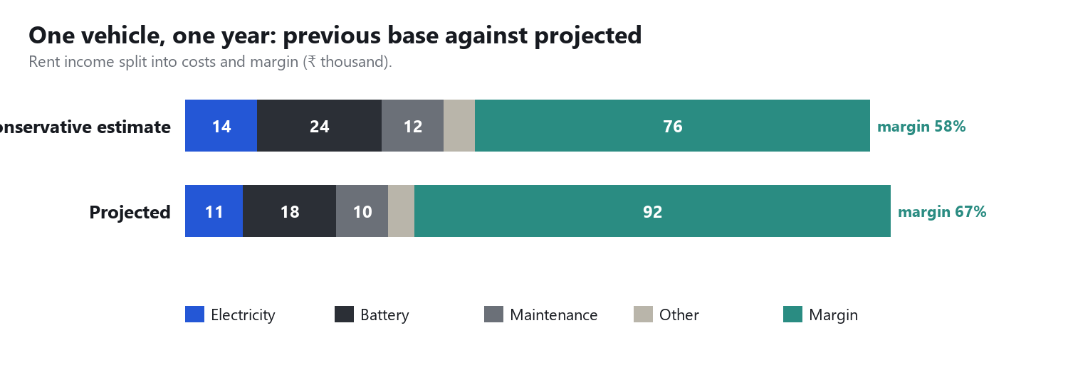
Chart 1. Best-case margin is about 67% of rent, from lower energy and battery costs and more rented days.

3. Solar and second-life storage
3 kW system, projected inputs | Net cost | Year-1 saving | Payback | 25-year net cash
Solar, banking 1:1 (net metering as assumed) | ₹1.08 lakh | ₹41,580 | 2.6 years | ₹11.69 lakh
Solar, no banking (surplus sold at ₹3) | ₹1.08 lakh | ₹16,200 | 7.4 years | ₹2.02 lakh
Solar + second-life storage, no banking | ₹2.23 lakh | ₹32,338 | 6.9 years | ₹6.40 lakh

Storage: 15 kWh nominal at 75% health (11.25 kWh usable), 90% round trip, 2% yearly loss, hybrid inverter ₹40,000 replaced in year 12. Stored energy displaces night tariff; the rest is sold at ₹3. Both settlement cases are shown because we could not verify UP's rule.
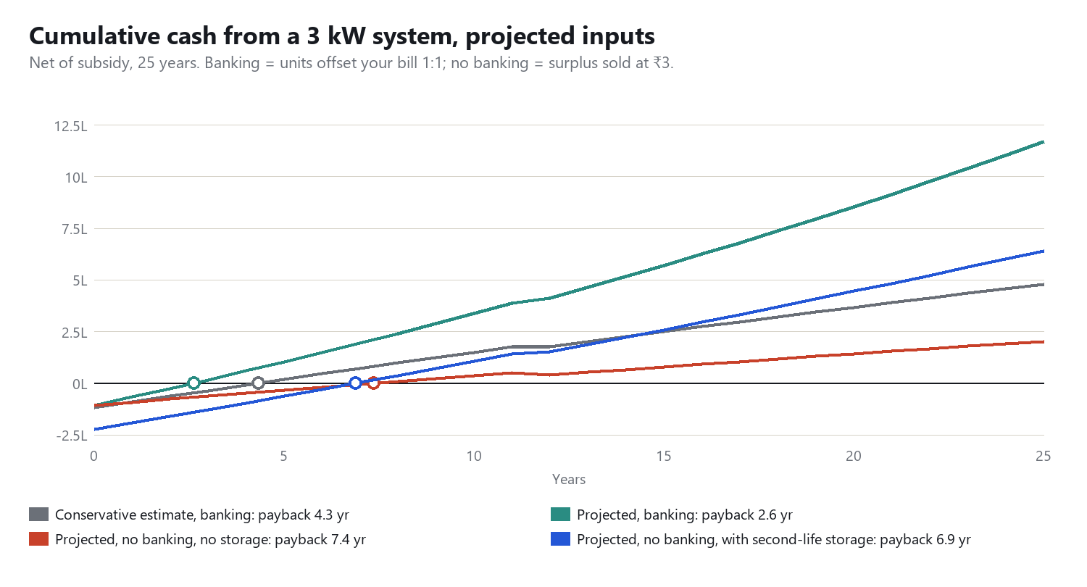
Chart 2. With banking, solar alone is the best investment (2.6 years). Without banking, storage cuts payback only slightly (7.4 to 6.9 years) but multiplies 25-year net cash from ₹2.02 lakh to ₹6.40 lakh, which supports the second-life design.
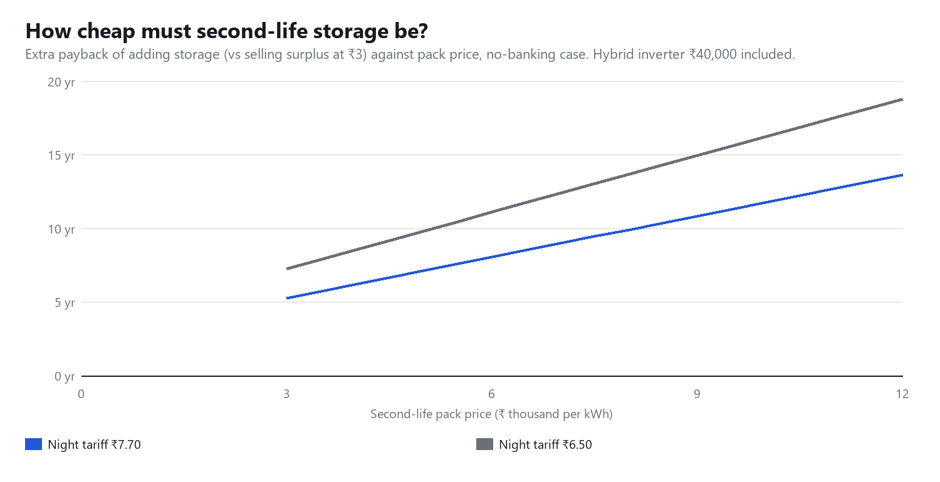
Chart 3. At ₹5,000 per kWh the storage repays its extra cost in about 7 years at a ₹7.70 night tariff; at ₹3,000 about 5; at ₹9,000 about 11.
Storage also does three things not counted above
• Peak shaving: it lets a garage run on a smaller connection (our 6 kW case: 5 of 10 ready on grid only, 10 of 10 with storage), avoiding a connection upgrade.
• Backup: charging can continue through power cuts. We have no data to value it.
• A second use for retired lithium packs, which cuts battery waste (the owner's largest controllable cost is ₹18,000–24,000 a vehicle a year).

4. What ChargeFlow adds per garage of 10
Benefit and features | Projected
Lower peak (about 4 kW less contracted load) and better timing | ₹6,800 a year
Battery-life gain, 10% of ₹180,000 a year | ₹18,000 a year
Total yearly value to the owner | ₹24,800
Subscription ₹1,000 a month plus battery-health add-on ₹500 for half of garages | ₹15,000
Owner's net gain from the controller | ₹9,800
Plus solar with banking, year 1 (less ₹1,000 O&M) | ₹40,580
Total yearly gain for the owner | ₹50,380

New features in the projected:
• Battery-health tracker: the owner enters kilometres per full charge, the app estimates remaining health (E: 60 of 150 km) and flags packs for replacement or reuse.
• Pay-per-charge billing: records each vehicle's kWh so the owner bills drivers fairly instead of guessing.
• Second-life pack supply and fitting: retired lithium packs reconditioned for the garage's storage.
Features other than scheduling are not yet built or priced by customers. Their value is a target.

5. Company economics
Per garage | Conservative estimate | Projected
Contribution per garage per month | ₹617 | ₹1,291
Hardware + acquisition cost per garage | ₹11,000 | ₹8,000
Payback of that cost | 18 months | 6 months
Breakeven garages (vehicles) | 162 (1,622) | 65 (646)
Upfront cash to reach breakeven | ₹17.84 lakh | ₹5.17 lakh

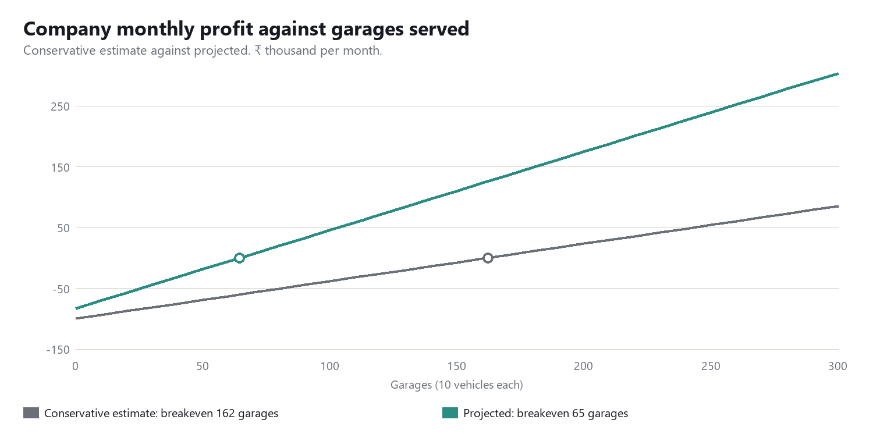
Chart 4. Projected breaks even at about 65 garages. Varanasi added about 17,000 e-rickshaws in 2022–24, so this is a small share of the reachable market.

6. How we prove it (one pilot garage, 4 weeks)
• Week 1: smart plugs and a meter on all chargers; log kW, start and stop times and kWh per vehicle.
• Weeks 2–4: run the schedule on half the chargers and leave the rest as usual; compare energy, peak and battery range readings.
• Ask the DISCOM: connection class, net-metering banking and surplus rate, and subsidy eligibility.
• Get one quote each for a 3 kW system and a 15 kWh second-life pack.
• Re-run this model with the results. Any assumption that fails moves the case back toward the first report.
Sources and the subsidy table are in the first report (Unit_Economics_Feasibility.docx). Both reports rely on installer blogs and secondary reports for some prices; verify before quoting to an owner.

