Alpha–Risk–Cost Portfolio Research
An independently implemented systematic-equity forecasting, factor-risk, transaction-cost and portfolio-optimization framework
Technical research and software documentation | 12 November 2026
Status: reproducible synthetic demonstration; NOT a historical performance study
Reference: Acadian Asset Management Inc., Investor Forum (19 May 2026), slides 19–23.

PROJECT AT A GLANCE
Dimension | Implemented system
Language | Python 3.10+; pandas, NumPy, SciPy, scikit-learn, matplotlib
Forecasting | Five Ridge regression components with walk-forward fit
Risk | Cross-sectional factor returns; Ledoit–Wolf covariance; diagonal idiosyncratic risk
Costs | Half-spread plus 3/2-power participation-based impact proxy
Optimization | SLSQP nonlinear benchmark-relative constrained optimization
Evaluation | 42 synthetic months; 15 warm-up; 27 out-of-sample decisions
Validation | 47 pytest tests passed; 94% statement coverage (rechecked locally)
Interpretation | Research software works on tested examples; profitability on actual markets is untested

Executive summary
The project operationalizes a public investment-process architecture: build security-level return forecasts, estimate unintended and intended risks, assign a cost to proposed trades, optimize a benchmark-relative portfolio, and evaluate the choices in a walk-forward experiment. The repository includes modular implementation, mathematical assumptions, controls, automated tests and inspectable simulation artifacts. It does not reproduce Acadian’s proprietary signals, risk model, proprietary networks, trading algorithms or estimated trading calibrations.
A fixed-seed synthetic experiment provides transparent comparisons among alpha-only, alpha-plus-risk, and alpha-plus-risk-plus-cost portfolio objectives. All strategies are evaluated after modeled transaction costs. Results are conditional on fictional asset returns and must not be represented as validated investment alpha.

1. Research motivation and hypothesis
A return forecast is not itself a deployable portfolio. It must be translated into investable positions with explicit risk, liquidity, benchmark and turnover restrictions. A theoretically attractive high-alpha stock may be expensive to acquire, correlated with existing holdings, or too large a benchmark-relative position.
Primary research hypothesis: incorporating an explicit factor risk penalty and nonlinear transaction costs changes optimal portfolios and can reduce unnecessary exposure and modeled implementation costs; whether it improves out-of-sample performance is an empirical question, not a guaranteed result.
Primary comparisons: (a) forecast-only weights, (b) forecasts plus risk, (c) forecasts plus risk and costs. Holding constraints are kept constant; transaction costs are deducted from all three strategies in evaluation.

2. Public-source provenance and independent design
Acadian’s SEC-hosted Investor Forum (19 May 2026, slides 19–23) describes security-specific, peer and macro forecasting; benchmark-relative risk-aware portfolio construction using dynamic transaction cost modeling; and execution intended to preserve alpha. Slide 21 contains a stylized contribution diagram. Slide 22 discusses uncompensated, generic-style, proprietary-alpha, execution and model/software risks. Slide 23 discusses order profiling and trading-cost analysis.
The repository uses these concepts as an architectural reference. Its five component regressions, fixed blend weights, factor definitions, covariance estimator, transaction cost coefficient, optimizer, synthetic data and experiments are independently designed approximations. The peer forecast uses sector membership, not an inferred proprietary peer graph.
SEC source: https://www.sec.gov/Archives/edgar/data/1748824/000162828026036160/a2026-masterfilexirforum.htm

3. End-to-end research workflow
- 1. Validate monthly as-of data: dates, ticker uniqueness, benchmark weights, financial feature availability, prices/returns/volume units.
- 2. Engineer sector-relative standardized stock signals, leave-one-out sector peer features, and macro group proxies.
- 3. Fit separate preceding-history Ridge regressions; produce demeaned stock-level monthly alpha forecasts.
- 4. Fit historical cross-sectional factor returns and forecast a monthly factor-plus-specific covariance matrix.
- 5. Compute proposed order sizes, spread costs and participation-aware market-impact costs.
- 6. Solve constrained portfolio construction for each of three ablation strategies.
- 7. Deduct modeled costs from ensuing monthly gross portfolio return; drift positions and repeat.
- 8. Export ranked forecasts, weights, trading costs, risk attribution, monthly returns, statistics and figures.

4. Data design and look-ahead safeguards
Each panel row is a security observed at a month-end decision date t. Features are assumed observable by t; next_return is the realized total return from t to t+1 and is used only as a training outcome once it has occurred, or for later evaluation. The optional available_date field must not post-date the decision date. Cross-sectional transformations use features from the same date, never the future outcome.
The synthetic generator creates 42 dates and fictional securities. It includes benchmark weights, group categories, factor proxies, spreads, average daily dollar volume, market cap, volatility and next-month returns. No SEC issuer holdings, actual fundamentals, actual close/quote snapshots or broker fills are included.
Limitations: a syntactically correct available_date does not prove point-in-time accuracy. A robust historical version needs delisted securities, historical constituents, actual earnings-release timestamps, corporate-action adjusted returns and legitimate quote/ADV histories.

5. Alpha forecasting: five-layer Ridge ensemble
Stock-specific layer: value, quality, growth, momentum and low-volatility are provided as raw model inputs. Within each sector and date, values are winsorized at the 2.5th/97.5th percentiles, standardized as z-scores and clipped to [−3,+3]. These are input proxy features; the repository does not compute public-accounting valuation ratios from point-in-time filings.
Peer layer: quality and momentum peer means exclude the stock itself using (sum of sector values – own value)/(sector count – 1). One-member sectors receive a fallback score of zero. This is an interpretable sector peer approximation, not Acadian’s proprietary network.
Macro layers: country-cycle, industry-cycle and country-by-industry intersection-cycle numeric fields are standardized across the cross-section. The synthetic generator provides the values. The code does not fetch or estimate real macro releases.
For component m, the training objective is: minimize ||y – X_m β_m||² + ρ||β_m||² after StandardScaler transformation. Each regression is trained using decision dates strictly before t. The future label at t is never passed to the optimizer.
Fixed blend: α = 0.55 stock + 0.20 peer + 0.08 country + 0.09 industry + 0.08 country×industry. Each component forecast is cross-sectionally demeaned; the final monthly forecast is clipped to [−0.10,+0.10]. The weights and Ridge penalty (50) are assumptions, not estimated optimal parameters and not firm disclosures.
Output: stock_forecasts.csv records model components, combined alpha, decision month and train_end for auditing. Quality is summarized using per-month Spearman rank information coefficient (IC) against the following month’s outcome.

6. Factor covariance and active risk
For each prior month s, estimate cross-sectional factor returns from realized security returns and current-at-s exposures by a lightly regularized least-squares regression. Exposures include: a global market intercept, sector and country dummies, value and momentum style factors, and a constructed stock-specific alpha factor based on quality, growth and low-volatility features.
Using historical factor-return observations, estimate covariance F with Ledoit–Wolf shrinkage. Estimate diagonal stock-specific variance D from historical regression residuals, with a minimum variance floor. The stock covariance used at t is Σ_t = B_t F B_tᵀ + D_t. The result is a symmetric positive-semidefinite monthly risk proxy.
For benchmark-relative active weights a = w – b, predicted active variance is aᵀΣa. Exposures q = Bᵀa permit decomposition into q_j(Fq)_j plus stock-specific Σ a_i²D_ii; correlated factor contributions can be negative even when total variance is nonnegative.
Risk groups in reported output include market, country, industry, generic-style, alpha and specific components. These are illustrative decompositions, not a reconstruction of Acadian’s internal classification or of market beta/rates/FX hedging controls.

7. Nonlinear transaction cost model
Let Δ_i = target weight_i – pretrade weight_i. The half-spread cost as a fraction of AUM is |Δ_i| × spread_bps_i/20,000 where spread_bps is the full quoted spread. Market impact uses a 3/2-power trade-size function: k × (σ_month/√21) × √[AUM/(ADV_usd_per_day × execution_days)] × |Δ_i|^(3/2). Aggregate TC is the sum over stocks.
The assumed impact coefficient k=0.12, execution window of two days and monthly-to-daily volatility scaling are demonstration choices. The cost curve is increasing and convex in trade magnitude, favoring more conservative trading for less liquid names. It is not calibrated to actual broker execution or historical order-book data.
Order profiling exports intended order size and approximate ADV participation. It does not implement broker routing, VWAP, order scheduling, exchange matching or post-trade observed implementation shortfall.

8. Benchmark-relative nonlinear optimization
At each decision t, choose weights w to maximize αᵀ(w−b) − (λ/2)(w−b)ᵀΣ(w−b) − γ TC(w−p), where b is benchmark weight and p is pretrade drifted weight. The code uses monthly expected returns and monthly covariance to avoid inconsistent annualization.
Constraints: long only; fully invested; maximum 25% weight per security; maximum ±11% active weight; maximum 65% total two-way turnover; maximum 8% of average daily volume over the two-day execution window; and maximum ±10% sector-relative active exposure. These are user-configurable fictional demonstration assumptions.
Implementation: SciPy Sequential Least Squares Programming (SLSQP) with an explicit objective gradient; auxiliary variables bound |w−p| in turnover and participation constraints. The solver output is checked against constraints before acceptance. Numerical optimizer convergence is not a universal guarantee.
Ablation | Risk term | Cost term in objective | Cost charged in simulated realized returns
Alpha only | off | off | yes
Alpha + risk | on | off | yes
Alpha + risk + costs | on | on | yes

9. Walk-forward backtesting and accounting
The system uses 15 initial months for training, then evaluates 27 successive month-end decisions in a 42-month fictional panel. Training labels are historical relative to each decision date. Portfolio returns use the next month’s realized returns only after weights have been selected. Costs are deducted once at the rebalancing event. Holdings are drifted using gross security returns before the following rebalance.
Gross return = Σ_i w_i r_i. Net return = (1 – estimated cost) × (1 + gross return) – 1. Pretrade next-period weights = w_i(1+r_i)/(1+gross return). Benchmark transaction costs are assumed zero, limiting comparability with a truly investable benchmark.
Statistics: CAGR, annualized arithmetic mean active return, annualized tracking error, information ratio (active return divided by tracking error), maximum compounded-wealth drawdown, gross/one-way turnover, modeled costs and mean monthly forecast rank IC.

10. Synthetic experiment: observed results
Strategy | CAGR | Information ratio | Max drawdown | Mean one-way turnover
Benchmark | 2.14% | — | -12.40% | 0.00%
Alpha Only | 6.37% | 1.039 | -10.24% | 32.12%
Alpha Risk | 5.70% | 0.883 | -9.74% | 31.64%
Alpha Risk Cost | 5.97% | 0.944 | -9.86% | 30.58%

Forecast mean monthly Spearman rank IC: 0.063; standard deviation across 27 months: 0.248.
Across this simulated run, cost-aware optimization achieved slightly lower modeled turnover than the alpha-and-risk approach (30.58% versus 31.64% one-way mean turnover) and lower summed modeled costs (1.070% versus 1.108% of initial portfolio-value fractions summed across periods). Nevertheless alpha-only achieved the highest fictional CAGR (6.37%), so the example does not establish a universal benefit from risk or cost penalties.
These results are generated from fictional securities whose return-generation structure is related to the signal inputs. They cannot be used as real-market investment return evidence, statistical proof of significant alpha, or claims regarding Acadian performance.
Figure 1. Synthetic cumulative wealth; portfolio returns are net of modeled transaction costs.
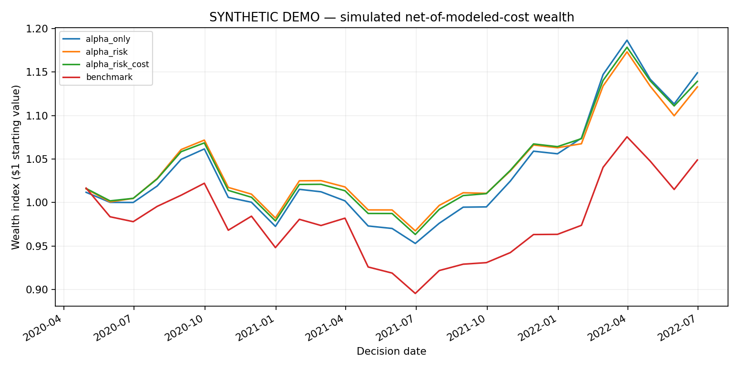
Figure 2. Cumulative modeled trading cost comparison; not observed actual fills.
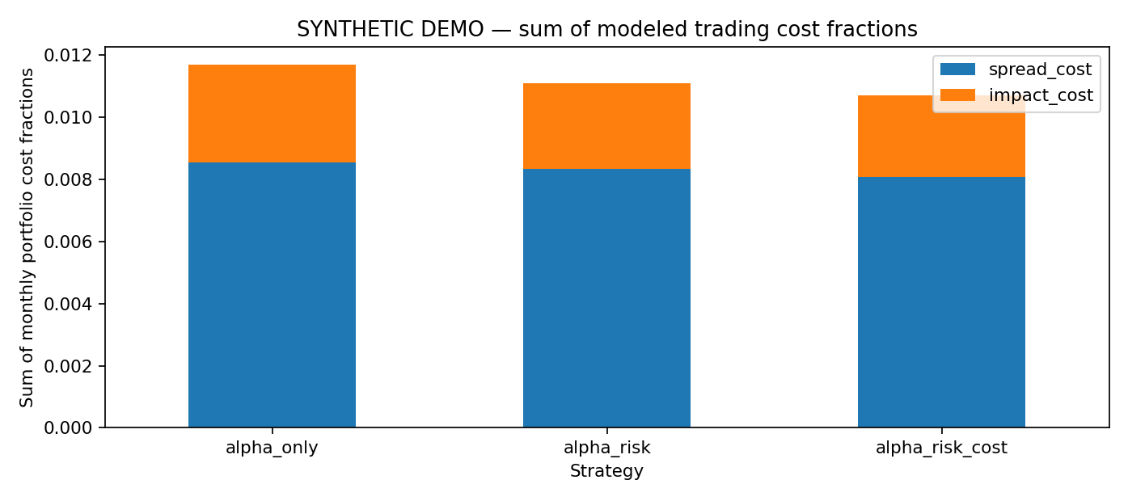

11. Python implementation and reviewer code map
File | Main responsibility | Techniques demonstrated
data.py | Panel schema checks, fictional data generator | Pandas, validation, deterministic simulation
signals.py | Winsorization, z-scores, leave-one-out peers | Grouped transforms, feature engineering
forecast.py | Five temporal Ridge prediction models | scikit-learn pipelines, time-aware training
risk.py | Cross-sectional factor risk and attribution | Linear algebra, shrinkage covariance
costs.py | Spread, volatility and nonlinear price impact | Nonlinear numerical functions
optimizer.py | Portfolio decision engine | SciPy SLSQP, gradients, linear constraints
backtest.py | Rolling portfolio accounting, strategy comparisons | State evolution, return attribution
metrics.py | Risk/return and rank IC metrics | Statistics, annualization
reporting.py | CSV/JSON/PNG report pipeline | Matplotlib, structured output
cli.py | Executable experiment entrypoint | argparse, files, reproducibility

Other repository materials: pyproject.toml declares package dependencies and console entrypoint; configs/research.json documents parameters; tests/ contains unit and integration tests; .github/workflows/ci.yml defines CI for Python 3.10/3.12; docs/ contains methodology, data schema, experiments, validation and publishing guide.

12. Quality assurance and reproducibility
A fresh local re-run using Python 3.13.5 succeeded: 47 tests passed, with 522 covered-source statements and 30 missed (94% statement coverage). Tests include data checks, forecast date cutoffs, numerical risk properties, transaction-cost arithmetic, optimizer feasibility, portfolio accounting, CLI artifact creation and consistency. This verifies tested software behavior, not absence of all bugs, real historical predictive power or GitHub-hosted CI success.
OPENBLAS_NUM_THREADS=1 OMP_NUM_THREADS=1 MKL_NUM_THREADS=1 MPLBACKEND=Agg PYTHONPATH=src python -m pytest -q --cov=acadian_arc --cov-report=term
To reproduce the simulated outputs after installation, run:
python -m pip install -e ".[dev]"
python -m acadian_arc.cli --months 42 --seed 17 --output-dir reports/my-run

13. Limitations and recommended empirical extension
- Real market validation has not been performed. The present return paths, features and benchmark are simulated.
- Value, quality, growth, momentum and low-volatility are input proxy fields; the project does not fetch/reconstruct SEC fundamentals, publication lags or delisting-inclusive histories.
- Ridge component/blend weights, transaction-cost coefficients and risk factor architecture are assumptions requiring validation against historical data.
- The risk model does not separately estimate explicit rates/FX/oil betas or independently calibrated risk premia.
- The trading module estimates costs and participation, but has no market microstructure order-book simulator or actual slippage data.
- The small 27-month out-of-sample simulation is not sufficient to claim robust outperformance or statistical significance.
- Next study: real point-in-time universe, historical benchmark membership, feature availability audit, uncertainty intervals, regime comparisons, return-decile studies, IC stability, impact sensitivities and live-data reproducibility.

14. Presenting the work on GitHub and in MFE applications
Recommended public repository title: alpha-risk-cost-portfolio-research. Its first-page README already displays the research question, architecture diagram, model-to-source-file mapping, model assumptions, results figures, reproducibility commands, source attribution and limitations. Keep the synthetic badge and independent-work disclaimer visible.
Publish the actual extracted folder contents, including hidden .github/workflows, not merely the ZIP. Preserve src/, tests/, docs/, examples/synthetic/, README.md, pyproject.toml, configs/ and LICENSE. Exclude caches, virtual environments, credentials and locally generated bulky data.
Suggested CV description: “Developed a modular Python systematic-equity research framework with five time-aware Ridge alpha models, a Ledoit–Wolf factor covariance risk engine, nonlinear liquidity-aware transaction costs and SLSQP benchmark-relative portfolio optimization; implemented walk-forward backtesting, strategy ablations, mathematical attribution and 47 automated tests (94% statement coverage), with reproducibility demonstrated on synthetic securities.”
Do not state that Acadian approved, provided or used these models; do not describe simulated performance as historical outperformance.

References and audit sources
1. Acadian Asset Management Inc. (2026). Investor Forum, May 19, SEC Exhibit 99.2, slides 19–23. https://www.sec.gov/Archives/edgar/data/1748824/000162828026036160/a2026-masterfilexirforum.htm
2. Acadian Alpha–Risk–Cost research repository (local sources): README.md, docs/METHODOLOGY.md, docs/DATA_SCHEMA.md, docs/EXPERIMENTS.md, docs/VALIDATION.md and examples/synthetic/summary.json.
3. Code evidence: src/acadian_arc/*.py; automated checks in tests/*.py. All computations and reported results are local to the project.

