**Answer to the Question no 1**

**a)**

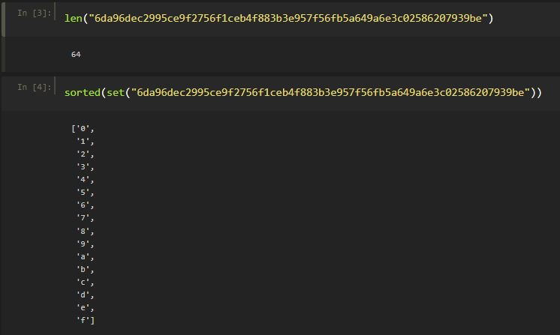

**B) 0.33MB**

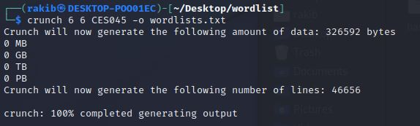

**B) 3min 17sec**

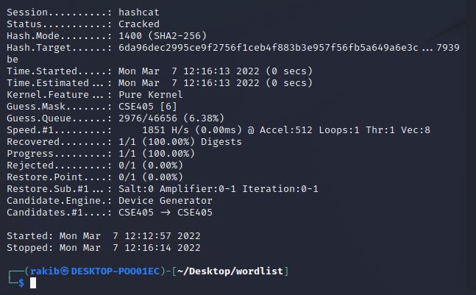

**C) Rainbow Table**

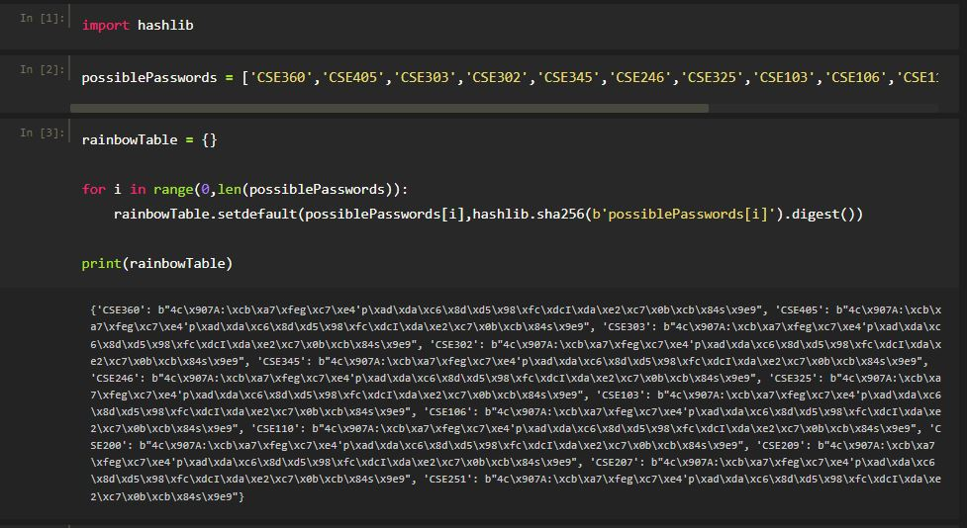

**D) The value of x is CSE405**

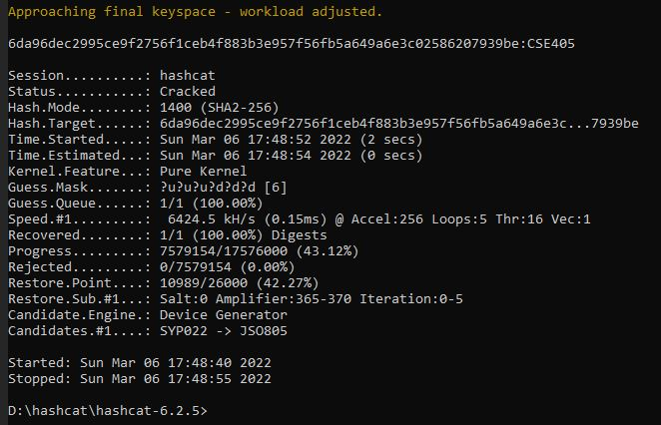

**Answer to the Question no 2**

**a)**



**b) 192.168.0.100:52763 <__>103.133.165.32:443**

**c)**

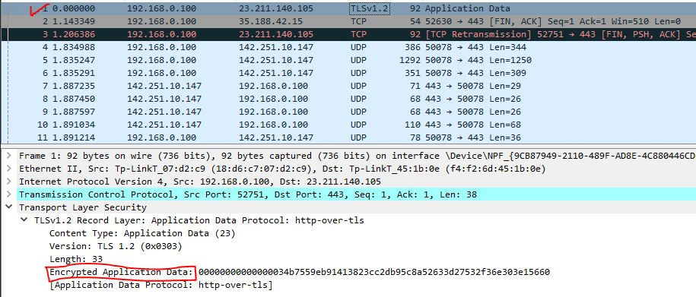

**d) 21 and 23**



**e) Cipher suites offered by the client**

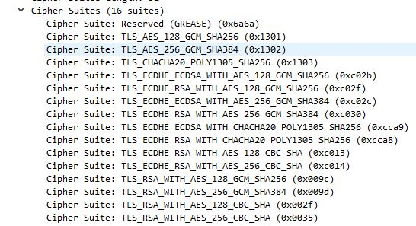

**f) Cipher suite selected by the server**



**g) Version: TLSv1.2**



**h) Packet number 26**

