**Deep Learning with Keras and TensorFlow**

In this workshop I’m going to walk the participants through building a simple autoencoder and a simple classifier using neural networks built with Google’s Keras and TensorFlow libraries.

To prepare each laptop for the session:

1. Install the version of Docker appropriate for the operating system: <https://www.docker.com/docker-windows> or <https://www.docker.com/docker-mac>
2. Check that Docker is running. At the command line, type ‘docker run hello-world’. If all is well you should see something like this:

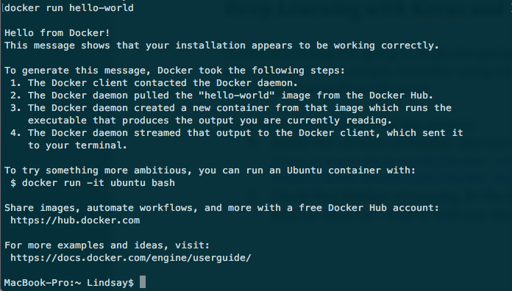

1. At the command line, type ‘docker pull jupyter/tensorflow-notebook’. Wait till the image has downloaded.
2. Now, at the command line type ‘docker run -it --rm -p 8888:8888 jupyter/tensorflow-notebook’. You should see something like this: 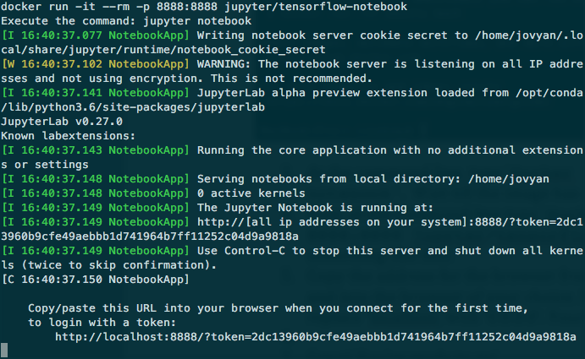
3. Copy the address for the browser from the command line interface (as instructed, see above) and paste it into the browser of your choice. If using a Mac, you will need to replace ‘localhost’ with ‘0.0.0.0’. Your browser should look like this: 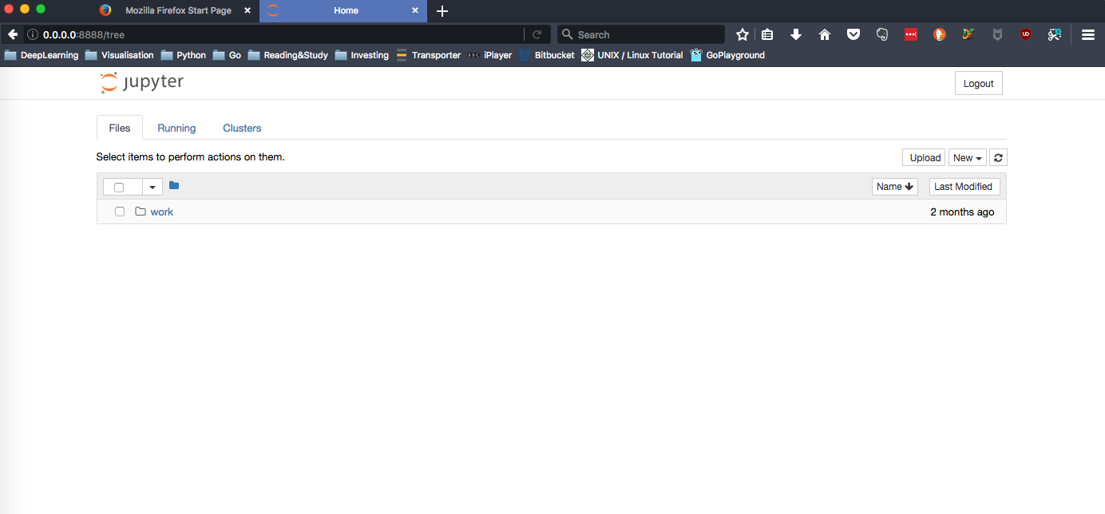
4. Great! You’re ready to go!