Classification labels
Initial data exploration showed that the Recurrence Free Survival (RFS) distribution for recurrent samples was skewed toward shorter intervals. Based on this observation, samples were stratified by RFS time: Recurrences within 36 months were classified as “High Recurrence Risk”, no recurrence or recurrences occurring after 36 months were classified as “Low Recurrence Risk”. This focus on RFS times ensures that the generated labels carry prognostic value.

Feature Selection
To ensure compatibility with the microarray data, genomic features not shared between the UROMOL and Knowles datasets were excluded. The UROMOL cohort was randomly divided into training and test sets using a 70:30 split, and all genomic feature selection was performed exclusively on the training set. To avoid overfitting to the generated labels, genomic features were selected based on direct impact on RFS time using a LASSO Cox regression model. Demographic information such as age, sex, and smoking have known impacts on bladder cancer and were included in the features set ^{1–3}. Similarly, tumor size, concomitant status, and incident tumor status may provide information about current growth. Tumor stage and grade were not considered as there was no variation within the training dataset. For prediction and utility purposes, Bacillus Calmette-Guerin (BCG) treatment status was also included.

Model
The final model employs a Support Vector Machine (SVM) classifier with a polynomial kernel to capture non-linear relationships among features. To ensure compatibility with the microarray data, all genomic features were z-score normalized prior to training. The RNA-seq test dataset was normalized using the mean and standard deviation derived from the training set. The microarray data was assumed to have a similar distribution and was z-scored independently.

The model scores a high AUC score on the training data, and maintains a reasonable AUC score on the RNA-seq test set, suggesting the presence of a weak but detectable predictive signal despite overfitting (Table 1). In contrast, AUC score on the microarray dataset is poor. Notably, Recall significantly exceeds precision on the test and microarray datasets, indicating a tendency toward false-positive predictions, with low-risk samples more likely to be misclassified as high-risk. Survival analysis of the predicted risk groups reveals a large difference in survival time before 36 months for the training set and a smaller, but still significant difference in the test set (Figure 1). However, the model has no prognostic value on the microarray data, as the predicted classes show minimal separation in survival outcomes.

 | Accuracy | Precision | Recall | F1 | AUC
Training  (RNA-seq) | 0.857 | 0.881 | 0.874 | 0.878 | 0.929
Testing (RNA-seq) | 0.616 | 0.667 | 0.756 | 0.708 | 0.637
Microarray | 0.521 | 0.371 | 0.500 | 0.426 | 0.505
Table 1: Various Scoring Metrics for Training, Testing, and Microarray Data

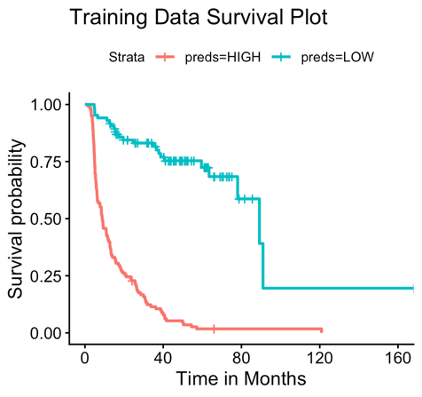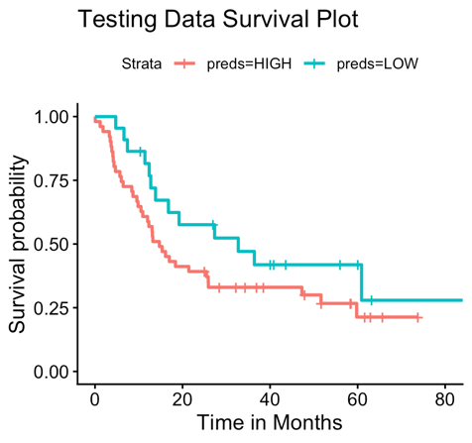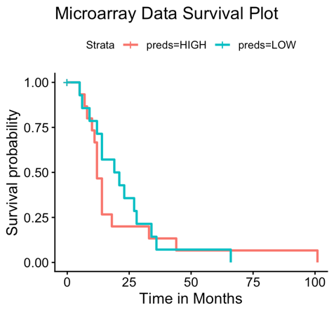

Figure 1: Recurrence Free Survival Curves stratified by Prediction Label

Clinical Interpretation:
The primary clinical application of this model would be to assess predicted patient response to BCG therapy by modifying the BCG feature within the model inputs. For instance, if inclusion of the BCG variable reclassifies a patient from high to low recurrence risk, BCG therapy may be considered a viable treatment option. Conversely, if a patient is classified as high risk regardless of BCG status, earlier exploration of alternative treatment strategies should be considered, with the aim of avoiding radical cystectomy ⁴. Clinicians should interpret these predictions with caution, given the model’s reduced performance on previously unseen data and its tendency for false-positive classifications. As a result, some patients may be incorrectly identified as unlikely to benefit from BCG despite having a potential therapeutic response.

Limitations and Future Work:
The weak predictive signal observed on the testing set is likely a result of cancer heterogeneity. Though multiple patients may achieve the same cancer state, there may be multiple genetic pathways in play that differ significantly, making it difficult to find a single defining genetic signal that unifies the group ⁵. Other models find labels by unsupervised clustering on gene data. Prognostic clusters must be identified manually and the prognostic value of the labels may be slightly reduced, but a genomic signal more robust to cancer heterogeneity is ensured ⁶. Future work should investigate the use of unsupervised clustering on genomic data to identify new groupings, with a focus on those that align well with or expand upon pre-existing clinical labels.

The model had very low applicability to microarray data, as it was trained exclusively on RNA-seq datasets. Although z-score normalization enables the model to learn from the relative shape of the training data rather than absolute expression values, reliable reference means and standard deviations for both RNA-seq and microarray are necessary for consistent transformation of new data inputs. Future work should therefore focus on integrating RNA-seq and microarray data during model training through cross-platform normalization strategies, or on aggregating genes into biologically meaningful gene sets that reduce platform-specific noise while preserving relevant biological signal ^{7,8}.

1. Lin, W., Pan, X., Zhang, C., Ye, B. & Song, J. Impact of Age at Diagnosis of Bladder Cancer on Survival: A Surveillance, Epidemiology, and End Results-Based Study 2004-2015. Cancer Control J. Moffitt Cancer Cent. 30, 10732748231152322 (2023).
2. Chaudhary, P. et al. Sex differences in bladder cancer: understanding biological and clinical implications. Biol. Sex Differ. 16, 31 (2025).
3. Wang, Y. et al. Smoking and bladder cancer: insights into pathogenesis and public health implications from a bibliometric analysis (1999–2023). Subst. Abuse Treat. Prev. Policy 20, 25 (2025).
4. Gupta, S. et al. Bladder Preservation Strategies in Muscle-invasive Bladder Cancer: Recommendations from the International Bladder Cancer Group. Eur. Urol. 89, 18–28 (2026).
5. da Costa, J. B. et al. Molecular tumor heterogeneity in muscle invasive bladder cancer: Biomarkers, subtypes, and implications for therapy. Urol. Oncol. Semin. Orig. Investig. 40, 287–294 (2022).
6. Lindskrog, S. V. et al. An integrated multi-omics analysis identifies prognostic molecular subtypes of non-muscle-invasive bladder cancer. Nat. Commun. 12, 2301 (2021).
7. Foltz, S. M., Greene, C. S. & Taroni, J. N. Cross-platform normalization enables machine learning model training on microarray and RNA-seq data simultaneously. Commun. Biol. 6, 222 (2023).
8. van der Kloet, F. M., Buurmans, J., Jonker, M. J., Smilde, A. K. & Westerhuis, J. A. Increased comparability between RNA-Seq and microarray data by utilization of gene sets. PLoS Comput. Biol. 16, e1008295 (2020).

