

**UNIVERSITI TUNKU ABDUL RAHMAN**

**Faculty of Information and Communication Technology (FICT)**

**UCCD2303 DATABASE TECHNOLOGY /**

**UCCD2203 DATABASE SYSTEMS**

**Group Assignment Mark sheet**

January 2024 Trimester

|  |  |
| --- | --- |
| Group Number (e.g. G999): | G017 |
| Group leader to provide the OneDrive folder hyperlink (editor mode) which contains the zip file and a group presentation video in mp4 format: | https://drive.google.com/drive/folders/1RT8oXvj3hb1GnTqXJXznviMfmh3yt4p4?usp=drive_link |
| Group leader name: | Ong Yi Sheng |
| Group leader email address: | ongyisheng0309@1utar.my |
| Submission date (dd-Mon-yy): | 16-Apr-24 |

|  |  |  |  |  |
| --- | --- | --- | --- | --- |
| No. | Name  (in ascending order)  Group leader with * | Student ID  (e.g. 2299999) | Programme | Signature |
| 1 | Desmond Ho Jia Shen | 2105034 | CS |  |
| 2 | *Ong Yi Sheng | 2103887 | CS |  |
| 3 | Seow Yi Xuan | 2105524 | CS |  |
| 4 | Tharini A/P Vijesh Kumar | 2206802 | CS |  |

Note:

* Maximum 4 members per group.
* The assignment grouping can be from different tutorial groups but must be from the same programme except with approval i.e. CS student work with CS student
* Programme e.g. IA/IB/DE/CS/CN/CT
* All members should attach their individual signature confirming that the report is not plagiarized
* For assignment answer submission include the Mark sheet, Table of Contents. Members’ contributions.

|  |  |  |  |
| --- | --- | --- | --- |
| **Assignment Mark Sheet** | |  |  |
| **PART 1: (Group Assessment – 50 marls)** | | Allocated marks | **Given Marks** |
| **1.** | **Scope of Work (5 marks)**  Analyse requirements study (briefly explain the requirements/ office / business rules in the system).  PLEASE INCLUDE ANY ASSUMPTIONS THAT YOU MAKE. | 5 |  |
| **2.** | **ER model** (**10 marks**)  You are required to design an ER diagram for the case study given, identify entities, identify relationships, identify associate attribute and determine keys.  Check your ERD with the transaction requirements stated in the case. | 10 |  |
| **3.** | **Redesign and EER** (**10 marks**)  Redesign your ER diagram with the new requirements and extending the ERD to EER model, if any. | 10 |  |
| **4.** | **Data Dictionary** (**10 marks**)  Based on EER diagram that you created in part 3, create a data dictionary for the solution. (Make sure the data types (Oracle) selected are appropriate) | 10 |  |
| **5.** | **Tables and records** (**5 marks**)  Create all relations in ERD and insert the necessary records (Minimum 5 record for each table) | 5 |  |
| **6.** | **Script** (**10 marks**)  You are required to submit the SQL schema script with proper codes. Should include Integrity and referential integrity constraints.  **Softcopy:** *Include the scripts in the submission* | 10 |  |

**PART 2: (Individual Assessment – 50 marks)**

(Fill in all your group members name and ID according to the same sequence on the cover page)

|  |  |  |  |  |  |
| --- | --- | --- | --- | --- | --- |
| Member |  | 1 | 2 | 3 | 4 |
| **Student Name: (to fill)** |  | **Desmond Ho Jia Shen** | **Ong Yi Sheng** | **Tharini A/P Vijesh Kumar** | **Seow Yi Xuan** |
| **Student ID; (to fill)** |  | **2105034** | **2103887** | **2206802** | **2105524** |
| Two Queries (10 marks) | 10 |  |  |  |  |
| Two Stored Procedure (10 marks) | 10 |  |  |  |  |
| Two Functions (10 marks) | 10 |  |  |  |  |
| Presentation (20 marks) | 20 |  |  |  |  |
| Total Individual Assessment (50 marks) |  |  |  |  |  |
| Group Assessment (50 marls) |  |  |  |  |  |
| **Total marks (100 marks)** |  |  |  |  |  |

|  |
| --- |
| **Presentation**   1. Group members are required to present a working database system, queries, stored procedures, and functions. 2. Every group has to present their assignment work and explain each group member contribution towards the completion of the assignment. 3. Group member must present his/her work as individual for 3-5 minutes each person and compiled by the group leader as a single presentation video. 4. Each member record individually then group leader compiles as a single group video. 5. Group leader to compile one group presentation video to be uploaded into OneDrive and provide the video hyperlink. 6. For Part 2 answers**:**  * Indicate the operations performed and include an explanations on how the user can use the corresponding SQL commands. * No duplication or similar answers should be listed among the group members. |

|  |  |  |
| --- | --- | --- |
| No. | Name  (in ascending order)  Group leader with * | A short description of members’ contributions |
| 1. | Desmond Ho Jia Shen | Data Dictionary, SQL Script |
| 2. | *Ong Yi Sheng | ERD, SQL Script |
| 3. | Seow Yi Xuan | Scope of Work, Table of Record, SQL Script |
| 4. | Tharini A/P Vijesh Kumar | ERD, EER |

**Table of Contents**

**Presentation** 3

(i). Group members are required to present a working database system, queries, stored procedures, and functions. 3

(ii). Every group has to present their assignment work and explain each group member contribution towards the completion of the assignment. 3

(iii). Group member must present his/her work as individual for 3-5 minutes each person and compiled by the group leader as a single presentation video. 3

(iv). Each member record individually then group leader compiles as a single group video. 3

(v). Group leader to compile one group presentation video to be uploaded into OneDrive and provide the video hyperlink. 3

(vi). For Part 2 answers**:** 3

• No duplication or similar answers should be listed among the group members. 3

1.0 Scope of Work 7

1.1 Business Rules 7

1.2 Assumptions 7

2.0 Entity Relationship Model 8

3.0 Enhanced Entity Relationship Model 9

4.0 Data Dictionary 10

4.1 Customer 10

4.2 Inventory 10

4.3 Food 11

4.4 Meal 12

4.5 Beverage 12

4.6 Dessert 12

4.7 Cart_Food 13

4.8 Cart 14

4.9 Invoice 15

4.10 Order_ 16

4.11 Table 17

4.12 Reservation 18

4.13 Staff 19

4.14 Chef 20

4.15 Waiter 20

4.16 Admin 20

5.0 Tables and Records 21

5.1 Customer 21

5.2 TABLE 21

5.3 RESERVATION 22

5.4 STAFF 22

5.5 CHEF 22

5.6 ADMIN 23

5.7 WAITER 23

5.8 INVENTORY 23

5.9 FOOD 24

5.10 MEAL 24

5.11 BEVERAGE 24

5.12 DESSERT 25

5.13 ORDER 25

5.14 CART 25

5.15 CART_FOOD 26

5.16 INVOICE 26

6.0 SQL Script Content 27

7.0 Individual Assignment (Part 2) 38

7.1 Ong Yi Sheng (*) 38

7.1.1 Queries 38

7.1.2 PL/SQL stored procedure 38

7.1.3 PS/SQL functions 41

7.2 Desmond Ho Jia Shen 43

7.2.1 Queries 43

7.2.2 PL/SQL stored procedure 43

7.2.3 PS/SQL functions 45

7.3 Seow Yi Xuan 46

7.3.1 Queries 46

7.3.2 PL/SQL stored procedure 47

7.3.3 PS/SQL functions 49

7.4 Tharini Vijesh Kumar 51

7.4.1 Queries 51

7.4.2 PL/SQL stored procedure 51

7.4.3 PS/SQL functions 53

# **Scope of Work**

## **1.1 Business Rules**

Each customer can have zero or many foods.

Each customer can have one or many invoices.

Each food can be consumed by only one customer.

Each food can be part of zero or many carts of food.

Each food can have one or many available in inventory.

Each food may be a meal, beverage, or dessert.

Each cart food can have only one food and each cart food can have only one cart.

Each cart can have zero or many food and each cart can have zero or one invoice.

Each invoice can be made to only one cart.

Each invoice can be made to only one customer.

Each invoice can be made for only one order.

Each order can only have one invoice.

Each order is only for one table.

Each order can be handled by only one staff.

Each table can have only one order.

Each table can have only one reservation.

Each table can have only one customer.

Each reservation can have one or many tables.

Each reservation can have only one customer.

Each staff can handle zero or many orders.

Each staff may be a chef, an admin, or a waiter.

## **1.2 Assumptions**

* All food items are assumed to be available.
* The prices of the food items are assumed to remain constant.
* Customers can customize their ordered food, but they are limited to modifying only the ingredients specified in the food details and cannot add any additional ingredients.
* Order can be cancelled if the ingredients needed are not sufficient.
* Item quantity in Inventory cannot be less than 20.
* Customer must receive their invoice after making their payment.

# **2.0 Entity Relationship Model**

## **3.0 Enhanced Entity Relationship Model**

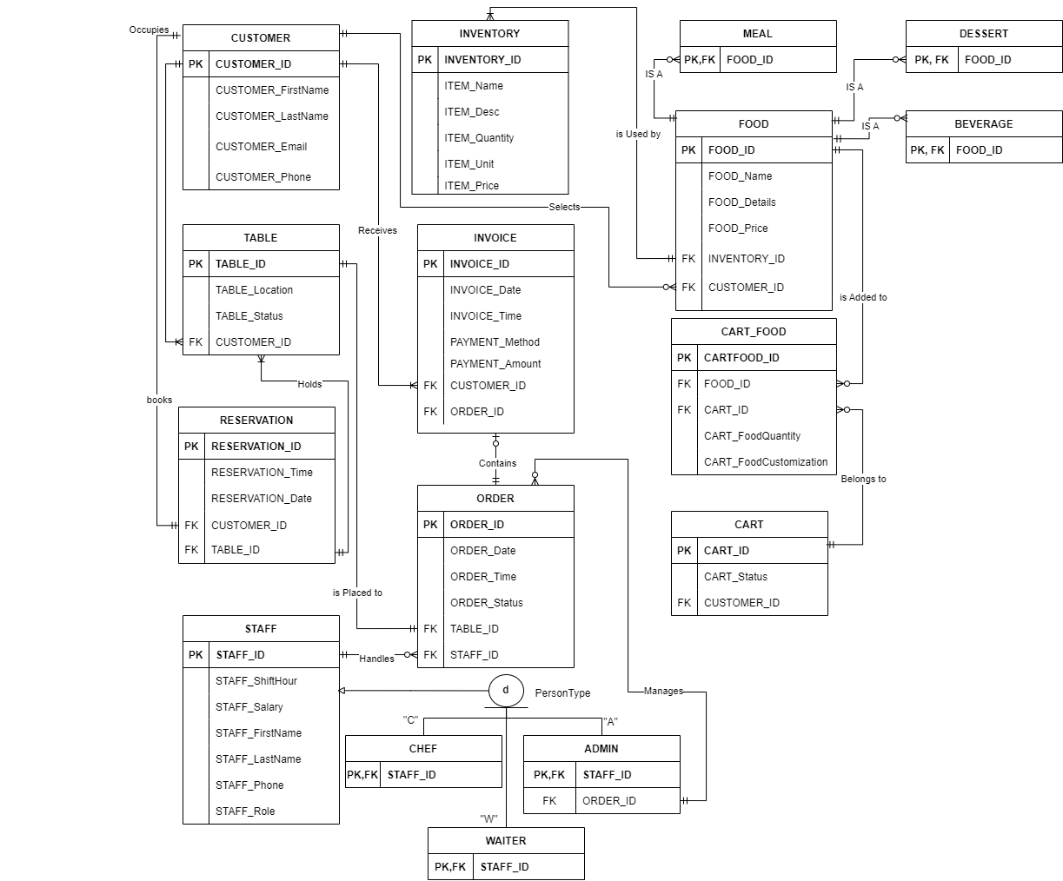

# **4.0 Data Dictionary**

## **4.1 Customer**

|  |  |  |  |  |  |
| --- | --- | --- | --- | --- | --- |
| **Occurrence:** Each customer can have zero or many foods, each customer can have one or many invoice | | | | | |
| **Entity Name** | **Data Type** | **Constraint Type** | **Field Size** | **Description** | **Example** |
| CUSTOMER_ID | VARCHAR2 | PK | 5 | Unique ID for each customer | C002 |
| CUSTOMER_FirstName | VARCHAR2 | - | 30 | Customer’s first name | Tan |
| CUSTOMER_LastName | VARCHAR2 | - | 30 | Customer’s last name | Lee Hwa |
| CUSTOMER_Email | VARCHAR2 | - | 30 | Customer’s email | tanleehwa@gmail.com |
| CUSTOMER_Phone | NUMBER | - | 12 | Customer’s contact number | 0111110298 |

## **4.2 Inventory**

|  |  |  |  |  |  |
| --- | --- | --- | --- | --- | --- |
| **Occurrence:** Each inventory can have only one food | | | | | |
| **Entity Name** | **Data Type** | **Constraint Type** | **Field Size** | **Description** | **Example** |
| INVENTORY_ID | VARCHAR2 | PK | 5 | Unique ID for each inventory | IT002 |
| ITEM_Name | VARCHAR2 | - | 30 | Item name in inventory | Oil |
| ITEM_Desc | VARCHAR2 | - | 30 | Item descriptions | Olive oil |
| ITEM_Quantity | NUMBER | - | 4 | Item quantity in stock | 250 |
| ITEM_Unit | NUMBER | - | 10 | Item unit number | 1.5Kg |
| ITEM_Price | NUMBER | - | 10 | Item price | 25.00 |

## **4.3 Food**

|  |  |  |  |  |  |
| --- | --- | --- | --- | --- | --- |
| **Occurrence:** Each food can be consumed by only one customer, each food can be part of zero or many cart food, each food can have one or many available in inventory, each food may be a meal, each food may be a beverage, each food may be a dessert | | | | | |
| **Entity Name** | **Data Type** | **Constraint Type** | **Field Size** | **Description** | **Example** |
| FOOD_ID | VARCHAR2 | PK | 5 | Unique ID for each food | F003 |
| FOOD_Name | VARCHAR2 | - | 40 | Food’s name | Mapo Tofu with White Rice |
| FOOD_Details | VARCHAR2 | - | 100 | Food’s ingredients and way of cooking | tofu cooked with rich spicy, and savory sauce |
| FOOD_Price | NUMBER | - | 10 | Food’s pricing | 8.00 |
| INVENTORY_ID | VARCHAR2 | NOT NULL CONSTRAINT  FK references  inventory(inventory_id) | 5 | Foreign key from Inventory table | IT002 |
| CUSTOMER_ID | VARCHAR2 | NOT NULL CONSTRAINT  FK references  customer(customer_id) | 5 | Foreign key from Customer table to identify which customer order a food | C001 |

## **4.4 Meal**

|  |  |  |  |  |  |
| --- | --- | --- | --- | --- | --- |
| **Occurrence:** Each Meal must be a food | | | | | |
| **Entity Name** | **Data Type** | **Constraint Type** | **Field Size** | **Description** | **Example** |
| FOOD_ID | VARCHAR2 | PK, FK | 5 | Primary & Foreign key from Food Table | F001 |

## **4.5 Beverage**

|  |  |  |  |  |  |
| --- | --- | --- | --- | --- | --- |
| **Occurrence:** Each Beverage must be a food | | | | | |
| **Entity Name** | **Data Type** | **Constraint Type** | **Field Size** | **Description** | **Example** |
| FOOD_ID | VARCHAR2 | PK, FK | 5 | Primary & Foreign key from Food Table | F001 |

## **4.6 Dessert**

|  |  |  |  |  |  |
| --- | --- | --- | --- | --- | --- |
| **Occurrence:** Each Dessert must be a food | | | | | |
| **Entity Name** | **Data Type** | **Constraint Type** | **Field Size** | **Description** | **Example** |
| FOOD_ID | VARCHAR2 | PK, FK | 5 | Primary & Foreign key from Food Table | F001 |

## **4.7 Cart_Food**

|  |  |  |  |  |  |
| --- | --- | --- | --- | --- | --- |
| **Occurrence:** Each cart food can have only one food, each cart food can have only one cart | | | | | |
| **Entity Name** | **Data Type** | **Constraint Type** | **Field Size** | **Description** | **Example** |
| CARTFOOD_ID | NUMBER | PK | 2 | Unique ID for each cart food | 1 |
| FOOD_ID | VARCHAR2 | Not Null Constraint  FK references  Food(food_id) | 5 | Foreign key from food table | F001 |
| CART_ID | VARCHAR2 | Not Null Constraint  FK references  Cart(cart_id) | 7 | Foreign key from cart table | Cart01 |
| CART_FoodQuantity | NUMBER | - | 2 | Quantity of food in a cart | 2 |
| CART_Food_Customization | VARCHAR2 | - | 100 | Customer can customize their food | No sesame (Teriyaki Chicken Poke Bowl) |

## **4.8 Cart**

|  |  |  |  |  |  |
| --- | --- | --- | --- | --- | --- |
| **Occurrence:** Each cart can have zero or many cart food, each cart can have zero or one invoice | | | | | |
| **Entity Name** | **Data Type** | **Constraint Type** | **Field Size** | **Description** | **Example** |
| CART_ID | VARCHAR2 | PK | 7 | Unique ID for each Cart | Cart02 |
| CART_Status | VARCHAR2 | Check Constraint (cart_status in (‘Abandoned', 'Pending’, ‘Processing’)) | 20 | Status of a cart | Pending |
| CUSTOMER_ID | VARCHAR2 | NOT NULL CONSTRAINT  FK references  customer(customer_id) | 5 | Foreign key from Customer table | C002 |

## **4.9 Invoice**

|  |  |  |  |  |  |  |
| --- | --- | --- | --- | --- | --- | --- |
| **Occurrence:** Each invoice can be made to only one cart, each invoice can be made to only one customer, each invoice can be made to only one order | | | | | | |
| **Entity Name** | **Data Type** | **Constraint Type** | **Field Size** | **Description** | **Example** |
| INVOICE_ID | VARCHAR2 | PK | 5 | Unique ID for each Invoice | IV002 |
| INVOICE_Date | DATE | Default Constraint  (invoice_date in (‘TO_DATE()’)) | - | Date of Invoice | 3/10/2024 |
| INVOICE_Time | VARCHAR2 | - | 8 | Time of Invoice | 16:45 |
| PAYMENT_Method | VARCHAR2 | Check Constraint (payment_method in ('Cash', 'QR Payment', 'Credit/Debit Card’)) | 20 | Payment method for the food ordered | Cash |
| PAYMENT_Amount | NUMBER | - | 20 | Payment total amount | 36.80 |
| CUSTOMER_ID | VARCHAR2 | Not Null Constraint  FK references  Customer(customer_id) | 5 | Foreign key from Customer table | C004 |
| ORDER_ID | VARCHAR2 | Not Null Constraint  FK references  Order(order_id) | 7 | Foreign key from Order table | Ord003 |

## **4.10 Order_**

|  |  |  |  |  |  |
| --- | --- | --- | --- | --- | --- |
| **Occurrence:** Each order can only have one invoice, each order is only for one table, each order can be handled by only one staff | | | | | |
| **Entity Name** | **Data Type** | **Constraint Type** | **Field Size** | **Description** | **Example** |
| ORDER_ID | VARCHAR2 | PK | 7 | Unique ID for each Order | Ord002 |
| ORDER_Date | DATE | Default Constraint  (order_date in (‘TO_DATE()’)) | - | Date of order | 15/11/2024 |
| ORDER_Time | VARCHAR2 | - | 8 | Time of order | 08:32 |
| ORDER_Status | VARCHAR2 | Check Constraint (order_status in ('Completed', 'Processing', Cancelled’)) | 20 | Status of order | Processing |
| TABLE_ID | VARCHAR2 | Not Null Constraint  FK references  Table(table_id) | 4 | Foreign key from Table table | T001 |
| STAFF_ID | VARCHAR2 | Not Null Constraint  FK references  Staff(staff_id) | 4 | Foreign key from Staff table | S001 |

## **4.11 Table**

|  |  |  |  |  |  |
| --- | --- | --- | --- | --- | --- |
| **Occurrence:** Each table can have only one order, each table can have only one reservation, each table can have only one customer | | | | | |
| **Entity Name** | **Data Type** | **Constraint Type** | **Field Size** | **Description** | **Example** |
| Table_ID | VARCHAR2 | PK | 5 | Unique ID for each table | T004 |
| Table_Location | VARCHAR2 | Check Constraint  (table_location in (‘Indoor’, ‘Outdoor’)) | 10 | Table location for customer | Indoor |
| Table_Status | VARCHAR2 | Check Constraint  (table_status in (‘Available’, ‘Occupied’, ‘Reserved’)) | 15 | Table availability | Occupied |
| CUSTOMER_ID | VARCHAR2 | Not Null Constraint  FK references  Customer(customer_id) | 5 | Foreign key from Customer table | C001 |

## **4.12 Reservation**

|  |  |  |  |  |  |
| --- | --- | --- | --- | --- | --- |
| **Occurrence:** Each reservation can have one or many table, each reservation can have only one customer | | | | | |
| **Entity Name** | **Data Type** | **Constraint Type** | **Field Size** | **Description** | **Example** |
| RESERVATION_ID | VARCHAR2 | PK | 5 | Unique ID for each reservation | R001 |
| RESERVATION_Time | VARCHAR2 | - | 8 | A composite primary key for prescription. A foreign key from appointment table | 10:04 |
| RESERVATION_Date | DATE | Default Constraint  (reservation_date in (‘TO_DATE()’)) | - | Date of reservation | 26/04/2024 |
| CUSTOMER_ID | VARCHAR2 | Not Null Constraint  FK references  Customer(customer_id) | 5 | Foreign key from Customer table | C004 |
| Table_ID | VARCHAR2 | Not Null Constraint  FK references  Table(table_id) | 5 | Foreign key from Table table | T005 |

## **4.13 Staff**

|  |  |  |  |  |  |
| --- | --- | --- | --- | --- | --- |
| **Occurrence:** Each staff can handle zero or many order, each staff may be a chef or not a chef, each staff may be an admin or not an admin, each staff may be a waiter or not a waiter | | | | | |
| **Entity Name** | **Data Type** | **Constraint Type** | **Field Size** | **Description** | **Example** |
| STAFF_ID | VARCHAR2 | PK | 5 | Unique ID for each staff | S001 |
| STAFF_ShiftHour | VARCHAR2 | Check Constraint  (staff_shifthour in (‘Morning’, ‘Evening’, ‘Off’)) | 15 | Staff working shift status | Evening |
| STAFF_Salary | NUMBER | - | 20 | Staff salary | 2500.00 |
| STAFF_FirstName | VARCHAR2 | - | 30 | Staff first name | Ong |
| STAFF_LastName | VARCHAR2 | - | 30 | Staff last name | Yi Sheng |
| STAFF_Phone | NUMBER | - | 12 | Staff contact number | 0126435156 |
| STAFF_Role | VARCHAR2 | Check Constraint  (staff_role in (‘Chef’, ‘Waiter’, ‘Admin’)) | 10 | Staff role | Waiter |

## **4.14 Chef**

|  |  |  |  |  |  |
| --- | --- | --- | --- | --- | --- |
| **Occurrence:** Each chef must be a staff | | | | | |
| **Entity Name** | **Data Type** | **Constraint Type** | **Field Size** | **Description** | **Example** |
| STAFF_ID | VARCHAR2 | PK | 6 | Unique ID for each chef | S001 |

## **4.15 Waiter**

|  |  |  |  |  |  |
| --- | --- | --- | --- | --- | --- |
| **Occurrence:** Each waiter must be a staff | | | | | |
| **Entity Name** | **Data Type** | **Constraint Type** | **Field Size** | **Description** | **Example** |
| STAFF_ID | VARCHAR2 | PK | 6 | Unique ID for each waiter | S002 |

## **4.16 Admin**

|  |  |  |  |  |  |
| --- | --- | --- | --- | --- | --- |
| **Occurrence:** Each admin must be a staff | | | | | |
| **Entity Name** | **Data Type** | **Constraint Type** | **Field Size** | **Description** | **Example** |
| STAFF_ID | VARCHAR2 | PK | 6 | Unique ID for each admin | S003 |

# **5.0 Tables and Records**

## **5.1 Customer**

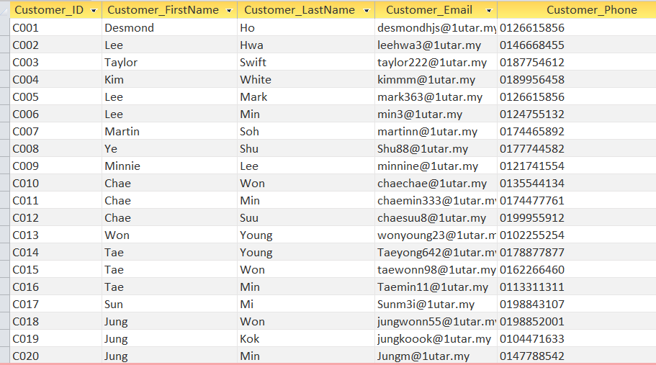

## **5.2 TABLE**

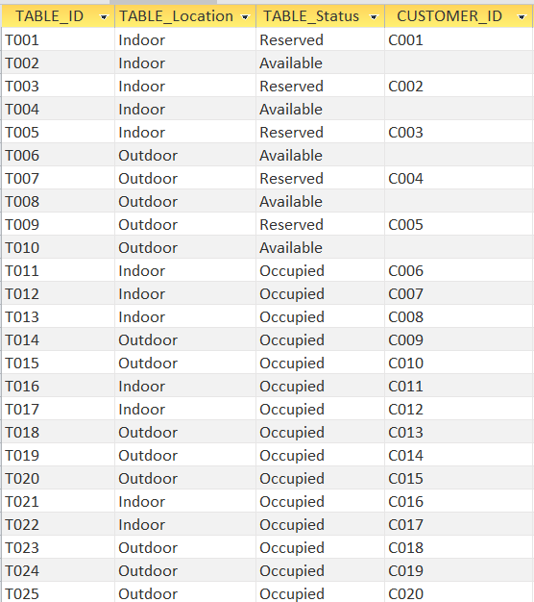

## **5.3 RESERVATION**

## **5.4 STAFF**

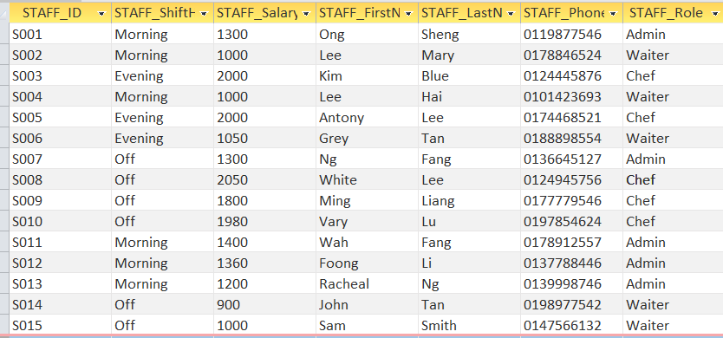

## **5.5 CHEF**

## **5.6 ADMIN**

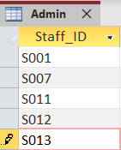

## **5.7 WAITER**

## **5.8 INVENTORY**

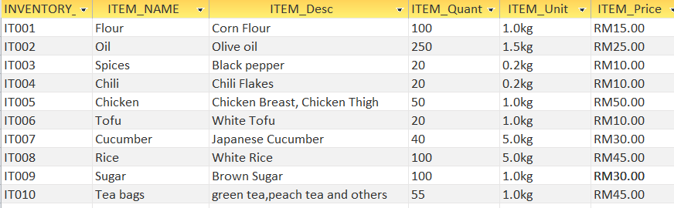

## **5.9 FOOD**

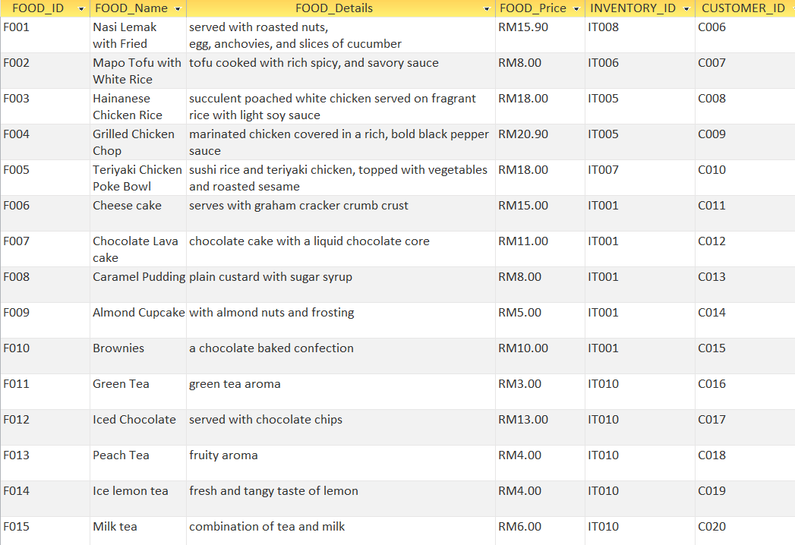

## **5.10 MEAL**

## **5.11 BEVERAGE**

## **5.12 DESSERT**

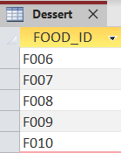

## **5.13 ORDER**

## **5.14 CART**

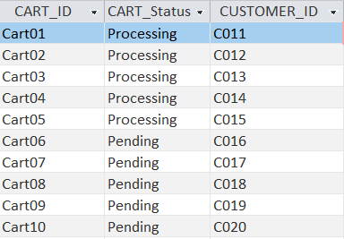

## **5.15 CART_FOOD**

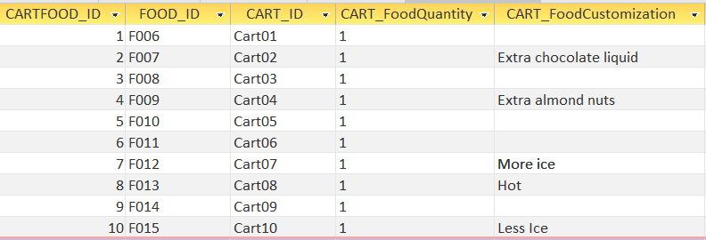

## **5.16 INVOICE**

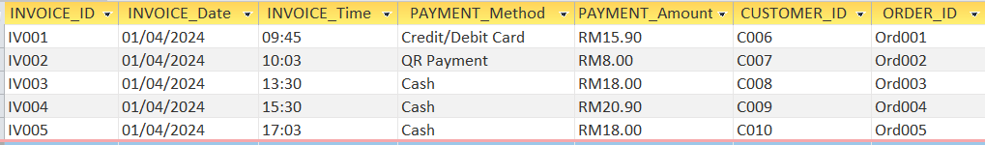

# **6.0 SQL Script Content**

-- Dropping tables with CASCADE CONSTRAINTS to remove all related constraints

DROP TABLE Invoice CASCADE CONSTRAINTS;

DROP TABLE Cart_food CASCADE CONSTRAINTS;

DROP TABLE Cart CASCADE CONSTRAINTS;

DROP TABLE Food CASCADE CONSTRAINTS;

DROP TABLE Inventory CASCADE CONSTRAINTS;

DROP TABLE Order_ CASCADE CONSTRAINTS;

DROP TABLE Staff CASCADE CONSTRAINTS;

DROP TABLE Reservation CASCADE CONSTRAINTS;

DROP TABLE "Table" CASCADE CONSTRAINTS;

DROP TABLE Customer CASCADE CONSTRAINTS;

DROP TABLE Chef CASCADE CONSTRAINTS;

DROP TABLE Admin CASCADE CONSTRAINTS;

DROP TABLE Waiter CASCADE CONSTRAINTS;

DROP TABLE Meal CASCADE CONSTRAINTS;

DROP TABLE Dessert CASCADE CONSTRAINTS;

DROP TABLE Beverage CASCADE CONSTRAINTS;

-- Now, creating tables with the corrected definitions

-- Customer Table

CREATE TABLE Customer (

CUSTOMER_ID VARCHAR2(5) PRIMARY KEY,

CUSTOMER_FirstName VARCHAR2(30),

CUSTOMER_LastName VARCHAR2(30),

CUSTOMER_Email VARCHAR2(30),

CUSTOMER_Phone VARCHAR2(12)

);

INSERT INTO Customer (CUSTOMER_ID, CUSTOMER_FirstName, CUSTOMER_LastName, CUSTOMER_Email, CUSTOMER_Phone)

VALUES

('C001','Desmond','Ho','desmondhjs@1utar.my','0126615856');

INSERT INTO Customer (CUSTOMER_ID, CUSTOMER_FirstName, CUSTOMER_LastName, CUSTOMER_Email, CUSTOMER_Phone)

VALUES

('C002','Lee','Hwa','leehwa3@1utar.my','0146668455');

INSERT INTO Customer (CUSTOMER_ID, CUSTOMER_FirstName, CUSTOMER_LastName, CUSTOMER_Email, CUSTOMER_Phone)

VALUES

('C003','Taylor','Swift','taylor222@1utar.my','0187754612');

INSERT INTO Customer (CUSTOMER_ID, CUSTOMER_FirstName, CUSTOMER_LastName, CUSTOMER_Email, CUSTOMER_Phone)

VALUES

('C004','Kim','White','kimmm@1utar.my','0189956458');

INSERT INTO Customer (CUSTOMER_ID, CUSTOMER_FirstName, CUSTOMER_LastName, CUSTOMER_Email, CUSTOMER_Phone)

VALUES

('C005','Lee','Mark','mark363@1utar.my','0126615856');

INSERT INTO Customer (CUSTOMER_ID, CUSTOMER_FirstName, CUSTOMER_LastName, CUSTOMER_Email, CUSTOMER_Phone)

VALUES

('C006','Lee','Min','min3@1utar.my','0124755132');

INSERT INTO Customer VALUES ('C007','Martin','Soh','martinn@1utar.my','0174465892');

INSERT INTO Customer VALUES ('C008','Ye','Shu','Shu88@1utar.my','0177744582');

INSERT INTO Customer VALUES ('C009','Minnie','Lee','minnine@1utar.my','0121741554');

INSERT INTO Customer VALUES ('C010','Chae','Won','chaechae@1utar.my','0135544134');

INSERT INTO Customer VALUES ('C011','Chae','Min','chaemin333@1utar.my','0174477761');

INSERT INTO Customer VALUES ('C012','Chae','Suu','chaesuu8@1utar.my','0199955912');

INSERT INTO Customer VALUES ('C013','Won','Young','wonyoung23@1utar.my','0102255254');

INSERT INTO Customer VALUES ('C014','Tae','Young','Taeyong642@1utar.my','0178877877');

INSERT INTO Customer VALUES ('C015','Tae','Won','taewonn98@1utar.my','0162266460');

INSERT INTO Customer VALUES ('C016','Tae','Min','Taemin11@1utar.my','0113311311');

INSERT INTO Customer VALUES ('C017','Sun','Mi','Sunm3i@1utar.my','0198843107');

INSERT INTO Customer VALUES ('C018','Jung','Won','jungwonn55@1utar.my','0198852001');

INSERT INTO Customer VALUES ('C019','Jung','Kok','jungkoook@1utar.my','0104471633');

INSERT INTO Customer VALUES ('C020','Jung','Min','Jungm@1utar.my','0147788542');

-- Table Table

CREATE TABLE "Table" (

Table_ID VARCHAR2(5) PRIMARY KEY,

Table_Location VARCHAR2(10),

Table_Status VARCHAR2(15),

CUSTOMER_ID VARCHAR2(5),

CONSTRAINT fk_customer_table FOREIGN KEY (CUSTOMER_ID) REFERENCES Customer(CUSTOMER_ID)

);

INSERT INTO "Table" (Table_ID, Table_Location, Table_Status, CUSTOMER_ID)

VALUES

('T001','Indoor','Reserved','C001');

INSERT INTO "Table" (Table_ID, Table_Location, Table_Status, CUSTOMER_ID)

VALUES

('T002','Indoor','Available','');

INSERT INTO "Table" (Table_ID, Table_Location, Table_Status, CUSTOMER_ID)

VALUES

('T003','Indoor','Reserved','C002');

INSERT INTO "Table" (Table_ID, Table_Location, Table_Status, CUSTOMER_ID)

VALUES

('T004','Indoor','Available','');

INSERT INTO "Table" (Table_ID, Table_Location, Table_Status, CUSTOMER_ID)

VALUES

('T005','Indoor','Reserved','C003');

INSERT INTO "Table" (Table_ID, Table_Location, Table_Status, CUSTOMER_ID)

VALUES

('T006','Outdoor','Available','');

INSERT INTO "Table" (Table_ID, Table_Location, Table_Status, CUSTOMER_ID)

VALUES

('T007','Outdoor','Reserved','C004');

INSERT INTO "Table" (Table_ID, Table_Location, Table_Status, CUSTOMER_ID)

VALUES

('T008','Outdoor','Available','');

INSERT INTO "Table" (Table_ID, Table_Location, Table_Status, CUSTOMER_ID)

VALUES

('T009','Outdoor','Reserved','C005');

INSERT INTO "Table" (Table_ID, Table_Location, Table_Status, CUSTOMER_ID)

VALUES

('T010','Outdoor','Available','');

INSERT INTO "Table" VALUES ('T011','Indoor','Occupied','C006');

INSERT INTO "Table" VALUES ('T012','Indoor','Occupied','C007');

INSERT INTO "Table" VALUES ('T013','Indoor','Occupied','C008');

INSERT INTO "Table" VALUES ('T014','Outdoor','Occupied','C009');

INSERT INTO "Table" VALUES ('T015','Outdoor','Occupied','C010');

INSERT INTO "Table" VALUES ('T016','Indoor','Occupied','C011');

INSERT INTO "Table" VALUES ('T017','Indoor','Occupied','C012');

INSERT INTO "Table" VALUES ('T018','Outdoor','Occupied','C013');

INSERT INTO "Table" VALUES ('T019','Outdoor','Occupied','C014');

INSERT INTO "Table" VALUES ('T020','Outdoor','Occupied','C015');

INSERT INTO "Table" VALUES ('T021','Indoor','Occupied','C016');

INSERT INTO "Table" VALUES ('T022','Indoor','Occupied','C017');

INSERT INTO "Table" VALUES ('T023','Outdoor','Occupied','C018');

INSERT INTO "Table" VALUES ('T024','Outdoor','Occupied','C019');

INSERT INTO "Table" VALUES ('T025','Outdoor','Occupied','C020');

-- Reservation Table

CREATE TABLE Reservation (

RESERVATION_ID VARCHAR2(5) PRIMARY KEY,

RESERVATION_Time VARCHAR2(8),

RESERVATION_Date DATE,

CUSTOMER_ID VARCHAR2(5),

Table_ID VARCHAR2(5),

CONSTRAINT fk_customer_reservation FOREIGN KEY (CUSTOMER_ID) REFERENCES Customer(CUSTOMER_ID),

CONSTRAINT fk_table_reservation FOREIGN KEY (Table_ID) REFERENCES "Table"(Table_ID)

);

INSERT INTO Reservation (RESERVATION_ID, RESERVATION_Time, RESERVATION_Date, CUSTOMER_ID,Table_ID)

VALUES

('R001','14:34',TO_DATE('03-04-2024', 'DD-MM-YYYY '), 'C001','T001');

INSERT INTO Reservation (RESERVATION_ID, RESERVATION_Time, RESERVATION_Date, CUSTOMER_ID,Table_ID)

VALUES

('R002','09:26',TO_DATE('03-04-2024', 'DD-MM-YYYY '), 'C002','T003');

INSERT INTO Reservation (RESERVATION_ID, RESERVATION_Time, RESERVATION_Date, CUSTOMER_ID,Table_ID)

VALUES

('R003','12:30',TO_DATE('04-04-2024', 'DD-MM-YYYY '), 'C003','T005');

INSERT INTO Reservation (RESERVATION_ID, RESERVATION_Time, RESERVATION_Date, CUSTOMER_ID,Table_ID)

VALUES

('R004','12:00',TO_DATE('05-04-2024', 'DD-MM-YYYY '), 'C004','T007');

INSERT INTO Reservation (RESERVATION_ID, RESERVATION_Time, RESERVATION_Date, CUSTOMER_ID,Table_ID)

VALUES

('R005','17:37',TO_DATE('10-04-2024', 'DD-MM-YYYY '), 'C005','T009');

-- Staff Table

CREATE TABLE Staff (

STAFF_ID VARCHAR2(5) PRIMARY KEY,

STAFF_ShiftHour VARCHAR2(20),

STAFF_Salary VARCHAR2(30),

STAFF_FirstName VARCHAR2(30),

STAFF_LastName VARCHAR2(30),

STAFF_Phone VARCHAR2(12),

STAFF_Role VARCHAR2(10)

);

INSERT INTO Staff VALUES ('S001', 'Morning','1300', 'Ong','Sheng', '0119877546', 'Admin');

INSERT INTO Staff VALUES ('S002', 'Morning','1000', 'Lee','Mary', '0178846524', 'Waiter');

INSERT INTO Staff VALUES ('S003', 'Evening','2000', 'Kim','Blue', '0124445876', 'Chef');

INSERT INTO Staff VALUES ('S004', 'Morning','1000', 'Lee','Hai', '0101423693', 'Waiter');

INSERT INTO Staff VALUES ('S005', 'Evening','2000', 'Anthony','Lee', '0174468521', 'Chef');

INSERT INTO Staff VALUES ('S006', 'Evening','1050', 'Grey','Tan', '0188898554', 'Waiter');

INSERT INTO Staff VALUES ('S007', 'Off','1300', 'Ng','Fang', '0136645127', 'Admin');

INSERT INTO Staff VALUES ('S008', 'Off','2050', 'White','Lee', '0124945756', 'Chef');

INSERT INTO Staff VALUES ('S009', 'Off','1800', 'Ming','Liang', '0177779546', 'Chef');

INSERT INTO Staff VALUES ('S010', 'Off','1980', 'Vary','Lu', '0197854624', 'Chef');

INSERT INTO Staff VALUES ('S011', 'Morning','1400', 'Wah','Fang', '0178912557', 'Admin');

INSERT INTO Staff VALUES ('S012', 'Morning','1360', 'Foong','Li', '0137788446', 'Admin');

INSERT INTO Staff VALUES ('S013', 'Morning','1200', 'Racheal','Ng', '0139998746', 'Admin');

INSERT INTO Staff VALUES ('S014', 'Off','900', 'John','Tan', '0198977542', 'Waiter');

INSERT INTO Staff VALUES ('S015', 'Off','1000', 'Sam','Smith', '0147566132', 'Waiter');

--Chef Table

CREATE TABLE Chef (

STAFF_ID VARCHAR2(5) PRIMARY KEY,

CONSTRAINT fk_staff_chef FOREIGN KEY (STAFF_ID) REFERENCES Staff(STAFF_ID)

);

INSERT INTO Chef(STAFF_ID) VALUES ('S003');

INSERT INTO Chef(STAFF_ID) VALUES ('S005');

INSERT INTO Chef(STAFF_ID) VALUES ('S008');

INSERT INTO Chef(STAFF_ID) VALUES ('S009');

INSERT INTO Chef(STAFF_ID) VALUES ('S010');

--Admin Table

CREATE TABLE Admin (

STAFF_ID VARCHAR2(5) PRIMARY KEY,

CONSTRAINT fk_staff_admin FOREIGN KEY (STAFF_ID) REFERENCES Staff(STAFF_ID));

INSERT INTO Admin (STAFF_ID) VALUES ('S001');

INSERT INTO Admin (STAFF_ID) VALUES ('S007');

INSERT INTO Admin (STAFF_ID) VALUES ('S011');

INSERT INTO Admin (STAFF_ID) VALUES ('S012');

INSERT INTO Admin (STAFF_ID) VALUES ('S013');

--Table Waiter

CREATE TABLE Waiter (

STAFF_ID VARCHAR2(5) PRIMARY KEY,

CONSTRAINT fk_staff_waiter FOREIGN KEY (STAFF_ID) REFERENCES Staff(STAFF_ID)

);

INSERT INTO Waiter (STAFF_ID) VALUES ('S002');

INSERT INTO Waiter (STAFF_ID) VALUES ('S004');

INSERT INTO Waiter (STAFF_ID) VALUES ('S006');

INSERT INTO Waiter (STAFF_ID) VALUES ('S014');

INSERT INTO Waiter (STAFF_ID) VALUES ('S015');

-- Inventory Table

CREATE TABLE Inventory (

INVENTORY_ID VARCHAR2(5) PRIMARY KEY,

ITEM_Name VARCHAR2(30),

ITEM_Desc VARCHAR2(30),

ITEM_Quantity NUMBER(4),

ITEM_Unit NUMBER(10,1),

ITEM_Price NUMBER(10,2)

);

INSERT INTO Inventory VALUES ('IT001', 'Flour','Corn Flour', '100', '1.0', '15.00');

INSERT INTO Inventory VALUES ('IT002', 'Oil','Olive oil', '250', '1.5', '25.00');

INSERT INTO Inventory VALUES ('IT003', 'Spices','Black pepper', '20', '0.2', '10.00');

INSERT INTO Inventory VALUES ('IT004', 'Chili','Chili Flakes', '20', '0.2', '10.00');

INSERT INTO Inventory VALUES ('IT005', 'Chicken','Chicken Breast, Chicken Thigh', '50', '1.0', '50.00');

INSERT INTO Inventory VALUES ('IT006', 'Tofu','White Tofu', '20', '1.0', '10.00');

INSERT INTO Inventory VALUES ('IT007', 'Cucumber','Japanese cucumber', '40', '5.0', '30.00');

INSERT INTO Inventory VALUES ('IT008', 'Rice','White Rice', '100', '5.0', '45.00');

INSERT INTO Inventory VALUES ('IT009', 'Sugar','Brown sugar', '100', '1.0', '30.00');

INSERT INTO Inventory VALUES ('IT010', 'Tea bags','green tea,peach tea and others', '55', '1.0', '45.00');

-- Food Table

CREATE TABLE Food (

FOOD_ID VARCHAR2(5) PRIMARY KEY,

FOOD_Name VARCHAR2(40),

FOOD_Details VARCHAR2(100),

FOOD_Price NUMBER(10,2),

INVENTORY_ID VARCHAR2(5),

CUSTOMER_ID VARCHAR2(5),

CONSTRAINT fk_inventory_food FOREIGN KEY (INVENTORY_ID) REFERENCES Inventory(INVENTORY_ID),

CONSTRAINT fk_customer_food FOREIGN KEY (CUSTOMER_ID) REFERENCES Customer(CUSTOMER_ID)

);

INSERT INTO Food VALUES ('F001', 'Nasi Lemak with Fried Chicken','served with roasted nuts,

egg, anchovies, and slices of cucumber', '15.90', 'IT008', 'C006');

INSERT INTO Food VALUES ('F002', 'Mapo Tofu with White Rice','tofu cooked with rich spicy, and savory sauce',

'8.00','IT006', 'C007');

INSERT INTO Food VALUES ('F003', 'Hainanese Chicken Rice','succulent poached white chicken served on fragrant rice with light soy sauce',

'18.00','IT005', 'C008');

INSERT INTO Food VALUES ('F004', 'Grilled Chicken Chop','marinated chicken covered in a rich, bold black pepper sauce',

'20.90', 'IT005', 'C009');

INSERT INTO Food VALUES ('F005', 'Teriyaki Chicken Poke Bowl','sushi rice and teriyaki chicken, topped with vegetables and roasted sesame',

'18.00', 'IT007', 'C010');

INSERT INTO Food VALUES ('F006', 'Cheese cake','serves with graham cracker crumb crust',

'15.00', 'IT001', 'C011');

INSERT INTO Food VALUES ('F007', 'Chocolate Lava cake','chocolate cake with a liquid chocolate core',

'11.00', 'IT001', 'C012');

INSERT INTO Food VALUES ('F008', 'Caramel Pudding','plain custard with sugar syrup',

'8.00', 'IT001', 'C013');

INSERT INTO Food VALUES ('F009', 'Almond Cupcake','with almond nuts and frosting',

'5.00', 'IT001', 'C014');

INSERT INTO Food VALUES ('F010', 'Brownies','a chocolate baked confection',

'10.00', 'IT001', 'C015');

INSERT INTO Food VALUES ('F011', 'Green Tea','green tea aroma',

'3.00', 'IT010', 'C016');

INSERT INTO Food VALUES ('F012', 'Iced Chocolate','served with chocolate chips',

'13.00', 'IT010', 'C017');

INSERT INTO Food VALUES ('F013', 'Peach Tea','fruity aroma',

'4.00', 'IT010', 'C018');

INSERT INTO Food VALUES ('F014', 'Ice lemon tea','fresh and tangy taste of lemon',

'4.00', 'IT010', 'C019');

INSERT INTO Food VALUES ('F015', 'Milk tea','combination of tea and milk',

'6.00', 'IT010', 'C020');

--Meal Table

CREATE TABLE Meal (

FOOD_ID VARCHAR2(5) PRIMARY KEY,

CONSTRAINT fk_food_meal FOREIGN KEY (FOOD_ID) REFERENCES Food(FOOD_ID)

);

INSERT INTO Meal(FOOD_ID) VALUES ('F001');

INSERT INTO Meal(FOOD_ID) VALUES ('F002');

INSERT INTO Meal(FOOD_ID) VALUES ('F003');

INSERT INTO Meal(FOOD_ID) VALUES ('F004');

INSERT INTO Meal(FOOD_ID) VALUES ('F005');

--Dessert Table

CREATE TABLE Dessert (

FOOD_ID VARCHAR2(5) PRIMARY KEY,

CONSTRAINT fk_food_dessert FOREIGN KEY (FOOD_ID) REFERENCES Food(FOOD_ID)

);

INSERT INTO Dessert(FOOD_ID) VALUES ('F006');

INSERT INTO Dessert(FOOD_ID) VALUES ('F007');

INSERT INTO Dessert(FOOD_ID) VALUES ('F008');

INSERT INTO Dessert(FOOD_ID) VALUES ('F009');

INSERT INTO Dessert(FOOD_ID) VALUES ('F010');

--Beverage Table

CREATE TABLE Beverage (

FOOD_ID VARCHAR2(5) PRIMARY KEY,

CONSTRAINT fk_food_beverage FOREIGN KEY (FOOD_ID) REFERENCES Food(FOOD_ID)

);

INSERT INTO Beverage(FOOD_ID) VALUES ('F011');

INSERT INTO Beverage(FOOD_ID) VALUES ('F012');

INSERT INTO Beverage(FOOD_ID) VALUES ('F013');

INSERT INTO Beverage(FOOD_ID) VALUES ('F014');

INSERT INTO Beverage(FOOD_ID) VALUES ('F015');

-- Order Table

CREATE TABLE Order_ (

ORDER_ID VARCHAR2(7) PRIMARY KEY,

ORDER_Date DATE,

ORDER_Time VARCHAR2(8),

ORDER_Status VARCHAR2(20),

Table_ID VARCHAR2(5),

STAFF_ID VARCHAR2(5),

CONSTRAINT fk_table_order FOREIGN KEY (Table_ID) REFERENCES "Table"(Table_ID),

CONSTRAINT fk_staff_order FOREIGN KEY (STAFF_ID) REFERENCES Staff(STAFF_ID)

);

INSERT INTO Order_ VALUES ('Ord001', TO_DATE('01-04-2024', 'DD-MM-YYYY'),'08:32',

'Completed','T011','S001');

INSERT INTO Order_ VALUES ('Ord002',TO_DATE('01-04-2024', 'DD-MM-YYYY'),'09:00',

'Completed','T012','S007');

INSERT INTO Order_ VALUES ('Ord003',TO_DATE('01-04-2024', 'DD-MM-YYYY'),'09:13',

'Completed','T013','S011');

INSERT INTO Order_ VALUES ('Ord004',TO_DATE('01-04-2024', 'DD-MM-YYYY'),'10:24',

'Completed','T014','S012');

INSERT INTO Order_ VALUES ('Ord005',TO_DATE('01-04-2024', 'DD-MM-YYYY'),'10:28',

'Completed','T015','S013');

INSERT INTO Order_ VALUES ('Ord006',TO_DATE('02-04-2024', 'DD-MM-YYYY'),'11:08',

'Processing','T016','S002');

INSERT INTO Order_ VALUES ('Ord007',TO_DATE('02-04-2024', 'DD-MM-YYYY'),'11:58',

'Processing','T017','S004');

INSERT INTO Order_ VALUES ('Ord008',TO_DATE('02-04-2024', 'DD-MM-YYYY'),'14:20',

'Processing','T018','S006');

INSERT INTO Order_ VALUES ('Ord009',TO_DATE('02-04-2024', 'DD-MM-YYYY'),'14:28',

'Processing','T019','S003');

INSERT INTO Order_ VALUES ('Ord010',TO_DATE('02-04-2024', 'DD-MM-YYYY'),'14:57',

'Processing','T020','S005');

-- Cart Table

CREATE TABLE Cart (

CART_ID VARCHAR2(7) PRIMARY KEY,

CART_Status VARCHAR2(20),

CUSTOMER_ID VARCHAR2(5),

CONSTRAINT fk_customer_cart FOREIGN KEY (CUSTOMER_ID) REFERENCES Customer(CUSTOMER_ID)

);

INSERT INTO Cart VALUES ('Cart01', 'Processing','C011');

INSERT INTO Cart VALUES ('Cart02', 'Processing','C012');

INSERT INTO Cart VALUES ('Cart03', 'Processing','C013');

INSERT INTO Cart VALUES ('Cart04', 'Processing','C014');

INSERT INTO Cart VALUES ('Cart05', 'Processing','C015');

INSERT INTO Cart VALUES ('Cart06', 'Pending','C016');

INSERT INTO Cart VALUES ('Cart07', 'Pending','C017');

INSERT INTO Cart VALUES ('Cart08', 'Pending','C018');

INSERT INTO Cart VALUES ('Cart09', 'Pending','C019');

INSERT INTO Cart VALUES ('Cart10', 'Pending','C020');

-- Cart_Food Table

CREATE TABLE Cart_food (

CARTFOOD_ID NUMBER(2) PRIMARY KEY,

FOOD_ID VARCHAR2(5),

CART_ID VARCHAR2(7),

CART_FoodQuantity NUMBER(2),

CART_FoodCustomization VARCHAR2(100),

CONSTRAINT fk_food_cartfood FOREIGN KEY (FOOD_ID) REFERENCES Food(FOOD_ID),

CONSTRAINT fk_cart_cartfood FOREIGN KEY (CART_ID) REFERENCES Cart(CART_ID)

);

INSERT INTO Cart_Food VALUES ('1','F006','Cart01','1',NULL);

INSERT INTO Cart_Food VALUES ('2','F007','Cart02','1','Extra chocolate liquid');

INSERT INTO Cart_Food VALUES ('3','F008','Cart03','1',NULL);

INSERT INTO Cart_Food VALUES ('4','F009','Cart04','1','Extra almond nuts');

INSERT INTO Cart_Food VALUES ('5','F010','Cart05','1',NULL);

INSERT INTO Cart_Food VALUES ('6','F011','Cart06','1',NULL);

INSERT INTO Cart_Food VALUES ('7','F012','Cart07','1','More ice');

INSERT INTO Cart_Food VALUES ('8','F013','Cart08','1','Hot');

INSERT INTO Cart_Food VALUES ('9','F014','Cart09','1',NULL);

INSERT INTO Cart_Food VALUES ('10','F015','Cart10','1','Less Ice');

-- Invoice Table

CREATE TABLE Invoice (

INVOICE_ID VARCHAR2(5) PRIMARY KEY,

INVOICE_Date DATE,

INVOICE_Time VARCHAR2(8),

PAYMENT_Method VARCHAR2(20),

PAYMENT_Amount NUMBER(20,2),

CUSTOMER_ID VARCHAR2(5),

ORDER_ID VARCHAR2(7),

CONSTRAINT fk_customer_invoice FOREIGN KEY (CUSTOMER_ID) REFERENCES Customer(CUSTOMER_ID),

CONSTRAINT fk_order_invoice FOREIGN KEY (ORDER_ID) REFERENCES Order_(ORDER_ID)

);

INSERT INTO Invoice VALUES ('IV001',TO_DATE('01-04-2024', 'DD-MM-YYYY'),'09:45',

'Credit/Debit Card','15.90','C006','Ord001');

INSERT INTO Invoice VALUES ('IV002',TO_DATE('01-04-2024', 'DD-MM-YYYY'),'10:03',

'QR Payment','8.00','C007','Ord002');

INSERT INTO Invoice VALUES ('IV003',TO_DATE('01-04-2024', 'DD-MM-YYYY'),'13:30',

'Cash','18.00','C008','Ord003');

INSERT INTO Invoice VALUES ('IV004',TO_DATE('01-04-2024', 'DD-MM-YYYY'),'15:30',

'Cash','20.90','C009','Ord004');

INSERT INTO Invoice VALUES ('IV005',TO_DATE('01-04-2024', 'DD-MM-YYYY'),'17:03',

'Cash','18.00','C010','Ord005');

# **7.0 Individual Assignment (Part 2)**

## **7.1 Ong Yi Sheng (*)**

### **7.1.1 Queries**

1. Shows the Staff's full name, order date and the table id, where the table location is indoor and arranged accordingly with the table id.

SELECT s.staff_firstname || s.staff_lastname AS "Full Name" , o.order_date AS "Order Time", t.table_id AS " Table ID", t.table_location

FROM staff s, order_ o, "Table" t

WHERE s.staff_id = o.staff_id

AND o.table_id = t.table_id

AND table_location = 'Indoor'

ORDER BY t.table_id;

2. Retrieve the Customer's full name, phone number, invoice ID, and payment Amount using the payment method as Cash and the payment amount is between 15 to 20 and arranged accordingly with the payment amount.

SELECT c.customer_firstname || c.customer_lastname AS "Full Name" , c.customer_phone AS "Phone Number" , i.payment_amount AS "Payment Amount"

FROM customer c , invoice i

WHERE c.customer_id = i.customer_id

AND payment_method LIKE 'Cash'

AND payment_amount BETWEEN 15.00 AND 20.00

ORDER BY payment_amount;

### **7.1.2 PL/SQL stored procedure**

1) update a staff information by giving the staff ID.

SET SERVEROUTPUT ON;

CREATE OR REPLACE PROCEDURE UpdateStaff(

p_Staff_ID IN VARCHAR2,

p_ShiftHour IN VARCHAR2,

p_Salary IN VARCHAR2,

p_FirstName IN VARCHAR2,

p_LastName IN VARCHAR2,

p_Phone IN VARCHAR2,

p_Role IN VARCHAR2

)

AS

BEGIN

UPDATE Staff

SET staff_shifthour = p_ShiftHour,

staff_salary = p_Salary,

staff_firstname = p_FirstName,

staff_lastname = p_LastName,

staff_phone = p_Phone,

staff_role = p_Role

WHERE staff_id = p_Staff_ID;

IF SQL%ROWCOUNT = 1 THEN

DBMS_OUTPUT.PUT_LINE('Staff member updated successfully.');

ELSIF SQL%ROWCOUNT = 0 THEN

DBMS_OUTPUT.PUT_LINE('Staff ID not found.');

END IF;

COMMIT;

EXCEPTION

WHEN OTHERS THEN

DBMS_OUTPUT.PUT_LINE('An error occurred: ' || SQLERRM);

ROLLBACK;

END;

/

**Execution Code:**

EXECUTE UpdateStaff('S001','Off','5000','Ace','Smie','01122323','Chef');

**Explanation:**

This procedure is named as UpdateStaff and this procedure is to change the staff info by giving the staff ID. At the procedure definition part, there are 7 input parameters which is p_staff_ID, p _shifthour, p_Salary, p_FirstName, p_LastName, p_Phone, and p_Role. These parameters gonna carry the input and insert into the real data that already exists in the database inside the block of UPDATE. At SQL%ROWCOUNT = 1 this means that the sql selected one row which to the staffID, if rowcount = 1 prompt the info has been changed successfully. Hence, SQL%ROWCOUNT = 0 handle the error when the staff ID not found.

2) Insert a reservation to the table when a customer wants to make reservation and add the new reservation ID, reservation time, reservation date, customer ID and Table ID. The procedure shows error when the tableID has been reserved and occupied, and the procedure handle error when the customerID not exist. The table status will update to reserved after the customer make the reservation.

CREATE OR REPLACE PROCEDURE Add_Reservation(

p_reservation_id IN VARCHAR2,

p_reservation_time IN VARCHAR2,

p_reservation_date IN DATE,

p_customer_id IN VARCHAR2,

p_table_id IN VARCHAR2

)

IS

BEGIN

DECLARE

customer_exists NUMBER;

BEGIN

SELECT COUNT(*)

INTO customer_exists

FROM Customer

WHERE CUSTOMER_ID = p_customer_id;

IF customer_exists = 0 THEN

DBMS_OUTPUT.PUT_LINE('Customer ID does not exist.');

END IF;

END;

DECLARE

table_status VARCHAR2(15);

BEGIN

SELECT Table_Status

INTO table_status

FROM "Table"

WHERE Table_ID = p_table_id;

IF table_status != 'Available' THEN

DBMS_OUTPUT.PUT_LINE('Table is not available for reservation.');

END IF;

END;

INSERT INTO Reservation (

RESERVATION_ID,

RESERVATION_Time,

RESERVATION_Date,

CUSTOMER_ID,

Table_ID

) VALUES (

p_reservation_id,

p_reservation_time,

p_reservation_date,

p_customer_id,

p_table_id

);

UPDATE "Table"

SET Table_Status = 'Reserved', CUSTOMER_ID = p_customer_id

WHERE Table_ID = p_table_id;

COMMIT;

EXCEPTION

WHEN OTHERS THEN

ROLLBACK;

RAISE;

END Add_Reservation;

/

Execution Code:

EXECUTE Add_Reservation('R006', '18:00', TO_DATE('12-04-2024', 'DD-MM-YYYY'), 'C002', 'T002');

**Explanation**:

This procedure name as Add_Reservation which insert a reservation to the table when a customer wants to make reservation and add the new reservation ID, reservation time, reservation date, customer ID and Table ID.first of all, customers_exist is a variable that test does the customerID exist or not. If not exist it will end and prompt the system error. Hence, table_status is a variable that stored the data in the Table_Status from the “Table” table. If the table status is not available it will prompt the table is not available for reservation. If the reservation is going successfully, the table_status in the “Table” table will be updated to reserved and the customer ID in the “Table” table will be updated to the customer ID that input.

### **7.1.3 PS/SQL functions**

1. The function that calculate the numbers of order in a specfic date.

CREATE OR REPLACE FUNCTION CountOrdersOnDate(p_date IN DATE)

RETURN NUMBER IS

order_count NUMBER;

BEGIN

SELECT COUNT(*)

INTO order_count

FROM Order_

WHERE TRUNC(ORDER_Date) = TRUNC(p_date);

RETURN order_count;

EXCEPTION

WHEN NO_DATA_FOUND THEN

RETURN 0;

WHEN OTHERS THEN

RAISE;

END;

/

Execution Code:

SELECT CountOrdersOnDate(TO_DATE('01-04-2024', 'DD-MM-YYYY')) AS Total_Order_Amount FROM dual;

Explanation:

This function is named as CountOrdersOnDate. This function is function as to count the order count at a specified date. Hence, the function will return the order count by referring the date given in execution code.

2. Return the numbers of staff who's salary exceed and equal 1300 by giving the specfic staff role.

CREATE OR REPLACE FUNCTION CountSalaryByrole(p_role IN VARCHAR2)

RETURN NUMBER IS

count_staff NUMBER;

BEGIN

SELECT COUNT(*)

INTO count_staff

FROM Staff

WHERE STAFF_Role = p_role

AND TO_NUMBER(STAFF_Salary) >= 1300;

RETURN count_staff;

EXCEPTION

WHEN NO_DATA_FOUND THEN

RETURN 0;

WHEN OTHERS THEN

RAISE;

END;

/

**Execution Code:**

SELECT CountSalaryByrole('Chef') AS "Staff's salary that exceed and equal 1300 " FROM dual;

**Explanation:**

This function is named as CountSalaryByrole. This function is function as to count the number of the staff which exceed and equal 1300. Hence, the function will return the number count of the staff who exceed and equal 1300 by referring the staff_role that given in execution code.

## **7.2 Desmond Ho Jia Shen**

### **7.2.1 Queries**

**1) List Customer with reservation on 03-04-2024**

This query will select all the customers and their information if they made a reservation on 3 April 2024. It will show their first name, last name, contact number and the reservation date.

SELECT c.CUSTOMER_FirstName, c.CUSTOMER_LastName, c.CUSTOMER_Phone, r.RESERVATION_Date

from Customer c

join Reservation r ON c.CUSTOMER_ID = r.CUSTOMER_ID

where r.RESERVATION_Date = '03-APR-24';

**2) Detailed Order Information with Customer and Table Data**

This query will select the order and table information of a customer. It will show their order ID, order date, order time, order status, customer id, customer name, table ID, table location, table status and the staff that is serving the customer.

SELECT

o.ORDER_ID,

o.ORDER_Date,

o.ORDER_Time,

o.ORDER_Status,

cust.CUSTOMER_ID,

cust.CUSTOMER_FirstName || ' ' || cust.CUSTOMER_LastName AS Customer_Name,

t.Table_ID,

t.Table_Location,

t.Table_Status,

s.STAFF_FirstName || ' ' || s.STAFF_LastName AS Staff_Name

FROM

Order_ o

JOIN "Table" t ON o.Table_ID = t.Table_ID

JOIN Customer cust ON cust.CUSTOMER_ID = t.CUSTOMER_ID

JOIN Staff s ON o.STAFF_ID = s.STAFF_ID

WHERE

o.ORDER_Date = TO_DATE('2024-04-01', 'YYYY-MM-DD');

### **7.2.2 PL/SQL stored procedure**

**1) Add new Customer into the table**

This stored procedure will add a new customer when they want to have a meal in the restaurant. It will add the necessary data into the Customer table which will include their customer ID, customer first name, customer last name, customer email and customer contact number. This procedure will also prompt an output line (“'Error: Duplicate Value for a Unique Constraint”) if there is any duplicated value added into the table that is already existed.

CREATE OR REPLACE PROCEDURE AddNewCustomer(

p_customer_id VARCHAR2,

p_first_name VARCHAR2,

p_last_name VARCHAR2,

p_email VARCHAR2,

p_phone VARCHAR2)

IS

BEGIN

INSERT INTO Customer (CUSTOMER_ID, CUSTOMER_FirstName, CUSTOMER_LastName, CUSTOMER_Email, CUSTOMER_Phone)

VALUES (p_customer_id, p_first_name, p_last_name, p_email, p_phone);

COMMIT;

EXCEPTION

WHEN DUP_VAL_ON_INDEX THEN

DBMS_OUTPUT.PUT_LINE('Error: Duplicate Value for a Unique Constraint.');

END;

/

================================

**Example:**

EXECUTE AddNewCustomer ('C001','Dreamy','Bull','dreamy@1utar.my','0126615856');

**2) Update Order Status**

This stored procedure will update the order status of a customer’s order to either ‘Completed’, ‘Processing’, ‘Cancelled’. If the status updated is the same as the current value, a message will prompt (“No difference as current”), If the order status is updated successfully, it will prompt a message (“Order status updated successfully”), and if there is an unavailable order ID used, it will prompt (“Error: Order ID not found”). Then if there is an error for the procedure, it will run a rollback to ensure that the data remains unchanged.

CREATE OR REPLACE PROCEDURE UpdateOrderStatus(

p_order_id VARCHAR2,

p_new_status VARCHAR2)

IS

v_current_status VARCHAR2(20);

BEGIN

-- Retrieve the current status for the given order ID

SELECT ORDER_Status INTO v_current_status

FROM Order_

WHERE ORDER_ID = p_order_id;

-- Check if the new status is the same as the current status

IF v_current_status = p_new_status THEN

DBMS_OUTPUT.PUT_LINE('No difference as current.');

ELSE

-- Update the order status if it's different

UPDATE Order_

SET ORDER_Status = p_new_status

WHERE ORDER_ID = p_order_id;

COMMIT;

DBMS_OUTPUT.PUT_LINE('Order status updated successfully.');

END IF;

EXCEPTION

WHEN NO_DATA_FOUND THEN

DBMS_OUTPUT.PUT_LINE('Error: Order ID not found.');

WHEN OTHERS THEN

DBMS_OUTPUT.PUT_LINE('Error: ' || SQLERRM);

-- Optional: Rollback changes if something goes wrong

ROLLBACK;

END;

/

======================================

**Example:**

EXECUTE UpdateOrderStatus ('Ord001','Processing');

### **7.2.3 PS/SQL functions**

**1) Calculate Total Orders for Customer**

This function will calculate the total orders for a customer by using the v_order_count variable. It will first count all the orders of a customer using their Customer ID and total the numbers. Then, we can select this function with a Customer ID to prompt the total orders in dual.

CREATE OR REPLACE FUNCTION TotalOrdersForCustomer(p_customer_id VARCHAR2)

RETURN NUMBER

IS

v_order_count NUMBER;

BEGIN

SELECT COUNT(*)

INTO v_order_count

FROM Order_ o

JOIN "Table" t ON o.Table_ID = t.Table_ID

WHERE t.CUSTOMER_ID = p_customer_id;

RETURN v_order_count;

END;

/

===========================

**Example**:

select TotalOrdersForCustomer ('C006') from dual;

**2) Get Total Revenue on a Date**

This function will calculate the total revenue on a certain date. It will first create a total_revenue variable to store the amount of revenue earned. Then it will select and sum all the payment_amount from the invoice table using a certain date. Finally, it will show the total revenue in dual.

CREATE OR REPLACE FUNCTION GetTotalRevenue(p_date DATE)

RETURN NUMBER

IS

v_total_revenue NUMBER(10,2);

BEGIN

SELECT SUM(PAYMENT_Amount)

INTO v_total_revenue

FROM Invoice

WHERE INVOICE_Date = p_date;

RETURN v_total_revenue;

END;

/

===========================

**Example:**

select GetTotalRevenue ('01-Apr-2024') from dual;

## **7.3 Seow Yi Xuan**

### **7.3.1 Queries**

1.Retrieve the table number and food name for completed orders and display the invoice id and the time of invoice generated for each food

SELECT t.TABLE_ID AS "Table", f.FOOD_NAME, i.INVOICE_ID AS "Inv"

, i.INVOICE_Time AS "Time"

FROM "Table" t, Food f, Order_ o, Invoice i,Customer c

WHERE c.CUSTOMER_ID = t.CUSTOMER_ID

AND t.CUSTOMER_ID = i.CUSTOMER_ID

AND f.CUSTOMER_ID = i.CUSTOMER_ID

AND o.TABLE_ID = t.TABLE_ID

AND TABLE_STATUS = 'Occupied'

AND ORDER_STATUS = 'Completed';

2.Select the Customer whose cart contains food which uses "Tea bags" or "Flour" as ingredient

SELECT c.CUSTOMER_ID, f.FOOD_NAME, i.ITEM_NAME AS "Ingredients", i.ITEM_DESC AS "Description"

FROM CART c, FOOD f, Inventory i, CART_FOOD t

WHERE c.CART_ID = t.CART_ID

AND t.FOOD_ID = f.FOOD_ID

AND f.INVENTORY_ID = i.INVENTORY_ID

AND (ITEM_NAME = 'Tea bags' OR ITEM_NAME = 'Flour');

### **7.3.2 PL/SQL stored procedure**

1.Insert new Table

SET SERVEROUTPUT ON

CREATE OR REPLACE PROCEDURE insertTable (

new_Table_ID IN VARCHAR2,

new_Table_Location IN VARCHAR2,

new_Table_Status IN VARCHAR2,

new_CUSTOMER_ID IN VARCHAR2

)

IS

BEGIN

INSERT INTO "Table" (Table_ID, TABLE_LOCATION, TABLE_STATUS, CUSTOMER_ID)

VALUES (new_Table_ID, new_Table_Location, new_Table_Status, new_CUSTOMER_ID);

COMMIT;

EXCEPTION

WHEN DUP_VAL_ON_INDEX THEN

DBMS_OUTPUT.PUT_LINE('Error: Duplicate Value for a Unique Constraint.');

END;

/

Execution Code :

EXECUTE insertTable ('T026','Indoor','Available','');

2.Update item quantity in Inventory where users cannot enter quantity less than 20

CREATE OR REPLACE PROCEDURE updateInventory (

new_INVENTORY_ID IN VARCHAR2,

new_ITEM_Quantity IN NUMBER

)

IS

-- Current item quantity

current_item_stock NUMBER;

BEGIN

-- Retrieve current item quantity

SELECT ITEM_Quantity INTO current_item_stock

FROM Inventory

WHERE INVENTORY_ID = new_INVENTORY_ID;

-- Check if new quantity meets the constraint

IF (new_ITEM_Quantity < 20) THEN

DBMS_OUTPUT.PUT_LINE('Error: Quantity cannot be less than 20.');

RETURN;

END IF;

-- Update inventory quantity and provide feedback

IF (new_ITEM_Quantity < current_item_stock) THEN

DBMS_OUTPUT.PUT_LINE('Item quantity decreases');

ELSIF (new_ITEM_Quantity > current_item_stock) THEN

DBMS_OUTPUT.PUT_LINE('Item restocked');

ELSE

DBMS_OUTPUT.PUT_LINE('Item quantity unchanged');

END IF;

-- Update the inventory with the new quantity

UPDATE Inventory

SET ITEM_Quantity = new_ITEM_Quantity

WHERE INVENTORY_ID = new_INVENTORY_ID;

COMMIT;

EXCEPTION

WHEN NO_DATA_FOUND THEN

DBMS_OUTPUT.PUT_LINE('Error: Inventory ID not in list.');

END;

/

Execution Code :

EXECUTE updateInventory ('IT004',22);

### **7.3.3 PS/SQL functions**

1.Calculate total salary of staff who is a Chef.

CREATE OR REPLACE FUNCTION ChefSalary(STAFF_SALARY IN VARCHAR2)

RETURN VARCHAR

IS

total_salary NUMBER(10,2);

BEGIN

SELECT SUM(STAFF_SALARY) INTO total_salary

FROM STAFF

WHERE STAFF_ROLE = 'Chef';

RETURN TO_CHAR(total_salary);

END;

/

DECLARE

--Declare variable as NUMBER to hold 2 decimal place

chef_total_salary NUMBER(10,2);

BEGIN

--Convert result

chef_total_salary := TO_NUMBER(ChefSalary('Chef'));

DBMS_OUTPUT.PUT_LINE('Total salary of all chefs: RM' || TO_CHAR(chef_total_salary, '9999.99'));

END;

/

2.Return total number of tables which are located at outdoor and occupied.

CREATE OR REPLACE FUNCTION OccupiedOutdoorTables(TABLE_LOCATION IN VARCHAR2)

RETURN NUMBER

IS

occupied_tables NUMBER;

BEGIN

SELECT COUNT(TABLE_LOCATION) INTO occupied_tables

FROM "Table"

WHERE TABLE_LOCATION = 'Outdoor'

AND TABLE_STATUS = 'Occupied';

RETURN occupied_tables;

EXCEPTION

WHEN NO_DATA_FOUND THEN

RETURN 0;

END;

/

DECLARE

num_occupied_tables NUMBER;

BEGIN

num_occupied_tables := OccupiedOutdoorTables('Outdoor');

DBMS_OUTPUT.PUT_LINE('Number of occupied outdoor tables: ' || num_occupied_tables);

END;

/

## **7.4 Tharini Vijesh Kumar**

### **7.4.1 Queries**

* 1. List waiters with earnings from completed orders on 01-04-2024 and 02-04-2024.

SELECT

i.INVOICE_Date,

(s.STAFF_FirstName || ' ' || s.STAFF_LastName) AS "FULL NAME",

s.STAFF_Phone AS "Contact. No",

SUM(i.PAYMENT_Amount) AS "Total Amount"

FROM

Staff s

JOIN

Order_ o ON s.STAFF_ID = o.STAFF_ID

JOIN

Invoice i ON o.ORDER_ID = i.ORDER_ID

WHERE

i.INVOICE_Date BETWEEN TO_DATE('01-04-2024', 'DD-MM-YYYY') AND TO_DATE('02-04-2024', 'DD-MM-YYYY')

AND o.ORDER_Status = 'Completed'

GROUP BY

i.INVOICE_Date, s.STAFF_ID, (s.STAFF_FirstName || ' ' || s.STAFF_LastName), s.STAFF_Phone

ORDER BY

i.INVOICE_Date, s.STAFF_ID;

* 1. list all ingredients, their unit left, price and counts the number of food items that are cooked with each ingredient

SELECT

i.ITEM_Name AS "Ingredient Name",

i.ITEM_Unit AS "Unit",

i.ITEM_Price AS "Price",

COUNT(f.FOOD_ID) AS "Number of Foods"

FROM

Inventory i

LEFT JOIN

Food f ON i.INVENTORY_ID = f.INVENTORY_ID

GROUP BY

i.ITEM_Name, i.ITEM_Desc, i.ITEM_Quantity, i.ITEM_Unit, i.ITEM_Price

ORDER BY

"Number of Foods" DESC, i.ITEM_Name;

### **PL/SQL stored procedure**

1. add ingredients into the inventory for a new menu

CREATE OR REPLACE PROCEDURE AddNewIngredients AS

BEGIN

INSERT INTO Inventory (INVENTORY_ID, ITEM_Name, ITEM_Desc, ITEM_Quantity, ITEM_Unit, ITEM_Price)

VALUES ('IT011', 'Sweetcorn', 'Frozen sweetcorn', '50', '1', '1.00');

INSERT INTO Inventory (INVENTORY_ID, ITEM_Name, ITEM_Desc, ITEM_Quantity, ITEM_Unit, ITEM_Price)

VALUES ('IT012', 'Peas', 'Frozen peas', '50', '1', '1.00');

INSERT INTO Inventory (INVENTORY_ID, ITEM_Name, ITEM_Desc, ITEM_Quantity, ITEM_Unit, ITEM_Price)

VALUES ('IT013', 'Red Onion', 'Fresh red onion', '1', '2', '0.50');

INSERT INTO Inventory (INVENTORY_ID, ITEM_Name, ITEM_Desc, ITEM_Quantity, ITEM_Unit, ITEM_Price)

VALUES ('IT014', 'Lemon', 'Fresh lemon', '1', '2', '0.75');

INSERT INTO Inventory (INVENTORY_ID, ITEM_Name, ITEM_Desc, ITEM_Quantity, ITEM_Unit, ITEM_Price)

VALUES ('IT015', 'Cajun Seasoning', 'Schwartz Cajun Seasoning', '1', '3', '2.50');

COMMIT;

EXCEPTION

WHEN DUP_VAL_ON_INDEX THEN

DBMS_OUTPUT.PUT_LINE('Error: Duplicate Value for a Unique Constraint.');

WHEN OTHERS THEN

DBMS_OUTPUT.PUT_LINE('An error occurred: ' || SQLERRM);

END AddNewIngredients;

/

EXEC AddNewIngredients;

1. Displays alert message when inventory item runs low

CREATE OR REPLACE PROCEDURE InventoryReorderAlert AS

v_message VARCHAR2(1000);

BEGIN

FOR item IN (SELECT INVENTORY_ID, ITEM_Name, ITEM_Quantity

FROM Inventory

WHERE ITEM_Quantity < 5)

LOOP

v_message := 'Inventory Alert: Item ' || item.ITEM_Name ||

' (ID: ' || item.INVENTORY_ID || ')' ||

' has a quantity of ' || item.ITEM_Quantity ||

'. Please reorder as soon as possible.';

DBMS_OUTPUT.PUT_LINE(v_message);

END LOOP;

EXCEPTION

WHEN OTHERS THEN

DBMS_OUTPUT.PUT_LINE('An error occurred: ' || SQLERRM);

END InventoryReorderAlert;

/

EXEC InventoryReorderAlert;

### **PS/SQL functions**

1. Cancels an existing order.

CREATE OR REPLACE FUNCTION CancelOrder(

p_order_id VARCHAR2

) RETURN VARCHAR2

IS

v_status VARCHAR2(20);

v_result VARCHAR2(100);

BEGIN

SELECT ORDER_Status INTO v_status

FROM Order_

WHERE ORDER_ID = p_order_id;

IF v_status = 'Cancelled' THEN

v_result := 'Order ' || p_order_id || ' has already been cancelled.';

RETURN v_result;

END IF;

UPDATE Order_

SET ORDER_Status = 'Cancelled'

WHERE ORDER_ID = p_order_id;

IF SQL%ROWCOUNT > 0 THEN

v_result := 'Order ' || p_order_id || ' has been cancelled successfully.';

ELSE

v_result := 'No order found with ID: ' || p_order_id;

END IF;

RETURN v_result;

EXCEPTION

WHEN NO_DATA_FOUND THEN

RETURN 'No order found with ID: ' || p_order_id;

WHEN OTHERS THEN

RETURN 'Error occurred while cancelling the order: ' || SQLERRM;

END CancelOrder;

/

DECLARE

v_result VARCHAR2(100);

BEGIN

v_result := CancelOrder('Ord009');

DBMS_OUTPUT.PUT_LINE(v_result);

END;

/

1. Displays all carts with the pending status along with the customer_id

CREATE OR REPLACE FUNCTION GetUnclaimedCarts

RETURN SYS_REFCURSOR

IS

v_cart_cursor SYS_REFCURSOR;

BEGIN

OPEN v_cart_cursor FOR

SELECT

CART_ID,

CART_STATUS,

CUSTOMER_ID

FROM

cart

WHERE

CART_STATUS = 'Pending';

RETURN v_cart_cursor;

EXCEPTION

WHEN OTHERS THEN

DBMS_OUTPUT.PUT_LINE('Error occurred: ' || SQLERRM);

RETURN NULL;

END GetUnclaimedCarts;

/

DECLARE

v_cart_cursor SYS_REFCURSOR;

v_cart_id VARCHAR2(7);

v_cart_status VARCHAR2(20);

v_customer_id VARCHAR2(5);

BEGIN

v_cart_cursor := GetUnclaimedCarts();

LOOP

FETCH v_cart_cursor INTO v_cart_id, v_cart_status, v_customer_id;

EXIT WHEN v_cart_cursor%NOTFOUND;

DBMS_OUTPUT.PUT_LINE('Cart ID: ' || v_cart_id);

DBMS_OUTPUT.PUT_LINE('Status: ' || v_cart_status);

DBMS_OUTPUT.PUT_LINE('Customer ID: ' || v_customer_id);

DBMS_OUTPUT.PUT_LINE('--------------------------');

END LOOP;

CLOSE v_cart_cursor;

EXCEPTION

WHEN OTHERS THEN

DBMS_OUTPUT.PUT_LINE('Error occurred: ' || SQLERRM);

END;

/