**Hack Infinity 3.0 Final Phase**

**Nexus**

**A peer-to-peer ending and borrowing tool**

**Brought to you by: Phishers+ve**

**Team Members:**

1. **Abhay Upadhyay**
2. **Sanidhya Kumar**
3. **Hitt Bahal**
4. **Samanway Maji**
5. **Riya**

**Problem statement:** peer to peer lending and borrowing based on blockchain technology.

**Blockchain Implementation:**

1. Initially when a new user signs up in our website we will read their meta-mask address and mint a profile Soul Bound Token (SBT) (an NFT that cannot be transferred). Its metadata will also contain credit/ reputation score of users.
2. After that if user chooses to borrow, they will be asked to input amount and token in which they choose to borrow. In backend this step interacts with our smart contract deployed on FVM (Filecoin Virtual Machine) and a Borrower instance is generated.
3. As this is a P2P lending, above created instance along with other borrowers is shown to lender with the credit score present in metadata of Profile NFT. So, lender can choose the interest rate based on Credit score and adjust his risk.
4. Once lender decides which borrower he wants to lend, he can then click on Lend button after deciding on interest rate, this with lead him to signing a transaction and transferring value directly to borrower through our Smart contract.

**Back-end Implementation:**

Connected the wallet with our application by minting the profile NFT and deployed it on **polygon** and store the wallet address on MongoDB.

Created **smart contract** deployed on **FVM (Filecoin virtual machine)** for the lending/borrowing process.

The wallet address of the borrower, amount to be borrowed, credit score and BID(borrower ID) are stored in the mongo server and the BID will be used to fetch and show the details of the borrower to the lender and by entering the BID, the lender can simply choose to lend the amount to whoever he/she wishes.

The amount will be safely transferred using the smart contract.

The sign-up process will only be successful if the profile is not already minted with a soul bound token since it is a NFT which cannot be transferred.

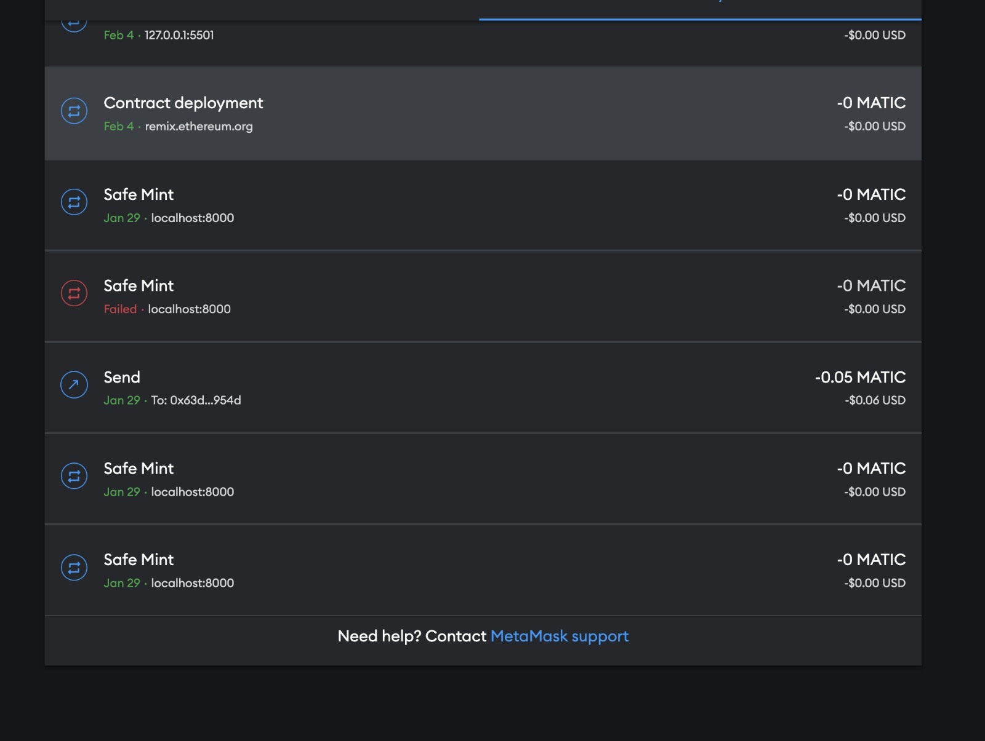

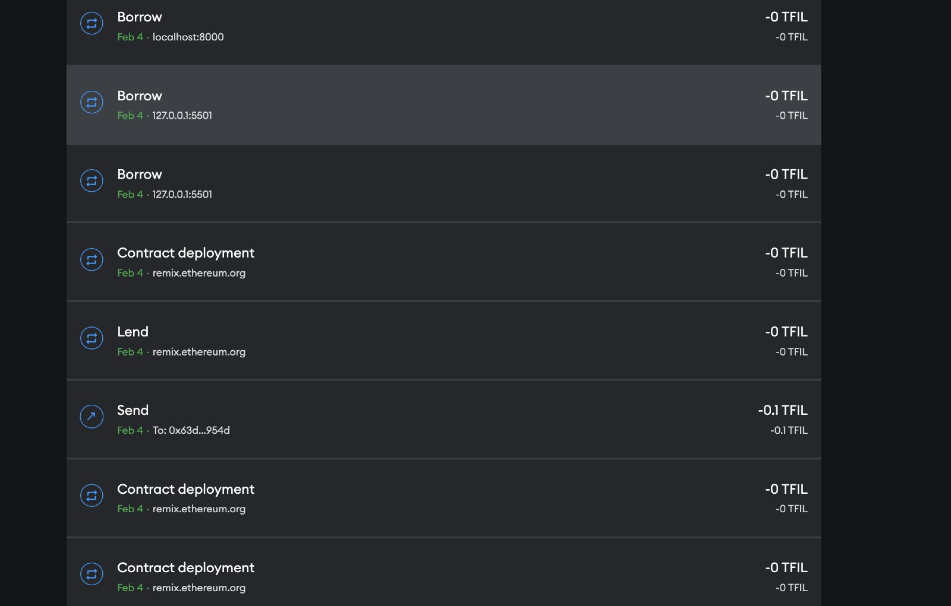

**Complete Implementation of the website:**

We are proud to offer a secure and efficient solution for lending and borrowing crypto assets. Our program provides a unique and innovative way for you to take advantage of the growing crypto market and achieve your financial goals.

The main page includes the details about the team, the website, why choose our website and how our application works.

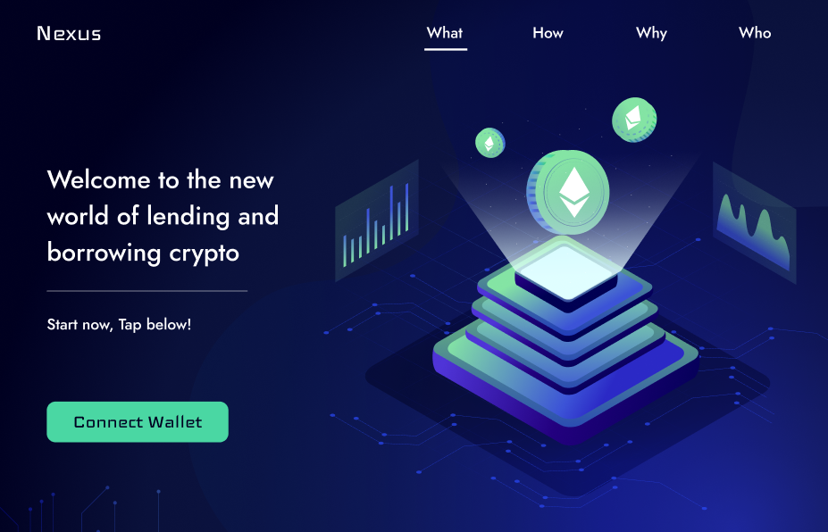

The connect wallet button allows the user to mint the profile NFT and to enable the lending/borrowing process.

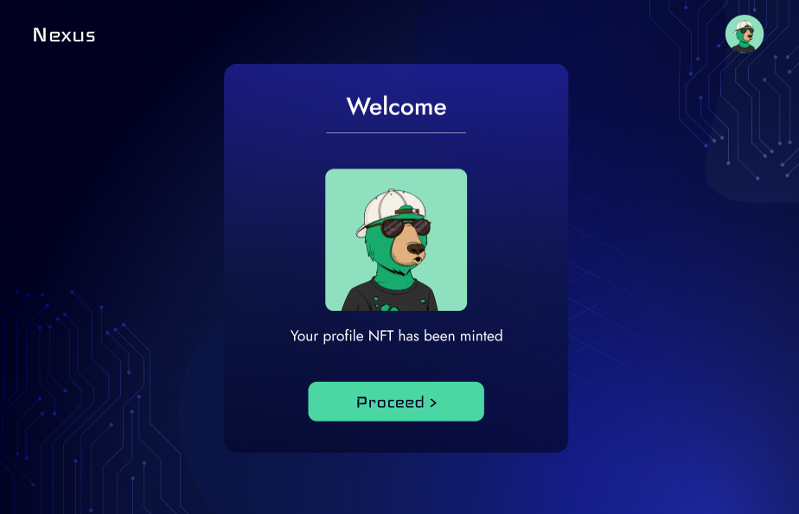

After successfully connecting the wallet by meta-masking deployed using polygon, the user is now able to lend/borrow the money through a smart contract for integrating the lending and borrowing of the funds deployed on FVM.

After this we go to the dashboard of the website. On the dashboard, a user can choose to either lend or borrow the funds as shown:

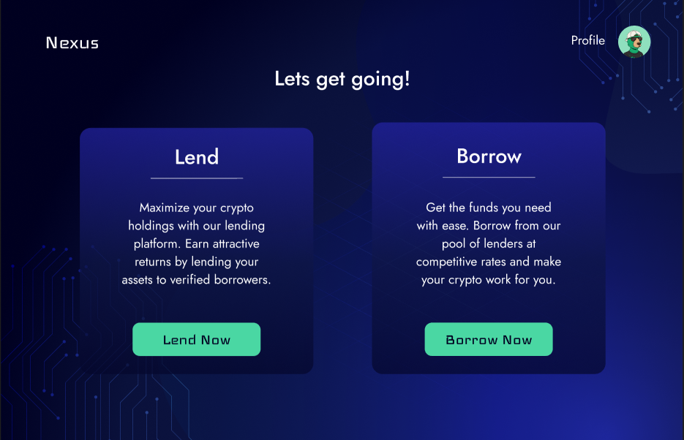

Here, on the dashboard we get option to Lend or Borrow crypto coins.

If clicked on borrow:

A borrower can choose the type of token and the amount they wish to borrow. Here, a borrower ID, the amount to be borrowed, credit score and the wallet address of the borrower will be passed to the request list from where the lender can choose to lend the funds to a borrower at a calculated risk.

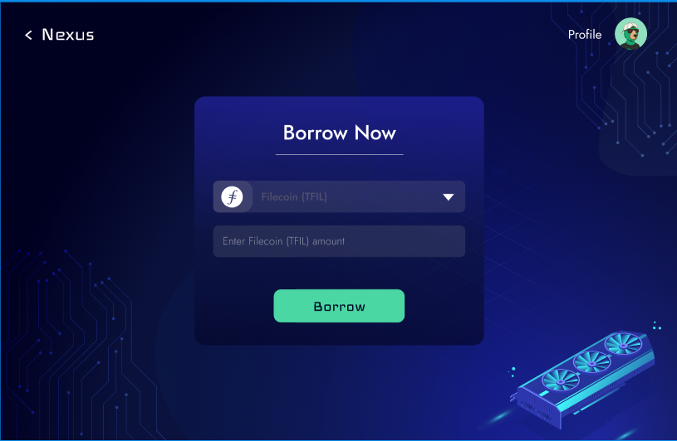

On clicking borrow button, the meta-mask will be switched from polygon and will get deployed on FVM.

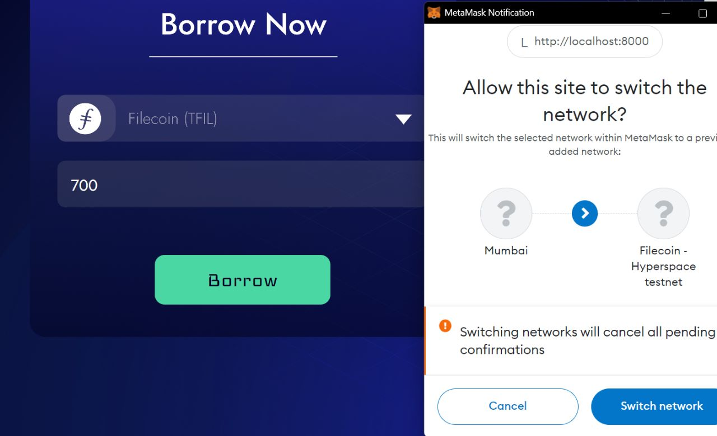

The borrower is bound to pay the full amount inclusive of the interest rate within the decided tenure or else he/she would lose the hold of their owned liquidity.

If clicked on lend:

Alternatively, if a user clicks on Lend Button on the dashboard then they will be directed to the following page which shows the list of requests and here lender can choose to lend the funds to borrower of your choice.

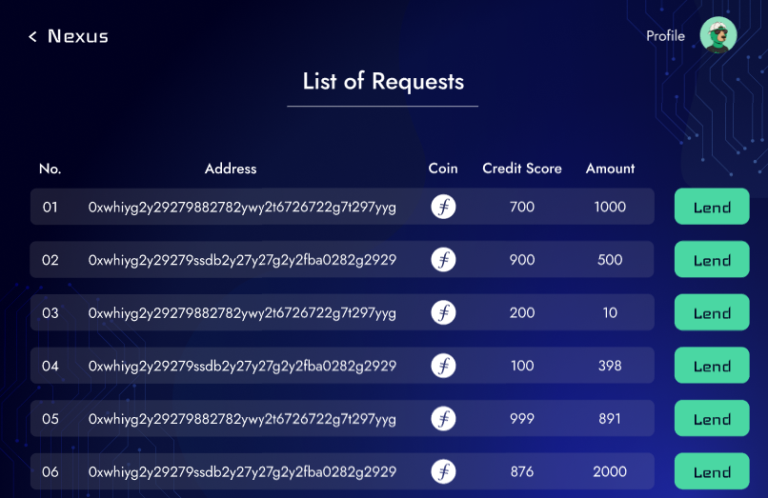

The lending page allows the lender to choose the interest rate and the tenure for which he/she wants to lend the funds.

By clicking on the lend button, the amount will be transferred to the borrower through our smart contract.

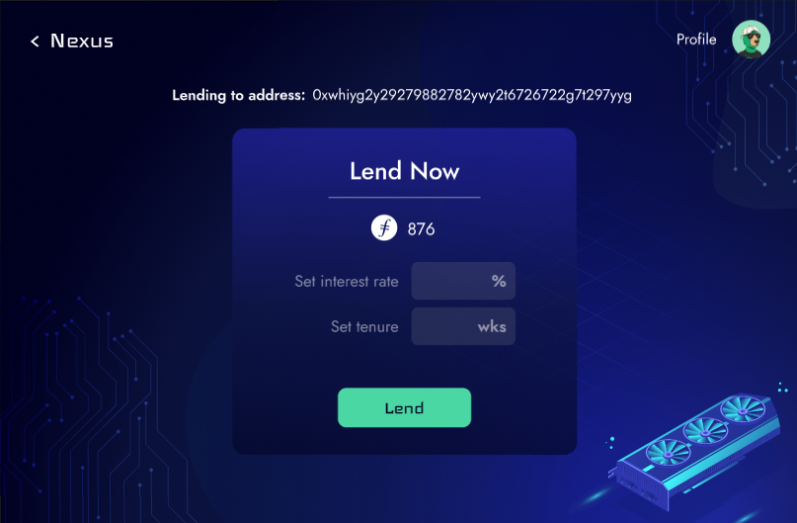

On clicking the Lend button, the meta-mask will be switched from polygon and will get deployed on FVM.

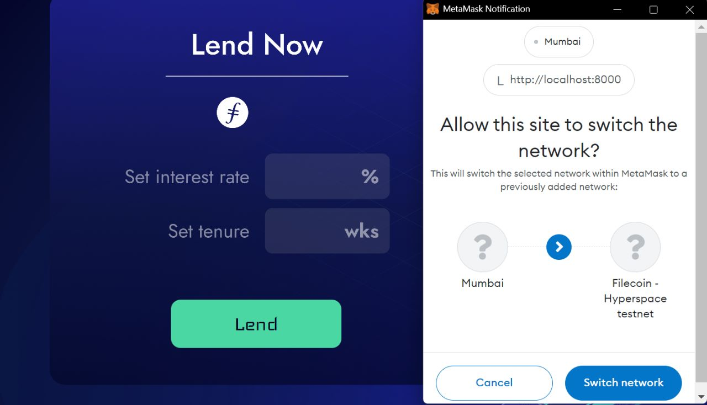

A user will be able to view their previous transaction details in the user profile.



     