User Manual

The program can be found on github at the link: <https://github.com/notsign/893FinalProject>

General Overview:

A megaman/mario style game where the player is placed in a pre-made level and has to fight enemies.

Controls

|  |  |
| --- | --- |
| Button | Description of Function |
| Left Arrow Key | Move left |
| Right Arrow Key | Move right |
| Z | Jump |
| X | Shoot |

Instructions:

1. Main Menu



You launch the game and the first screen that pops up is the main menu screen above. To start the game. Click the start button.

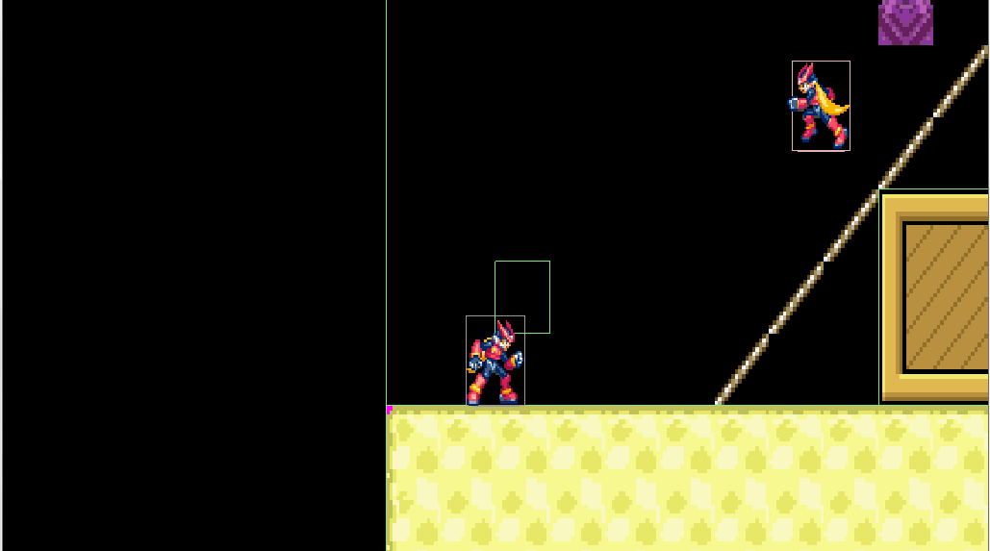

You will spawn into the game and immediately enemies will spawn from the purple blocks located around the map. The blocks cannot be destroyed.

If you hit X, the player will shoot a bullet that is represented by a pink box

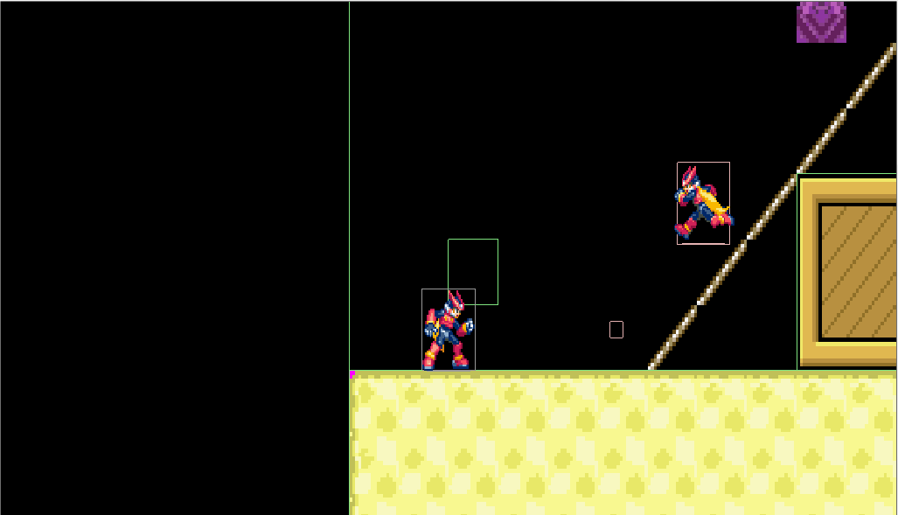

When the bullet collides with the enemy, the enemy will disappear

If the player collides with the enemy, you are transferred over to the game over screen



The screen above is the game over screen. From here you can respawn by clicking the respawn button or you can go back to the main menu by clicking the main menu button.

The objective of the game is to stay alive for as long as possible.