Republic of the Philippines

**DAVAO DEL SUR STATE COLLEGE**

**(Formerly SPAMAST– Digos Campus)**

Matti, Digos City Davao Del Sur

**INSTITUTE OF COMPUTING, ENGINEERING AND TECHNOLOGY COMPUTINGDEPARTMENT**

**CAPSTONE CONCEPT PAPER**

**Smart Event Organizer:**

An Online Platform for Seamless Event Planning and Coordination

**I. CAPSTONE FOCUS**

This capstone project focuses on developing a web-based and mobile-based platform that

aimed streamlining the process of organizing events, The system will feature online event Booking, AI-powered weather forecasting, and automated task scheduling The system will also provide real-time communication between clients, organizers, and suppliers, the platform will integrate online payment gateways and supplier management to simplify service transactions and well-coordinated, hassle-free events.

**II. BACKGROUND OF THE STUDY**

* **Introduction**

The Smart Event Organizer is an online Event Planning and Coordination and also to allow only registered user login and new user are allowed to register on the application .This proposed to be a web application. The system project provides most of the basic functionality required for an event type like for example marriage, birthday party, etc., the system then allows the user to select date and time of event, place and the event equipment. All the data is logged in the database and the user is given a receipt number for his booking. The data is then send to administrator and they may interact with the client as per his requirement.

* **Problem Statement**

Many event Organizers still continue to rely on manual methods for planning and coordination, leading to inefficient workflows, miscommunication, and unexpected delays. These issues often result in poorly organized events and dissatisfied clients. The lack of a centralized and automated system, prevents event organizers from effectively managing tasks, monitoring suppliers, and predicting weather conditions. The absence of real-time communication tools makes it difficult for clients, organizers, and suppliers to collaborate effectively. These issues still remain unresolved. The Smart event project aims to address these challenges by providing an Online platform that simplifies event coordination, enhances communication, and reduces manual workloads, leading to more organized and hassle-free events.

* **General Description of Solution**

The solution involves the design and implementation of **Smart Event Organizer: An Online Platform for Seamless Event Planning and Coordination** is a web-based and Mobile-based system designed to simplify the event planning process by providing anautomated and centralized platform. The system will allow event organizers to create andmanage events, assign tasks, that can communicate with suppliers, and process payments inone platform. The system will integrate AI weather forecasting to provide real-time weatherupdates, helping organizers make better decisions regarding outdoor events. It will also featureautomated task scheduling that generates to-do lists based on the event type and date.Through its real-time chat functionality, the system will facilitate seamless communicationbetween clients, organizers, and suppliers. Accessible through both web and mobilePlatforms, the system will ensure that users can manage their events anytime and anywhere.

* **Objectives of the Study**

The main purpose of this capstone project is to design a web based and mobile based system that is able to automate and improve event management processes in Smart Event Organizer: An Online Platform for Seamless Event Planning and Coordination. The system will have modules for administrators, event organizers, clients and suppliers to ensure that coordination, communication and transactions are well coordinated.

Specifically, it aims to:

**1. Create an Admin Module that has the following functions:**

1.1. CRUD (Create, Read, Update, Delete) operations for user accounts

1.2. CRUD operations for user information.

1.3. CRUD operations for event records and system data.

1.4. Manage and monitor bookings, payments, and supplier transactions.

1.5. Generate analytics and reports on events, bookings, and payments.

1.6. Oversee system security, including authentication and data privacy.

**2. Create an Event Organizer Module that has the following functions:**

2.1. Create and manage events, including schedules and task assignments.

2.2. Communicate in real time with clients and suppliers.

2.3. Monitor bookings, payments, and supplier services.

2.4. Access AI-powered weather forecasting for event planning.

2.5. Receive notifications and reminders for event updates and deadlines.

**3. Create a Client Module that has the following functions:**

3.1. Register, log in, and manage a personal profile.

3.2. Book events, select event details (venue, date, time, services), and confirm payments.

3.3. Communicate with organizers and suppliers for real-time updates.

3.4. Receive notifications and reminders for upcoming events.

3.5. View event history and transaction records.

**4.Evaluate the system in terms of:**

4.1. Functional Suitability;

4.2. Performance Efficiency;

4.3. Usability;

4.4. Reliability;

4.5. Maintainability; and

4.6 Compatibility;

* **Significance of the study**

The **Smart Event Organizer**: Is a web and mobile system for automating and streamlining event management. It has user registration, event booking, automatic scheduling of tasks, AI-driven weather forecasting, real-time communication, online payment integration, and supplier management. The system provides cross-device accessibility and data analytics to support decision-making.These all cumulatively hail as some important limitations that a platform has: Ability to function only with internet connectivity which is quite stable; Ability to consult even when the AI gives inaccurate weather forecasts; and Ability to control the logistics management without proper and physical supervision. In some instances, the payment gateway can only be accessed from certain regions, so some members may need training on how to use the platform. Security is guaranteed, but concerns on privacy remain. Therefore, despite these limitations, it enhanced a lot the effectiveness, coordination, and organization that inspire event planning efforts.

**III.REVIEW ON CAPSTONE RESEARCH AREA**

### Table 1. List of Systems that Image Processing has been Applied

|  |  |  |  |  |  |
| --- | --- | --- | --- | --- | --- |
| **Name of Systems** | **Author/Year** | **Description** | **Strength** | **Weakness** | **Application** |
| **Eventbrite** | Eventbrite, Inc. / 2006 | A widely used event management and ticketing platform that offers event creation, registration, and marketing tools. | Highly scalable, user-friendly, integrates with various social media platforms. | Limited customization options for advanced event planners. | Used for  organizing and promoting  events like conferences, workshops, and fundraisers. |
| **Cvent** | Cvent, Inc. / 1999 | A comprehensive event management software offering tools for event registration, venue selection, and budgeting. | Advanced reporting and analytics, highly customizable for large-scale events. | Can be complex for smaller event planners to navigate and requires extensive training. | Primarily used  by corporate  event planners,  Large  conferences,  and trade shows. |
| **Whova** | Whova / 2014 | An event management and networking app offering features like attendee engagement, session scheduling, and event analytics. | Strong attendee engagement tools, including networking and gamification features. | Limited vendor management features compared to other platforms. | Used for  conferences, conventions,  and hybrid  events,  offering both  in-person and  virtual event management. |
| **Asana** | Asana / 2011 | A project management tool that can be adapted for event planning, offering task assignments, deadlines, and team collaboration. | Highly versatile, easy task management, great for organizing team collaboration. | Not specifically designed for event planning, lacks event-specific features like vendor management. | Useful for  managing  smaller events  or teams,  especially for  task and  Deadline  tracking. |
| **Trello** | Trello / 2011 | A flexible visual project management tool based on boards, lists, and cards, widely used for event planning tasks. | Easy to use, highly visual, and adaptable to various event planning needs. | Limited advanced features, may not be ideal for large-scale event management. | Best for  small-scale  events, and  organizing  individual event planning tasks  or schedules. |
| **Bizzabo** | Bizzabo / 2011 | An event management platform offering tools for event marketing, attendee engagement, and event analytics. | Excellent attendee engagement tools, seamless integration with event marketing and analytics. | The learning curve for new users, limited customization options for advanced features. | Used for  conferences, corporate  events, and  large gatherings, focusing on  attendee  experience and engagement. |

## III.Conceptual Framework

## The conceptual framework for Smart Event Organizer is built on the integration of web-app technology and event planning tools to streamline the event management process.

1. **Existing**  
   No existing study has created a concept like this for Smart Event Organizer app-based system.
2. **Proposed New Modification**

The Smart Event Organizer will have several advanced features that are expected to improve user experience and enhance overall efficiency. A real-time venue availability system will allow instant checking and booking of venues for real-time venue availability; AI event assistant helps planning, vendor suggestion, and task management. A customizable event package can be created by clients, including services like catering and decorations. The system will include good supplier management to enable organizers to compare prices, reviews, and availability. A conflict-free scheduling system will eliminate double-booking; notification via mobile and SMS will be immediate. Online payment will provide a secure transaction for payments. It will also set the organizer’s tools to send invitations to guests and keep track of plans, automatic event reports, and a collaboration feature where multiple users can manage events together. These changes will make event planning much smoother, secure, and high-efficient.

Conceptual Frameworks

Input Stage Processing Stage Output Stage

IMG_256Event Details

* Real-time data tracking, scheduling, and task delegation
* Vendor selection and contract management
* Budget tracking and expense management
* Registration and engagement tracking
* Analysis of feedback and attendee satisfaction

 Event schedule, task progress updates

IMG_256Vendor contracts,contact details, and schedules

IMG_256 Budget reports, cost breakdowns

IMG_256Attendee lists, feedback, engagement insights

IMG_256 Event improvements, attendee satisfaction ratings

IMG_256Vendor Information

Budget Data

IMG_256AttendeeInformation

Customer feedback

**IV. METHODOLOGY**

**Project Locale:**This study will be conducted at the Daniella’s Function Hall, situated in Lapu-Lapu Tandang sora St. Digos City, Philippines. It was selected for its comprehensive event management features like real-time collaboration, budget tracking, and vendor management. It was chosen for its ability to meet the growing demand for efficient, mobile-based solutions in the event planning industry.

offering organizers a streamlined and user-friendly tool for both small and large events 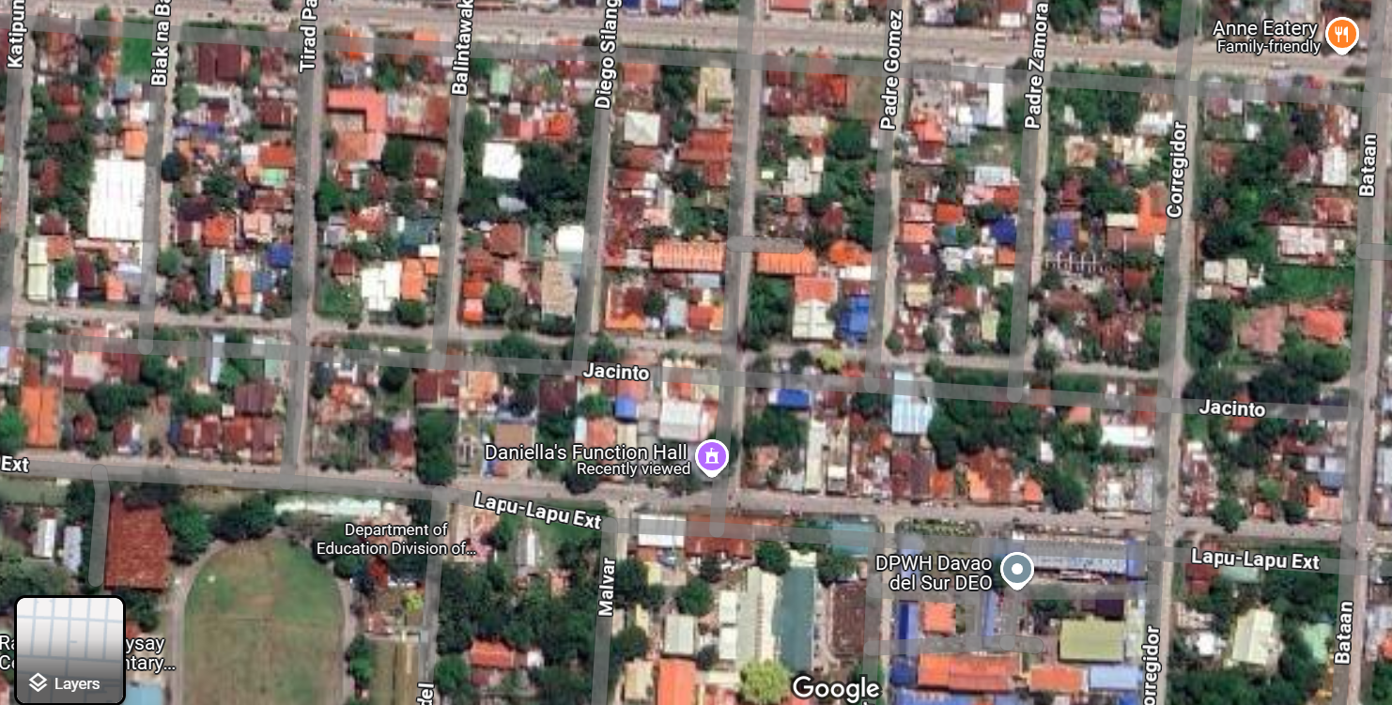

**Development Process**

The study will adopt the “Systems Development Life Cycle (SDLC) Waterfall Model”, a structured and linear approach with distinct phases that ensure systematic progress. This methodology is suitable for the development of the **Smart Event Organizer** platform, as it focuses on clearly defined project requirements such as event scheduling, budget tracking, vendor management, attendee engagement, and feedback collection. By following this approach, the study aims to optimize the event planning process, enhance communication among organizers, improve overall event execution, and provide valuable insights through real-time feedback to further improve the event experience for attendees and organizers

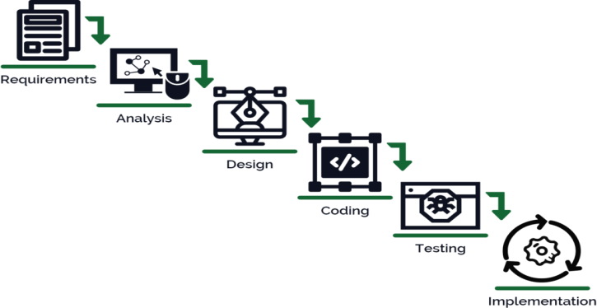

### ****Tools and Technologies****

#### ****Software:****

* **PHP:** Used for backend development, enabling seamless integration of event scheduling, budget tracking, and vendor management.
* **HTML/CSS:** Essential for creating the structure and styling of the mobile app's interface, ensuring an attractive and user-friendly design.
* **Firebase:** A cloud-based backend service that simplifies development with real-time database capabilities, authentication, and push notifications, ideal for managing dynamic features like event updates, attendee interactions, and real-time collaboration.
* **Bootstrap:** For responsive and stylish frontend design, ensuring the mobile application looks and functions flawlessly across various Android devices.
* **MySQL:** Provides reliable local data storage and management for user information, event details, and offline access to schedules.

**Hardware:**

* Personal Laptop
* Personal Phone

**How the Project will works?**

The Smart Event Organizer platform is an online and mobile tool that automates the key processes in planning an event to ease the workflow. Therefore, all users-clients, event organizers, and suppliers-have to register and log in to access features for their specific role. Clients can book events and customize service options like catering and decoration and receive a recommendation from AI. Organizers manage schedules and task allocations with real-time chats and notifications with suppliers. The system comes with an AI-powered weather forecast, secure online payment options, and tracking of guest RSVP to ease events preparations. Suppliers can list services for booking and availability updates. Automated task scheduling helps keep everything on track, and dashboards that are real-time display of event status, finances, and reports. The platform allows collaborative interaction among multi-users through instant notifications, thereby ensuring seamless communication and coordination for more efficient and timely execution of event planning.

**Phase 1: Research and Planning**

* Needs Assessment: Engage with event planners, organizers, and attendees to identify challenges in event management, including scheduling, budget tracking, vendor coordination, and attendee engagement.
* Requirement Definition: Determine essential features such as real-time collaboration, task automation, budget management, vendor coordination, and attendee engagement tools.
* Workflow Design: Map out workflows for event scheduling, budget tracking, vendor management, task automation, and attendee interactions to ensure a seamless user experience.

**Phase 2: System Design and Development**

* System Architecture: Design the mobile app using a robust backend (Java/Kotlin) and a responsive user interface with Material Design. Integrate Firebase for real-time data synchronization and push notifications.
* Event Scheduling: Develop a user-friendly event scheduling system with real-time updates and calendar integration.
* Budget Management: Implement a comprehensive budget tracking feature to help organizers manage expenses and monitor financial health.
* Vendor Management: Build a module for managing vendor contacts, contracts, and scheduling, streamlining the coordination process.
* Task Automation: Create automation tools to handle repetitive tasks such as reminders, follow-ups, and task assignments.
* Attendee Engagement: Develop interactive features like live polls, Q&A sessions, and personalized notifications to enhance attendee participation.
* Feedback Collection: Integrate a feedback system for attendees to provide real-time reviews and ratings, enabling organizers to improve future events.

Interface Design create intuitive, user-friendly interfaces for event organizers, vendors, and attendees, ensuring easy navigation for event scheduling, budget tracking, vendor coordination, task management, and attendee engagement.

**Phase 3: Testing and Deployment**

* System Testing: Test the app’s functionality, including event scheduling, real-time collaboration, budget tracking, and notification systems. Ensure the app performs smoothly across various devices and platforms.
* Usability Testing: Gather feedback from event planners and attendees to refine the user experience and improve the app’s usability.
* Deployment: Deploy the app to the app stores with a pilot phase to identify and fix any potential issues before a full-scale launch.

**Phase 4: Monitoring and Evaluation**

* Performance Monitoring: Continuously monitor the app’s performance, focusing on speed, security, and reliability to ensure optimal user experience.
* User Feedback: Collect regular feedback from users (event organizers, vendors, and attendees) to implement iterative improvements.
* Impact Analysis: Assess how well the app meets its objectives of streamlining event management, improving organizer efficiency, and enhancing attendee engagement.

**Phase 5: Scalability and Future Enhancements**

* Adaptation: Scale the app to support larger events and multiple user groups, including large conferences and diverse event types.
* Feature Expansion: Introduce advanced features such as integrated marketing tools, advanced analytics, and enhanced attendee interaction options.
* Training and Support: Offer ongoing training and support to event organizers and users to ensure smooth adoption and effective use of the platform.

**References**

· Smith, J., & Johnson, K. (2024). Development of an app-based event management system for enhancing client experience and operational efficiency. Journal of Event Planning Technology, 15(2), 78-92. https://doi.org/10.1016/j.eventplan.2024.02.004

· Patel, R., & Verma, P. (2023). Vendor collaboration in app-based event planning systems: A comprehensive approach to optimizing supplier relationships and event execution. International Journal of Event Management, 17(3), 112-128. https://doi.org/10.1016/j.ijem.2023.03.012

· Williams, M., & Evans, L. (2022). App-based scheduling and client engagement in event planning: A case study. Technology in Event Management, 9(4), 45-59. https://doi.org/10.1016/j.techevent.2022.04.009

· Lee, A., & Cho, D. (2023). Real-time vendor collaboration in app-based event planning systems. Journal of Event Technology, 13(1), 20-35. https://doi.org/10.1016/j.jetech.2023.01.002

· Thompson, E., & Clark, D. (2024). Integrating client feedback and review systems in app-based event management platforms. Journal of Client Experience in Events, 10(2), 91-105. https://doi.org/10.1016/j.jceevent.2024.02.001

Noted by:Submitted by:

**DOMINGO V. ORIGINES JR., IT.D Jocel Jean T. Ayao & Prencis Laika M. Asamley**

AdviserProponent

Approved by:

**DOMINGO V. ORIGINES JR., IT. D.**

Chairperson, Com. Department