Linux Assignment

# Linux Commands

# 

## Description

Went in to d drive in my system and created a directory named assignment where I created a file called flile1.txt. Edited the file using nano command and used cat to view the file in the terminal. Used head, tail, tac to view part of the file. Used “Cat >” to overwrite the file. Used rm command to remove the file. Id, date, cal, time, df, ifconfig, iwconfig to view system details. Ping command to connect to google and see details about the network packets. Created a new user and a new group and then deleted both of them. Used wc command to view the word count in the file. Used find command to find all files with pdf and txt in their name. Removed the assignment directory. Used sleep 1 to put the terminal to sleep for 1sec. Clear to clear the terminal and history to view all the recent commands. echo "User: $(whoami), Hostname: $(hostname)" && history | tail -n 40 to view the whoami hostname and history with the last 40 entries.

# Shell Scripts

## Script-1

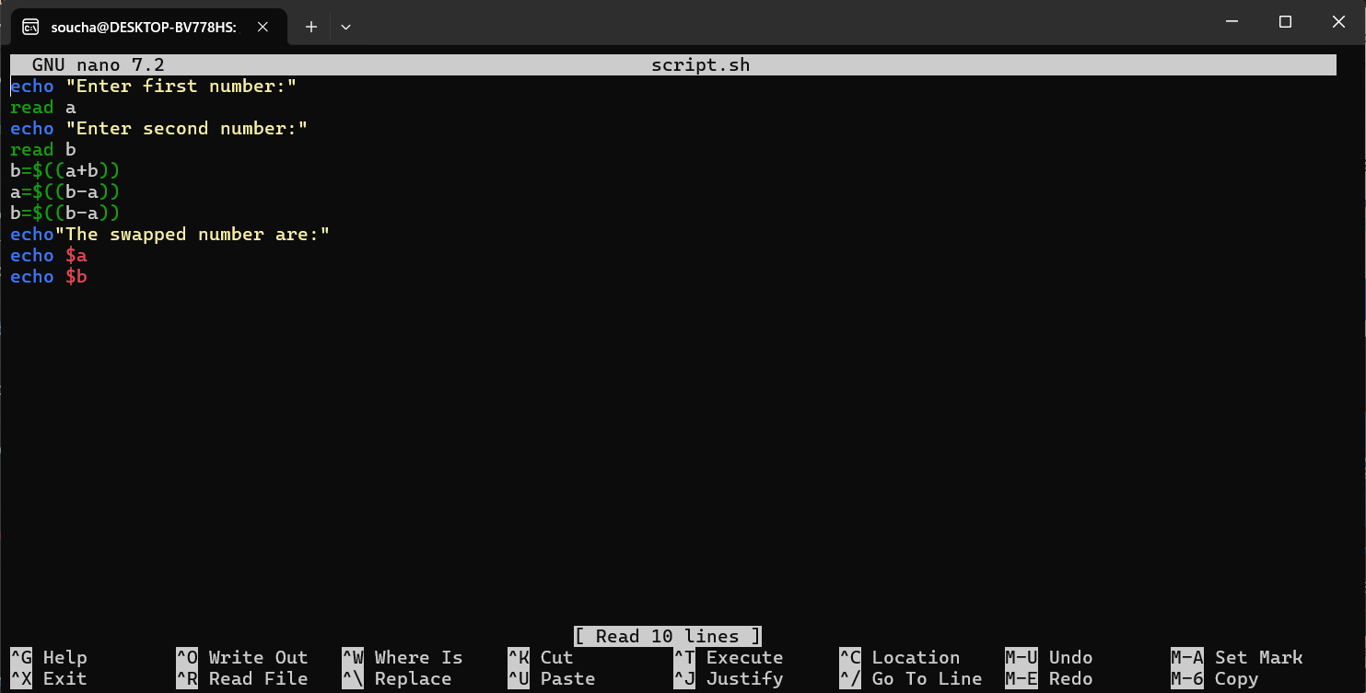

### Execution

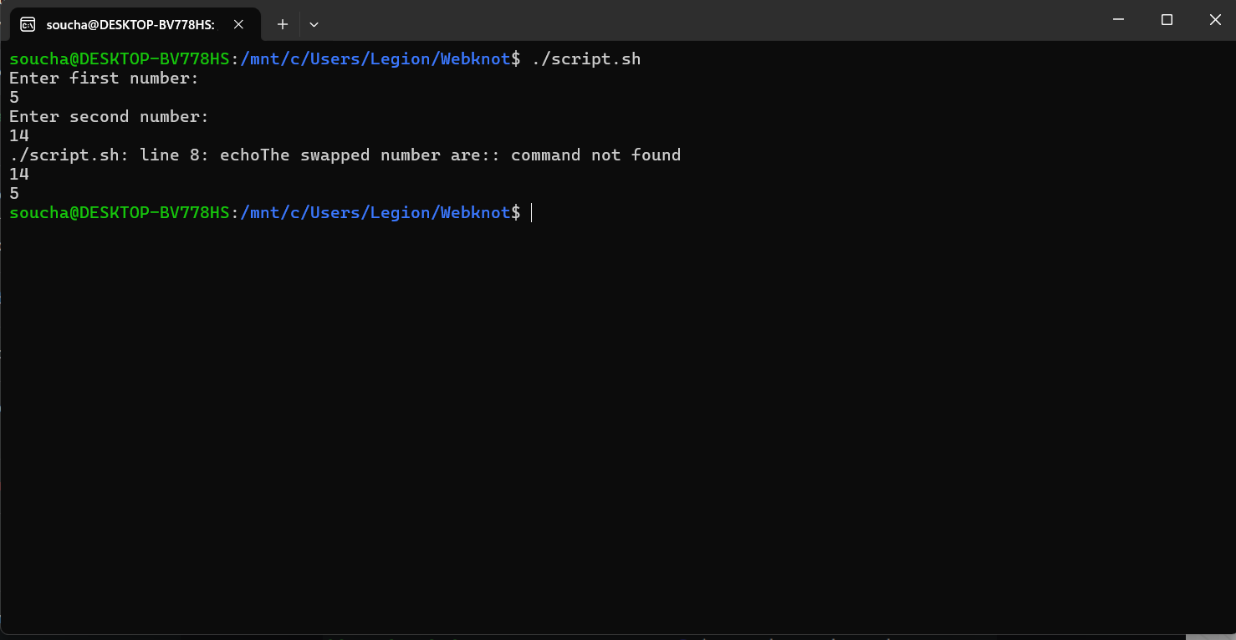

### Description

The script takes two numbers and interchanges their value of both numbers. In the script 5 is provided as the first number and 14 is provided as the second number but in result it can be seen that the first number is 14 and second number is 5.

## Script-2

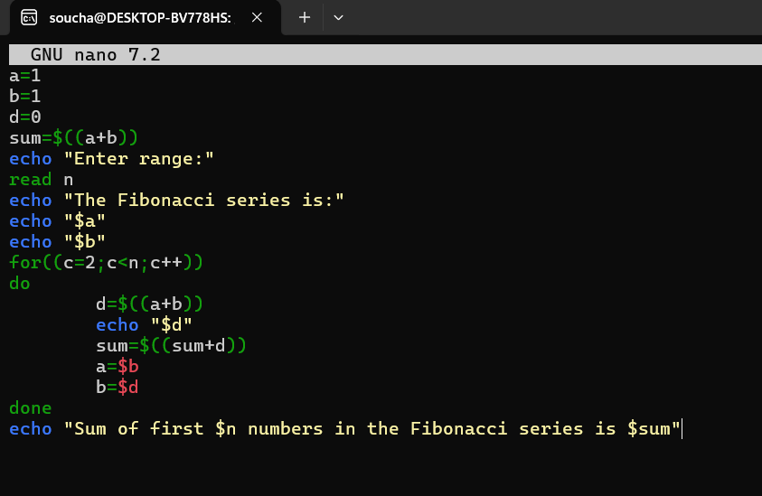

### Execution

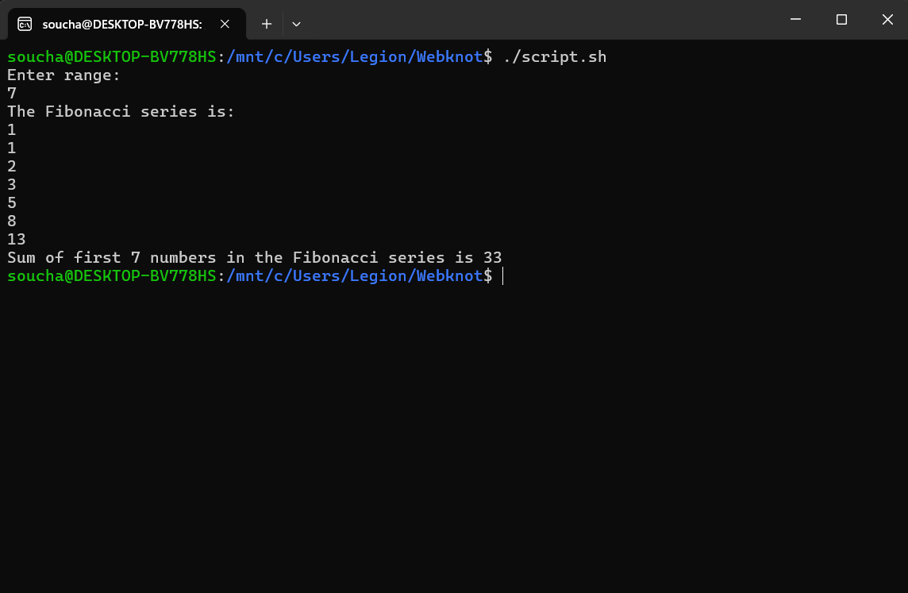

### Description

The script takes in a number and prints all the Fibonacci series till that number along with the total sum of all the numbers.

# Running a simple C program on linux

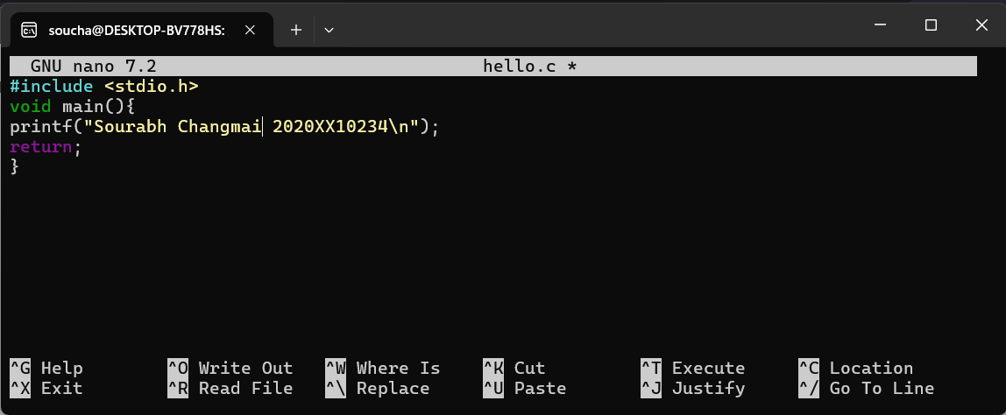

### Execution

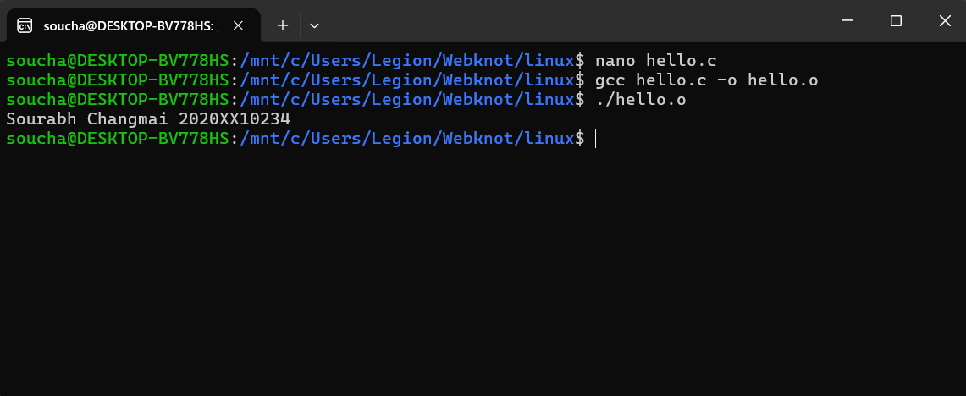

### Description

Using nano to edit hello.c and writing the c code. Then compile the code using gcc and then run the hello.o file using ./hello.o.

# Shell scripts - Research on Shell scripts

## Script to Print All .txt and .c Files

## 

### Execution

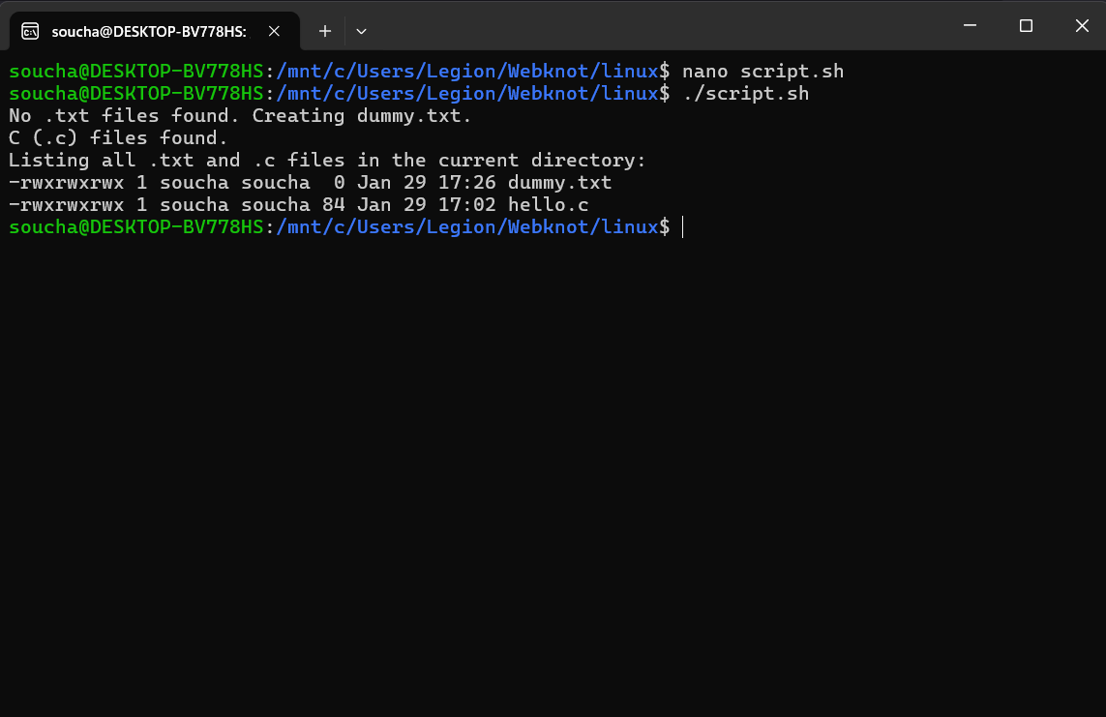

### Description

Doing check if .txt and .c files exist if it does it prints that the files are present and if not present then it creates a dummy .txt or .c file. At last prints all the files with .txt and .c present in the name.

## Script to Add Two Numbers

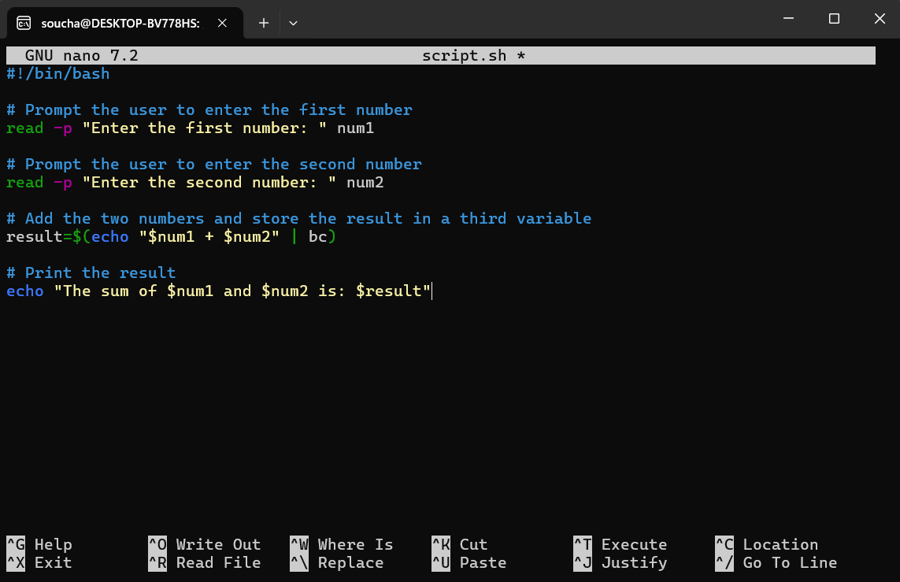

### Execution

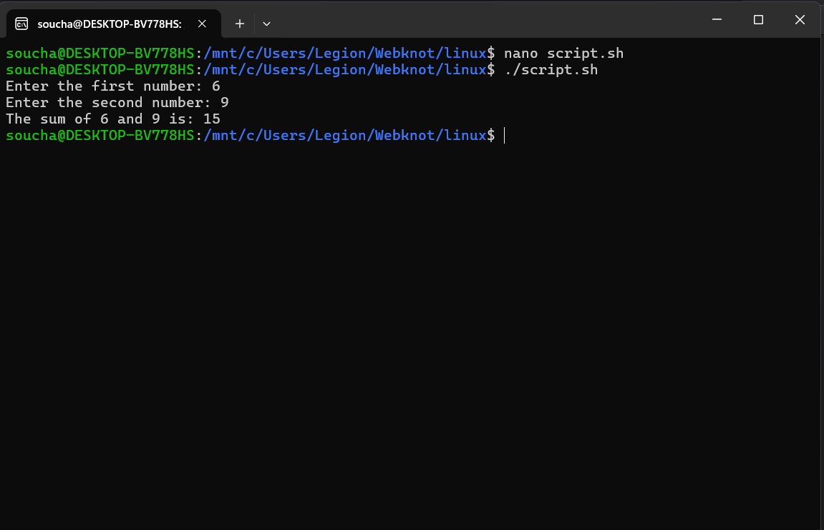

### Description

* read -p is used to prompt the user for input and store it in variables (num1 and num2).
* bc (Basic Calculator) is used to perform arithmetic operations since Bash doesn’t natively support floating-point arithmetic.
* The result is stored in the result variable.
* echo is used to print the result

## Installing Docker Using a Shell Script

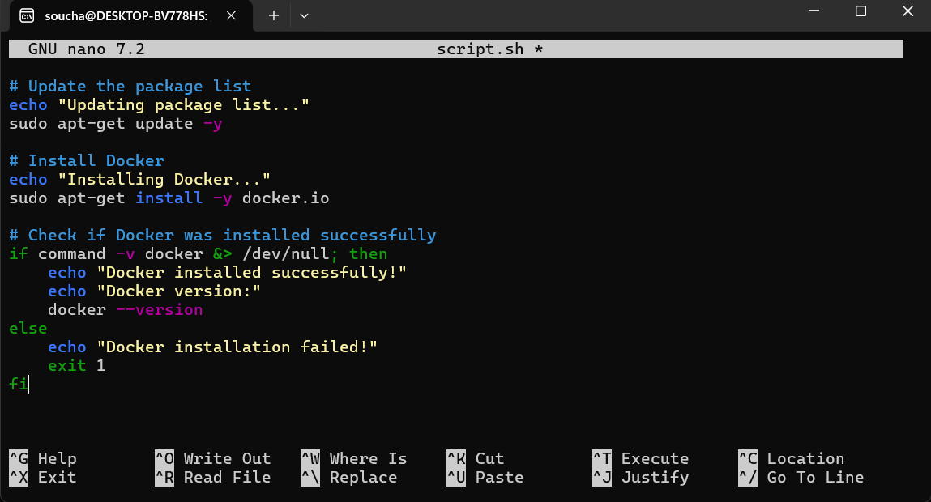

### Execution

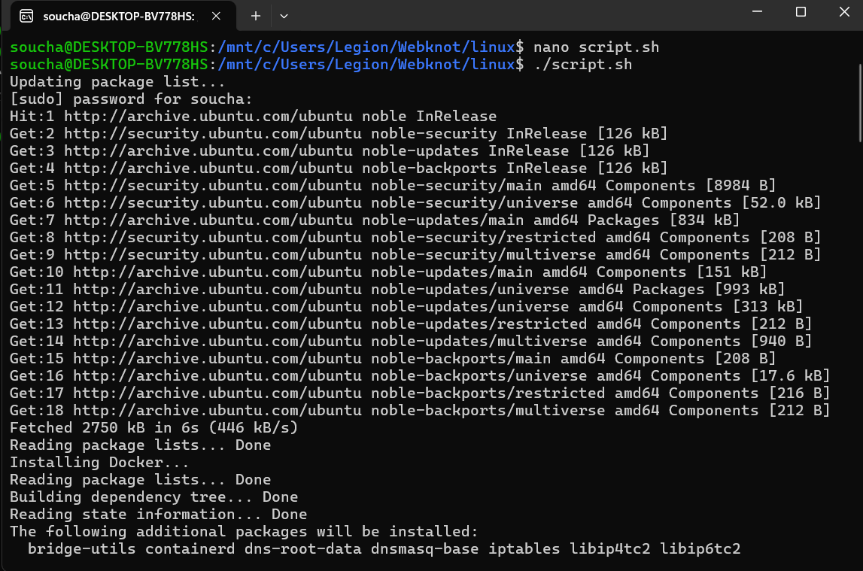

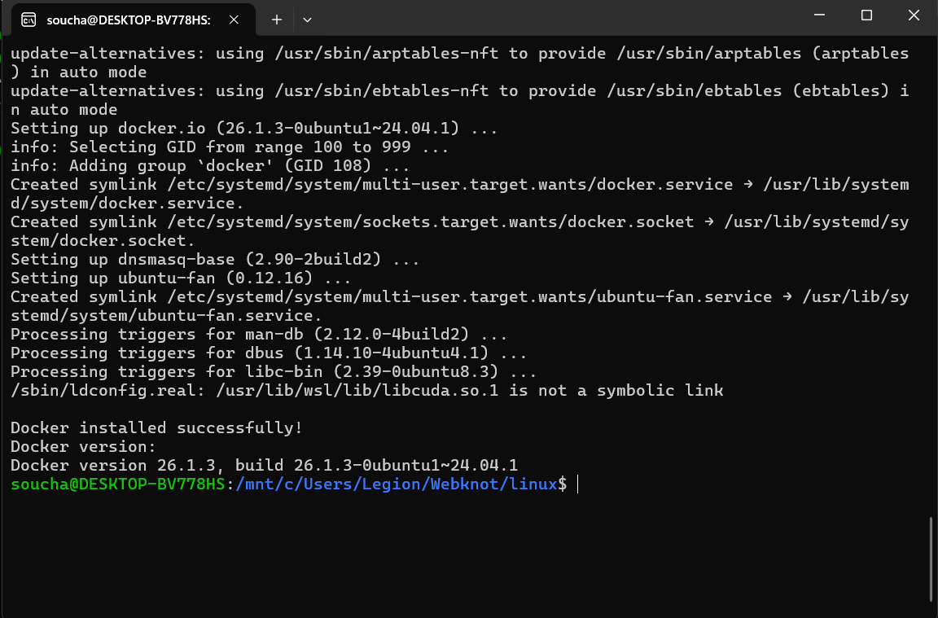

### Description

* Update the package list: The script starts by updating the package list.
* Install Docker: It then installs Docker using sudo apt-get install -y docker.io.
* Check Docker installation: The script checks if Docker was installed successfully by using the command -v docker command. If Docker is installed, it prints the Docker version using docker --version. If Docker is not installed, it prints an error message and exits with a non-zero status.

## Download and Install MySQL Database

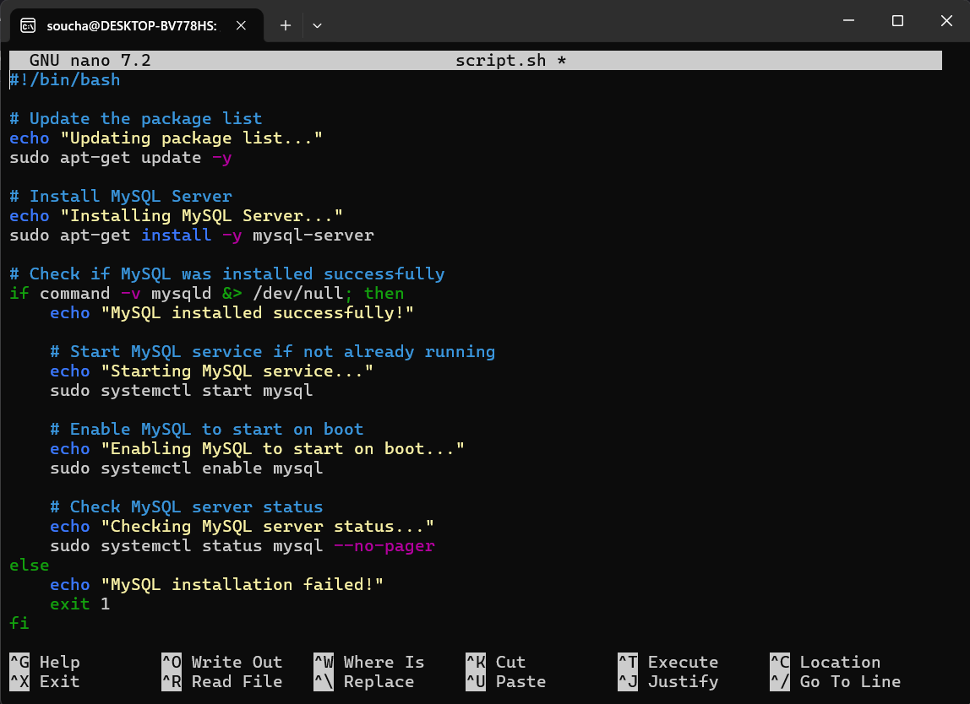

### Execution

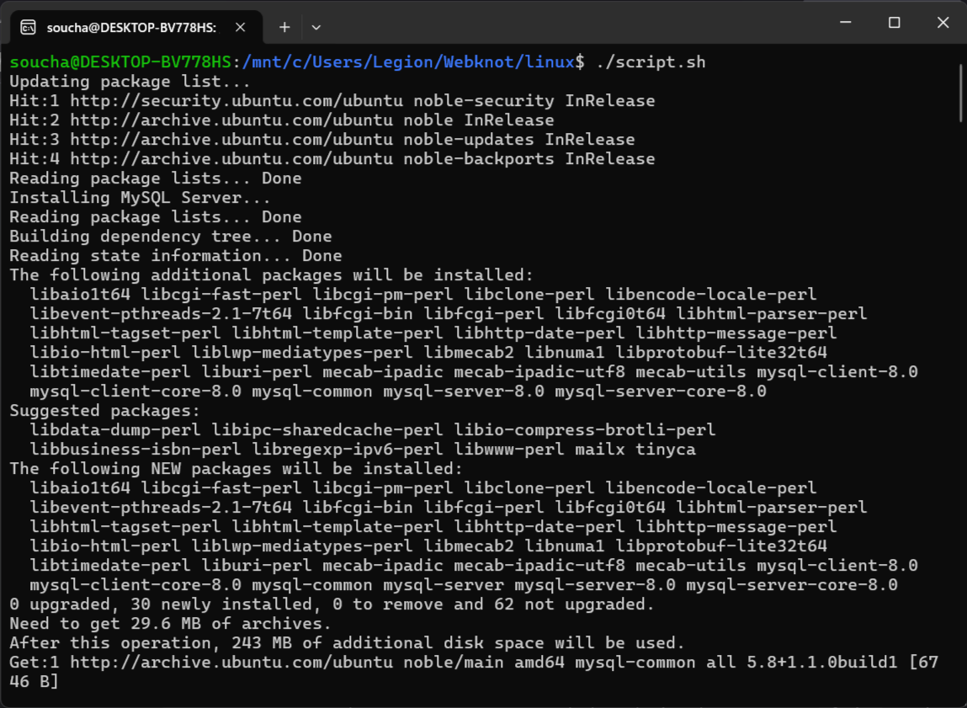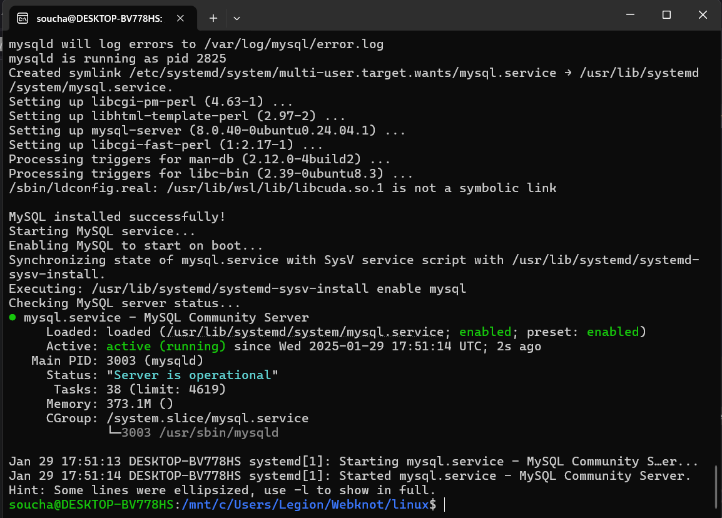

### Description

* Update the package list: The script starts by updating the package list using sudo apt-get update -y.
* Install MySQL Server: It installs MySQL Server using sudo apt-get install -y mysql-server.
* Verify MySQL installation:
  + It checks if MySQL was installed successfully by verifying the presence of the mysqld binary using command -v mysqld.
  + If MySQL is installed, it starts the MySQL service using sudo systemctl start mysql and enables it to start on boot with sudo systemctl enable mysql.
  + Finally, it checks the MySQL server status using sudo systemctl status mysql --no-pager to confirm that the service is running.