Open the folder 01-css-diner from the unit's zip file

● Open the file index.html

● Complete all levels of the game

● For each level there can be many solutions, try to find as many as you can

● Submit a css-diner.txt or a css-diner.md file in which for each level

○ Write all the solutions that you have found

○ For each solution, write the name/type of the all selectors

○ For each solution, explain how the selector works and which HTML tags it targets

● Note some of the HTML in this game is not "real"

○ For example the tags are not valid HTML. This is just a game

**Livello 1:**

TYPE OF SELECTOR 🡪 **element selector**

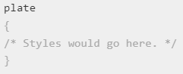

**Livello 2:**

TYPE OF SELECTOR 🡪 **element selector**

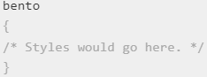

**Livello 3:**

TYPE OF SELECTOR 🡪 **ID SELECTOR**

[ID selectors - CSS: Cascading Style Sheets | MDN (mozilla.org)](https://developer.mozilla.org/en-US/docs/Web/CSS/ID_selectors)

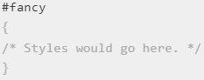

**Livello 4:**

TYPE OF SELECTOR 🡪 **RELATIONAL SELECTOR (descendant)**

[& nesting selector - CSS: Cascading Style Sheets | MDN (mozilla.org)](https://developer.mozilla.org/en-US/docs/Web/CSS/Nesting_selector)

[Descendant combinator - CSS: Cascading Style Sheets | MDN (mozilla.org)](https://developer.mozilla.org/en-US/docs/Web/CSS/Descendant_combinator)

**Combination of 2 element selectors**

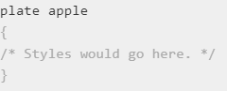

**Livello 5:**

TYPE OF SELECTOR 🡪 **RELATIONAL SELECTOR (descendant)**

[Descendant combinator - CSS: Cascading Style Sheets | MDN (mozilla.org)](https://developer.mozilla.org/en-US/docs/Web/CSS/Descendant_combinator)

**Combination of 1 element selector and 1 ID selector**

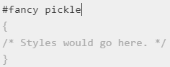

**Livello 6:**

TYPE OF SELECTOR 🡪 **CLASS SELECTOR**

[Class selectors - CSS: Cascading Style Sheets | MDN (mozilla.org)](https://developer.mozilla.org/en-US/docs/Web/CSS/Class_selectors)

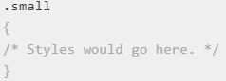

**Livello 7:**

TYPE OF SELECTOR 🡪 **GROUPS SELECTOR** + **RELATIONAL SELECTOR (descendant)**

[Selector list - CSS: Cascading Style Sheets | MDN (mozilla.org)](https://developer.mozilla.org/en-US/docs/Web/CSS/Selector_list)

[Descendant combinator - CSS: Cascading Style Sheets | MDN (mozilla.org)](https://developer.mozilla.org/en-US/docs/Web/CSS/Descendant_combinator)

**Combination of 1 element selector and 1 class selctor** (2 times)

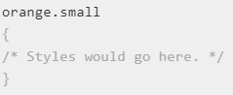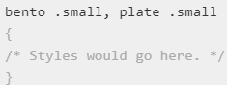

**Livello 8:**

TYPE OF SELECTOR 🡪 **RELATIONAL SELECTOR (descendant)**

[Descendant combinator - CSS: Cascading Style Sheets | MDN (mozilla.org)](https://developer.mozilla.org/en-US/docs/Web/CSS/Descendant_combinator)

**It will select <orange> elements that are inside an element with the "bento" class and simultaneously have the "small" class.**

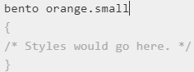

**Livello 9:**

TYPE OF SELECTOR 🡪 **GROUPS SELECTOR** + **element selector**

[Selector list - CSS: Cascading Style Sheets | MDN (mozilla.org)](https://developer.mozilla.org/en-US/docs/Web/CSS/Selector_list)

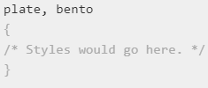

**Livello 10:**

TYPE OF SELECTOR 🡪 **UNIVERSAL SELECTOR**

[Universal selectors - CSS: Cascading Style Sheets | MDN (mozilla.org)](https://developer.mozilla.org/en-US/docs/Web/CSS/Universal_selectors)

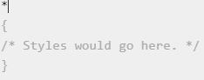

**Livello 11:**

TYPE OF SELECTOR 🡪 **UNIVERSAL SELECTOR + RELATIONAL SELECTOR** **(descendant)**

[Universal selectors - CSS: Cascading Style Sheets | MDN (mozilla.org)](https://developer.mozilla.org/en-US/docs/Web/CSS/Universal_selectors)

[Descendant combinator - CSS: Cascading Style Sheets | MDN (mozilla.org)](https://developer.mozilla.org/en-US/docs/Web/CSS/Descendant_combinator)

**We're going to select all the elements within the** **<plate>**

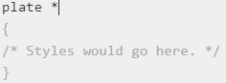

**Livello 12:**

TYPE OF SELECTOR 🡪 **GROUPS SELECTOR** **+ RELATIONAL SELECTOR** **(adjacent sibling)**

[Selector list - CSS: Cascading Style Sheets | MDN (mozilla.org)](https://developer.mozilla.org/en-US/docs/Web/CSS/Selector_list)

[Next-sibling combinator - CSS: Cascading Style Sheets | MDN (mozilla.org)](https://developer.mozilla.org/en-US/docs/Web/CSS/Next-sibling_combinator)

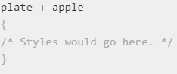**Let's select the <apple> tag if it is instantly preceded by the <plate> tag**

**Livello 13:**

TYPE OF SELECTOR 🡪 **RELATIONAL SELECTOR** **(general sibling)**

[Subsequent-sibling combinator - CSS: Cascading Style Sheets | MDN (mozilla.org)](https://developer.mozilla.org/en-US/docs/Web/CSS/Subsequent-sibling_combinator)

**select all siblings of an element that follow it. This is like the Adjacent Selector (A + B) except it gets all of the following elements instead of one.**

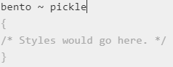

**Livello 14:**

TYPE OF SELECTOR 🡪 **RELATIONAL SELECTOR** **(direct child)**

[Child combinator - CSS: Cascading Style Sheets | MDN (mozilla.org)](https://developer.mozilla.org/en-US/docs/Web/CSS/Child_combinator)

**select elements that are direct children of other elements. A child element is any element that is nested directly in another element.**

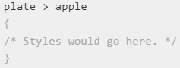

**Livello 15:**

TYPE OF SELECTOR 🡪 **RELATIONAL SELECTOR** **(descendant) + STRUCTURAL & POSITION PSEUDO-CLASSES**

https://developer.mozilla.org/en-US/docs/Web/CSS/:first-child

**A child element is any element that is directly nested in another element.**

**selects all first child <orange> elements that are in <plate> elements OR**

**select all first child <orange> elements**

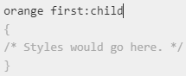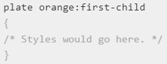

**Livello 16:**

TYPE OF SELECTOR 🡪 **RELATIONAL SELECTOR** **(descendant) + STRUCTURAL & POSITION PSEUDO-CLASSES**

https://developer.mozilla.org/en-US/docs/Web/CSS/:only-child

**select an element that are the only element inside of another.**

**It will select all elements that are the only child of the <plate> element, so they have no brothers**

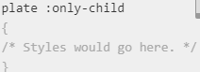

**Livello 17:**

**TYPE OF SELECTOR 🡪 RELATIONAL SELECTOR (descendant) + STRUCTURAL & POSITION PSEUDO-CLASSES**

https://developer.mozilla.org/en-US/docs/Web/CSS/:last-child

**Select the last element inside of another element.**

**We're going to select the last element contained within the #fancy id, and select all the <pickle> elements with the "small" class.**

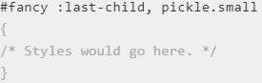

**Livello 18:**

**TYPE OF SELECTOR 🡪 STRUCTURAL & POSITION PSEUDO-CLASSES**

https://developer.mozilla.org/en-US/docs/Web/CSS/:nth-child

**select an element by its order in another element.**

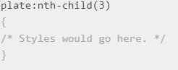

**We're going to select the 3 element of <plate>**

**EX: div p:nth-child(2) selects the second p in every div**

**Livello 19:**

**TYPE OF SELECTOR 🡪 STRUCTURAL & POSITION PSEUDO-CLASSES**

<https://developer.mozilla.org/en-US/docs/Web/CSS/:nth-last-child>

**In this case, we start from the bottom and NOT from the beginning as we did with nth-child( ), let's select the 2 <bento> starting from the BOTTOM.**

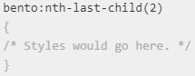

**Livello 20:**

**TYPE OF SELECTOR 🡪 STRUCTURAL & POSITION PSEUDO-CLASSES**

<https://developer.mozilla.org/en-US/docs/Web/CSS/:first-of-type>

**In this case, we are going to represent the FIRST element of type <apple>, among a group of elements of the same level / type**

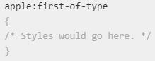

**Livello 21:**

**TYPE OF SELECTOR 🡪 STRUCTURAL & POSITION PSEUDO-CLASSES**

<https://developer.mozilla.org/en-US/docs/Web/CSS/:nth-of-type>

**In this case, we are going to match the elements based on the even position between siblings of the same type <plate>**

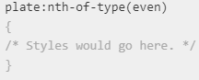

**Livello 22:**

**TYPE OF SELECTOR 🡪 STRUCTURAL & POSITION PSEUDO-CLASSES**

<https://developer.mozilla.org/en-US/docs/Web/CSS/:nth-of-type>

**In this case, we are going to match the elements of the type <plate>, STARTING with the 3rd item (also selected) and then the same type elements will be selected each 2 elements**

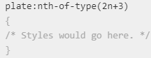

**Livello 23:**

**TYPE OF SELECTOR 🡪 STRUCTURAL & POSITION PSEUDO-CLASSES**

<https://developer.mozilla.org/en-US/docs/Web/CSS/:only-of-type>

**In this case, We're going to select the elements** that **are the only <Apple> type element within their parent, so DON’T HAVE SIBLINGS!!**

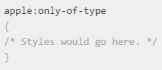

**Livello 24:**

**TYPE OF SELECTOR 🡪 GROUPS SELECTOR** **+ STRUCTURAL & POSITION PSEUDO-CLASSES**

<https://developer.mozilla.org/en-US/docs/Web/CSS/:last-of-type>

**In this case, we are going to represent the LAST element of type <apple>, among a group of elements of the same level / type**

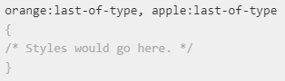

**Livello 25:**

**TYPE OF SELECTOR 🡪 STRUCTURAL & POSITION PSEUDO-CLASSES**

<https://developer.mozilla.org/en-US/docs/Web/CSS/:empty>

**In this case, we are going represents any <bento> element that has no children in it. !! CAN be either element nodes or text (including whitespace). Comments, processing instructions**

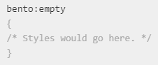

**Livello 26:**

**TYPE OF SELECTOR 🡪 STRUCTURAL & POSITION PSEUDO-CLASSES**

**Livello 27:**

**TYPE OF SELECTOR 🡪 ACTRIBUTE SELECTOR**

[Attribute selectors - CSS: Cascading Style Sheets | MDN (mozilla.org)](https://developer.mozilla.org/en-US/docs/Web/CSS/Attribute_selectors)

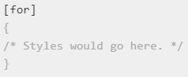

**Let's select the elements that have the for attribute**

**Livello 28:**

**TYPE OF SELECTOR 🡪 ACTRIBUTE PRESENT SELECTOR**

[Attribute selectors - CSS: Cascading Style Sheets | MDN (mozilla.org)](https://developer.mozilla.org/en-US/docs/Web/CSS/Attribute_selectors)

**Let's select all the <plate> elements that have the for attribute**

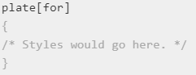

**Livello 29:**

**TYPE OF SELECTOR 🡪 ACTRIBUTE EQUALS SELECTOR**

[Attribute selectors - CSS: Cascading Style Sheets | MDN (mozilla.org)](https://developer.mozilla.org/en-US/docs/Web/CSS/Attribute_selectors)

**Let's select all the <bento> elements that have a specific value (“*value*”) in the for attribute**

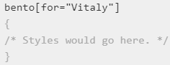

**Livello 30:**

**TYPE OF SELECTOR 🡪 ACTRIBUTE BEGINS SELECTOR**

[Attribute selectors - CSS: Cascading Style Sheets | MDN (mozilla.org)](https://developer.mozilla.org/en-US/docs/Web/CSS/Attribute_selectors)

**Let's select the elements that STARTS with a specific value (^=“*value*”) in the for attribute**

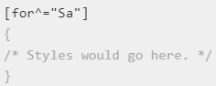

**Livello 31:**

**TYPE OF SELECTOR 🡪 ACTRIBUTE ENDS SELECTOR**

[Attribute selectors - CSS: Cascading Style Sheets | MDN (mozilla.org)](https://developer.mozilla.org/en-US/docs/Web/CSS/Attribute_selectors)

**Let's select the elements that ENDS with a specific value ($=“*value*”) in the for attribute**

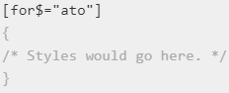

**Livello 32:**

**TYPE OF SELECTOR 🡪 ACTRIBUTE CONTAINS SELECTOR**

[Attribute selectors - CSS: Cascading Style Sheets | MDN (mozilla.org)](https://developer.mozilla.org/en-US/docs/Web/CSS/Attribute_selectors)

**Let's select the elements that CONTAIN a specific value (*=“*value*”) It doesn't matter where it is, as long as it's part of the content in the for attribute**

