For each selector, calculate the specificity explain it in a markdown file: most-specific.md

Note: Your explanation should be very detailed!

some elements when think they should Quick reference: <https://specifishity.com/>

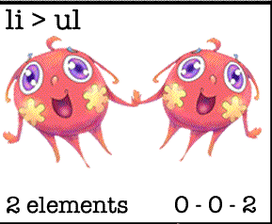**1 selettore:**

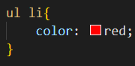

**SPECIFITY** 🡪 (0, 0, **2**)

Element has a specifity of (0,0,**1**) in this example there **are 2 elements selectors**

**2 selettore:**

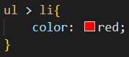

**SPECIFITY** 🡪 (0, 0, **2**)

Also in this case we have **2 elements selectors**, so the specificity is the same.

*IMPORTANT:* Combination selectors **do NOT** change/inflection specificity!!

**3 selettore:**

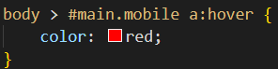

**SPECIFITY** 🡪 (1, 2, 2)

In this example we can see that we have **1 "body" element selector** which has a specifity (0,0,**1**), **1 "#main" selector ID** which has a specifity (**1**,0,0) and it is combined with **1 ".mobile" selector class** which has a specifity (0,**1**,0).

At the end we have **1 element selector"a"** (0,0,**1**) combined with **1 :pseudo-class**  whit a specifity(0,**1**,0)

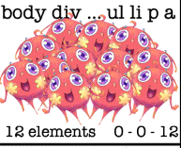**4 selettore:**

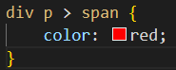

**SPECIFITY** 🡪 (0, 0, 3)

In this case we have **3 elements selectors** (0,0,**1**), remember for the last time that the combination selectors do not change the specificity.

**5 selettore:**

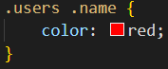

**SPECIFITY** 🡪 (0, 2, 0)

In this case we have **2 selector classes 🡪** **".user"** / **".name"** with a specifity (0,**1**,0) for everyone

**6 selettore:**

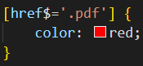

**SPECIFITY** 🡪 (0, 1, 0)

In this case we have **1 attribute selector** which has a specifity of (0,**1**,0)

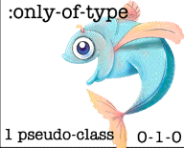**7 selettore:**

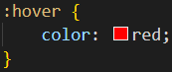

**SPECIFITY** 🡪 (0, 1, 0)

In this case we have **1 :pseudo-classes selector** which has a specifity of (0,**1**,0)

**8 selettore:**

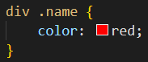

**SPECIFITY** 🡪 (0, 1, 1)

In this case we have **1 element selector “div”** (0,0,**1**) and and **1 ".name" selector class** (0,**1**,0)

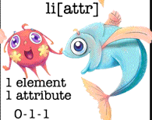**9 selettore:**

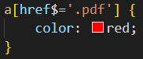

**SPECIFITY** 🡪 (0, 1, 1)

In this case we have **1 element selector “a”** (0,0,**1**) combinated whit **1 attribute selector** (0,**1**,0);

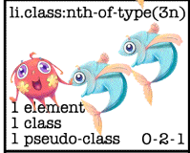**10 selettore:**

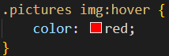

**SPECIFITY** 🡪 (0, 2, 1)

In this case we have **1 ".pictures" selector class** (0,**1**,0), and a combination of **1 element selector “img”** (0,0,**1**) + **1 :pseudo-classes selector** (0,**1**,0)

**11 selettore:**

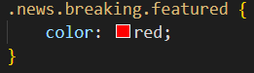

**SPECIFITY** 🡪 (0, 3, 0)

In this case we have **3 selector classes 🡪** **".news"** / **".breaking"** / **“.featured”** with a specifity (0,**1**,0) for everyone

**12 selettore:**

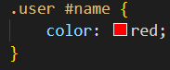

**SPECIFITY** 🡪 (1, 1, 0)

In this case we have **1 ".user" selector class** (0,**1**,0), and **1 "#name" selector ID** (**1**,0,0)

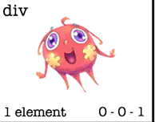**13 selettore:**

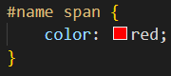

**SPECIFITY** 🡪 (1, 0, 1)

In this case we have **1 "#name" selector ID** (**1**,0,0) and **1 element selector “span”** (0,0,**1**)

**14 selettore:**

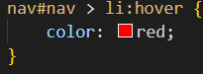

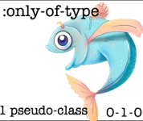********

**SPECIFITY** 🡪 (1, 1, 2)

In this case we have **1 element selector “nav”** (0,0,**1**) is combinated whit **1 "#main" selector ID** (**1**,0,0) those elements has a relation whit **1 element selector “li”** (0,0,**1**) which is combinated whit **1 :pseudo-classes selector** (0,**1**,0)

**15 selettore:**

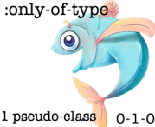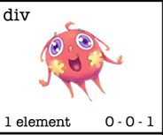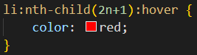

**SPECIFITY** 🡪 (0, 2, 1)

In this case we have **1 element selector “li”** (0,0,**1**), which has a double combination of **2 :pseudo-classes selector** (0,**1**,0) x2