In the exercise folder create a .txt or .doc or .md file in which you explain the difference between the following string methods:

● slice()

● substring()

● substr()

Explain the differences in terms of parameters and behavior Provide code examples to prove your point

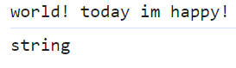-**.slice()** 🡪It extracts a section of the string and returns it as a new string, **without** modifying the original string! (count starts at 0), and will be of type **STRING:**

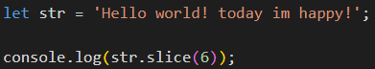

is composed of an **indexStart** ex (**4**) index of the first character to be included in the substring and is composed of an **indexEnd** (4, **10**) index of the first character to be excluded in the substring.

if you don't insert an indexEnd, you will extract to the bottom of the string (as in the previous example).

 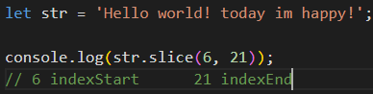

It is possible to use **negative** indexes to indicate the position from the end of the . slice(**-4**) string, with an index -4 we extract the last 4 characters of the string:

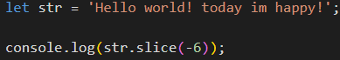

-**.substring()** 🡪 It's one of the 2 methods **very similar to .slice(),** and it does the same job as the slice (although today it's considered obsolete)

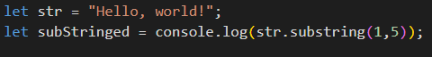

the main difference is that the substring() **does NOT allow the use of negative indexes** to indicate positions backwards from the end of the array, **and treats them as if it were 0:**



-**.substr()** 🡪 While some browsers may still support it, it may have already been removed from the relevant web standards, today it is **DEPRECATED**

returns a substring of the original string, starting with the initial **indexStart**(**2**), and **length** indicates the length of the substring to be extracted:





If the length is not **specified**, all characters from the startIndex position to the end of the string **will be** returned:

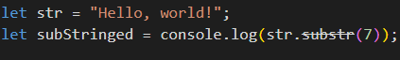

**It does NOT allow the use of negative indices for length** to indicate the length of the substring to be extracted, and treats them as if it were **0** :

