In the exercise folder create a .txt or .doc or .md file in which you explain the difference between the following array methods: ○ slice(), splice() ○ Explain the differences in terms of parameters and behavior ○ Provide code examples to prove your point

- .**slice( )** 🡪 Returns a shallow copy of a portion of an array to a new array object. It does not modify the original array but creates a new one.

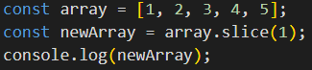

It consists of an **indexStart** ex (**4**) index from which the extraction starts, and an **indexEnd** (4, **10**) indicates *the index before which the extraction* ends.

if an indexEnd is not inserted, it will be extracted to the BOTTOM:

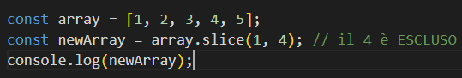

- **.splice( )** 🡪 This method **modifies the contents of an array by removing or replacing** existing elements and/or adding new elements within the array.

It is mainly composed of 3 parameters:

* **indexStart** 🡪 is the index from which to start modifying the array
* **deleteCount 🡪** is the number of elements to be removed from the array (if set to 0, no elements are removed).

If it is *omitted*, or if its value is greater than or equal to the number of elements after the position specified by , all elements after the **indexStart** of the array will be deleted

* **item 🡪** are the elements to be added to the array (0-N), starting with the **indexStart**, will be inserted before the indexStart

Examples using **indexStart** and **deleteCount**:

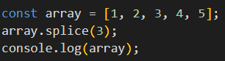

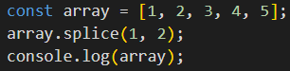



Examples using **indexStart** and **deleteCount** and **items:**

