Pollinator diversity and abundance on WCU campus

J. Ted Hillert

2022-12-11

Studies to date indicate that wild pollinator diversity has been in global decline for the last few decades with almost 1 in 4 bee species at risk of extinction (Senapathi et al. 2015, Kopec and Burd 2017). Leading causes for the loss of biodiversity are from climate change and anthropogenic causes - agricultural intensification, habitat destruction and fragmentation, pesticide use, and urbanization. Diversity in early successional meadow habitats leads to diversity in pollinators by supplying multiple food sources for generalist and specialised pollinators. *Solidago spp.* are native to North America with nearly 120 species and many cultivars. It is a late season bloomer beginning around May and rapidly growing through August when it blooms and provides an alternative food source. Outside of North America, *Solidago* is a rapidly proliferating invasive species that can outcompete native species by excreting alleleopathic compounds, clonal growth, high dispersal rate, high growth rate and shading effect over other plants (Moroń et al. 2009, 2021). Understanding the impacts of invasive species on plant-pollinator diversity leads to better understanding of management practices to prevent further invasions. A small strip of *Solidago* on WCU campus was used to sample pollinator diversity and a literature review was conducted to examine the role of this plant as an invader and the management implications.

The strip of wildflowers on WCU campus was dominated by *Solidago spp* with a few other species. When a pollinator landed on a flower for greater than 2 seconds, it counted as a “visit”. If that pollinator visited another flower, it counted as a second “visit”. Nineteen observers surveyed a one meter transect of wildflowers for two ten-minute intervals for a total of 38 observations of 1136 flower visits. Nine species types were identified - honeybees, bumble and carpenter bees, small bees, wasps, small butterflies, large butterflies, beetles, flies, and ants. Data were compiled and Shannon’s Diversity Index was calculated to estimate pollinator diversity.

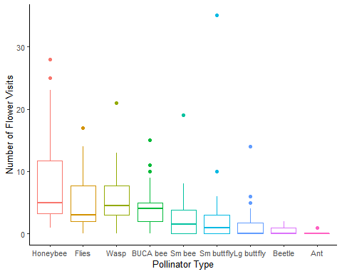

Figure 1: Pollinator abundance and diversity curve for a strip of wildflowers on WCU campus.

# References

Kopec, K., and L. A. Burd. 2017. Pollinators in peril: A systematic status review of north american and hawaiian native bees:15.

Moroń, D., M. Lenda, P. Skórka, H. Szentgyörgyi, J. Settele, and M. Woyciechowski. 2009. [Wild pollinator communities are negatively affected by invasion of alien goldenrods in grassland landscapes](https://doi.org/10.1016/j.biocon.2008.12.036). Biological Conservation 142:1322–1332.

Moroń, D., E. Marjańska, P. Skórka, M. Lenda, and M. Woyciechowski. 2021. [Invader–pollinator paradox: Invasive goldenrods benefit from large size pollinators](https://doi.org/10.1111/ddi.13221). Diversity and Distributions 27:632–641.

Senapathi, D., J. C. Biesmeijer, T. D. Breeze, D. Kleijn, S. G. Potts, and L. G. Carvalheiro. 2015. [Pollinator conservation—the difference between managing for pollination services and preserving pollinator diversity](https://doi.org/10.1016/j.cois.2015.11.002). Current Opinion in Insect Science 12:93–101.