EMPLOYEE TRANSFER MANAGEMENT
******
Installation Guide

- Open SQL Server 2008, enter login name and password to login system of SQL Server 2008

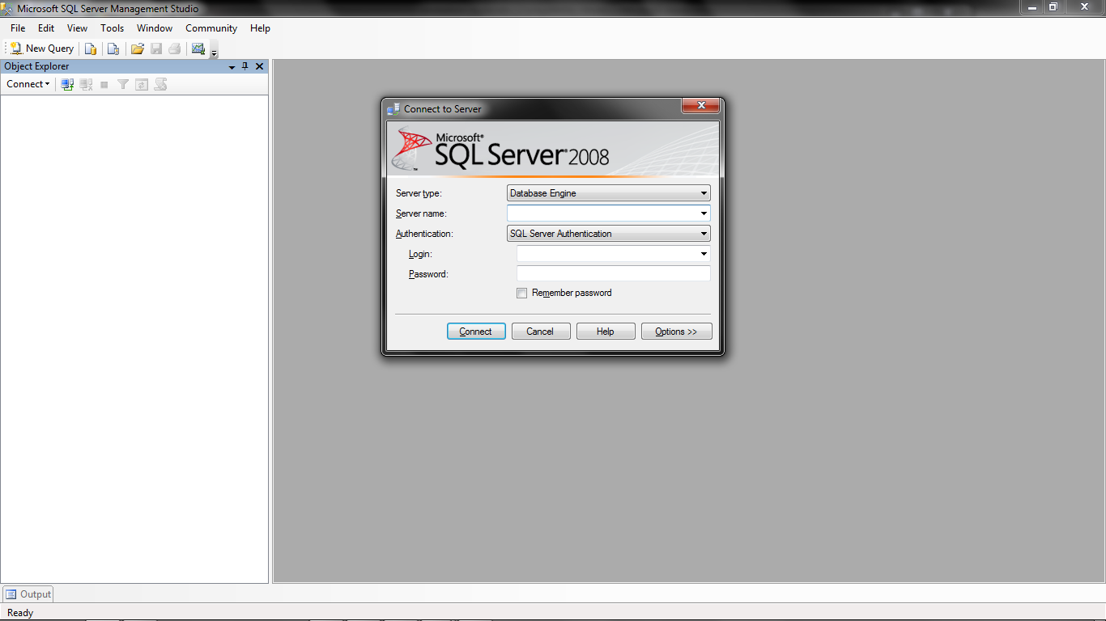
Figure 1: SQL Server 2008 Login

- Left click on “Open” and choose “etm.sql”

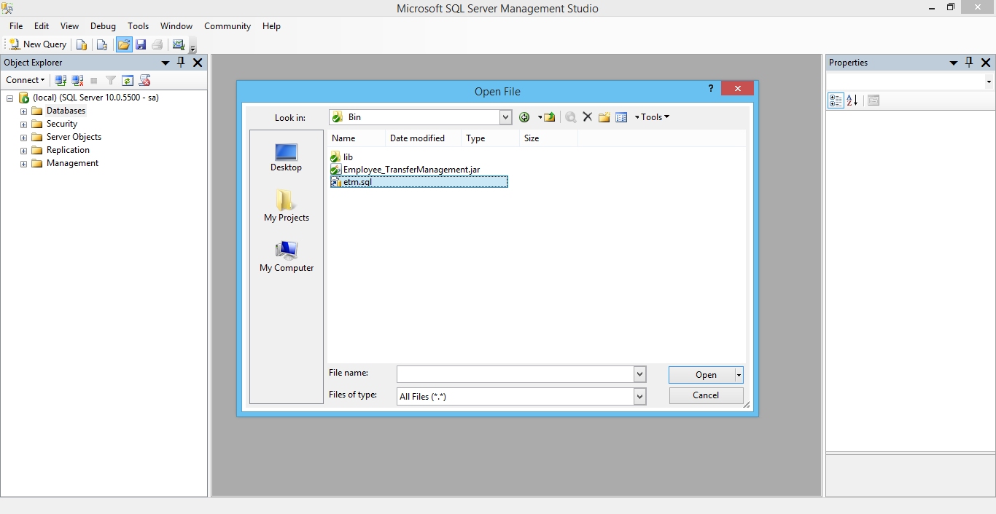
Figure 2: Choose sql file

- Then click “Execute” button

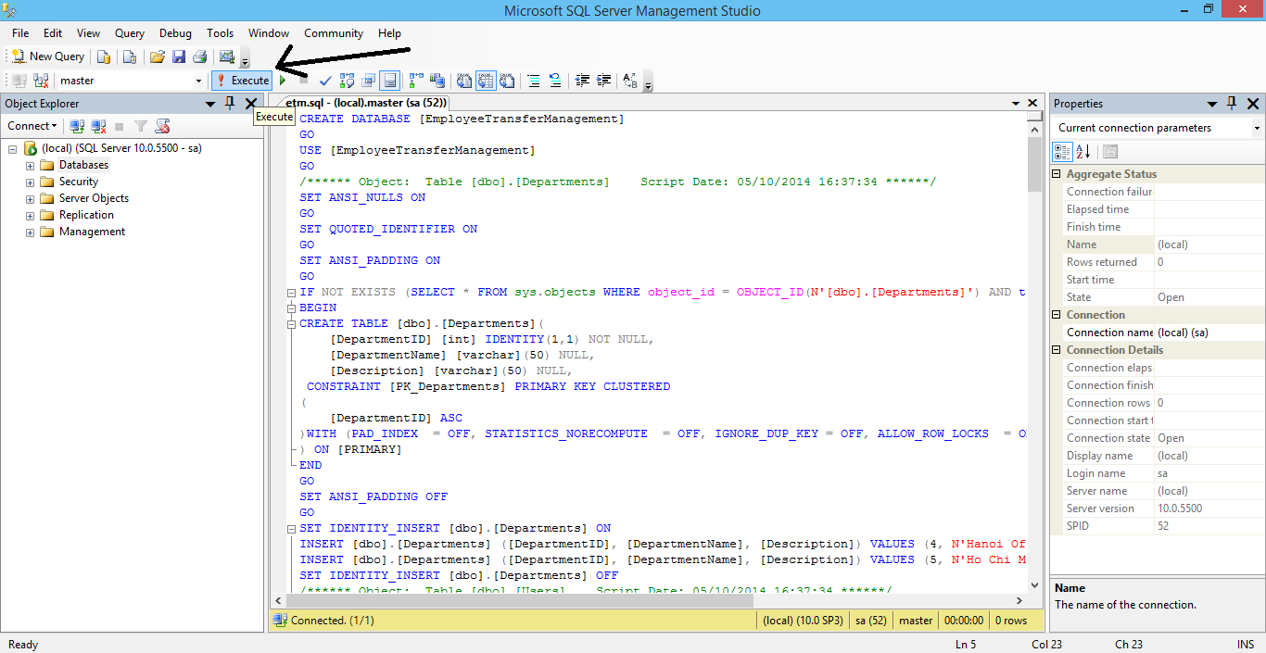
Figure 3: Execute sql

- Then open “Lib/config.txt” and edit your config look like:
localhost;1433;EmployeeTransferManagement;sa;123456

- After that open “Employee Transfer Management” then enter your username and password

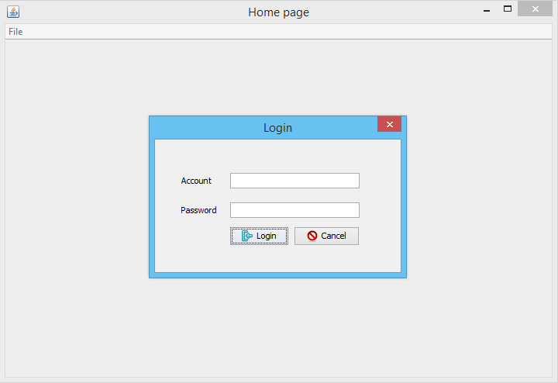
Figure 6: Login screen

For more help and information about product please contact:
Group: 3
Thanks you!

