EMPLOYEE TRANSFER MANAGEMENT

******
Manual Guide

- Login as Admin
- Login with below detail:
admin / admin
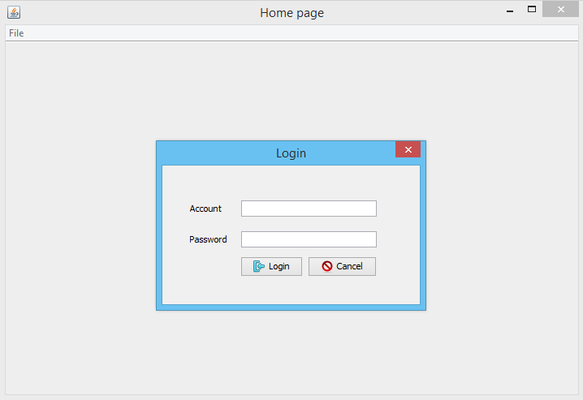

- You will see the main of application
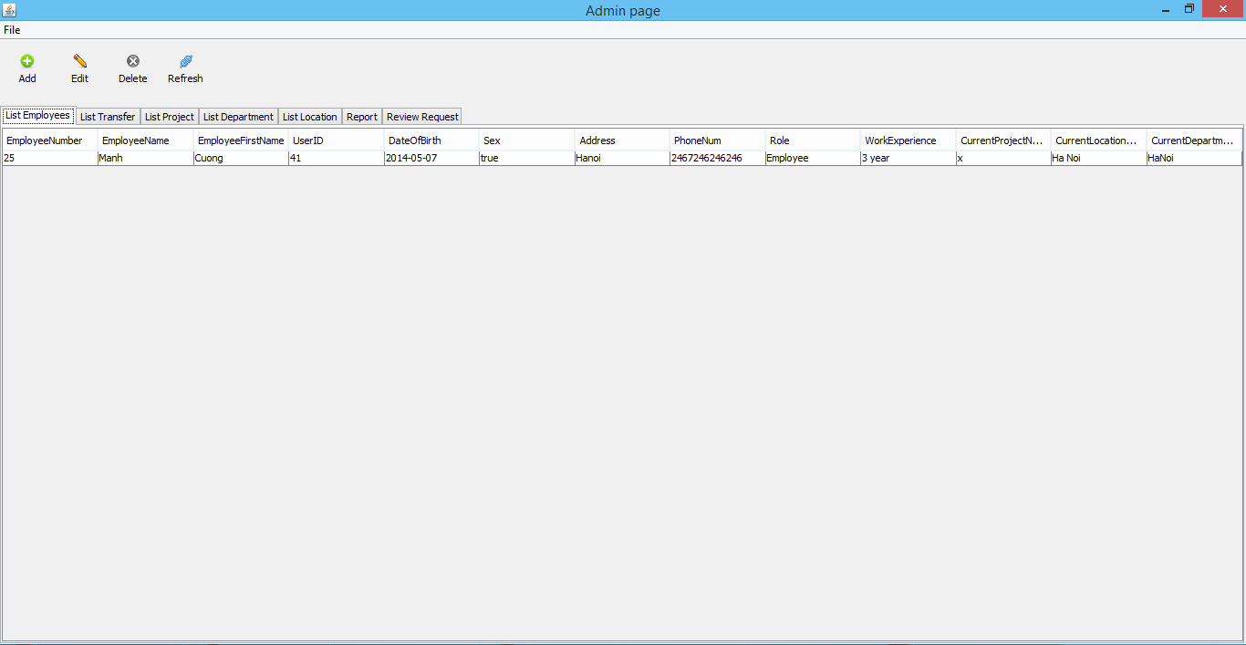
- If you want to add new employees, click Add button at List Employees Tab
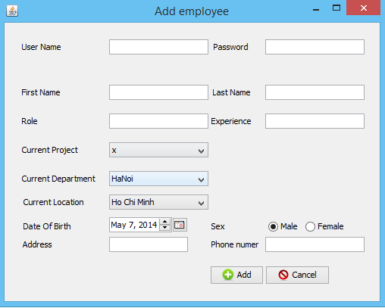

- If you want to edit an existed employee, select one and click Edit button at List Employees Tab
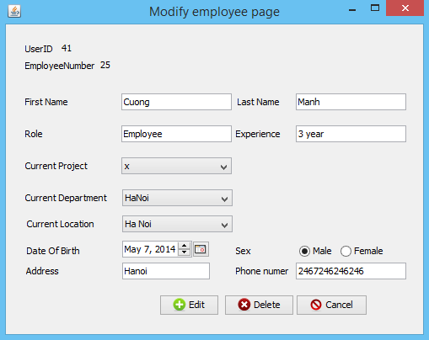
5. To add a new Location, Project, Department, please click Add button on respective tab.

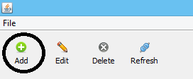

6. To edit an existed Location, Project, Department, please click Edit button on respective tab.
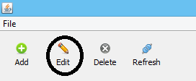
7. To delete one or more Location, Project, Department, please click Delete button on respective tab.
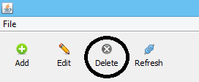
8. To make a new transfer for an employee, move to tab List Transfer, then click Add button.
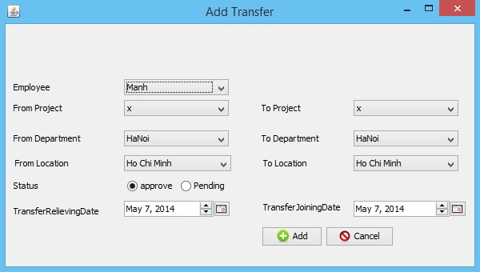

9. To view report of transfer, move to Report tab, pick a ranger date, and click View button.
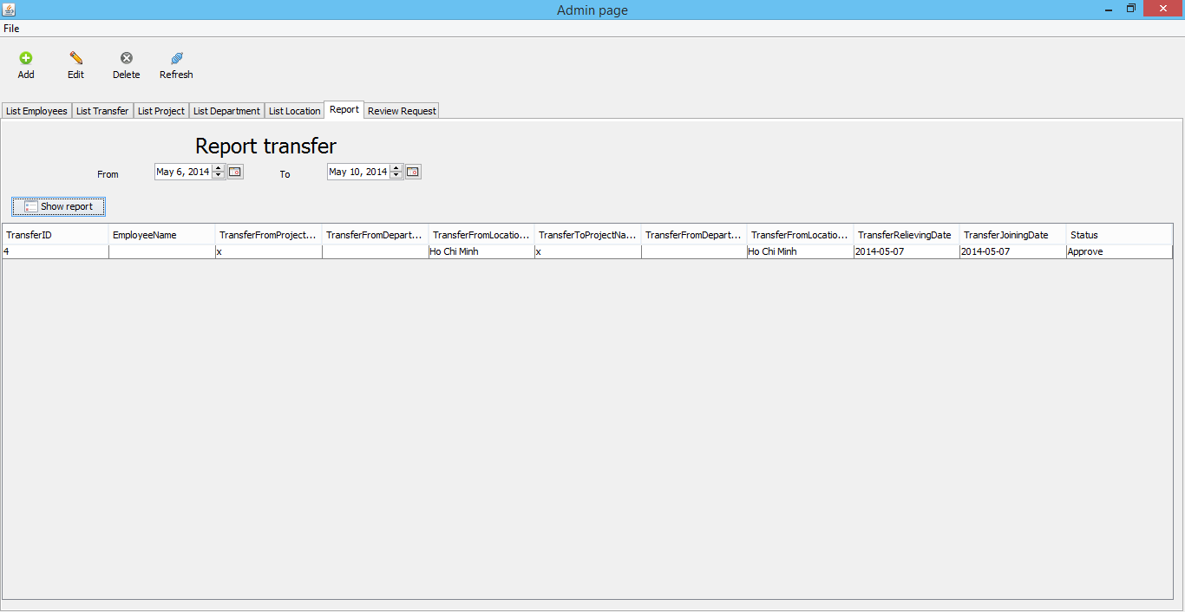

10. To approve for request of employees, move to Review Request tab, choose one, then click Approved at right bottom.
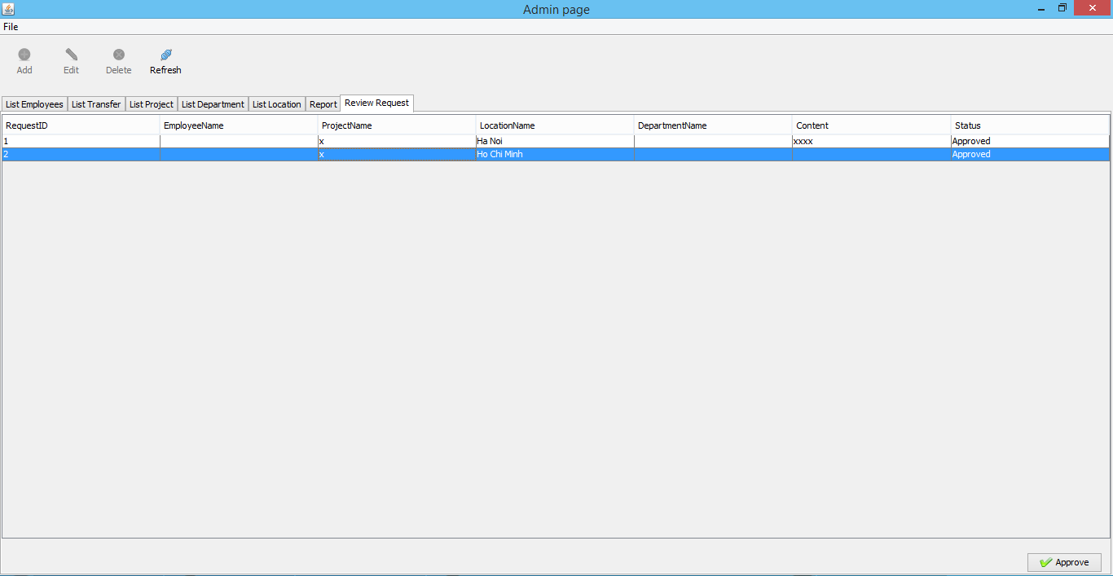

11. To change password, click File, then click Change Password
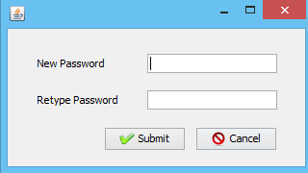

II, Login as employee
- Login with below detail:
demo / 123456
- The employee only can request a transfer, click Request button:
