Experiment: 1
PART B
(PART B: TO BE COMPLETED BY STUDENTS)
(Students must submit the soft copy within two hours of the practical. The soft copy must be uploaded on the Portal)

Roll No. A046 | Name: TEJAS PADMAKAR
Program: MCA | Division: MCA
Semester: 2 | Batch : 2
Date of Experiment: 03/1/25 | Date of Submission: 04/1/25
Grade :

A.1 AIM: - To understand the syntax and commands in Python programming

Task 1:
  - What is the result of the following operation in Python?
3+2*2**2//3
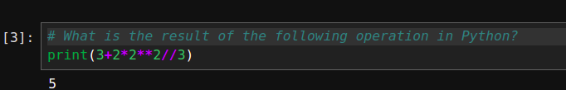

  - The variables A= ‘1’ and B = ’2’, What is the result of A+B?
- You can’t add two strings b) ‘3’ c) ‘12’ d) 3

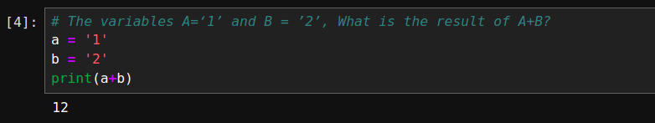
  - What is the output of the following lines of code?
x=1
if(x!=1):
print('Hello')
else:
print('Hi')
print('Mike')

Hi
Mike

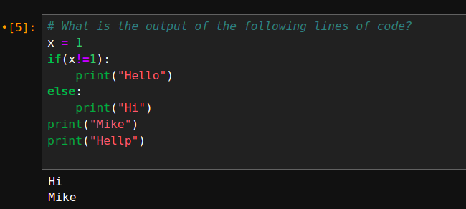

  - How many iterations are performed in the following loop and what is the output
for n in range(3):
print(n+1)
1
2
3
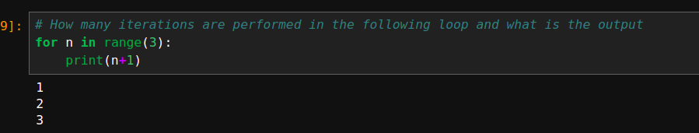
1.5 What is g(25) – g(24), given the definition of g below?
def g(n):
s=0
for i in range(1, n+1):
if n%i == 0:
s = s+1
return(s)
-5
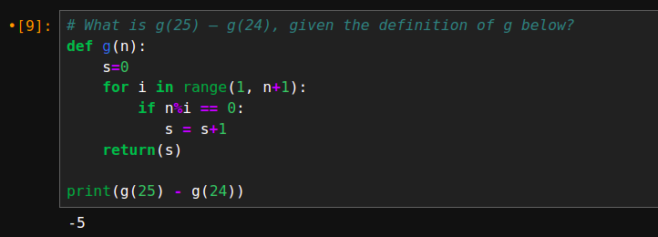

Task 2: Write a python program to reverse a given number
Sample Input and output: 783
Output: 387

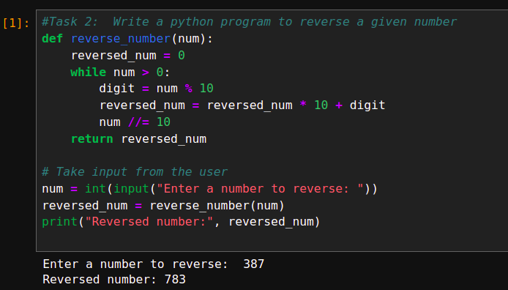
Task 3: Write a program to print Fibonacci series of a number entered by user
Sample Input and output
How many terms? 7
Fibonacci sequence:
0
1
1
2
3
5
8
Sample Input and output
How many terms? -1
Enter a positive integer
Sample Input and output
How many terms? 1
Fibonacci sequence:
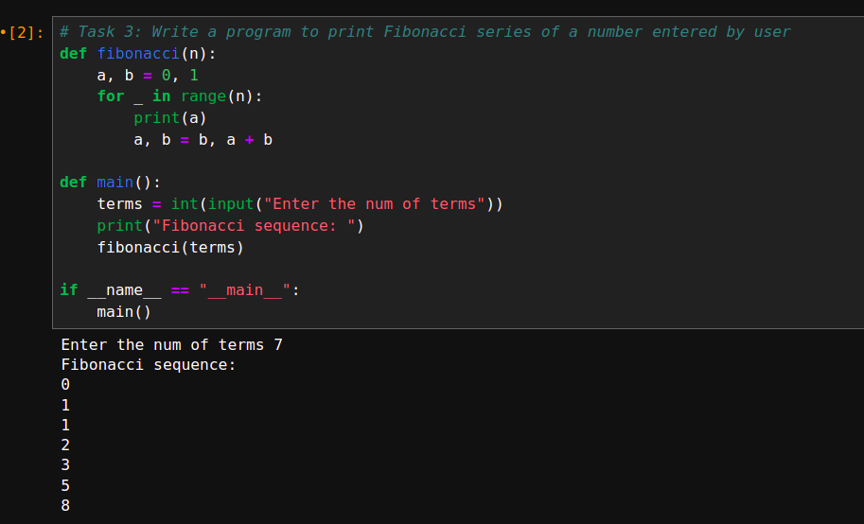

Task 4: Write a python program to read a number n and print the sum of odd natural numbers between the range of 1 to n both inclusive
Sample Input and output
Enter a number10
Sum = 25
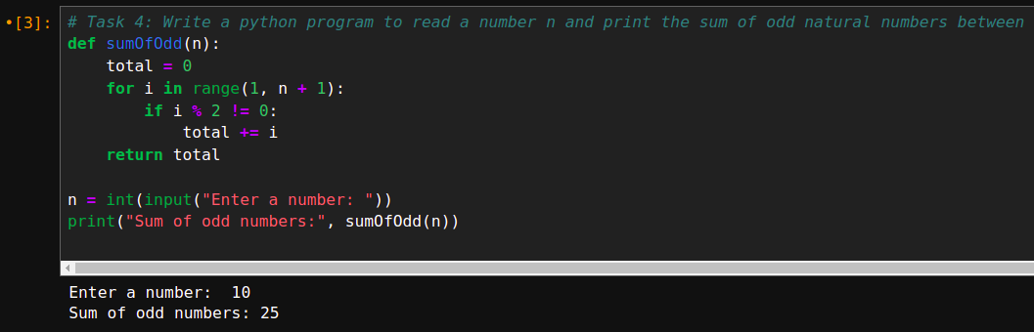
Task 5: Write a Program to find whether a given number is Strong Numbers
Sample Input and output
Enter a number:145
The number is a strong number.
Enter a number:234
The number is not a strong number.
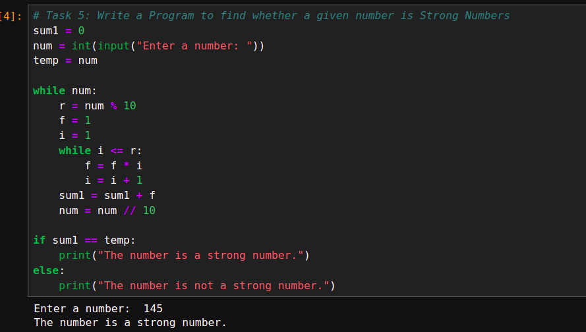
Task 6: Write a python Program to compute the roots of the equation ax2 + bx + c = 0 and print using three-decimal places.

The roots are real if the discriminant D = b² − 4ac is non-negative.
If the discriminant is negative, then the roots are complex conjugate
The program proceeds in the following steps.
(a) It accepts the values of a, b and c from the keyboard.
(b) No solution if both a and b are zero. The program finishes with appropriate message.
(c) Linear equation if a = 0 but and the root is −c/b. The program prints out the root with appropriate message and the program finishes.
(d) Calculates the discriminant D and determines the corresponding roots.
(e) Prints out the roots with appropriate message and the program finishes.

Test data and expected output:
Enter a,b,c: 0 2 3
Linear equation: root=-1.500
Enter a,b,c: 1 3 2
The roots are real: -1.000 and -2.000
Enter a,b,c: 2 6 9 The roots are complex: -1.500+1.500 i and -1.500-1.500 i
Enter a,b,c: 0 0 4 No solution: a & b both zero
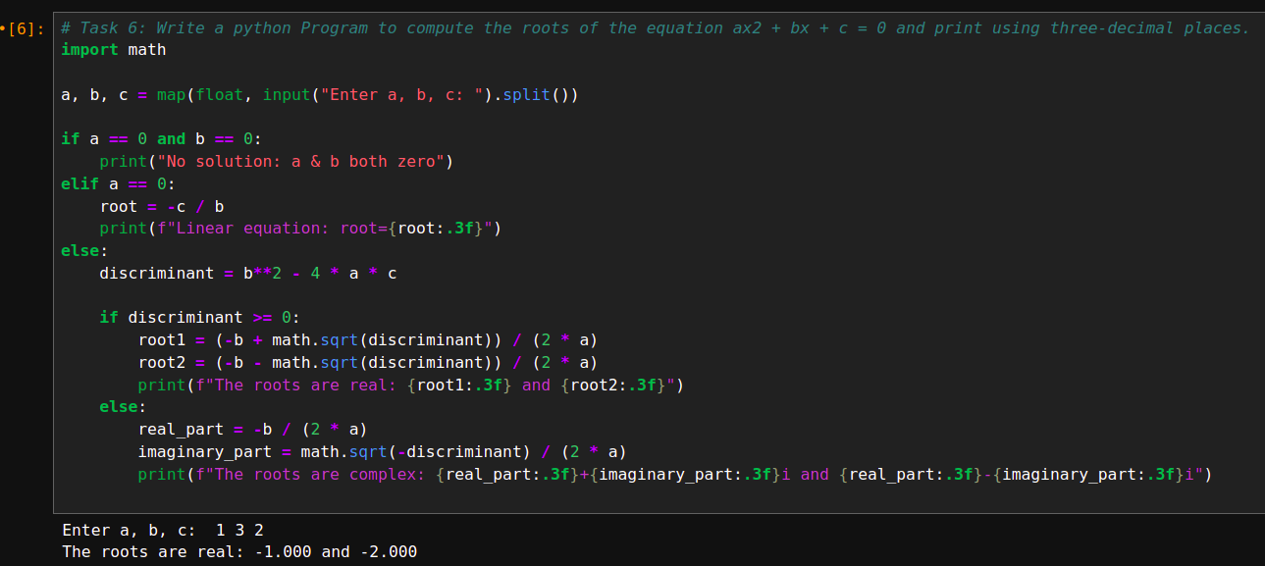
Task 7:
Accept the marks for the number of subjects studying in this semester. While accepting marks check the constraints that entered marks should not be negative as well as should not be more than 100 (if entered terminate the code). If the constraint is satisfied calculate the total & percentage. If % is greater than equal to 92 display “Merit” if % is between 75 and 91 display “Distinction” if % is between 60 and 74 “First class” if % is between 45 to 59 display “Second class” else display “Fail”
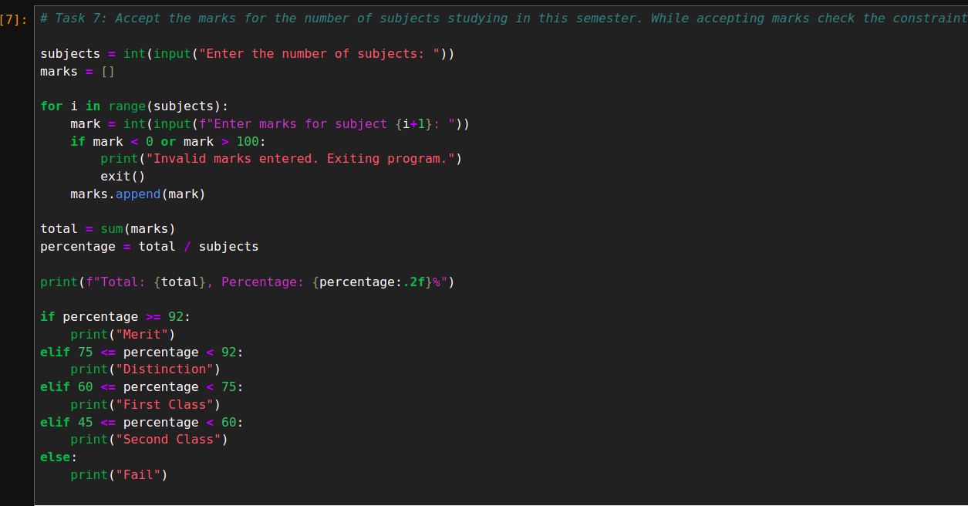
Task 8: Write a Python program to print the following pattern. Take number of lines as input from user.
5 4 3 2 1
4 3 2 1
3 2 1
2 1
1
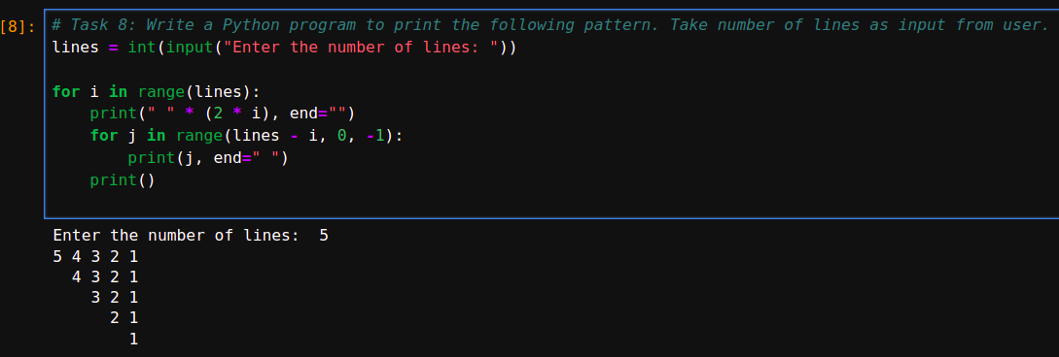
Question of curiosity:
State any five applications of Python applied in Machine learning/Artificial Intelligence domain. Provide details of any one application.

Five Applications of Python in Machine Learning/Artificial Intelligence:
- Natural Language Processing (NLP): Python is widely used in NLP for tasks like sentiment analysis, text classification, language translation, and chatbot development. Libraries like NLTK, SpaCy, and Hugging Face Transformers are commonly used.
- Computer Vision: Python is popular in computer vision applications such as image recognition, object detection, and facial recognition. Libraries like OpenCV, TensorFlow, and Keras enable these applications.
- Speech Recognition: Python powers speech recognition systems used in virtual assistants, transcription services, and voice command systems. Libraries such as SpeechRecognition and PyAudio facilitate this application.
- Predictive Analytics: Python is heavily used in predictive analytics for forecasting, trend analysis, and decision-making. Libraries like Scikit-learn, Statsmodels, and TensorFlow are used to build predictive models.
- Reinforcement Learning: Python is a go-to language for building and training reinforcement learning models, where an agent learns to make decisions through trial and error. Libraries like OpenAI Gym, TensorFlow, and Keras are used in this domain.

Detailed Application: Natural Language Processing (NLP)
Application: Sentiment Analysis
Sentiment analysis is a key application of NLP where Python is used to analyze text data and determine whether the sentiment expressed is positive, negative, or neutral. It's widely applied in fields like social media monitoring, customer feedback analysis, and market research.

How Python is used:
- Libraries: Python libraries such as NLTK (Natural Language Toolkit), TextBlob, and Hugging Face Transformers provide easy-to-use tools for processing and analyzing text data.
- Preprocessing: Text data is cleaned and tokenized, removing stop words and irrelevant symbols. Techniques like lemmatization and stemming are used to reduce words to their root forms.
- Modeling: Machine learning models, such as Naive Bayes or deep learning models (like LSTM or BERT), are trained to predict sentiment from text data.
- Output: The result is a classification of text into sentiment categories, helping businesses understand customer opinions, social media trends, and brand perception.
Python's simplicity and rich ecosystem of libraries make it an ideal language for developing and deploying sentiment analysis models in real-world applications.

B.3 Conclusion:

From this practical, I have learned the fundamentals of Python, including the use of loops and basic programming concepts. I gained hands-on experience in solving simple problems, such as reversing numbers, calculating sums, and analyzing conditions using if-else statements. These exercises have helped me build a strong foundation in Python programming.

