Explain the concept of Constraints Satisfaction Problem with respect to graph coloring example 10
Sure — here’s a neat, 10-mark answer format explanation for your question:

📌 What is a Constraint Satisfaction Problem (CSP)?
A Constraint Satisfaction Problem (CSP) is a type of problem where a set of variables must be assigned values from a given domain such that a set of constraints is satisfied.
It is widely used in fields like AI, scheduling, planning, and resource allocation.

📌 Components of a CSP:
- Variables: Elements to be assigned values.
→ Example: X, Y, Z
- Domains: The possible values each variable can take.
→ Example: {Red, Green, Blue}
- Constraints: Conditions that restrict the combinations of values the variables can simultaneously take.
→ Example: X ≠ Y (X and Y should have different colors)

📌 Graph Coloring as a CSP Example:
Problem:
Assign colors to each node of a graph such that no two adjacent nodes have the same color.
Components:
- Variables: Nodes of the graph (A, B, C, D)
- Domain: Colors available (e.g., {Red, Green, Blue})
- Constraints: Adjacent nodes must have different colors.
Graph Example:
A ----- B
| \
| C
| /
D
Constraints:
- A ≠ B
- A ≠ C
- A ≠ D
- C ≠ D
Objective:
Find a color assignment for A, B, C, D such that no two connected nodes share the same color.
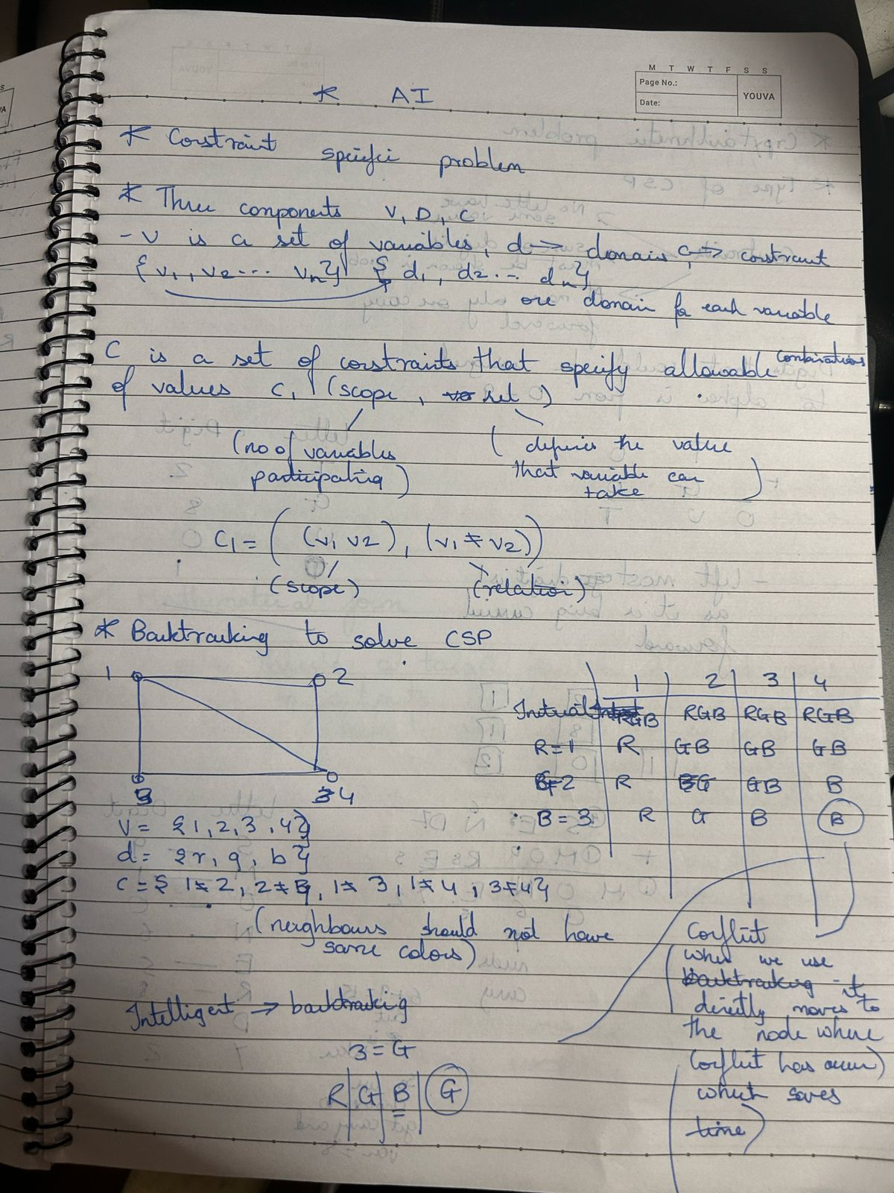

📌 Solving CSP:
Methods:
- Backtracking
- Forward Checking
- Constraint Propagation (like AC-3 algorithm)
Example Color Assignment:
- A = Red
- B = Green
- C = Blue
- D = Green
This assignment satisfies all the constraints.

📌 Significance:
- Graph coloring problems like this are crucial in scheduling problems, register allocation in compilers, and frequency assignment in mobile networks.
- CSP techniques help find valid solutions efficiently while managing complex constraints.

What is variable ordering? Give example 5 What is value ordering? Give examples. 5
Sure — here’s a clean, to-the-point explanation for both, suited for a 5-mark answer each:

📌 What is Variable Ordering? (5 Marks)
Variable ordering is the strategy of deciding the sequence in which variables are selected for assignment while solving a Constraint Satisfaction Problem (CSP).
Why it matters:
A good ordering can significantly reduce the search space and time required to find a solution.

📌 Example:
In a graph coloring problem with nodes {A, B, C, D}, we can decide to assign colors in this order:
- A → B → C → D
Or use a heuristic like:
- Minimum Remaining Values (MRV): Choose the variable with the fewest legal values left.
If A has 2 possible colors, B has 3, C has 1, and D has 2:
→ Pick C first since it’s most constrained.

📌 What is Value Ordering? (5 Marks)
Value ordering is the strategy of deciding the sequence in which possible values for a selected variable are tried during the search in a CSP.
Why it matters:
A good ordering increases the chance of finding a solution quickly by trying the most promising values first.

📌 Example:
In a graph coloring problem, if for node A the possible colors are {Red, Green, Blue}, we can order them based on:
- Least Constraining Value (LCV): Choose the color that leaves the most options open for neighboring variables.
If assigning Red to A restricts neighbors a lot, but Green restricts less:
→ Try Green first, then others.

Constraint Types in CSP
With respect to the variables, basically there are following types of constraints:
- Unary Constraints: It is the simplest type of constraints that restricts the value of a single variable.
- Binary Constraints: It is the constraint type which relates two variables. A value x2 is not equal to x1.
- Local Constraints: Applicable to single or pair of variables. A value x2 is not x1 and x3.
- Global Constraints: It is the constraint type which involves an arbitrary number of variables.
- Linear Constraints: These type of constraints are commonly used in linear programming where each variable containing an integer value exists in linear form only. X + 2Y - 3Z = 10.
- Non-linear Constraints: These type of constraints are used in non-linear programming where each variable (an integer value) exists in a non-linear form. X^2 + Y^2 = 25.

Crypt Arithmetic Problem
- Crypt arithmetic Problem is a type of constraint satisfaction problem where the game is about digits and its unique replacement either with alphabets or other symbols.
- In crypt arithmetic problem, the digits (0-9) get substituted by some possible alphabets or symbols.
- The task in cryptarithmetic problem is to substitute each digit with an alphabet to get the result arithmetically correct.
The rules or constraints on a cryptarithmetic problem are as follows:
- Digits should be from 0-9 only
- One letter should have one value only
- No two letters can have same value
  - There should be a unique digit to be replaced with a unique alphabet.
- Sum of arithmetic values should satisfy the sum of words
- The result should satisfy the predefined arithmetic rules, i.e., 2+2 =4, nothing else.
- There should be only one carry forward, while performing the addition operation on a problem.
- The problem can be solved from both sides, i.e., left hand side (L.H.S), or right hand side (R.H.S)

Explain significance of local search used in CSP with the help of Sudoku problem.
Sure — let’s break this down smoothly and clearly:

📌 Significance of Local Search in CSP
Unlike complete search algorithms (like backtracking) that explore the entire search space, local search starts with a complete assignment (even if it’s invalid) and then iteratively moves to a neighboring state to improve constraint satisfaction.
It’s especially useful when:
- The state space is huge
- An approximate solution is acceptable
- Real-time or near-optimal solutions are needed

🎲 Example: Sudoku Problem
Sudoku CSP:
- Variables: Cells in a 9×9 grid
- Domain: Numbers 1-9
- Constraints:
  - No number repeats in a row, column, or 3×3 subgrid

📌 How Local Search Works for Sudoku:
- Start with a complete but possibly invalid Sudoku grid
(randomly fill empty cells while respecting initial clues)
- Define a cost function:
Number of conflicts (e.g., how many repeated numbers in a row, column, or block)
- Iteratively make small changes (swap values within a subgrid) to reduce conflicts.
- Stop when:
  - Zero conflicts (solved)
  - Or after a maximum number of steps

🎮 Example Move:
If a row has two ‘5’s, local search might swap one of them with a different number in the same subgrid to reduce conflicts.

📌 Why Local Search is Significant:
- Fast and efficient for large or complex CSPs
- Can escape local minima using techniques like Simulated Annealing or Random Restarts
- Useful when full backtracking is too slow or infeasible

In short:
Local search provides a practical way to approach tough CSPs like Sudoku by progressively improving a solution through small adjustments — trading completeness for efficiency. 🔍✨
Want me to sketch a mini visual for this too? 📊🎨

Explain significance of local search used in CSP with the help of Chess problem.
Excellent question — let’s break down how local search works for Chess, and I'll give you a concrete example you can easily visualize.

♟️ What is Local Search in Chess?
In AI for Chess (especially for position optimization or move selection), local search doesn’t look through the entire game tree like Minimax would. Instead, it:
- Generates a possible board position
- Applies small changes (local moves)
- Evaluates each resulting board with a cost/utility function
- Keeps moving to positions with better evaluation

🎲 Example: Simplified Chessboard — Queen Positioning Problem
Let’s take a 4×4 board with 4 queens (like N-Queens) where no two queens should attack each other.
Initial Board (random positions — with conflicts):
| Q | | | | | | | Q | | | | Q | | | | | | | Q |
Conflict Check:
- Q on (1,1) attacks Q on (3,2) diagonally
- Q on (2,3) attacks Q on (4,4) diagonally
Total Conflicts: 2

🛠️ Step 1: Define Cost Function
Cost = Number of attacking pairs
Here, Cost = 2

🛠️ Step 2: Make Local Moves
- Pick a random Queen (say on (3,2))
- Move it to a different row in its column (can only move within its column to maintain 1 queen per column rule)
New Position: (3,4)
New Board:
| Q | | | | | | | Q | | | | | | Q | | | Q | | |
Conflict Check:
- No two queens attack each other now.
Cost = 0

✅ Step 3: Done
If Cost = 0 → solution found
Else, continue making moves reducing conflicts.

✨ Application in Actual Chess
For actual chess moves:
- Generate legal moves
- Evaluate board position using heuristics (e.g., material advantage, king safety, control of center)
- Pick moves leading to positions with higher evaluation
- Optionally use Simulated Annealing / Hill Climbing to explore slightly worse positions to avoid local optima

what is arc consistency in CSP? Explain with the help of Graph Coloring problem.
Great question — let’s clarify Arc Consistency in CSP and tie it to the Graph Coloring problem with a clear example.

📌 What is Arc Consistency in CSP?
In Constraint Satisfaction Problems (CSP), Arc Consistency is a form of constraint propagation that ensures for every value of a variable, there exists at least one consistent value in the connected variable’s domain.
In simple terms:
For a pair of connected variables (X → Y), every possible value of X should have at least one value in Y's domain that doesn’t violate the constraint between them.
If not, we remove that value from X’s domain.

🎨 Example: Graph Coloring Problem
Problem: Color each node in a graph using 3 colors (Red, Green, Blue) so no two connected (adjacent) nodes have the same color.
Graph:
- A connected to B and C
- B connected to C
Variables: A, B, C
Domain: {Red, Green, Blue} for each
Constraints: Adjacent nodes ≠ same color

🎛️ Applying Arc Consistency (AC-3 Algorithm style)
Arcs to check:
- (A, B), (B, A), (A, C), (C, A), (B, C), (C, B)
1️⃣ Check (A → B):
For each color of A, is there a possible color in B’s domain satisfying the constraint?
- A = Red → B = {Green, Blue} ✔️
- A = Green → B = {Red, Blue} ✔️
- A = Blue → B = {Red, Green} ✔️
If any value had no support in B’s domain, remove it from A’s domain.
Repeat this for all arcs

🔧 Example Case:
Suppose:
- Domain(A) = {Red, Green}
- Domain(B) = {Red}
Check (A → B):
- A = Red → B can only be Red ❌ (invalid, as adjacent nodes can’t be same color)
- A = Green → B = Red ✔️
Since A = Red is not consistent (no possible value in B), remove Red from A’s domain.
New Domain(A) = {Green}

✅ Conclusion:
Arc Consistency helps:
- Reduce variable domains early
- Eliminate impossible options before search
- Speed up CSP solving by pruning invalid choices

Would you like me to draw this small graph with color options and domains too? ⚡🎨

