What is an Expert system?
- An expert system is an interactive computer-based decision tool that uses both facts and heuristics to solve difficult decision problems, based on knowledge acquired from an expert.

Expert system components and human interface?
- Expert systems have a number of major system components and interface with individuals in various roles. These are illustrated below.
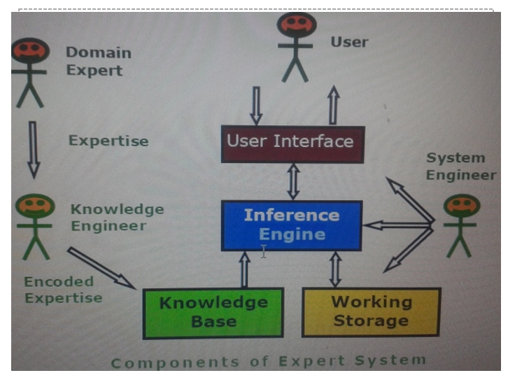
Domain Expert
- A human expert with deep, practical knowledge in a specific field (e.g., medicine, finance, mechanics).
- Shares their expertise to build the system
Knowledge Engineer
- Works closely with the domain expert.
- Gathers expertise and converts it into a formal representation (rules, facts, heuristics) called Encoded Expertise.
- Stores this in the Knowledge Base.
Knowledge base : a declarative representation of the expertise; often IF THEN rules;
Working storage : the data; specific to a problem being solved;
Inference engine : the code at the core of the system; derives recommendations from the knowledge base and problem-specific data in working storage;
User interface : the code that controls the dialog between the user and the system.
System Engineer
- Manages the overall design, development, and maintenance of the expert system.
- Ensures system performance, reliability, and security

Roles of individuals who interact with the system
- Domain expert : the individuals who currently are experts solving the problems, here the system is intended to solve;
- Knowledge engineer : the individual who encodes the expert's knowledge in a declarative form that can be used by the expert system;
- User : the individual who will be consulting with the system to get advice which would have been provided by the expert.

What are Expert System Shell , Characteristic and Featuers?
Expert system shells, also known as development environments or toolkits, provide a framework and set of tools for building, testing, and deploying expert systems. Here's how the key components you mentioned are typically integrated into expert system shells:
• User Interface (UI):
Allows users to interact with the system through forms, menus, or graphical interfaces. Developers can design simple command-line UIs or advanced GUIs for inputting queries and viewing results.
• Knowledge Base Format:
A structured format for representing knowledge. It lets developers input, edit, and manage facts and rules, often using specialized syntax or editors.
• Inference Engine:
The system’s reasoning core, which processes the knowledge base to draw conclusions. It may use techniques like forward chaining, backward chaining, or others, based on the system’s design

• Knowledge Engineer:
Acquires and organizes expert knowledge, then encodes it into the system using the shell. Works closely with domain experts to ensure accuracy and completeness.
• System Engineer:
Handles the technical setup — building UIs, structuring the knowledge base, and implementing the inference engine’s logic and algorithms.

Characteristic
•Operates as an interactive system : This means
–responds to questions
–asks for clarifications
–makes recommendations
–aids the decision-making process.

•Tools have ability to store and select (filter) knowledge
–storage and retrieval of knowledge
–mechanisms to expand and update knowledge base on a continuing basis

- Capability to make logical inferences based on knowledge stored
–simple reasoning mechanisms is used
–KB with means of exploiting the knowledge stored, else it is not useful

•Ability to explain reasoning
–remembers logical chain of reasoning therefore user may ask
–for explanation of a recommendation
–factors considered in recommendation
–enhances user confidence in recommendation and acceptance of expert system

•Systems are very domain-specific
–a particular system caters a narrow area of specialization; a medical expert system cannot be used to find faults in an electrical circuit
–quality of advice offered by an expert system is dependent on the amount of knowledge stored.

- Cost-effective alternative to human expert
–Expert systems have become increasingly popular because of their specialization, although in a narrow field.
–The small size of the domain makes encoding and storing the domain specific knowledge an economic process.
–specialists in many areas are scarce, and the cost of consulting them is high, an expert system catering to any of those areas can be considered to be a useful and cost-effective alternative, in the long run.

What is Goal Driven and Data Driven Reasoning with eg?

📌 Goal-Driven Approach (Backward Chaining)
Goal-driven reasoning, also called backward chaining, is a reasoning technique often used in expert systems. It starts with a desired outcome and works backward to find supporting evidence. Here’s how it operates:

🔹 1️⃣ Starting with the Goal
- The process begins with a specific goal or desired conclusion that the system tries to achieve.

🔹 2️⃣ Reasoning Backward
- The system searches for facts or evidence that directly support the goal.
- If direct evidence is unavailable, it looks for sub-goals or intermediate conditions that, if proven, would support the original goal.
- This continues by tracing back through rules and known facts to verify if the goal can be satisfied.

🔹 3️⃣ Generating New Sub-Goals
- During reasoning, the system may generate new sub-goals that need to be proven.
- These are derived using inference rules from the existing knowledge base.

🔹 4️⃣ Termination
- The process stops when:
  - The goal is proven based on existing evidence.
  - No further rules or facts can support the goal, meaning it can’t be achieved with the available knowledge.

🔹 5️⃣ Example Scenario
- In a diagnostic expert system, the goal might be to identify a disease.
- The system begins by hypothesizing a disease and works backward to see if patient symptoms and test results support it.
- It continues this process until a likely diagnosis is confirmed or ruled out.

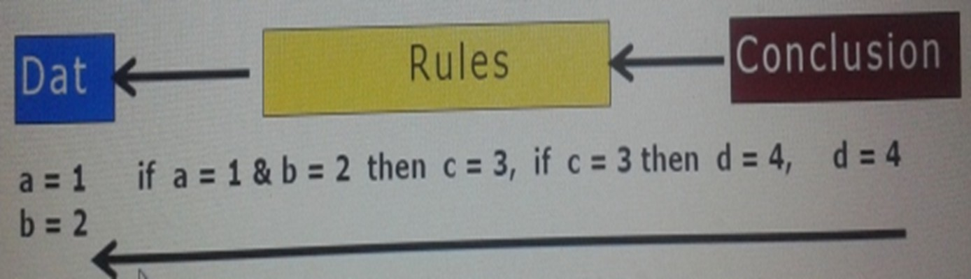

📌 Data-Driven Approach (Forward Chaining)
The data-driven approach, also called forward chaining, is a reasoning technique used in expert systems. It focuses on starting with known facts and applying rules to derive new conclusions, working its way toward a goal. Here’s how it works:

🔹 1️⃣ Starting with the Current State
- Unlike backward chaining, which starts by identifying a goal, forward chaining begins with the current set of facts or data.
- The system uses these available facts as its starting point to reason and generate new conclusions.

🔹 2️⃣ Progressing Toward the Goal
- The system applies rules to the known facts to produce new facts or assertions.
- This process repeats, gradually expanding the knowledge base and moving the system closer to a possible solution or conclusion.

🔹 3️⃣ Generating New Assertions
- Every time a rule is applied successfully, new facts are added to the working memory.
- These new facts help the system learn more about the problem and bring it closer to resolving the issue.

🔹 4️⃣ Stopping the Process
- Forward chaining continues until:
  - A specific goal is achieved, or
  - No further rules are applicable, meaning the system cannot infer any more conclusions.

🔹 5️⃣ Example Scenario
- In a medical diagnostic system, forward chaining might start with a patient’s symptoms.
- Diagnostic rules are applied to infer possible diseases.
- The system keeps applying rules and updating conclusions until it reaches a final diagnosis or can no longer infer new information.

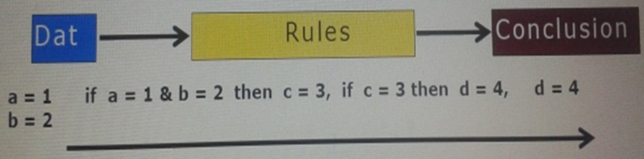

Discuss any two suitable applications of Expert System with detail specification.
Sure — let’s neatly cover two suitable applications of Expert Systems with detailed specifications as you’d write in a 5-mark answer:

1️⃣ Medical Diagnosis System
Description:
An Expert System in the medical field assists doctors in diagnosing diseases based on patient symptoms, history, and test results.
Specifications:
- Knowledge Base:
Contains expert medical knowledge, symptoms, diseases, diagnostic rules, and treatment protocols.
- Inference Engine:
Applies reasoning rules (like forward or backward chaining) to match patient symptoms with possible diseases.
- User Interface:
Allows healthcare professionals to input patient symptoms and view diagnosis suggestions.
- Example:
MYCIN — one of the earliest expert systems developed for diagnosing bacterial infections and recommending antibiotics.
Advantages:
- Supports decision-making in critical situations.
- Reduces human error.
- Provides rapid diagnostic assistance.

2️⃣ Credit Card Fraud Detection System
Description:
Expert systems are used in banks and financial institutions to detect unusual transaction patterns that indicate potential fraud.
Specifications:
- Knowledge Base:
Includes rules based on past fraud patterns, transaction limits, geographic anomalies, and user behavior.
- Inference Engine:
Continuously analyzes transaction data in real time and applies fraud detection rules to identify suspicious activity.
- User Interface:
Enables fraud analysts to monitor alerts and investigate flagged transactions.
- Example:
Banking systems that instantly block or flag suspicious transactions for manual review.
Advantages:
- Detects and prevents financial fraud proactively.
- Enhances transaction security.
- Reduces financial loss and improves customer trust.

What is knowledge acquisition and Issues in Knowledge Acquisition
Knowledge acquisition is the process of gathering, organizing, and verifying knowledge for use in an expert system. It involves:
- Elicitation: Drawing knowledge from experts or sources.
- Collection: Gathering and documenting it.
- Analysis: Checking for accuracy and relevance.
- Modeling: Structuring it into usable forms like rules or decision trees.
- Validation: Testing to ensure it works correctly in the system.
Issues
- The important issues in knowledge acquisition are:
■ knowledge is in the head of experts
■ Experts have vast amounts of knowledge
■ Experts have a lot of unspoken (tacit) knowledge
  - They do not know all that they know and use
  - Unspoken knowledge is hard (impossible) to describe
■ Experts are very busy and valuable people
■ One expert does not know everything
■ Knowledge has a "shelf life“

Explain backward chaining method used by the inference engine. Give suitable example. -> 10

Sure — let’s explain it clearly like you’d write in an exam answer:

📌 Backward Chaining Method
Definition:
Backward Chaining is a reasoning technique used by the Inference Engine of an Expert System where it starts with the goal (hypothesis) and works backward to see if there are facts or rules in the knowledge base that support the goal.
In simple terms —
👉 “What do I need to prove this conclusion is true?”

📖 How it Works:
- Identify the Goal.
(What we want to prove.)
- Search the Knowledge Base for rules where this goal appears in the THEN (conclusion) part.
- Check if the IF (condition) part of the rule is true.
  - If true — the goal is proved.
  - If not — make the condition a new sub-goal and repeat the process.
- This continues until:
  - The goal is proven, or
  - No supporting rules or facts are found.

📌 Example:
Knowledge Base:
- If it is raining, then the ground is wet.
- If the sky is cloudy, then it is raining.
- The sky is cloudy.
Goal:
Is the ground wet?
Backward Chaining Process:
- To prove the ground is wet, check Rule 1:
If it is raining → the ground is wet.
- Is it raining? Not directly known.
So check Rule 2:
If the sky is cloudy → it is raining.
- Is the sky cloudy?
Yes (Fact 3).
Therefore:
Sky is cloudy → it is raining → ground is wet.
✅ Goal is proved using Backward Chaining.

📌 Key Points:
- Works backwards from goal to facts.
- Uses rules and sub-goals.
- Example of goal-driven reasoning.
- Common in medical diagnosis and problem-solving expert systems.
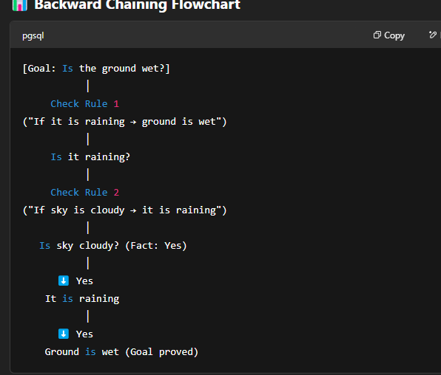

Explain forward chaining method in detail with suitable example used for inference
from the knowledge base. -> 10
Sure — here’s a neat, exam-friendly explanation of Forward Chaining, just like you’d write in your paper:

📌 Forward Chaining Method
Definition:
Forward Chaining is a reasoning technique used by the Inference Engine of an Expert System where it starts from the available facts and applies inference rules to extract more facts until it reaches the desired conclusion (goal).
In simple words —
👉 “Given these facts, what can I conclude?”

📖 How it Works:
- Start with known facts from the knowledge base.
- Check for rules whose IF (condition) part matches the available facts.
- Apply those rules to generate new facts.
- Add these new facts to the knowledge base.
- Repeat this process until:
  - The goal (desired conclusion) is reached, or
  - No new facts can be inferred.

📌 Example:
Knowledge Base:
- If it is raining, then the ground is wet.
- If the ground is wet, then traffic is slow.
- It is raining. (Fact)
Goal:
Will the traffic be slow?
Forward Chaining Process:
- Fact: It is raining.
- Apply Rule 1:
If it is raining → the ground is wet.
New Fact: Ground is wet.
- Apply Rule 2:
If ground is wet → traffic is slow.
New Fact: Traffic is slow.
✅ Goal achieved through Forward Chaining.

📌 Key Features:
- Data-driven reasoning.
- Starts from known facts, moves toward conclusions.
- Common in diagnostic systems, expert systems, and control systems.

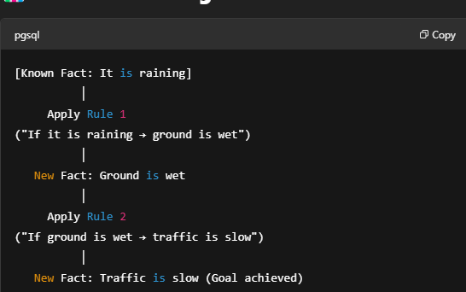

✅ Summary:
- Forward Chaining: Fact ➝ Rule ➝ New Fact ➝ Goal
- Backward Chaining: Goal ➝ Rule ➝ Sub-goal ➝ Fact

Would you like me to prepare a comparison table between Forward and Backward Chaining too? I can quickly do that for you!

  - What are the techniques of knowledge Acquisition?
PHP MLS D
- Protocol-generation Techniques:
  - These techniques involve conducting interviews with domain experts to gather information. Interviews can be unstructured (open-ended),
semi-structured (combination of open and closed questions), or structured (predetermined questions). Additionally, reporting and observational techniques may be used to supplement interview data.

- Protocol Analysis Techniques:
  - After interviews, protocol analysis techniques are applied to transcripts or text-based information to identify key knowledge objects such as goals, decisions, relationships, and attributes. This helps in understanding the structure and content of the knowledge obtained.

- Hierarchy-generation Techniques (Laddering):
  - Laddering techniques involve creating, reviewing, and modifying hierarchical knowledge structures such as goal trees and decision networks. Different forms of ladders, such as concept ladder, attribute ladder, and composition ladder, may be used to represent hierarchical relationships.

- Matrix-based Techniques:
  - Matrix-based techniques involve constructing grids or tables to represent relationships between problems and possible solutions. Frames may be used to represent the properties of concepts, facilitating the organization and analysis of knowledge.

- Sorting Techniques:
  - Sorting techniques capture how people compare and order concepts, revealing knowledge about classes, properties, and priorities. This helps in understanding how experts perceive and categorize information.

- Limited-information and Constrained-processing Tasks:
  - These techniques restrict the time and/or information available to experts when performing tasks. For example, the twenty questions technique prioritises key information in a domain by asking targeted questions.

- Diagram-based Techniques:
  - Diagram-based techniques involve the generation and use of visual representations such as concept maps, state transition networks, event diagrams, and process maps. These diagrams help in capturing the "what, how, when, who, and why" of tasks and events, providing a holistic view of the domain.

  - Methods of Knowledge Representation?
•The knowledge acquired from the human expert must be encoded in such a way that it remains a faithful representation of what the expert knows, and it can be manipulated by a computer.
•Three common methods of knowledge representation evolved over the years are IF-THEN rules, semantic networks and frames.

