Explain the concept of learning agent with the help of block diagram.
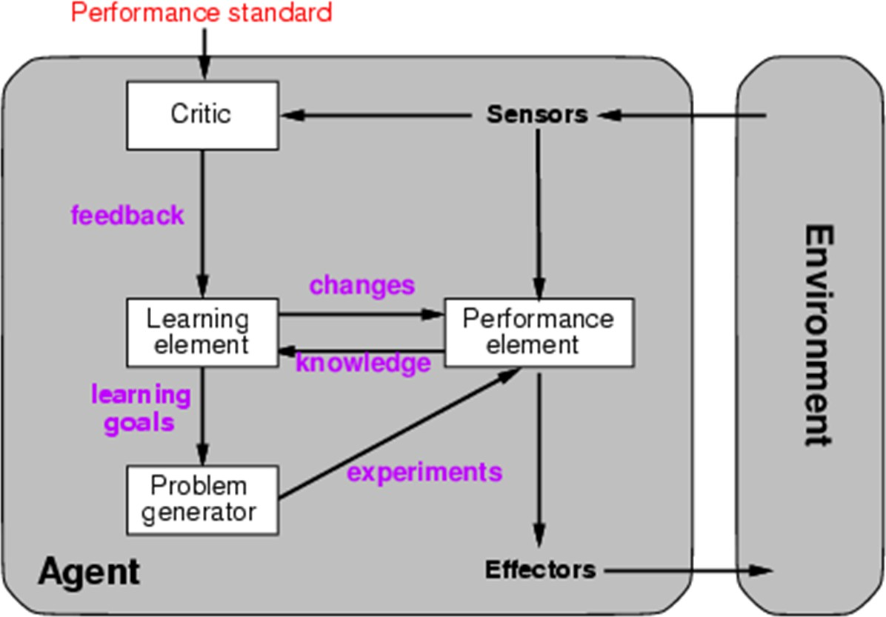
A Learning Agent has four main components:
- Performance Element:
  - Takes percepts from the environment and decides on actions.
  - Acts as the agent’s operational part, handling external interaction.
- Learning Element:
  - Responsible for making improvements in the agent's behavior.
  - Uses feedback from the critic to adjust and enhance the performance element over time.
- Critic:
  - Evaluates how well the agent is performing based on a fixed performance standard.
  - Provides feedback to the learning element since percepts alone don’t indicate success.
  - Example: A chess program needs a standard to know that checkmate is a good result.
- Problem Generator:
  - Suggests new, exploratory actions to help the agent gain useful experiences.
  - Encourages short-term suboptimal actions to potentially discover better long-term strategies.
Example
Example : Automated Taxi on city roads
■ Performance Element: Consists of knowledge and procedures for driving actions.
e.g., turning, accelerating, braking are performance element on roads.
■ Learning Element: Formulates goals.
e.g., learn rules for braking and accelerating, learn geography of the city, etc.
■ Critic: Observes world and passes information to learning element.
e.g. quick right turn across three lanes of traffic, observe reaction of other drivers.
■ Problem Generator: Try South city Road.

What is learning Element and how it is affected?
The learning element is the part of a learning agent responsible for improving the agent's performance by making changes based on feedback and experiences. It helps the agent adapt and perform better in the future.
The design of a learning element is affected by three major issues:
  - Which components of the performance element are to be learned:
    - In many cases, not all components of the performance element need to be learned. Instead, the focus might be on learning only certain parameters or policies that directly impact the agent's decision-making process.
    - For example, in a reinforcement learning setting, the learning element might focus on learning the values of state-action pairs (Q-values) or the policy that governs the agent's behavior.

  - What feedback is available to learn these components:
    - Feedback refers to the information provided to the learning element about the quality of its decisions.
    - The type and availability of feedback greatly influence the learning process. Feedback can be explicit, such as rewards in reinforcement learning, or implicit, such as observing the success or failure of actions.

    - For example, in supervised learning, the learning element receives explicit feedback in the form of labeled training data, while in unsupervised learning, feedback might be less direct and more implicit.

  - What representation is used for the components:
    - Representation refers to how the components of the performance element, such as states, actions, and feedback, are encoded or represented in the learning process.
    - Different learning algorithms may require different types of representations. For instance, in deep learning, neural networks are used to represent complex relationships in data, while in symbolic learning, logic-based representations are used to capture symbolic relationships.

Explain supervised learning. State the significance of training and testings phases of the learning algorithms with example. -> 10
Absolutely — here’s a nicely expanded 10-mark answer you could write in an exam or notes, clear and structured:

Supervised Learning
Supervised learning is a popular type of machine learning technique where the model is trained using labeled data. In this approach, each training example consists of an input object (like a number, image, or text) and a desired output value (label). The learning algorithm uses this data to learn a mapping function from inputs to outputs.
Once trained, the model can predict the output for new, unseen inputs based on the patterns it has learned. It’s called "supervised" because the process of learning is guided by known labels or outcomes.

Phases of Supervised Learning
Supervised learning typically involves two major phases:

📌 1. Training Phase
- In this phase, the model is provided with a large dataset containing input-output pairs.
- The algorithm processes this data and attempts to identify patterns, trends, and relationships within the data.
- Based on this, it formulates a mapping function (like a mathematical model) from inputs to outputs.
- The internal parameters of the model (like weights in a neural network) are adjusted iteratively to reduce errors in prediction.
- The goal is to minimize the difference between the actual output and the predicted output.
Example:
A spam email classifier is trained on thousands of emails labeled as either ‘spam’ or ‘not spam’. The system learns features like specific keywords, sender details, or formatting that are typical in spam emails.

📌 2. Testing Phase
- After training, the model's accuracy and performance are evaluated using a separate dataset called the testing dataset.
- This dataset contains new, unseen input-output pairs not used during training.
- The model predicts the outputs for this test data, and its predictions are compared with the actual labels.
- Performance metrics like accuracy, precision, recall, F1-score, and confusion matrix are computed to assess the model's reliability.
- This phase ensures that the model is not overfitting (memorizing) the training data and can generalize to real-world data effectively.
Example:
Once the spam classifier is trained, it is tested on a new set of emails to check if it correctly identifies spam messages it has never seen before.

Significance of Training and Testing Phases
- Training phase ensures the model gains knowledge and identifies underlying patterns in the data.
- Testing phase evaluates how well the model can apply this knowledge to predict outcomes for new, unseen data.
- Both phases are essential — training without testing might result in a model that works well on known data but poorly in practice.
- Testing prevents overfitting and helps fine-tune the model for better generalization.
- Together, these phases determine the overall success and reliability of a supervised learning model.

Explain supervised learning. State the significance of training and testings phases of the learning algorithms with example. -> 10
Sure — let’s do a clean, expanded, structured 10-mark answer for Unsupervised Learning, similar to the one I wrote for supervised:

Unsupervised Learning
Unsupervised learning is a type of machine learning where the model is trained on unlabeled data. In this approach, the algorithm is not given any explicit outputs or labels for the data; instead, it tries to identify hidden patterns, structures, or relationships within the data by itself.
Since there are no target outputs, the learning is unsupervised — the model discovers useful features and groupings from the input data without guidance.

Phases of Unsupervised Learning
Unsupervised learning also involves two important phases:

📌 1. Training Phase
- In this phase, the model is given a dataset containing only input features without any labels.
- The algorithm analyzes the data to find underlying patterns, similarities, or structures.
- It groups similar data points together or reduces the dataset’s complexity by identifying important features.
- The model uses techniques like clustering or dimensionality reduction during this phase.
Example:
A clustering algorithm like K-Means might group customers into segments based on their purchasing behavior, without knowing in advance which customer belongs to which group.

📌 2. Testing/Validation Phase
- After training, the model’s ability to discover meaningful patterns is evaluated.
- Since there are no predefined labels, validation involves checking how logically or naturally the model’s groupings or patterns align with real-world expectations or known characteristics.
- In some cases, human experts or statistical measures like Silhouette Score or Elbow Method are used to assess the quality of the groupings.
Example:
Once the customer segments are formed, a business analyst might inspect whether the groups correspond to logical categories like high spenders, occasional buyers, or seasonal customers.

Significance of Training and Testing Phases
- Training phase allows the model to explore the dataset, identify natural groupings, and learn the structure without external guidance.
- Testing or validation phase ensures that the discovered patterns are meaningful, consistent, and practically useful.
- Testing also helps verify that the model isn’t detecting random noise or irrelevant patterns.
- Both phases are crucial — training helps in pattern discovery, while testing validates its usefulness in decision-making or further supervised tasks.

Common Techniques in Unsupervised Learning
- Clustering Algorithms: K-Means, Hierarchical Clustering, DBSCAN.

What is the significance of learning in AI? Discuss inductive learning with suitable example. -> 10
Great — let’s write a clean, expanded 10-mark answer for that too. Here you go:

What is the Significance of Learning in AI?
Learning in AI is one of its most essential capabilities. It allows artificial systems to adapt, improve, and make better decisions over time based on experience or data, rather than relying solely on explicitly programmed instructions.
📌 Key Significances:
- Adaptability: AI systems can adjust their behavior when exposed to new data or changing environments.
- Improved Accuracy: Over time, AI models can refine their predictions or decisions, leading to better outcomes.
- Automation of Complex Tasks: AI can learn patterns and relationships in data that are too complex or time-consuming for humans to manually identify.
- Self-Correction: Learning systems can detect and correct their own mistakes by continuously updating their knowledge.
- Handling Uncertainty: Learning allows AI systems to deal with uncertain or incomplete information by making probabilistic or predictive decisions.
In short, learning transforms AI systems from static tools into dynamic, evolving problem solvers capable of handling real-world complexities.

Inductive Learning
Inductive learning is a type of machine learning where the system infers general rules or patterns from specific examples (instances of data) and then applies these rules to make predictions on unseen data.
It’s based on the principle of induction:
From specific cases → derive general rules.
📌 How It Works:
- The system is trained on a dataset consisting of inputs and corresponding outputs (labels).
- It learns patterns or relationships within the data.
- These patterns are then generalized into rules or models.
- The learned rules can predict outcomes for new, unseen data.

Example of Inductive Learning
Imagine a dataset of fruits with the following attributes:
- Color
- Size
- Shape
And a label for each fruit, like 'Apple', 'Banana', 'Grapes', etc.
Training Data:
Color | Size | Shape | Label
Red | Medium | Round | Apple
Yellow | Large | Long | Banana
Green | Small | Round | Grapes
📌 Process:
- The AI system analyzes these examples.
- It learns that if a fruit is Red and Round, it’s likely an Apple.
- If it’s Yellow and Long, it’s probably a Banana.
Generalized Rule:
- If Color = Red and Shape = Round, then Label = Apple.
This learned rule can now classify new, unseen fruits based on their attributes.

Significance of Inductive Learning in AI
- Handles Incomplete Knowledge: It helps AI systems learn from available data even when complete domain knowledge isn’t provided.
- Flexible and Scalable: New rules can be inferred as more data becomes available.
- Foundation for Many ML Techniques: Most supervised machine learning models like decision trees, neural networks, and support vector machines rely on inductive learning principles.
- Predictive Capability: It enables AI to predict outcomes for unknown situations based on patterns learned from the past.

Explain decision tree with example
Sure — let’s write a neat, 10-mark style answer for Decision Trees with an example:

📌 What is a Decision Tree?
A Decision Tree is a popular supervised machine learning algorithm used for classification and regression problems. It models decisions and their possible consequences in a tree-like structure. Each internal node represents a test on an attribute, each branch represents the outcome of that test, and each leaf node represents a final decision or classification.
It is called a "tree" because it starts from a root node and branches out to possible outcomes, ending in leaf nodes.

📌 Key Components:
- Root Node: Represents the entire dataset, and the first decision to be made.
- Internal Nodes: Represent tests or decisions based on attributes.
- Branches: Outcomes of a decision at a node.
- Leaf Nodes: Final decision or classification outcomes.

📌 How Decision Trees Work:
- The algorithm selects the best attribute to split the data using criteria like:
  - Information Gain (ID3)
  - Gini Index (CART)
  - Gain Ratio (C4.5)
- The dataset is split into subsets based on this attribute.
- The process repeats recursively for each subset, creating branches and nodes, until:
  - All instances in a subset belong to the same class, or
  - No attributes are left, or
  - A stopping condition is reached (like a max depth).

📌 Example:
Let’s classify whether a person will play tennis based on weather conditions:
Outlook | Temperature | Humidity | Wind | Play Tennis
Sunny | Hot | High | Weak | No
Sunny | Hot | High | Strong | No
Overcast | Hot | High | Weak | Yes
Rain | Mild | High | Weak | Yes
Rain | Cool | Normal | Weak | Yes
Rain | Cool | Normal | Strong | No
Overcast | Cool | Normal | Strong | Yes
Sunny | Mild | High | Weak | No
Decision Tree (simplified):
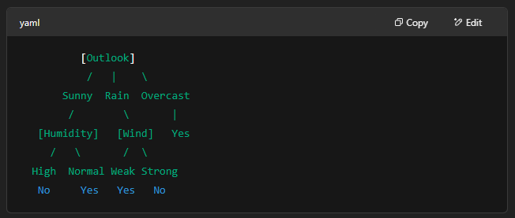
Explanation:
- If Outlook is Overcast → Play Tennis = Yes
- If Outlook is Sunny:
  - If Humidity is High → No
  - If Humidity is Normal → Yes
- If Outlook is Rain:
  - If Wind is Weak → Yes
  - If Wind is Strong → No

📌 Advantages:
- Easy to understand and interpret.
- Can handle both numerical and categorical data.
- Requires little data preparation.
- Performs well with large datasets.
📌 Limitations:
- Prone to overfitting.
- Can become unstable if small changes in data result in a completely different tree.
- Greedy algorithms may not guarantee the optimal tree.

What is K Means Clustering?
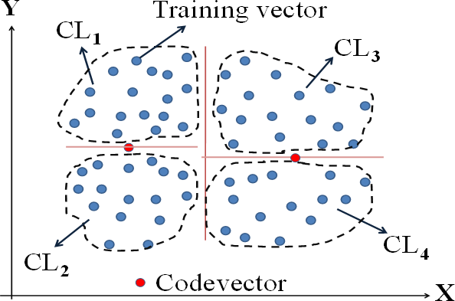
K-means clustering is one of the most popular and widely used unsupervised learning algorithms for clustering. It is a centroid-based clustering algorithm that partitions a dataset into K clusters, where each data point belongs to the cluster with the nearest mean (centroid). The goal of K-means clustering is to minimize the within-cluster variance, also known as inertia or sum of squared distances, which measures the compactness of clusters.

Here's how the K-means clustering algorithm works:
- Initialization:
    - Choose the number of clusters, K, and randomly initialize K cluster centroids. These centroids can be randomly selected from the data points or generated using other initialization methods.
- Assignment Step:
    - Assign each data point to the nearest cluster centroid based on the Euclidean distance between the data point and the centroids. Each data point is assigned to the cluster with the closest centroid.
- Update Step:
    - Update the cluster centroids by calculating the mean of all data points assigned to each cluster. The new centroid position is the average of the data points in the cluster.
- Convergence:
    - Repeat the assignment and update steps iteratively until convergence criteria are met. Convergence is typically reached when the cluster assignments and centroids no longer change significantly between iterations, or when a maximum number of iterations is reached.
- Finalization:
    - Once convergence is achieved, the algorithm outputs the final cluster centroids and the cluster assignments for each data point.



What do you mean by clustering? Discuss its challenges with respect to K means clustering. -> 10
Sure — here’s a clean, 10-mark style answer for your question:

📌 What is Clustering?
Clustering is an unsupervised learning technique used to group a set of objects or data points into clusters such that objects in the same cluster are more similar to each other than to those in other clusters.
It is widely used in data analysis, pattern recognition, image segmentation, customer segmentation, and anomaly detection.

📌 What is K-Means Clustering?
K-Means is one of the most popular clustering algorithms. It partitions the data into K distinct, non-overlapping clusters based on feature similarity.
The value of K (number of clusters) is specified beforehand.
📌 Working of K-Means:
- Choose the number of clusters K.
- Randomly initialize K cluster centroids.
- Assign each data point to the nearest cluster centroid.
- Recalculate the centroids as the average of the points assigned to each cluster.
- Repeat steps 3 and 4 until the centroids no longer change (convergence).

📌 Challenges in K-Means Clustering:
Challenge | Description
Choosing K (number of clusters) | Selecting the correct value of K is difficult and crucial. Methods like the Elbow Method or Silhouette Score are used, but they don't always give a clear answer.
Initialization Sensitivity | The final clusters depend heavily on the initial placement of centroids. Poor initialization can lead to suboptimal clustering results.
Non-convex Shapes | K-Means works best for spherical or convex clusters. It struggles with non-convex, overlapping, or varying-size clusters.
Scaling of Data | K-Means is sensitive to the scale of data. Features with larger ranges dominate the clustering unless the data is normalized.
Outliers and Noise | Outliers can heavily influence the position of centroids, resulting in misleading clusters.
High Dimensionality | In high-dimensional data, distance measures become less meaningful (curse of dimensionality), reducing clustering effectiveness.
Equal Cluster Size Assumption | K-Means assumes clusters are of similar size. It struggles with clusters of different densities and sizes.

Gotta learn Dt

