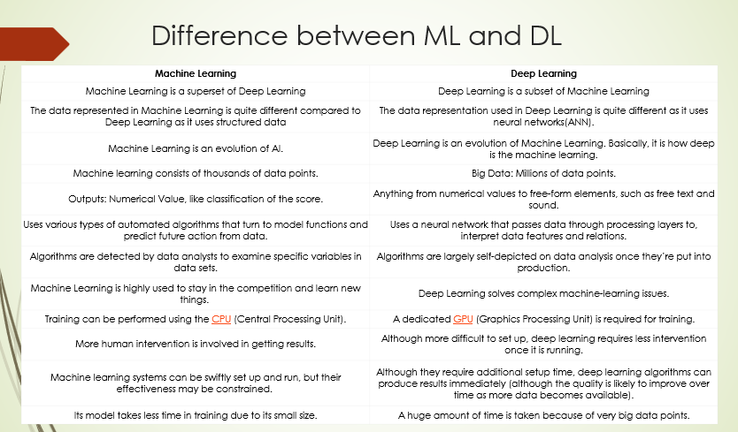

Types of Deep Learning
Deep learning encompasses various architectures, each suited to different types of tasks:
- Convolutional Neural Networks (CNNs): Primarily used for image processing tasks, CNNs are designed to automatically and adaptively learn spatial hierarchies of features through convolutional layers.
- Recurrent Neural Networks (RNNs): Ideal for sequential data, such as time series or natural language, RNNs have loops that allow information to persist, making them effective for tasks like speech recognition and language modeling.
- Long Short-Term Memory Networks (LSTMs): A type of RNN that addresses the vanishing gradient problem, LSTMs are used for complex sequences, including text and speech.
- Generative Adversarial Networks (GANs): These consist of two neural networks (generator and discriminator) that compete against each other, leading to the creation of high-quality synthetic data, such as images.
- Transformers: A more recent architecture designed for handling long-range dependencies in data, transformers are the backbone of models like GPT and BERT, used extensively in natural language processing.

Goals of Artificial Intelligence
Following are the main goals of Artificial Intelligence:
- Replicate human intelligence
- Solve Knowledge-intensive tasks
- An intelligent connection of perception and action
- Building a machine which can perform tasks that requires human intelligence such as:
  - Proving a theorem
  - Playing chess
  - Plan some surgical operation
  - Driving a car in traffic
- Creating some system which can exhibit intelligent behavior, learn new things by itself, demonstrate, explain, and can advise to its user.
Advantages of Artificial Intelligence

Following are some main advantages of Artificial Intelligence:

  - High Accuracy with less error: AI machines or systems are prone to less errors and high accuracy as it takes decisions as per pre-experience or information.
  - High-Speed: AI systems can be of very high-speed and fast- decision making; because of that AI systems can beat a chess champion in the Chess game.
  - High reliability: AI machines are highly reliable and can perform the same action multiple times with high accuracy.
  - Useful for risky areas: AI machines can be helpful in situations such as defusing a bomb, exploring the ocean floor, where to employ a human can be risky.
  - Digital Assistant: AI can be very useful to provide digital assistant to the users such as AI technology is currently used by various E-commerce websites to show the products as per customer requirement.
  - Useful as a public utility: AI can be very useful for public utilities such as a self-driving car which can make our journey safer and hassle-free, facial recognition for security purpose, Natural language processing to communicate with the human in human-language, etc.
Disadvantages of Artificial Intelligence

Every technology has some disadvantages, and the same goes for Artificial intelligence. Being so advantageous technology still, it has some disadvantages which we need to keep in our mind while creating an AI system.

Following are the disadvantages of AI:

- High Cost: The hardware and software requirement of AI is very costly as it requires lots of maintenance to meet current world requirements.
- Can't think out of the box: Even we are making smarter machines with AI, but still they cannot work out of the box, as the robot will only do that work for which they are trained, or programmed.
- No feelings and emotions: AI machines can be an outstanding performer, but still it does not have the feeling so it cannot make any kind of emotional attachment with human, and may sometime be harmful for users if the proper care is not taken.
- Increase dependency on machines: With the increment of technology, people are getting more dependent on devices and hence they are losing their mental capabilities.

AI APPLICATIONS
- AI in Astronomy
  - Artificial Intelligence can be very useful to solve complex universe problems. AI technology can be helpful for understanding the universe such as how it works, origin, etc
- AI in Healthcare
  - In the last, five to ten years, AI becoming more advantageous for the healthcare industry and going to have a significant impact on this industry.
  - Healthcare Industries are applying AI to make a better and faster diagnosis than humans. AI can help doctors with diagnoses and can inform when patients are worsening so that medical help can reach to the patient before hospitalization.

- AI in Gaming
  - AI can be used for gaming purpose. The AI machines can play strategic games like chess, where the machine needs to think of a large number of possible places.

- AI in Finance
  - AI and finance industries are the best matches for each other. The finance industry is implementing automation, chatbot, adaptive intelligence, algorithm trading, and machine learning into financial processes.

- AI in Data Security
  - The security of data is crucial for every company and cyber- attacks are growing very rapidly in the digital world. AI can be used to make your data more safe and secure. Some examples such as AEG bot, AI2 Platform, are used to determine software bug and cyber-attacks in a better way.

- AI in Social Media
  - Social Media sites such as Facebook, Twitter, and Snapchat contain billions of user profiles, which need to be stored and managed in a very efficient way. AI can organize and manage massive amounts of data. AI can analyze lots of data to identify the latest trends, hashtag, and requirement of different users.

TYPES OF AI
Based on Capabilities:
1️⃣ Narrow AI (Weak AI)
- Designed for a specific task
- Can’t perform beyond its programmed function
- Examples: Siri, Google Assistant, Chess-playing AI
2️⃣ General AI (Strong AI)
- Can perform any intellectual task a human can do
- Capable of reasoning, learning, and adapting
- Still theoretical, no current example
3️⃣ Super AI
- Hypothetical AI surpassing human intelligence
- Can perform tasks better than humans in every aspect
- Examples: Purely futuristic concept (like AI from sci-fi movies — e.g. Ultron, Jarvis in Marvel)

📖 Based on Functionalities:
1️⃣ Reactive Machines
- No memory, only reacts to current input
- Example: IBM’s Deep Blue (Chess AI)
2️⃣ Limited Memory
- Can use past data for a short period
- Example: Self-driving cars (using recent observations)
3️⃣ Theory of Mind
- Can understand emotions, beliefs, intentions
- Not fully achieved yet
4️⃣ Self-aware AI
- AI with its own consciousness and self-awareness
- Purely theoretical for now

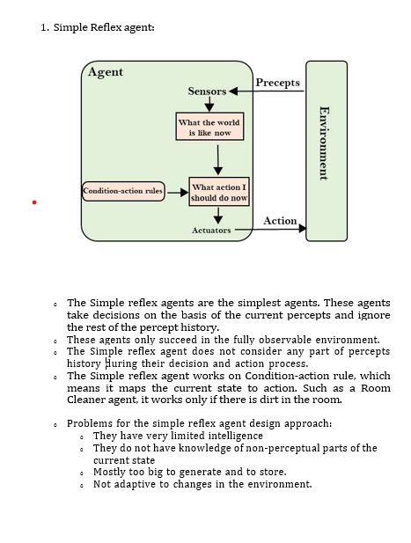

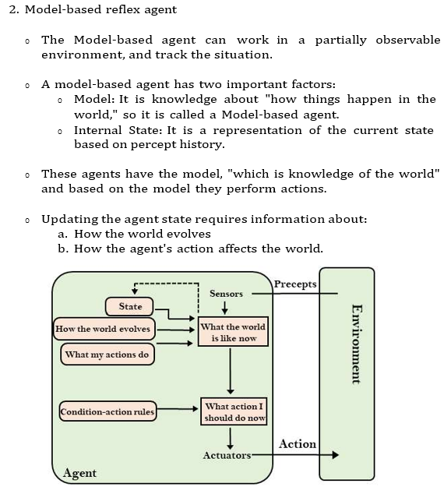

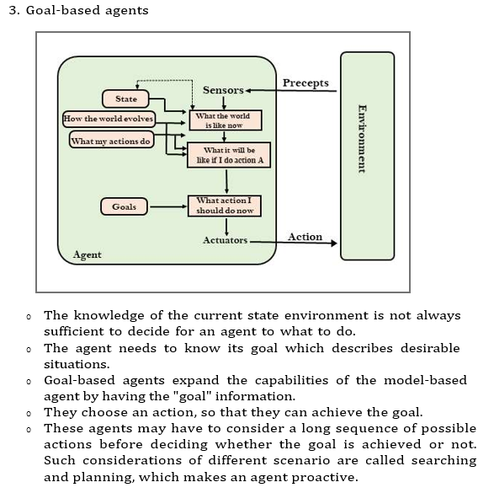
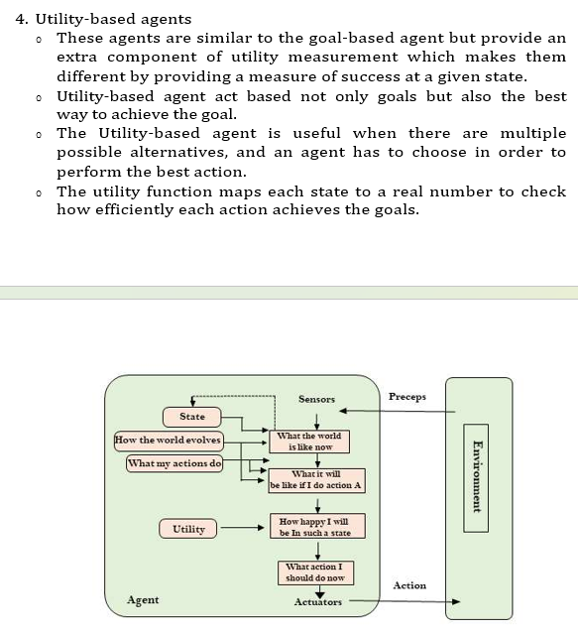
- Learning Agents
  - A learning agent in AI is the type of agent which can learn from its past experiences, or it has learning capabilities.
  - It starts to act with basic knowledge and then able to act and adapt automatically through learning.
  - A learning agent has mainly four conceptual components, which are:
- Learning element: It is responsible for making improvements by learning from environment
- Critic: Learning element takes feedback from critic which describes that how well the agent is doing with respect to a fixed performance standard.
- Performance element: It is responsible for selecting external action
- Problem generator: This component is responsible for suggesting actions that will lead to new and informative experiences.

Hence, learning agents are able to learn, analyze performance, and look for new ways to improve the performance
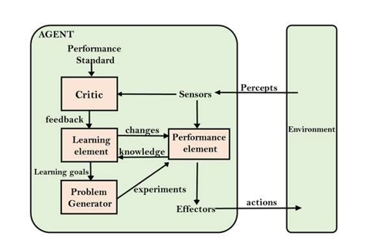

Features of Environment

As per Russell and Norvig, an environment can have various features from the point of view of an agent:

- Fully observable vs Partially Observable
- Static vs Dynamic
- Discrete vs Continuous
- Deterministic vs Stochastic
- Single-agent vs Multi-agent
- Episodic vs sequential
- Known vs Unknown
- Accessible vs Inaccessible

- Fully observable vs Partially Observable:
  - If an agent sensor can sense or access the complete state of an environment at each point of time then it is a fully observable environment, else it is partially observable.
  - A fully observable environment is easy as there is no need to maintain the internal state to keep track history of the world.
  - An agent with no sensors in all environments then such an environment is called as unobservable.
- Deterministic vs Stochastic:
  - If an agent's current state and selected action can completely determine the next state of the environment, then such environment is called a deterministic environment.
  - A stochastic environment is random in nature and cannot be determined completely by an agent.
  - In a deterministic, fully observable environment, agent does not need to worry about uncertainty.

- Episodic vs Sequential:
  - In an episodic environment, there is a series of one-shot actions, and only the current percept is required for the action.
  - However, in Sequential environment, an agent requires memory of past actions to determine the next best actions.
- Single-agent vs Multi-agent
  - If only one agent is involved in an environment, and operating by itself then such an environment is called single agent environment.
  - However, if multiple agents are operating in an environment, then such an environment is called a multi-agent environment.
  - The agent design problems in the multi-agent environment are different from single agent environment.
- Static vs Dynamic:
  - If the environment can change itself while an agent is deliberating then such environment is called a dynamic environment else it is called a static environment.
  - Static environments are easy to deal because an agent does not need to continue looking at the world while deciding for an action.
  - However for dynamic environment, agents need to keep looking at the world at each action.
  - Taxi driving is an example of a dynamic environment whereas Crossword puzzles are an example of a static environment.

- Discrete vs Continuous:
  - If in an environment there are a finite number of percepts and actions that can be performed within it, then such an environment is called a discrete environment else it is called continuous environment.
  - A chess gamecomes under discrete environment as there is a finite number of moves that can be performed.
  - A self-driving car is an example of a continuous environment.

- Known vs Unknown
  - Known and unknown are not actually a feature of an environment, but it is an agent's state of knowledge to perform an action.
  - In a known environment, the results for all actions are known to the agent. While in unknown environment, agent needs to learn how it works in order to perform an action.
  - It is quite possible that a known environment to be partially observable and an Unknown environment to be fully observable.

