README – LUCAS BEAL
Running the Final Program:
To run the query.py file, either load the entire folder into Visual Studio Code and run the file, or call the file with Git Bash by doing:
python query.py
To close the application at any time, enter ExitApp
Sample Screenshots:
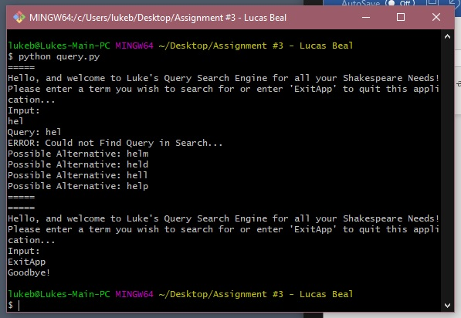
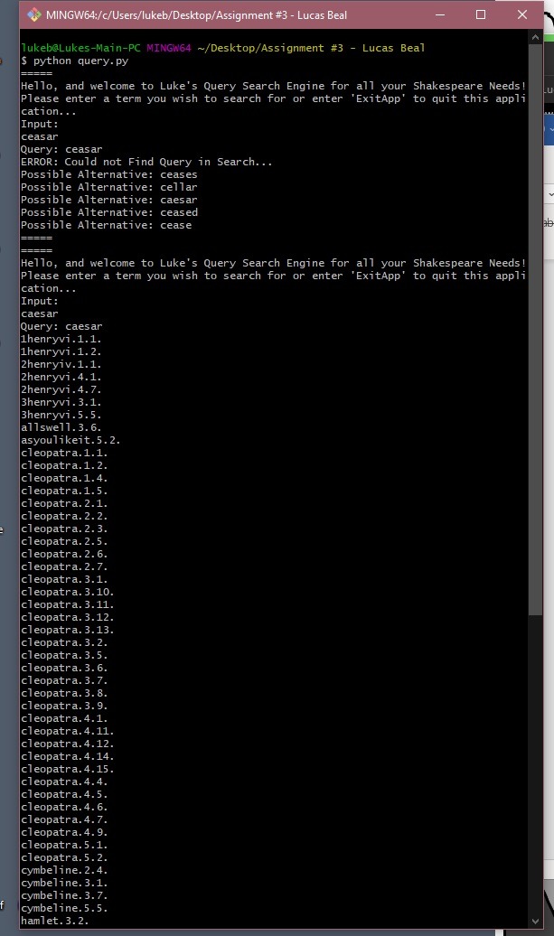
The list continues in the 2nd example, just couldn’t fit it into a single screenshot.
File Descriptions:
Saved Documents is the folder where I stored all of the saved HTML and TXT files for each work produced by Shakespeare. Normally, these files would need to be in the same folder for tokenizer to work properly, but I separated them for ease of access, and to not clutter the main folder.
Scrape_test.py is the file that scraps all of the works of Shakespeare on the website and saves them as html files.
Tokenizer.py is the file that reads in all the html files, saves them as easy to read txt files with the name of the play, act, scene saved as its name to make it easy to find, and then creates an inverted-index of all the terms and the relevant docs that those terms appear in. It then saves this information into a file called data.json.
Bigram.py is the file that takes in data.json and creates a bi-gram index of all the terms, and saves it as the bigram.json file.
Query.py is the file that is used to run the program as a whole, by asking for user input, and then searching data.json and bigram.json to return its results, or alternative spellings if necessary.
Additional Notes:
I thoroughly enjoyed the class, and especially liked the project that we utilized throughout the course. I felt that the first part of the project was rather difficult to get working, scrapping the webpages, but that could also be attributed to me being rather new to Python (I usually code in Java), but I appreciated the challenge of having to really study and utilize a new language as well.

