Connecting TV and the Web

Using Second Screen Applications

1st Author

1st author's affiliation  
1st line of address  
2nd line of address  
Telephone number, incl. country code

1st author's email address

2nd Author

2nd author's affiliation  
1st line of address  
2nd line of address  
Telephone number, incl. country code

2nd E-mail

3rd Author

3rd author's affiliation  
1st line of address  
2nd line of address  
Telephone number, incl. country code

3rd E-mail

**ABSTRACT**

People are using the Web to augment their TV experience, in particular by using their preferred social networking sites to talk about what they were watching. This behaviour evolved without any specific technical infrastructure in place; people used whatever tools and services were available to them, producing interesting network effects as ad-hoc communities developed in real time around programmes.

In this paper we describe three two-screen TV applications we have built to illustrate the possibilities of using *open* protocols and linked data in social TV applications and our planned techniques for evaluating them.

Within the rapidly evolving field of Web and TV convergence we have identified two core components which are key to enhancing the TV experience for audiences: TV URLs and open APIs to TV. We describe why we believe these are important to making interesting social applications.

**General Terms**

Measurement, Human Factors

**Keywords**

Social networks, second screens, linked data

# INTRODUCTION

Permission to make digital or hard copies of all or part of this work for personal or classroom use is granted without fee provided that copies are not made or distributed for profit or commercial advantage and that copies bear this notice and the full citation on the first page. To copy otherwise, or republish, to post on servers or to redistribute to lists, requires prior specific permission and/or a fee.

*EuroITV2011*, June 29th-July 1st 2011, Lisbon, PORTUGAL.

Copyright 2010 ACM 978-1-60558-831-5 /10/06…$10.00.

Integration of TV and the social web is already happening. People are increasingly using online social networks to talk about TV, nearly all via second screens such as laptops, tablets or smartphones. There is evidence to suggest that a high proportion of the conversations in social media are around what people are watching on TV[1]. During prime-time scheduling Twitter trending topics are often TV-related, and this Twitter activity can influence what people decide to watch. For example, people reported watching The Eurovision Song Contest on the basis of what was being said about it on Twitter, even though they wouldn’t normally have watched it[2].

With the rise of ‘couch potato multi-tasking’ (the trend for people to use the TV and the Web simultaneously), this behaviour has evolved ad-hoc as TV viewers used whatever existing applications, devices, tools and services were available. Increasingly specific ‘Social TV’ applications are being built - however, they do not need to exist for this behaviour to happen.

Despite this, we still think that there are tools that can help people communicate socially about TV - including the infrastructure described below, such as APIs which can improve the integration of the second screen and TV, and other lightweight tools such as targeted autocomplete for TV. There are also unsolved problems to do with finding video content in large collections, and unmet opportunities around small groups temporarily coming together around TV programmes. Our approach has been to build prototypes which show what sorts of applications could be built in this area, starting with user stories.

# OUR SCENARIOS

Our protoyping work is driven by realistic user stories combined with the business needs of media organizations, framed as questions a user might ask.

## How can I find something interesting to watch?

We are exploring different ways to solve the problem of finding something interesting to watch on TV, which is becoming increasingly relevant to all TV watchers as channels and other sources of video proliferate.

Initally, we explored the generation of personalised recommendations based on user profiling from existing social activity data. This scenario is for people who would like to relax at the end of the day and be able to watch personalized TV without doing anything at that point (‘lean back’). In this scenario the user would like to get interesting and novel programme recommendations without having to spend time and effort setting up her preferences about TV programmes in any social network and then having to remember to keep them all up to date, but instead based on her activity within all social networks. For this scenario we have built a prototype which shows personalized recommendations based on social network activity on the TV screen.

For the person willing to engage in ‘lean forward’ effort to find something interesting to watch, we looked at the central unsolved problem of finding something to watch from large on-demand video collections. For people willing to put some time into search and browsing, common ways of organizing videos such as ‘what’s popular’ or ‘what’s new’ may be a less satisfactory option than some niche content buried deep in the long tail, so to cover this scenario, we have built a prototype to show how serendipitous videos of interest from the long tail might be presented to users.

## How can I find out more about a programme I’m watching?

A common scenario while watching TV is the desire to find out more information about a programme, either now or later. The user we have in mind does not necessarily want to have her laptop open all the time during this and neither does she want to interfere with the playing of the programme too much as she often watches TV with other people in the same room. For this scenario we built a prototype that shows specific related information about the programme from the linked data cloud on a second screen, and also allows you to bookmark a programme to refer to it later.

## How can I share what I’m watching with others?

On the Web there cannot be any default assumption of shared context. Unlike TV, many social networks are not geographically constrained and people often have quite diverse networks. Because of this, links are often used to provide some of that context.

Without a means to refer to the item being watched, the conversation can only go so far. If a person is watching an interesting documentary she can talk about how fascinating it is by referring to it using its title, but there the conversation will probably end, unless someone they know also happens to be watching at the same time. When people are watching at the same time there is the potential for interesting conversations to occur spontaneously, but for less popular or on-demand programmes this will not occur. If the person watching it can give a link to information about the programme, then people can find out more about it, perhaps watch it, and maybe even respond to her original comments, sparking a more interesting discussion and a longer life for the recommendation. Providing the means to automatically insert the URL of a programme into users’ comments therefore helps to create the structure for more meaningful conversations.

## How can I share my emotional reactions to a programme with a wider group?

Sport, politics, reality shows, comedies and national events can all produce emotional responses in people watching them, and the desire to share some of these feelings is part of the fun of watching these kinds of programmes. The Social Web provides the means to widen out the groups that can participate in this sharing. People need not be physically in the same place, and the groups need not be existing friends. Some broadcasters are already tapping into this experience - for example Channel 4’s game show ‘The Million Pound Drop’ includes an online element that lets users play along live as the show progresses[3] that has proved very popular. Reading other people’s funny or insightful comments can capture the excitement and emotion of watching TV with others, and encourage individuals to add their own opinions to the conversation. We know this is already happening, so we wanted to take the idea further.

We wanted to explore how social media could be used as a trigger for the formation of ad-hoc interest groups who want to do something specific. The simple example we have prototyped is a group casting real-time votes on the popularity of participants of a TV programme, but more complex examples could include collaborative TV annotation or commentary, in small or large groups.

## Business Drivers

While users remain central to our work, we also take account of business considerations:

• Many large media organisations have huge archives of video, often with metadata describing them. A big problem for those organizations is: how can our audiences find interesting content in these archives, particularly when they contain videos that no-one has yet watched, or where there is little metadata associated with them? Can metadata created with the programme be (re-)used to help them find it? Can this be enhanced with other external sources of metadata? How do people find and share the content? Can social media be used to surface long tail content (that no-one has yet watched)? From a content owner’s point of view, there’s no point in one person finding something interesting if they are not able to tell anyone else about it.

• The big advantage of broadcasters is just that: that they have the ability to reach large numbers of people simultaneously. Relevant questions for broadcasters might include: What kinds of applications can encourage people to watch with others? What benefit could these applications bring?

• Finally, as more catch-up and archival video is created by broadcasters, a key question for them is how they can gather information about audience interest in the programme over the complete lifecycle of pre-broadcast, broadcast, on-demand and archive? And are there ways to use social networks to benefit those large numbers of people who are not in social networks?

# Context: Trends in Web and TV Convergence

Integration of TV and the Social Web is a very fast moving area. This brief overview of current trends sets our work in context.

## Trends in user behaviour

Increasingly, people are using online social networks to talk about TV. For example, YouGov’s Social TV trends report[4] found many of the 76% of 18 to 24-year- olds who browse the Web whilst watching TV want to vote and download information about what they’re watching, as well as comment and view reactions to shows in real- time from their friends and family via instant messaging, or through social networking sites.

Research suggests that people often use ‘second screens’ such as a laptop, tablet or mobile phone while watching TV[5]. In the last few months ‘second screen experiences’ specifically designed to complement TV have proliferated - particularly around live sport events such as the World Cup[6]. This trend has been accelerated by the success of the iPad and its suitability for use in the home for leisure and entertainment purposes[7]. Tablets such as the iPad also lend themselves much better than smartphones to being shared among family and friends[8]. In addition to their larger screen size, this makes them more suitable for use as a communal TV remote control[9].

## Growth in social TV apps

There is a growing trend, particularly in the US, for second screen services and platforms designed around creating ‘Social TV’ experiences. Several apps and sites (such as Philo, Miso, and GetGlue) have repurposed the check-in concept popularised by Foursquare and adapted it for TV for a shared television watching experience (although it could be argued that people are doing this already by using hashtags for programmes on Twitter).

Other services, such as yap.tv, Starling TV, Clicker and Tunerfish are concentrating on integration with Twitter and/or Facebook. In the UK, BBC’s iPlayer catch-up now links with Twitter and Facebook and integration with Microsoft’s Windows Live messenger is expected to be available in summer 2011.

## Web-connected TVs

Connecting the TV to the Web has become a focus for manufacturers and makers of set top boxes, with Apple TV, Sony’s Google TV, the Boxee Box, and Roku XDS, to name a few, all recently coming to market. DisplaySearch forecasts that by 2013, 100 million connected TVs will be shipped worldwide, up 546% from nearly 15 million in 2009[10]. This development is likely to have an impact on future Social TV scenarios; for example, the potential role of video telephony will be interesting to watch. We also wait to see whether these all-encompassing single-screen solutions threaten to make second screens redundant.

## Analysis

Here are some key observations driving our work:

• APIs to various kinds of TV-like devices and software are proliferating, and this suggests the application equivalent to having many physical remote controls for your TV setup. We know that users do not want this; it also makes things more difficult for manufacturers and application developers. It makes sense to look for the common elements of such an API. Our use cases work is ultimately geared towards being able to feed into such work and propose such an API to a wider community.

• The trends described above suggest that our work on connected second screens is on track with a large portion of the industry. However it is not clear at the moment what second screen applications give the user that existing tools (such as using Twitter or Facebook on a laptop or phone) do not. People started using second screens for TV watching without any of these tools being available. We are therefore attempting to look a step ahead to where future TV APIs might lead.

• There is a strong trend towards the provision of web-connected TVs. However, from a user’s point of view, using the Web on the TV is an unfamiliar and relatively uncomfortable proposition, and involves the use of very complicated remote controls or keyboards while watching the TV[11]. Further, the user has less control. For example, Google TV’s ‘dual view’ mode for Twitter shows the majority of the TV screen taken up by the Twitter stream, with the TV content itself confined to a smaller window, potentially compromising the main experience of watching the TV. It may be that the focus of Web-connected TVs is not the Web per se, but the delivery of video content.

# PROTOTYPES

All the prototypes described below use second screens to allow the user to choose and control comfortably and then, when ready, play on a larger screen. All also use XMPP over HTTP to do the controlling. This technical framework allows us to quickly create two-screen applications in HTML and so speeds development. There is no reason why native XMPP applications could not be used instead.

XMPP is chosen as the messaging prototcol, because of its built-in user- centric ‘friend-based’ security model. We use the Strophe implementation of XMPP over HTTP and the eJabberd XMPP server.

## Two-way iPhone TV remote

Our first prototype explored the idea of re-using a user’s existing activity data from social media sites to generate personal TV programme recommendations based on the user’s interests. This was based on the observation that a user should not have to explicitly tell any system what her preferences are, since a lot of data about these preferences are already available online; for example, in her social network profiles and ratings on YouTube and IMDB. This scenario requires that the user sets up an interests profile by adding one or more sources of data from existing social media sites that she uses. The demo shows a user linking a social network account to an activity aggregator to automatically generate a statistical summary of her interests.

Using an iPhone app the user is able to operate a media centre (in this case MythTV) with the smartphone acting as a remote control to view a personalised TV programme guide based on the links between the interests in her User Profile and the programme, change channel and watch a programme.

We also used the smartphone to show that connecting the TV to the Web does not have to mean showing the Web on the TV screen. Instead, the Web can be treated as a useful companion to the TV via a 'second' (subsidiary) screen. This is less obtrusive and gives the user more control over the experience, and it provides a natural extension to the trend for people to use the TV and Web simultaneously on dual screens. This technique relies on the TV being able to tell other devices what its currently playing: we used XMPP as a communication protocol to strike a balance between personalisation and privacy: the user has to ‘make friends’ with their TV.

Once paired, the devices can then do useful things with the information, which could be as simple as enabling the user to say something about the what they are watching using social media without having to look it up, or as complicated as automatically finding more information about the programme, or looking up related programmes.

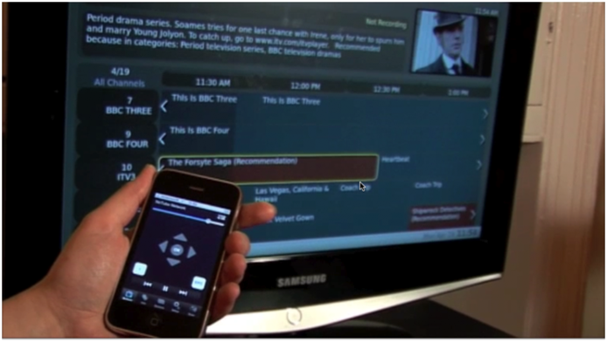

Figure : A prototype showing a smartphone being used to navigate a personalised EPG

Based on the observation that people would often like to know more about a programme they are watching, our demo showed automatically gathered related information about the programme being broadcast, presented to the user on the smartphone. By using a URL to identify the programme, it was possible to unambiguously link the programme to related information from different sources around the Web using the Linked Data Cloud. In this case the data was originally sourced from Wikipedia and the BBC website.

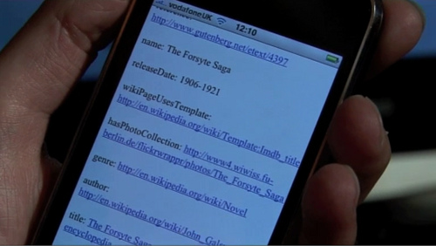

Figure : A two-screen prototype showing information from the Web relating to a programme being broadcast on TV

To avoid interrupting the viewing of the programme, the user was able to quickly bookmark the programme from the TV to delicious.com, so that she could easily find it again later.

## Navigating a large video collection using Linked Data

This two-screen prototype was designed to aid serendipitous content discovery and sharing of newly discovered programmes of interest. It uses a private research collection of three years’ worth of BBC video archive. The goal is to help people find interesting videos to watch, and the technique used is to suggest related videos. A relatedness measure is generated based on the number and diversity of the links the programmes have in common.

Our initial experiments with Linked Data programme recommendations as described above were based on automated entity recognition and extraction of terms in programme metadata being matched to relevant DBPedia concepts. The results suggest that using DBpedia alone may produces suggestions that are too general, such as ‘Eastenders is recommended because you like programmes made in the 1980s’. We concluded that there may be inherent limitations to such a scattergun approach, which also depends very much on the quality of the source material and the classifier. Because of these issues, for our second prototype we decided to remove some of the inaccuracy by experimenting with using some semi-editorialised data based on Lonclass, a BBC-specific classification system based on Universal Decimal Classification (UDC) codes. This is a nice dataset for experimentation because it removes some of the sources of potential irrelevancy (the entity recognition) while retaining some of the interesting characteristics of the data (its complexity and diversity), and increasing the relevancy to within the TV domain.

Lonclass provides a rich vocabulary of ready-made programme metadata that is:

• Extremely flexible and precise: the structure of the classification allows for detailed multi-concept descriptions of the subject content.

• TV-focused: Since 1964 the BBC has adapted and extended UDC for television content adding specialised subject terms. New terms are created daily for new concepts and subjects to describe scenes, sequences, clips and shots. We propose that the sheer diversity of terms should help with the interestingness of the recommendations.

• Used by professional cataloguers for subject indexing as part of the cataloguing procedure for the BBC’s internal TV and radio programme catalogue. Since a human indexer has assigned the specific link between the programme and the term, we might also expect the recommendations to be more accurate as well as more interesting.

• Potentially better than DBPedia for abstract concepts, i.e. for describing the ‘aboutness’ of a programme.

Within the prototype, from any programme the user can follow suggestions for similar programmes based on the number of common Lonclass links between them and the number of different links between them. The idea is to support “hours of fascinated clicking” through the programmes archive, similar to the way that following links in Wikipedia articles can take users on surprising and unexpected journeys through the content.

Our initial experiments gave rich and diverse links between programmes based on their Lonclass categories, with multiple programme pairs linked by more than one category. When the user has found something interesting to watch, she can play it on a second screen.

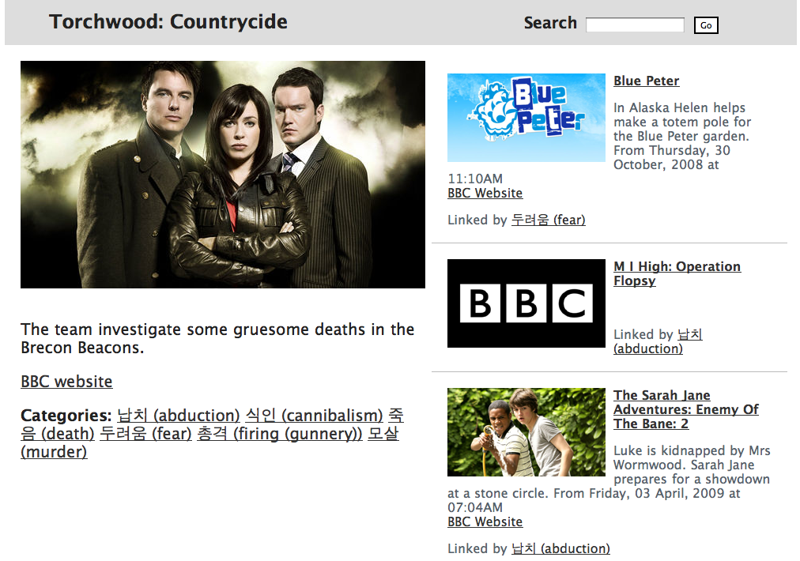

Figure : Screenshot of a prototype for browsing a video archive (Korean version)

## Interactive voting

The third prototype is an application that allows the end user to join an ad-hoc group associated with a broadcast event and get near-immediate feedback on how the other members of the group are voting. This initial version is primed with the participants of a political panel programme broadcast in the UK, that is also very popular on Twitter. The user can vote each participant up or down. The goal is to provide a companion to the social network chatter but in a more structured and visual form.

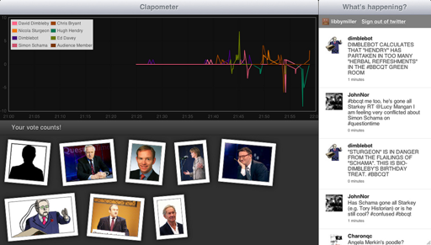

Figure : Screenshot of a prototype for interactive voting

The prototype uses the Twitter API to enable the user to login and then spawns an anonymous XMPP user that connects to a backend vote aggregator. Votes are sent as XMPP messages, aggregated and returned as presence messages for display back to the user. An administration interface allows the addition and deletion of options and enables setting of a hashtag for filtering Twitter messages that the application users see.

# INFRASTRUCTURE

To support the prototypes we have worked on an Open API to TV (‘Buttons’) and associated services.

## Open API to TV

To avoid the application equivalent of having a different physical remote for each device, the idea of our API to TV, ‘Buttons’ is to create an Open API usable for many different TV applications. This is the difference between our approach and the various remote control applications available for Boxee, Vimeo, YouTube, TIVO, Apple TV and the Android Google TV remote: the API is the important part, not the specific application of it.

The API is two-way, including the usual control commands (Play, Pause, etc), additional web-based video commands (Load Page) and also specific responses (Now Playing, providing basic or extended metadata, together with a URL to identify the programme (see TVDNS section below). We have used the API in the first prototype to communicate between MythTV and the iPhone, and in the second prototype to ‘send’ the video to the larger screen when the user has finished browsing and decided what to watch.

## CRID Resolver

The CRID resolver service provides a means of linking from broadcast TV to a webpage describing the programme. The social web is about linking - linking is the usual way of talking about things on the Web. If you cannot refer to something by URL, it’s difficult to share it. Although the some broadcasters provide resolvable URLs for individual programmes, these are not broadcast along with the content, so there is nothing explicitly connecting the URL and the programme being broadcast. Other pieces of information are sent, however, and we can use these to determine the unique URL using a resolver.

TVDNS builds on RadioDNS[12], and is a way to use of the DNS system together with some pieces of information that *already* get sent with the DVB Stream to tell a DNS-capable device that a resolvable URL is a associated with a piece of content. Part of the TVDNS service we have built (CRID to URL resolution) is used in the first prototype (two-way iPhone remote), in order to select appropriate information to display. The idea is to take published information about the TV schedule, and use date and channel to look up the URL where available.

## EPG Autocompleter

For less connected devices, we can still make it easier for people to link to programmes by using a filtered autocompleter. This could be used in a tweet box to help people talk about what they are watching. It works by taking schedule data for a given day and running an SQL query over it based on the current time, so that the channel or programme title autocompletes to the nearest matching instance in time. When selected it places the title, channel and URL in the tweetbox ready for the user to augment with their own text. It uses the jQuery autocomplete plugin.

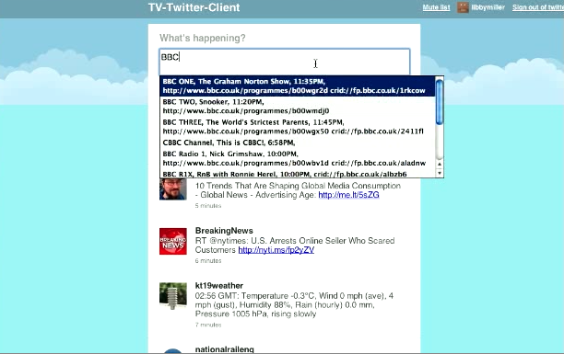

Figure : Screenshot of EPG autocompleter prototype

# Evaluation plan

As the second (browsing on-demand video) prototype is the most stable and well-understood, our current evaluation plan focuses on that. We have highlighted three main areas for user testing that relate to this prototype. For each of these we have identified a hypothesis and designed a test. The tests will be carried out in the first quarter of 2011.

## Navigating on-demand content using interesting links

The first hypothesis is: **Using Lonclass (a BBC subject classification system) to present content-based links between programmes for users to follow allows for serendipitous browsing of large video collections and helps people find programmes of interest buried in the long-tail that they would otherwise not find.**

Here we want to test the value of using graph-based ‘interestingness measures’ in a practical experiment to see if this specific application of it produces the expected behaviour - i.e. people carry on clicking through a large video collection by following interesting links.

We plan to conduct a test asking users to browse the video database using the prototype interface, while adding programmes of interest to a playlist. We will then measure the time spent on this activity and the length and diversity of the playlists compared with measures of the size of the database. We want to see whether the Lonclass-based links have kept people clicking, and enabled individuals to follow their own particular interests.

## Using explanations to test Linked Data recommendations

The second hypothesis is: **Presenting the pathways through the graphs allows the user to see the connection that led to a recommendation being made and can lead to greater user satisfaction with the recommendations.**

This gives the user a more interesting story than the ‘black box’ explanations of collaborative filtering techniques, which typically such explanations such as ‘People who watched this programme also watched these other programmes’. Using graph-based recommendations allows us to say why they are similar: ‘Here are some more programmes about aliens and time travel’.

We also believe that different types of connections will trigger different levels of interestingness in the explanations, resulting in different levels of user satisfaction. For example, links based on subject may be generally more or less interesting than links based on people (such as actors, directors, authors or presenters).

We plan to test this by randomising the types of recommendations shown to each user (e.g. recommendations based on personal interests compared with content-based recommendations), and showing the associated explanations. We will ask users to complete a questionnaire indicating their satisfaction with each recommendation. We will also conduct lab-based tests for more in-depth verbal feedback to explore which aspects of the explanation made a recommendation interesting to the user.

## Second screen usability

Our hypothesis is that, **in some contexts, using a second screen to show Web-based information about a programme creates a better user experience than integrating the information with the TV screen**

This is because it:

• Does not take the user away from main viewing experience

• Does not clutter the TV screen with graphics/widgets

• Is easier for reading and entering text

• Allows for the potential for personalised interfaces

We plan to take the simplest possible scenario (for example: “show me more about the programme”) and implement it both as widget on a TV and as a simple two-screen prototype, and then conduct lab-based tests to compare users’ reactions to the different experiences.

## Evaluation Challenges

We approach our evaluation work with the observation that getting accurate feedback from users about the quality of programme recommendations is challenging for several reasons. These include the need to for users to try out some new programmes, which might at first seem rather too obscure or too far removed from their traditional choices. Ideally, users would also need to give reflective and retrospective thought to the question of whether a programme recommendation really was ‘relevant’ or ‘useful’, which is difficult to do without actually watching the programme itself.

# FUTURE WORK

## Graph analysis

In prototype 2 (Navigating Large Video Collection Using Linked Data) we observed anecdotally that browsing interest is higher when more than one category links two programmes, or when a programme is linked to others by more than one category. We term these two features respectively ‘pairwise connectedness’ and ‘fanning’: browsing interest appears to be higher if pairwise connectedness and fanning are both high. If they are both equal to 1, this is the same as a search for the single category and puts the user in a ‘rathole’ of very similar content, especially given the fine distinctions made in this particular dataset. High pairwise connectedness and fanning mean that there are multiple options for the user to browse.

Figure : ‘Pairwise connectedness'

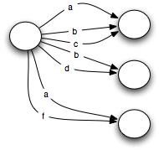

Figure : ‘Fanning’

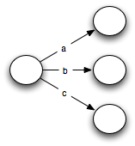

We can think of the set of connections between programmes and Lonclass as being a labeled graph, which suggests that investigation into measures of ‘interestingness’ like this might be extended into RDF graphs in general, and in particular, once we have a measure of it, we should be able to tell if the addition of another graph - for example a set of preferences or an activity stream - is likely to increase interest or not. We intend to look more closely into graph theory for any other features of graphs that can help us characterise their interestingness.

## Privacy and public data

We are mindful of the privacy implications of our work. The focus of our initial prototype was on re-using a user’s existing activity data from social media sites to generate personal programme recommendations based on the user’s interests. As part of this, we identified various potential privacy issues around the aggregation and sharing of personal data. Anecdotal evidence also suggested that that people are naturally quite guarded about automatically sharing their TV viewing behaviours.

In prototype 3 (Interactive Voting) the Twitter login is not strictly required, but is there because the goal is to enhance existing users’ use of the social network during the programme, not to replace it. A new anonymous login is spawned each time the user refreshes the page, and no information about the user (such as friends) is kept by the application. Using XMPP we can help people communicate without them needing to have persistent logins.

The other interesting issue from a privacy point of view with this prototype has to do with using second screens for social networking. In most cases, it’s *my* social network but *our* TV, so displaying personal social network comments on the TV screen, as well as being a usability nightmare, is also a privacy problem.

## Limiting the Search Space

A recurring research question is “how best can we limit the search space to make entity recognition successful?” This applies to the related programmes search space (identification of categories based on metadata). Our intuition, which needs to be tested. is that a smaller, TV-related dataset (Lonclass) will produce better results for this purpose than DBPedia / Wikipedia,.

## Adding Social Features

A common way of organising on-demand collections is to allow the user to see what’s popular. Social networks allow us to give the user information about the popularity of shows as they are broadcast - and also to see what’s popular among their friends, so extending this technique to broadcast TV, and personalising it, with minimal effort on the part of the user. In addition, people who do not actually use social networking sites can also benefit from the trending information.

We plan to extend the two-screen MythTV prototype by

• Showing which programmes are being tweeted about the most as ‘hot spots’ on the EPG, capturing the zeitgeist to suggest programmes of interest.

• Displaying what the user’s friends on Twitter are saying about a particular programme.

• Automatically inserting the URL for the programme into the user’s tweet.

• Showing on-demand programmes related to those currently showing.

• Showing other programmes that a friend has been tweeting about and make it selectable to watch on-demand.

Integrating social influences using publically available Twitter data is one option for eliminating some of the privacy issues we have identified. Consistent with our previous findings, it is instructive that this is the way in which people seem to be choosing to share their TV consumption data in general, rather than using activity-based aggregators. Whilst there is plenty of evidence of people explicitly talking about programmes, we have found less evidence of people using tools that automate sharing, for all the reasons we discussed before (such as anxieties around indiscriminate disclosure of personal data and perceived high privacy of TV-related activity).

# Conclusions

Within this paper we have presented three second screen prototypes for social TV watching, and have highlighted the importance of open APIs to TV, and URLs for TV in the context of the integration of TV and the Social Web. We see the ongoing development of these technical components as the foundation for making future TV experiences more enjoyable.

# ACKNOWLEDGMENTS

# REFERENCES

1. For example: a YouGov/Deloitte report published in August 2010 found that 42% of those UK adults who use the Internet while watching television do so to discuss or comment on the programmes they are currently watching at the time. (http://today.yougov.co.uk/consumer/television-going-social).
2. http://www.broadstuff.com/archives/1696-Eurovision-songs-sound-better-on-Twitter.html
3. http://www.channel4.com/programmes/the-million-pound-drop-live/articles/game
4. http://today.yougov.co.uk/consumer/television-going-social
5. http://www.reuters.com/article/idUSTRE62L4UB20100322
6. https://picklive.com/ and http://mintdigital.com/blog/livepitch
7. For example, eMarketer’s research has shown that 24% of iPad owners in the UK use their iPad as their primary entertainment device, and 62% of iPad owners in a similar study said they had never or rarely taken it out of the house.
8. http://blog.nielsen.com/nielsenwire/wpcontent/uploads/2010/10/Nielsen-Connected-Devices-Summary-Oct-2010.pdf
9. http://www.ericsson.com/news/1440031
10. http://www.displaysearch.com/cps/rde/xchg/displaysearch/hs.xsl/100405_tv_manufacturers_continue_to_breathe_new_life_into_tv_market.asp
11. Wow, Sony’s Google TV Remote Looks Like A Ten Thousand Button Nightmare: http://techcrunch.com/2010/10/05/google-tv-remote/
12. http://radiodns.org/