TASKFLOW
Sequential Operational Manual
A screen-by-screen guide to daily work, planning, administration, reporting, and audit

Audience | Users, team leads, project managers, administrators
Application | TaskFlow Web and TaskFlow.Api
Edition | 1.0 - screenshot edition
Issued | 11 August 2026

How to use this manual
Follow the numbered screens in sequence for onboarding. Experienced operators may jump directly to the required screen. Each section identifies the screen purpose, the normal operating procedure, and an operational control.
- Screenshots show the implemented application at a desktop viewport.
- Displayed records are examples from the current TaskFlow environment.
- Available data and actions may vary by account permissions and configuration.
- Avoid duplicate submission while a button shows Saving, Posting, Uploading, Loading, or Please wait.

Screen sequence
- 1. Sign in
- 2. Dashboard
- 3. My Work
- 4. Board
- 5. Backlog
- 6. Releases
- 7. Projects
- 8. Software
- 9. Teams
- 10. Departments
- 11. Vendors
- 12. Work Item Types
- 13. Custom Fields
- 14. Workflows
- 15. Reports
- 16. Audit Log
- 17. Create Account

1. Sign in
Purpose. Access TaskFlow with a registered account.
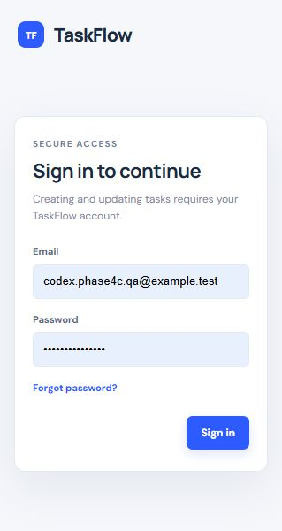
Figure 1. Sign in screen.

Operating sequence
- Open http://localhost:4200/dashboard.
- Enter the registered email address and password.
- Select Sign in and wait for the Dashboard.
- If access fails, verify credentials or use Forgot password?.
- If the API is unavailable, confirm http://localhost:5183/health returns Healthy.
Security control: Never share passwords or reset tokens. Sign out on shared workstations.

2. Dashboard
Purpose. Start each shift by reviewing delivery health and attention items.
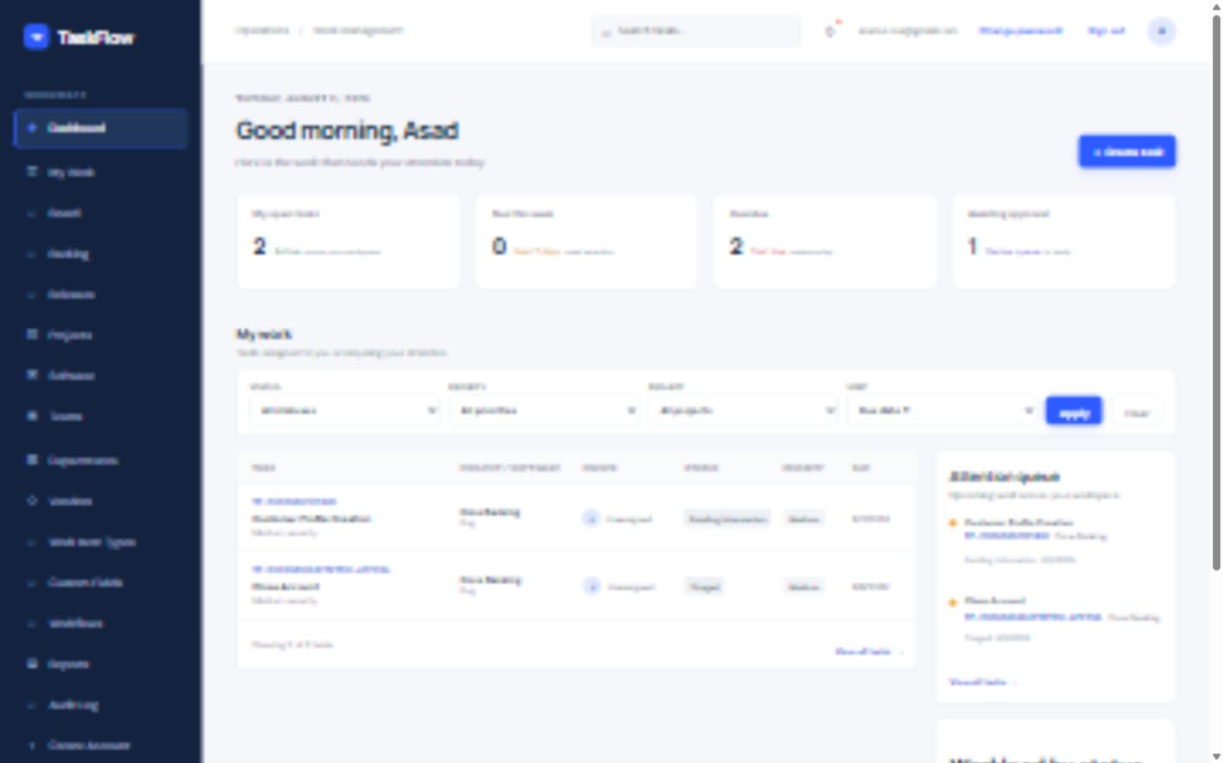
Figure 2. Dashboard screen.

Operating sequence
- Review open, due-this-week, overdue, and approval totals.
- Scan My work for tasks requiring immediate action.
- Use filters and Apply to narrow the dashboard list.
- Open an attention-queue item to review its full record.
- Select Create task only when a new, non-duplicate work record is required.
Operational control: Confirm the saved result or refreshed screen before moving to the next activity.

3. My Work
Purpose. Find, prioritize, open, and manage operational tasks.
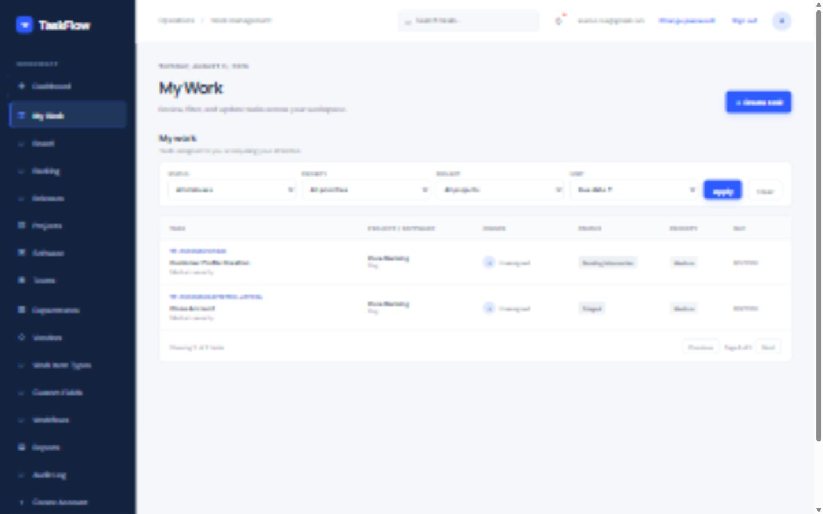
Figure 3. My Work screen.

Operating sequence
- Choose Status, Priority, Project, and Sort filters.
- Select Apply; use Clear to restore the full list.
- Open a task row to view details, history, comments, attachments, links, and assignments.
- Use Create task to record new work.
- Use Previous and Next to move between pages when the result set is larger.
Operational control: Confirm the saved result or refreshed screen before moving to the next activity.

4. Board
Purpose. Move work through the configured lifecycle.
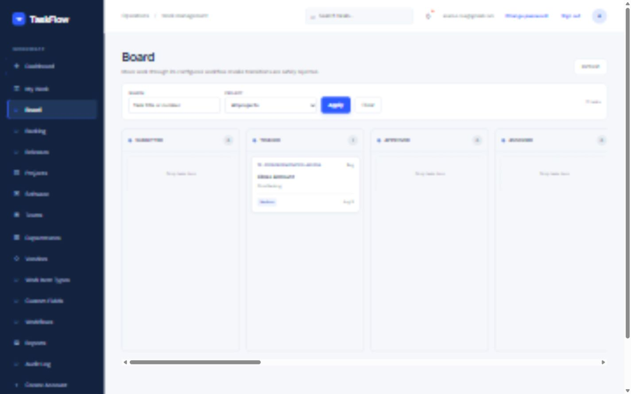
Figure 4. Board screen.

Operating sequence
- Filter by task title/number or project, then select Apply.
- Locate the task card in its current status column.
- Drag the card to the required destination status.
- Confirm the success message and destination placement.
- If rejected, use an allowed intermediate transition or contact the workflow administrator.
Workflow control: Rejected transitions indicate a configuration rule; do not bypass them by changing unrelated fields.

5. Backlog
Purpose. Plan tasks into sprints and control sprint execution.
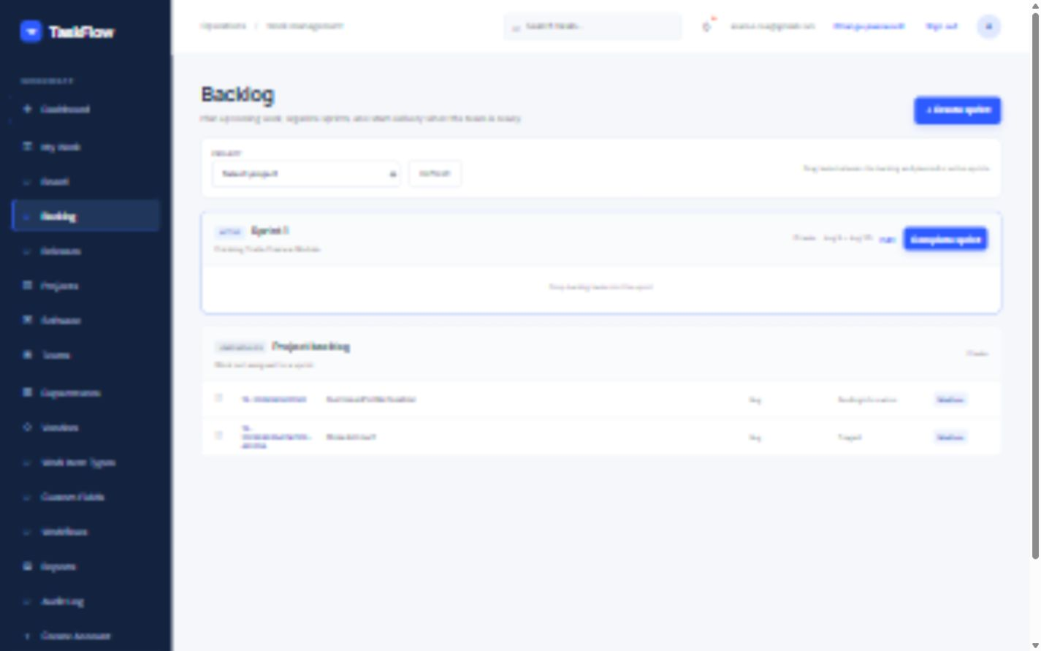
Figure 5. Backlog screen.

Operating sequence
- Select the project to load its sprint plan.
- Create a sprint with name, goal, start date, and end date.
- Drag unscheduled tasks into a planned or active sprint.
- Start a planned sprint only when operating policy permits.
- Complete the active sprint after reconciling unfinished work.
Planning control: Sprint placement represents scope; task status represents execution.

6. Releases
Purpose. Plan versions/releases and maintain delivery scope.
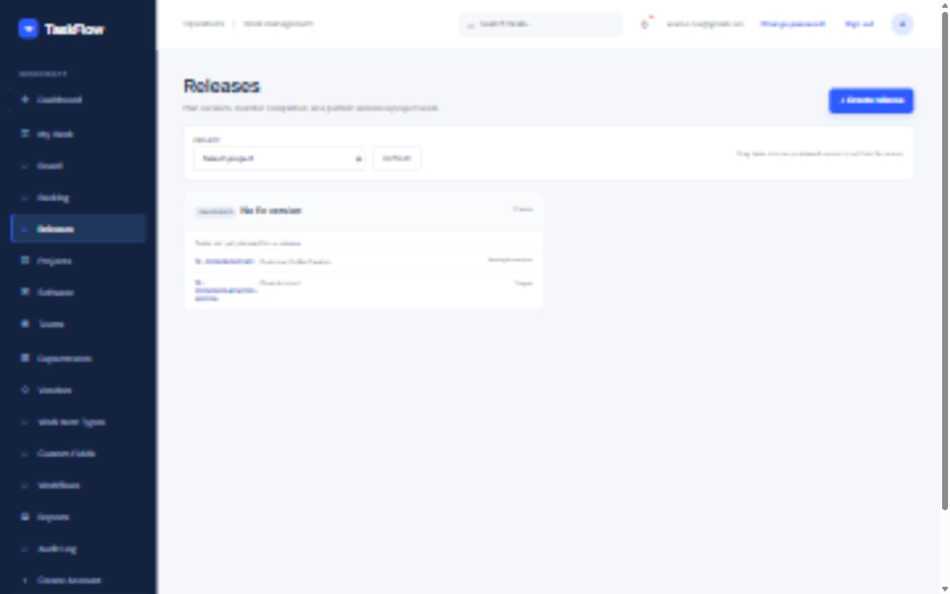
Figure 6. Releases screen.

Operating sequence
- Select a project to load its releases.
- Select Create release and enter the release details.
- Open a release to review dates, status, and assigned tasks.
- Add or remove tasks as scope changes.
- Reconcile scope and outstanding work before completing a release.
Operational control: Confirm the saved result or refreshed screen before moving to the next activity.

7. Projects
Purpose. Maintain project identity, ownership, dates, and objectives.
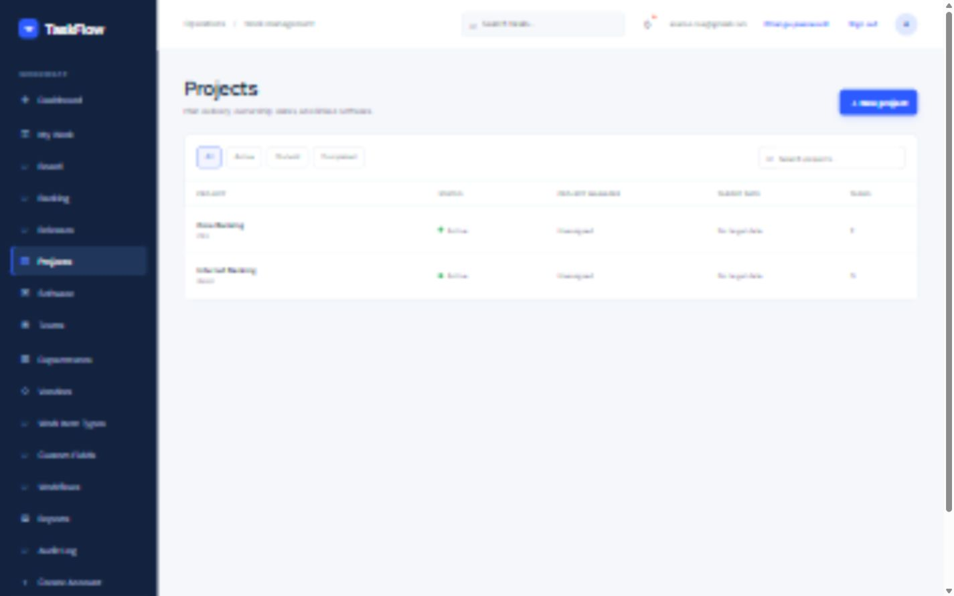
Figure 7. Projects screen.

Operating sequence
- Search or filter the project list before creating a new record.
- Select New project and enter a unique name and project key.
- Record objectives, dates, manager, sponsor, and linked software.
- Open a project row to review details and task count.
- Use Edit for maintenance; use Archive only after confirming operational impact.
Operational control: Confirm the saved result or refreshed screen before moving to the next activity.

8. Software
Purpose. Maintain the application and service catalog.
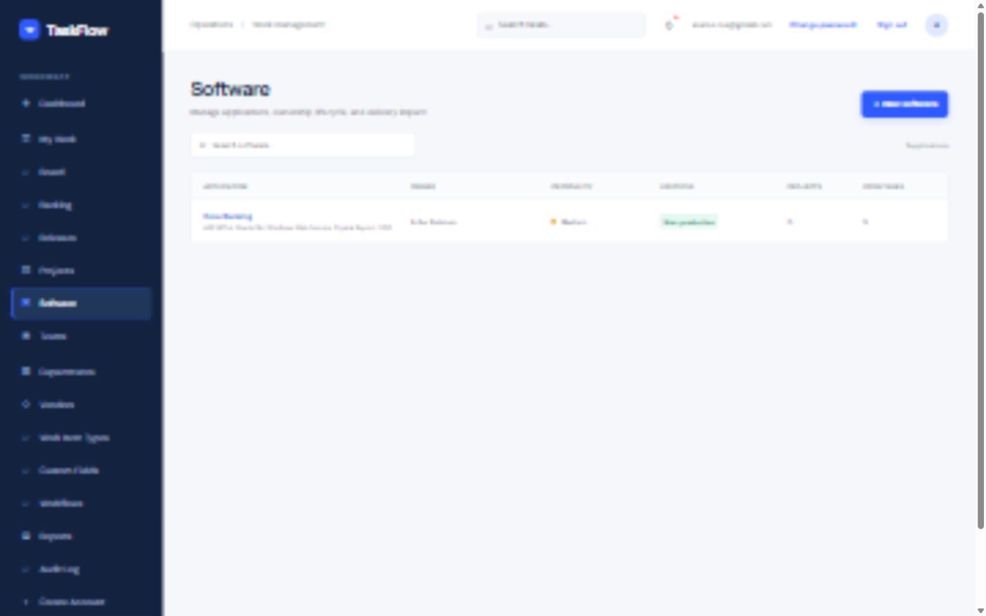
Figure 8. Software screen.

Operating sequence
- Search for an existing application before selecting New software.
- Record technology, current version, and criticality.
- Maintain business owner, technical owner, and support team.
- Set production and third-party flags accurately.
- Review linked projects and open tasks before changing lifecycle information.
Operational control: Confirm the saved result or refreshed screen before moving to the next activity.

9. Teams
Purpose. Maintain delivery teams and department association.
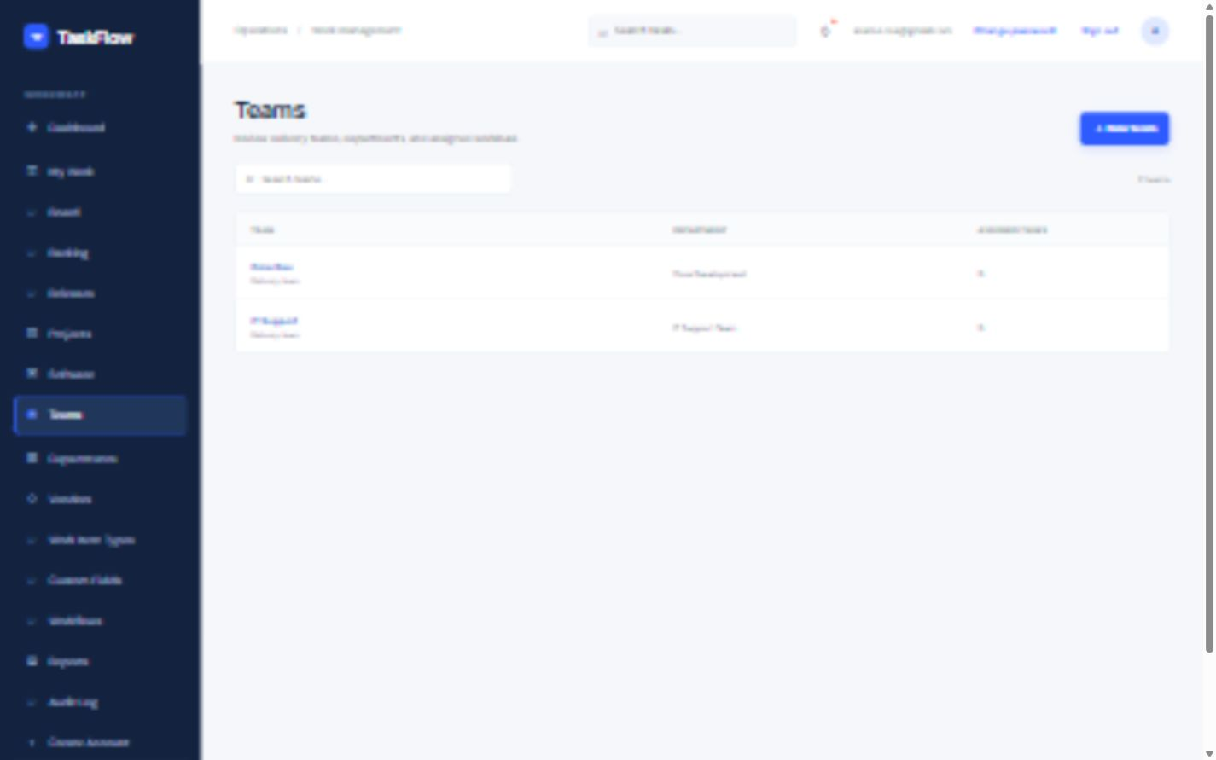
Figure 9. Teams screen.

Operating sequence
- Search for the team before creating a duplicate.
- Select New team and enter the team name.
- Choose the correct department.
- Open a team row to review department and assigned-task count.
- Use Edit team when ownership or organizational placement changes.
Operational control: Confirm the saved result or refreshed screen before moving to the next activity.

10. Departments
Purpose. Maintain organizational departments used across TaskFlow.
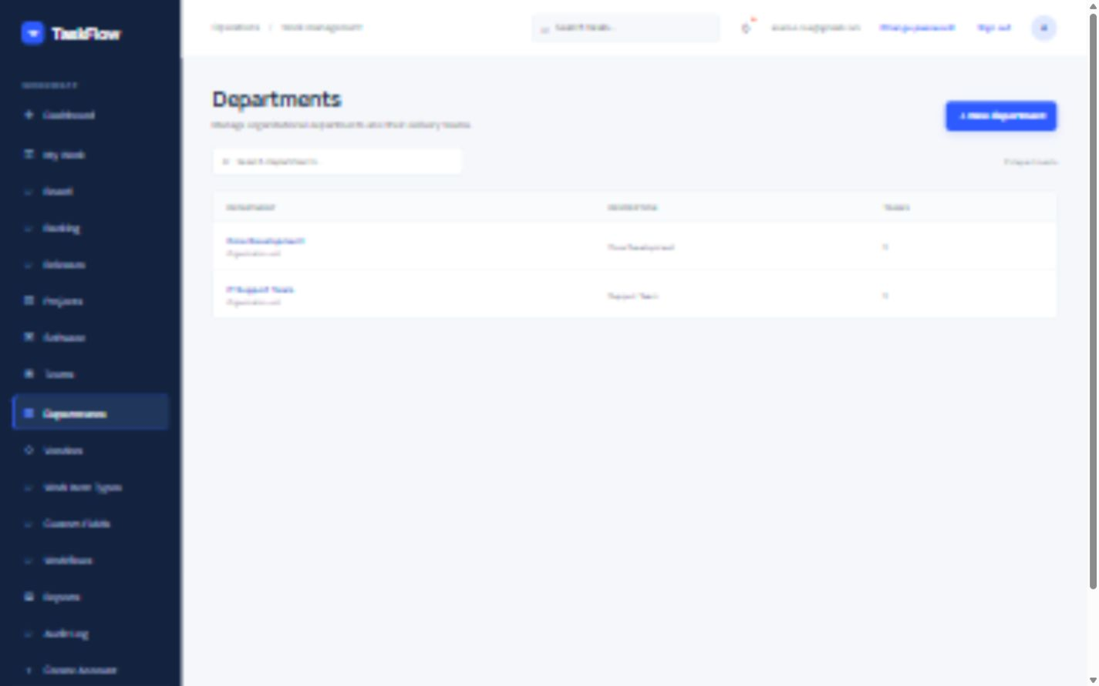
Figure 10. Departments screen.

Operating sequence
- Search for an existing department.
- Select New department and enter its name and description.
- Save and confirm the department appears in the list.
- Open the record to review linked teams or operating data.
- Edit instead of creating a second record for renamed departments.
Operational control: Confirm the saved result or refreshed screen before moving to the next activity.

11. Vendors
Purpose. Maintain external support partners, contracts, and SLA context.
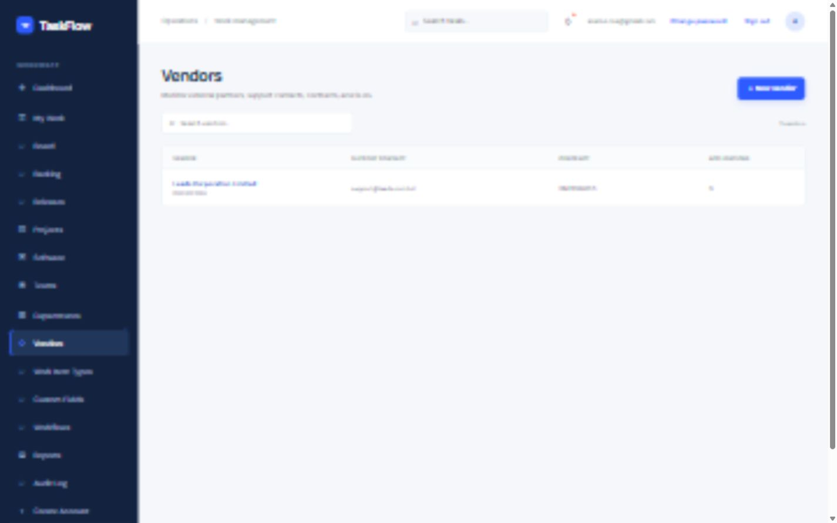
Figure 11. Vendors screen.

Operating sequence
- Search for an existing vendor.
- Select New vendor and enter support email and phone.
- Record the contract reference and SLA details.
- Save and verify linked application information.
- Update support contacts promptly when the vendor changes them.
Operational control: Confirm the saved result or refreshed screen before moving to the next activity.

12. Work Item Types
Purpose. Control the classifications available when tasks are created.
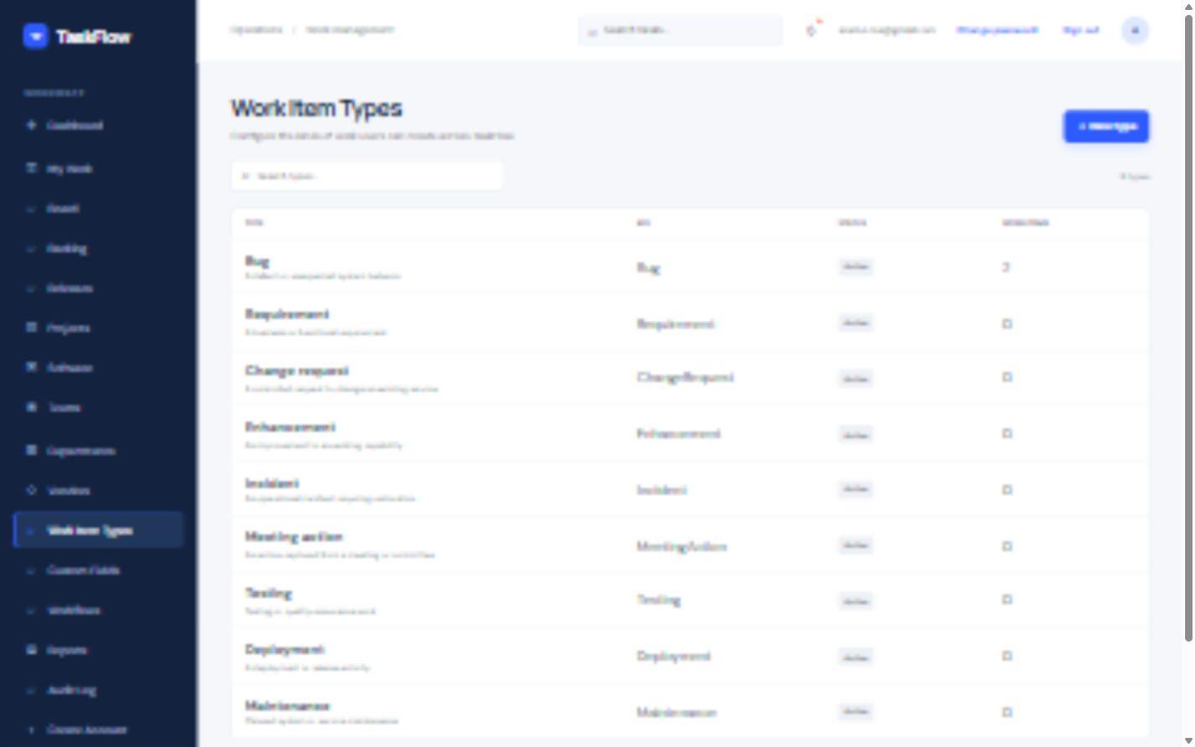
Figure 12. Work Item Types screen.

Operating sequence
- Review existing types and usage counts.
- Select New type only for a distinct operational classification.
- Define the display name, key, description, and active state.
- Confirm related custom fields and workflow behavior.
- Test the type on a non-critical task before general rollout.
Operational control: Confirm the saved result or refreshed screen before moving to the next activity.

13. Custom Fields
Purpose. Extend task data without changing the core task model.
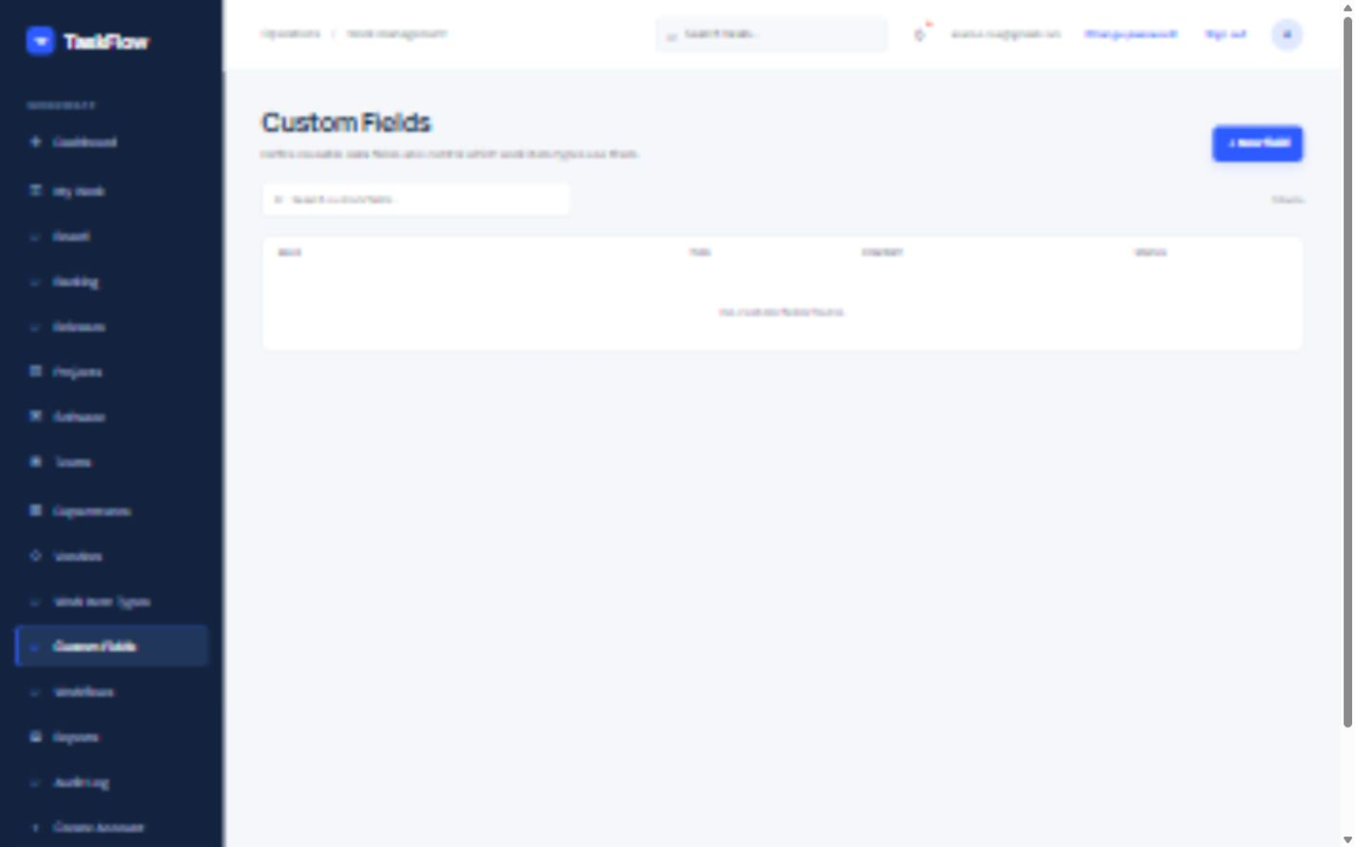
Figure 13. Custom Fields screen.

Operating sequence
- Search existing fields before selecting New field.
- Choose the field type and define options/defaults where applicable.
- Set required behavior and create/edit visibility carefully.
- Associate the field with applicable work item types or screens.
- Test validation and historical display before rollout.
Operational control: Confirm the saved result or refreshed screen before moving to the next activity.

14. Workflows
Purpose. Configure valid task status transitions.
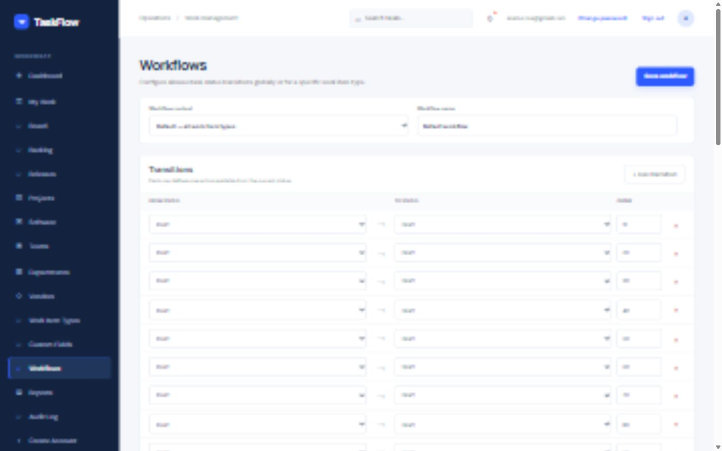
Figure 14. Workflows screen.

Operating sequence
- Select the workflow context and review its name.
- Review every From status, To status, and label.
- Add only transitions required by the operating process.
- Remove invalid or duplicate transitions cautiously.
- Select Save workflow and test the change on the Board.
Change control: Test configuration changes on non-critical work before production use.

15. Reports
Purpose. Review current workload and delivery-health indicators.
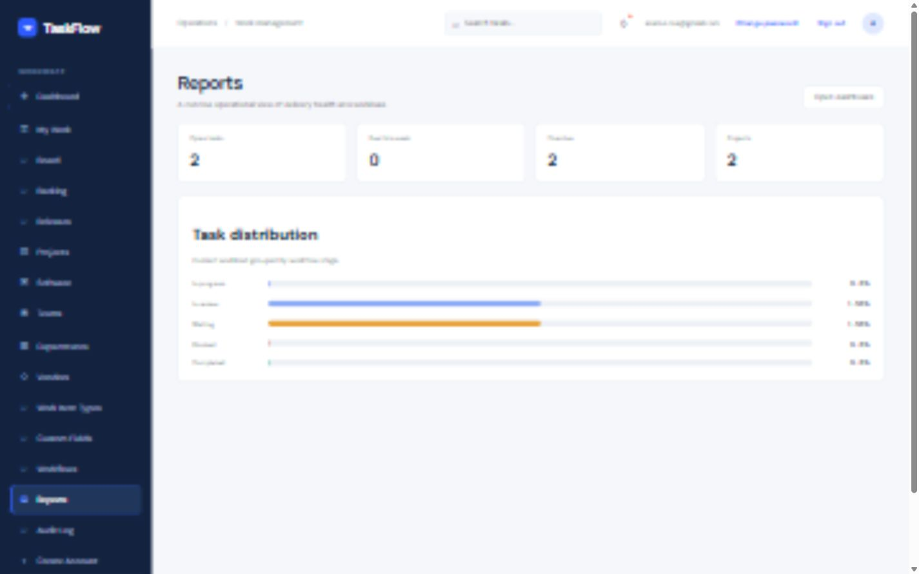
Figure 15. Reports screen.

Operating sequence
- Review open, due-this-week, overdue, and project totals.
- Use task distribution to identify accumulating statuses.
- Open the Dashboard or source task list for investigation.
- Validate filters and data freshness before sharing results.
- Treat figures as a current operational snapshot unless formally archived.
Operational control: Confirm the saved result or refreshed screen before moving to the next activity.

16. Audit Log
Purpose. Trace authenticated changes across operational records.
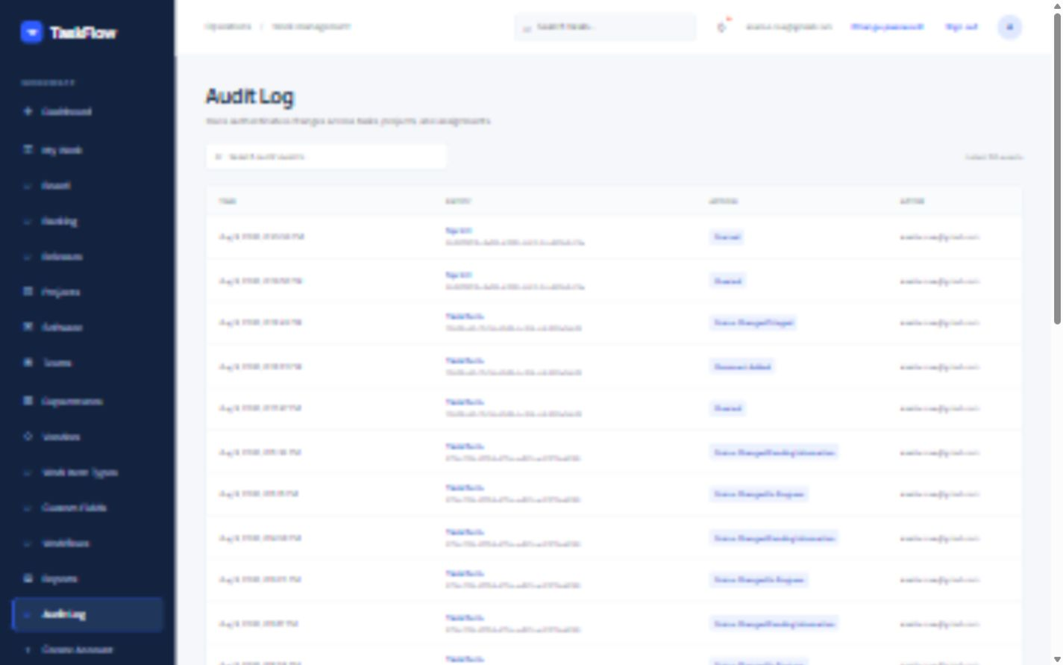
Figure 16. Audit Log screen.

Operating sequence
- Enter a focused search term such as entity, action, actor, or identifier.
- Review timestamp, entity, action, and actor reference.
- Correlate the event with task history, comments, or project details.
- Capture relevant evidence before escalation.
- Report unexplained changes according to security and access-control policy.
Operational control: Confirm the saved result or refreshed screen before moving to the next activity.

17. Create Account
Purpose. Provision a TaskFlow account for an authorized user.
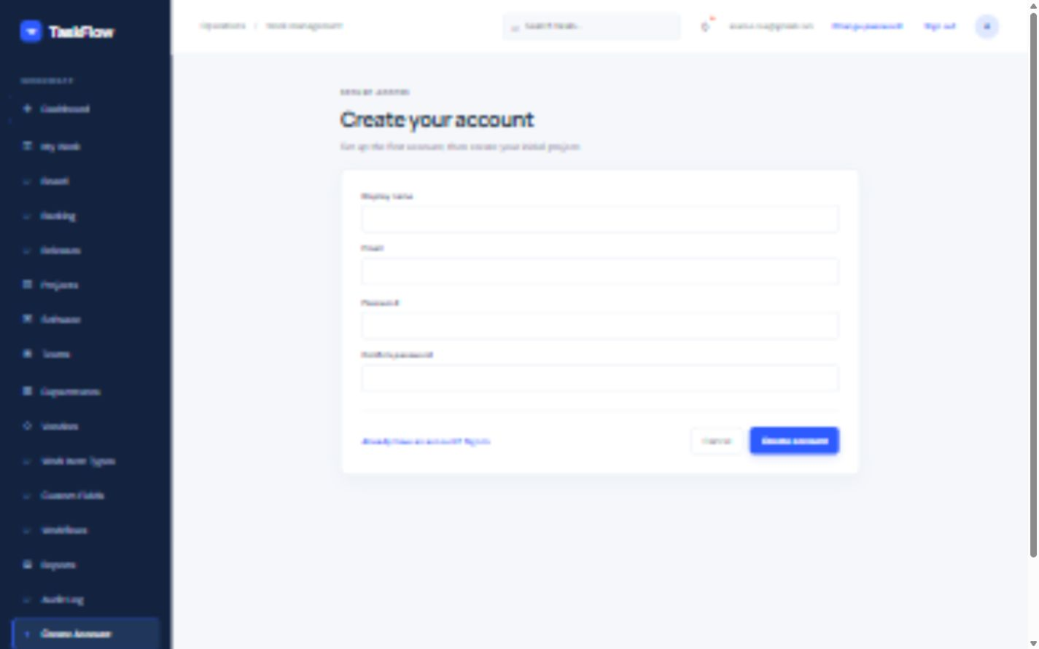
Figure 17. Create Account screen.

Operating sequence
- Confirm approval to create the account.
- Enter display name and a unique business email address.
- Enter a compliant password and matching confirmation.
- Select Create account and confirm success.
- Communicate access through an approved secure channel; never place credentials in task comments.
Access control: Create accounts only after authorization and use secure credential delivery.

Quick troubleshooting
API unavailable or server error. Check http://localhost:5183/health, start or restart TaskFlow.Api, and review server logs.
Sign-in failed. Verify credentials, account status, and password reset options.
Session expired. Sign in again and repeat any unsaved operation.
Screen does not load. Refresh once, check API/database connectivity, and record the visible error.
Board movement rejected. Review the configured workflow and use an allowed transition.
No matching records. Clear filters, verify selected project/context, and refresh.
Save remains busy. Wait; do not submit twice. Check network/API health if the state persists.

Evidence to capture for support
- Date/time and account
- Screen and URL
- Exact action and visible message
- Task/project identifier
- API health result
- Relevant server log excerpt

