Test and Investigation of Video Learning Project

Tuan Nghia Nguyen   
ntuan@fra-uas.de

Khaled kandil  
khaled.kandil@fra-uas.de

line 1: 3rd Given Name Surname  
line 2: email address

*Abstract-*The main purpose of the project is to test and investigate the Video Learning project. In order to do that, different video inputs were provided to the program and is applied with various parameters in the configuration. Afterwards, the results are carefully documented for each experiment, which are demonstrated as data tables. It is observed that the project performed decently in average, along with some great exceptions under specific conditions. Overall, the Video Learning process has been developed properly, that only a few adjustments to the configuration in the code of the program are required so that the trained model can achieve an even better performance.

Keywords—parameters, HTM, Video Learning, frame, HTM configurations

# Introduction

Hierarchical temporal memory (HTM) is a biologically constrained [machine intelligence](https://en.wikipedia.org/wiki/Machine_intelligence) technology developed by [Numenta](https://en.wikipedia.org/wiki/Numenta" \o "Numenta). Originally described in the 2004 book [On Intelligence](https://en.wikipedia.org/wiki/On_Intelligence) by [Jeff Hawkins](https://en.wikipedia.org/wiki/Jeff_Hawkins) with [Sandra Blakeslee](https://en.wikipedia.org/wiki/Sandra_Blakeslee), HTM is primarily used today for [anomaly detection](https://en.wikipedia.org/wiki/Anomaly_detection) in streaming data. The technology is based on [neuroscience](https://en.wikipedia.org/wiki/Neuroscience) and the [physiology](https://en.wikipedia.org/wiki/Physiology) and interaction of [pyramidal neurons](https://en.wikipedia.org/wiki/Pyramidal_cell) in the [neocortex](https://en.wikipedia.org/wiki/Neocortex) of the [mammalian](https://en.wikipedia.org/wiki/Mammal) (in particular, [human](https://en.wikipedia.org/wiki/Human_brain)) brain[1]. Regarding the concept, this project takes on the already developed framework of HTM, in which a model is trained to learn and remember videos. Although the Video Learning program is already completed and fully functional, it’s performance has not been thoroughly tested under different settings. Therefore, it is necessary to not only experiment the software with various input and several modified parameters, but also to record the result in detail. More over, these settings can be implemented later that results in a much more optimal video learning, i.e, higher accuracy with lower elapsed time.

# Methods

The aforementioned project of Video Learning with HTM functions by using Temporal Memory to learn binary representation of videos (sequence of bit-arrays, with each bit-array represents 1 frame). This whole experiment was conducted with the input of randomly chosen videos to ensure the project’s objectivity in order to evaluate the video learning process’s performance accurately. Firstly, the source code of the Video Learning project[2] was executed and the video’s input folder path was required to be dragged into the command prompt of the program. After a period of run time, the result of the learning process was determined by how well the trained model could predict the next frame of the video based on what it had learned, when a specific frame was assigned to the model. Finally, an image (or a frame) was provided to the trained model. The model then attempted to recreate a video with proceeding frame after the input frame. The model’s performance was assessed by two aspects: the accuracy and the elapsed time of the learning process, that were obtained by experimenting with two types of input videos:

## Simple Shape Video Inputs

The first experiment was running the program with many set of simple videos, in which only basic shapes (a black circle, rectangle and triangle) moving around on a white background[2]. These videos are generated via Python code. All of them have the same duration length of 2 seconds. The difference between these sets is the angle that these shape moves. By changing the Angle parameter in the python code[3], different set of videos with different moving angle (varies from 0 to 360 degree for this experiment) can be generated.

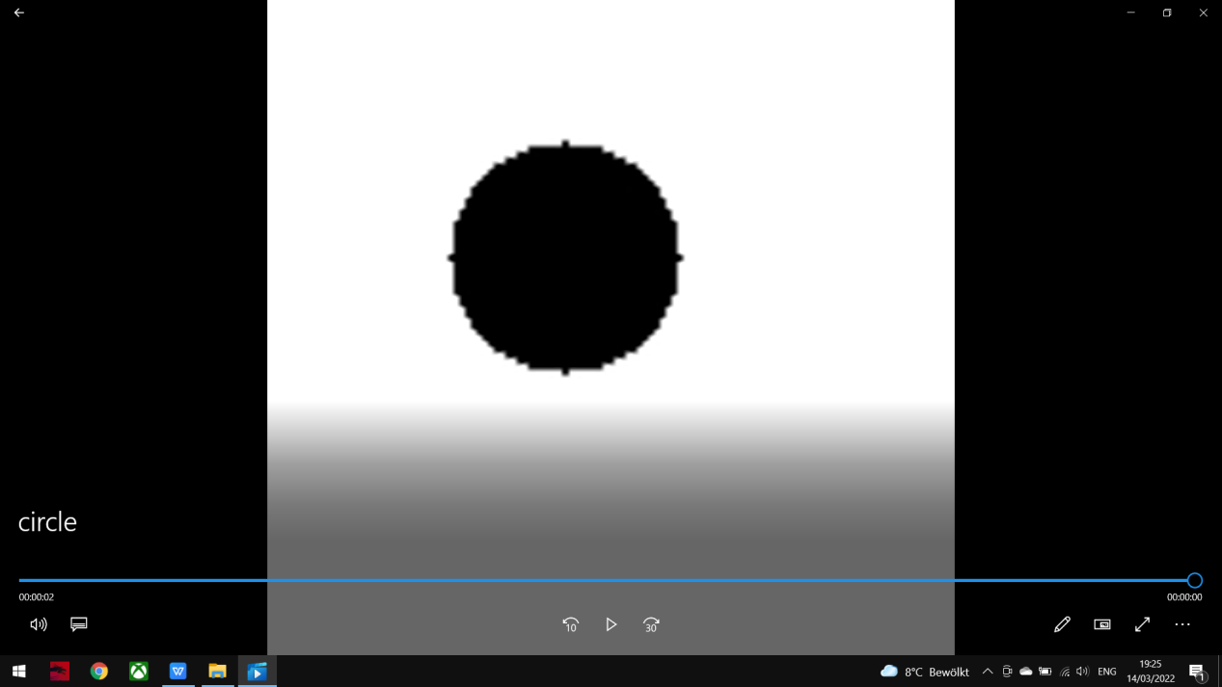

Figure 1a: Circle Video

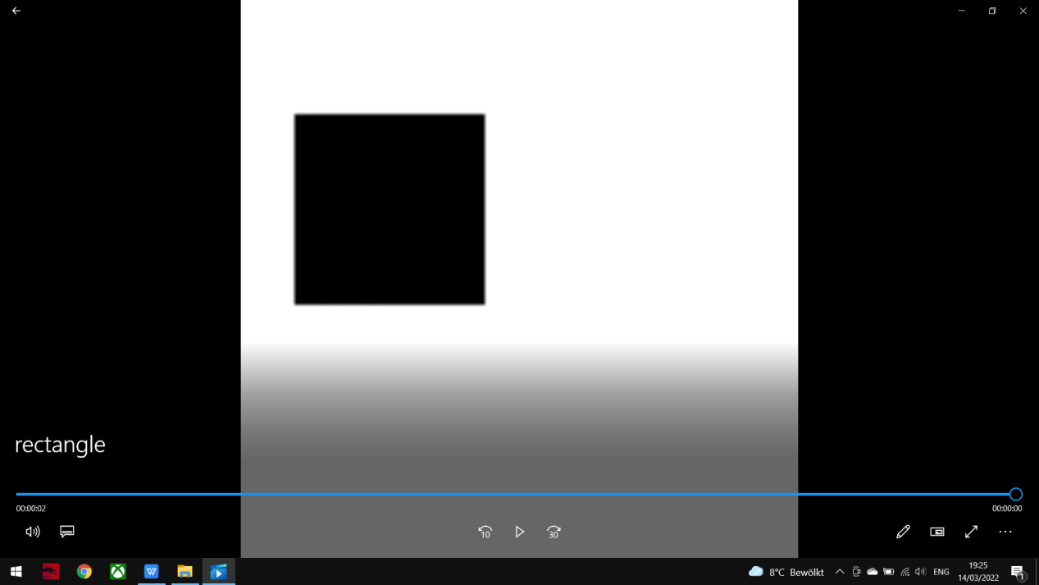

Figure 1b: Rectangle Video

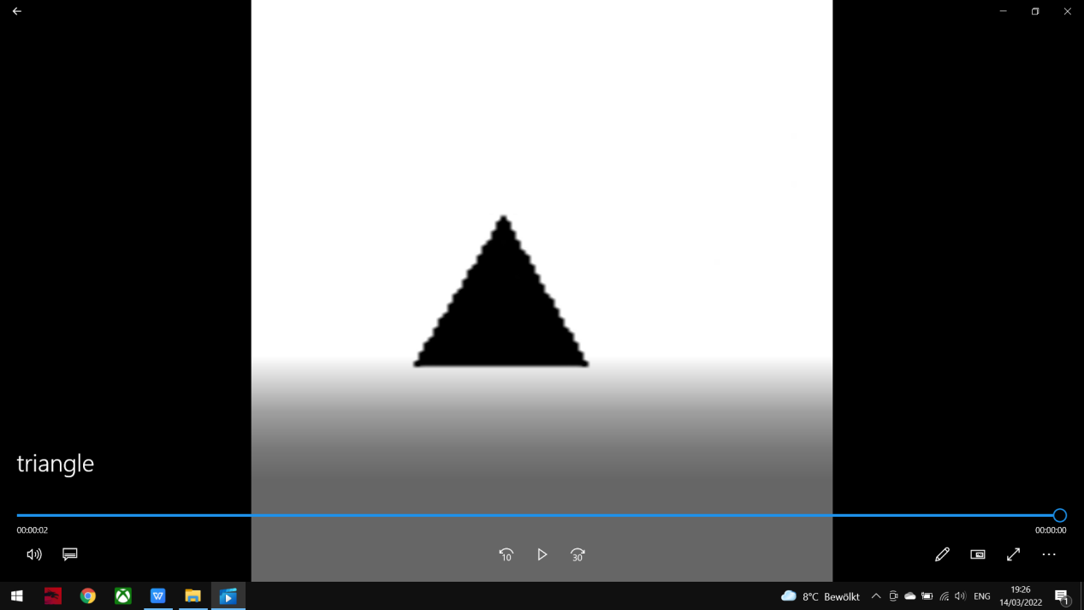

Figure 1c: Triangle Video

## Random Video Inputs

A random music video on Youtube[4] is edited down to a small 5-second video which is used as an input for the learning process of the program. The editing is done by an online editor called Kapwing[5]. This short-version video[6] was put under many different conditions, such as by changing the video’s resolutions or the HTM configurations of the program, including Cells per column, Global Inhibition, Max Boost, etc. Another Video input was used (“Frankfurt Video”) edited first into 11 seconds with 184 frames which was a lot of patterns to take care of though for Run1 testing resolution was done in a reasonable time, the video was edited down again into 5 seconds with 85 frames, but it took a very long time to learn such video so Youtube Video was carried on for testing on Run2.

Figure 2a: Frankfurt Video

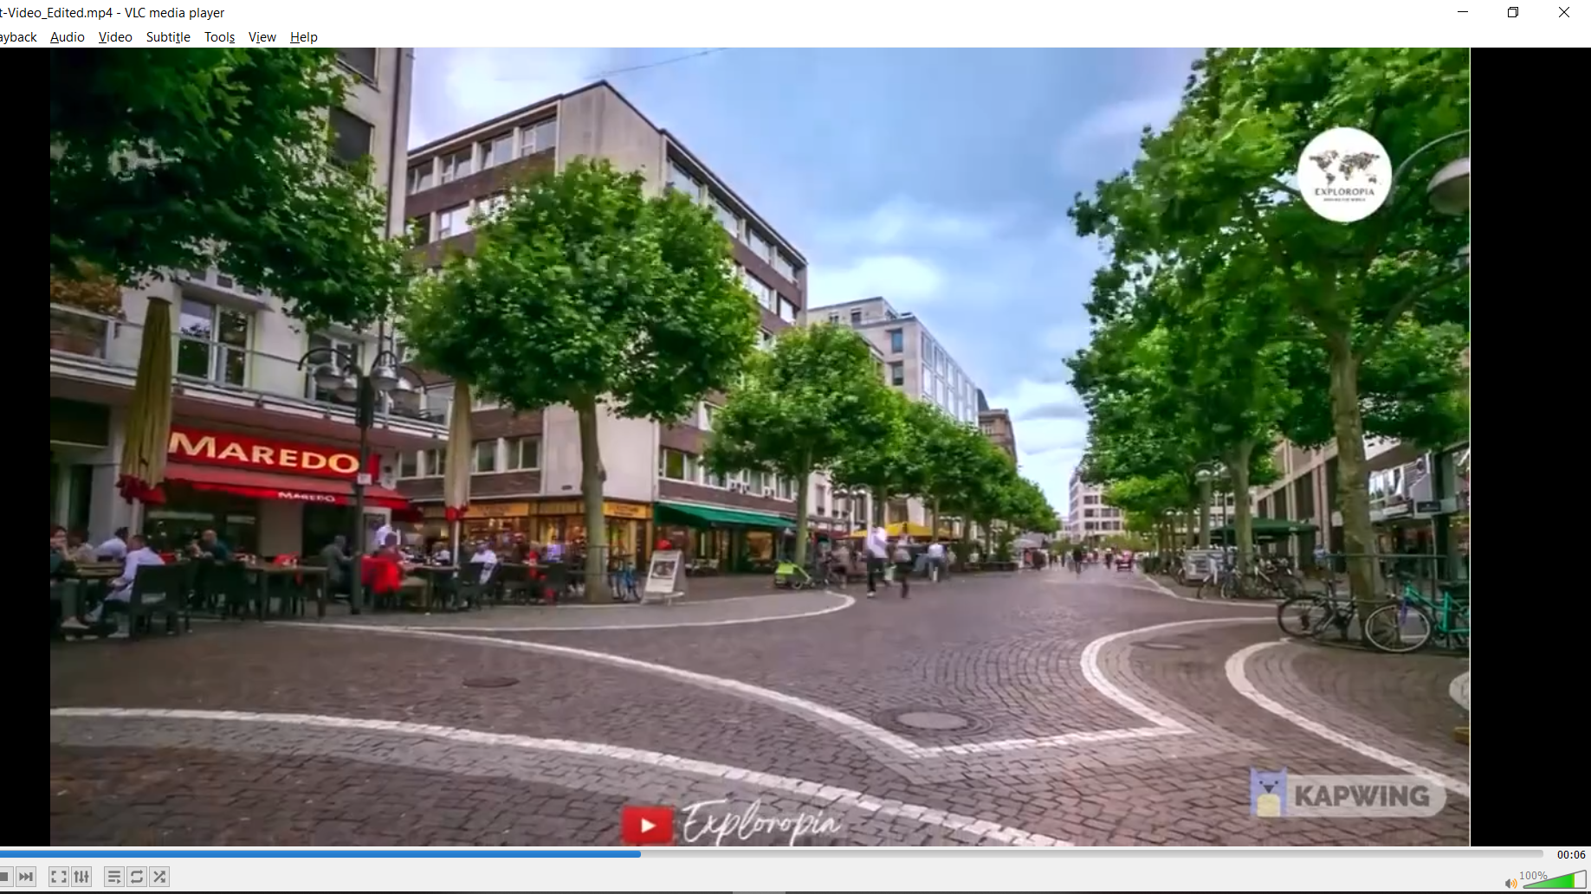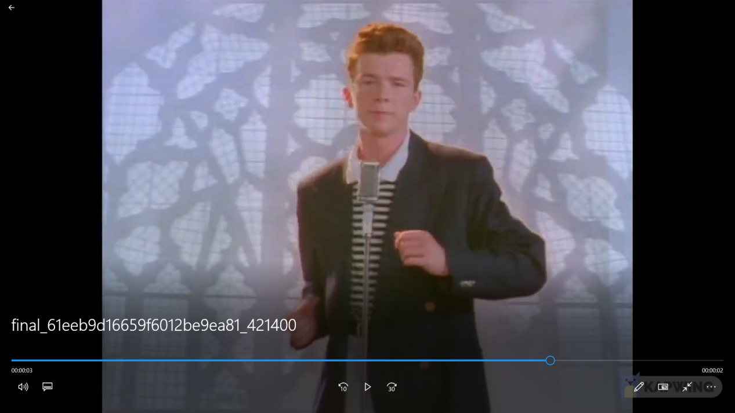

Figure 2b: Youtube Video

These Configuration was used for these inputs: Video’s configuration[7], Default HTM configuration[8]. For the HTM configuration experiment, each below parameter is modified independently, while the others remained the same as the default HTM Configuration. The value of N/A indicates the experiment required too long an elapsed time without reaching a specific result, so they were cancel. Additionally, only Run2 was applied for this testing. Because Run1 (with Max Cycle = 1000 so the model could reach proper accuracy) required too much run time and there would not be enough time to experiment with various HTM configuration parameters. Additionally, Run2 is superior since the key used for learning is generated from the FrameKey List previousInputs of the current Video, in which one frame information is associated with the information of the whole frame sequence (Video). Compared to Run1 that predicts the frame one by one, the error of the learning process is reduced. Therefore, testing with only Run2 would be a much more optimal choice.

Additionally, the parameters of the HTM configuration that were used to experiment the software’s performance include:

* Cells per column: indicates the number of input cells in each column cell.
* GlobalInhibition: If the value is TRUE, global inhibition algorithm will be used. If it is FALSE, local inhibition algorithm will be used.
* LocalAreaDensity: Density of active columns inside of local inhibition radius. If set on value < 0, explicit NumActiveColumnsPerInhArea will be used.
* NumActiveColumnsPerInhArea: An alternate way to control the density of the active columns. If this value is specified then LocalAreaDensity must be less than 0, and vice versa.
* PotentialRadius: Defines the radius in number of input cells visible to column cells. It is important to choose this value, so every input neuron is connected to at least a single column. For example, if the input has 50000 bits and the column topology is 500, then you must choose some value larger than 50000/500 > 100.
* InhibitionRadius: Defines neighbourhood radius of a column.
* MaxBoost: Maximum boost factor of a column.
* DutyCyclePeriod: Number of iterations. The period used to calculate duty cycles. Higher values make it take longer to respond to changes in boost. Shorter values make it more unstable and likely to oscillate.
* MinimumPctOverlapDutyCycles
* MaxSynapsesperSegment: Defines the maximum number of Synapses for each Segment.
* ActivationThreshold: One mini-column is active if its overlap exceeds overlap threshold θo of connected synapses.
* ConnectedPermanence: Defines Connected Permanence Threshold θp, which is a float value, which must be exceeded to declare synapse as connected.
* PermanenceDecrement: Decrement step of synapse permanence value within every inactive cycle. It defines how fast the NeoCortex will forget learned patterns.
* PermanenceIncrement: Increment step of connected synapse during learning process.

# Results

## Angle Experiments with Simple Shape inputs

Run1 was only run with Max Cycle = 10 to see the difference between each case of the experiment, since elapsed time of Run1 with Max Cycle = 1000 took much longer for each case than Run2. This is also the reason that the average accuracy for Run1 is much lower than Run2. The accuracy and the elapsed time of the Video Learning process for each angles, in which the shape was moving in these sets of videos were recorded as in the following tables:

Run1: Max Cycle = 10

|  |  |  |  |  |  |
| --- | --- | --- | --- | --- | --- |
| **Angle** | 36 | 72 | 108 | 144 | 180 |
| **Accuracy** | 0.73 | 0.61 | 0.73 | 0.75 | 0.64 |
| **Elapsed time** | 7min | 5min | 7min | 6min | 15min |

|  |  |  |  |  |  |
| --- | --- | --- | --- | --- | --- |
| **Angle** | 216 | 252 | 288 | 324 | 360 |
| **Accuracy** | 0.65 | 0.69 | 0.69 | 0.64 | 0.6 |
| **Elapsed time** | 5min | 6min | 6min | 7min | 17min |

Run2: Max Cycle = 1000

|  |  |  |  |  |  |
| --- | --- | --- | --- | --- | --- |
| **Angle** | 36 | 72 | 108 | 144 | 180 |
| **Accuracy** | 0.93 | 0.91 | 0.88 | 0.88 | 0.88 |
| **Elapsed time** | 7min | 10min | 7min | 11min | 11min |

|  |  |  |  |  |  |
| --- | --- | --- | --- | --- | --- |
| **Angle** | 216 | 252 | 288 | 324 | 360 |
| **Accuracy** | 0.75 | 0.71 | 0.77 | 0.74 | 0.8 |
| **Elapsed time** | 5min | 6min | 6min | 7min | 12min |

## Resolution Experiments with Youtbe Video inputs

As shown below are the table results of the performance of the trained model, which also consists of the accuracy and the elapsed time of the learning process. However, for these experiments, Video’s configuration[5] is slightly modified for the resolution section. This parameter represents the height and the width of the input video after it is binarized by the ColorMode and converted into frames for the learning process. The number of frames depends on the frameRate parameter.

Run1: Max Cycle = 10

|  |  |  |  |  |  |
| --- | --- | --- | --- | --- | --- |
| **Resolution** | 18x18 | 30x30 | 40x40 | 50x50 | 50x25 |
| **Accuracy** | 0.58 | 0.68 | 0.78 | 0.69 | 0.59 |
| **Elapsed time** | 4min | 10min | 21min | 37min | 16min |

Run2: Max Cycle = 1000

|  |  |  |  |  |  |
| --- | --- | --- | --- | --- | --- |
| **Resolution** | 18x18 | 30x30 | 40x40 | 50x50 | 50x25 |
| **Accuracy** | 0.92 | 0.98 | 0.90 | 0.90 | 0.98 |
| **Elapsed time** | 6min | 7min | 12min | 7min | 8min |

## Resolution Experiments with Frankfurt Video inputs

Run1: Max Cycle = 10

|  |  |  |  |  |
| --- | --- | --- | --- | --- |
| **Resolution** | 18x18 | 30x30 | 40x40 | 30x40 |
| **Accuracy** | 0.28 | 0.33 | 0.31 | 0.25 |
| **Elapsed time** | 19min | 29min | 46min | 36min |

Run2: Max Cycle = 1000

|  |  |  |  |  |
| --- | --- | --- | --- | --- |
| **Resolution** | 18x18 | 30x30 | 40x40 | 30x40 |
| **Accuracy** | 0.86 | 0.5 | 0.43 | 0.82 |
| **Elapsed time** | 35min | 45min | 48min | 50min |

## HTM Configuration Experiments with Youtube Video input

The final experiment was to test the Youtube Video with different settings in the HTM. As mentioned before, every single parameter is adjusted independently, while the others are maintained with the exact values as in the Default HTM configuration[6]. Therefore, the performance of the program is recorded specifically for each of the parameter in order to produce the comparison between the features in the HTM more clearly.

Cells per column:

|  |  |  |  |  |  |
| --- | --- | --- | --- | --- | --- |
| **Parameter** | 30 | 40 | 60 | 80 | 100 |
| **Accuracy** | 0.81 | 0.88 | 0.82 | 0.90 | 0.84 |
| **Elapsed time** | 6min | 7min | 12min | 7min | 8min |

Switch Global Inhibition = false: Accuracy is 0.88 and Elapsed Time is 40min.

Enable LocalAreaDensity

|  |  |  |  |
| --- | --- | --- | --- |
| **Parameter** | -1 | 0 | 1 |
| **Accuracy** | 0.85 | 0.91 | N/A |
| **Elapsed time** | 14min | 22min | N/A |

NumActiveColumnsPerInhArea with adjusted constant

|  |  |  |  |  |
| --- | --- | --- | --- | --- |
| **Constant** | 0.01 | 0.02 | 0.03 | 0.04 |
| **Accuracy** | 0.95 | 0.86 | 1 | 1 |
| **Elapsed time** | 16min | 10min | 25min | 30min |

PotentialRadius

|  |  |  |  |  |
| --- | --- | --- | --- | --- |
| **Constant** | 0.15 | 0.2 | 0.3 | 0.1 |
| **Accuracy** | 0.86 | 0.81 | 0.99 | 0.99 |
| **Elapsed time** | 10min | 11min | 32min | 14min |

Enable InhibitionRadius

|  |  |  |  |  |  |
| --- | --- | --- | --- | --- | --- |
| **Parameter** | 40 | 50 | 60 | 70 | 80 |
| **Accuracy** | 0.92 | 0.82 | 0.85 | 0.90 | 0.84 |
| **Elapsed time** | 18min | 13min | 21min | 16min | 15min |

MaxBoost

|  |  |  |  |  |  |
| --- | --- | --- | --- | --- | --- |
| **Parameter** | 10 | 20 | 30 | 40 | 50 |
| **Accuracy** | 0.81 | 0.88 | 0.81 | 0.81 | 0.85 |
| **Elapsed time** | 6min | 22min | 20min | 15min | 10min |

Enable DutyCyclePeriod

|  |  |  |  |  |  |
| --- | --- | --- | --- | --- | --- |
| **Parameter** | 50 | 60 | 70 | 80 | 90 |
| **Accuracy** | 0.86 | 0.89 | 0.89 | 0.81 | 0.96 |
| **Elapsed time** | 10min | 38min | 19min | 12min | 19min |

Enable MinPctOverlapDutyCycles

|  |  |  |  |  |  |
| --- | --- | --- | --- | --- | --- |
| **Parameter** | 0.5 | 0.75 | 1.0 | 1.25 | 1.5 |
| **Accuracy** | 0.86 | 0.82 | 0.81 | 0.86 | 0.85 |
| **Elapsed time** | 10min | 21min | 20min | 8min | 13min |

MaxSynapsesPerSegment with adjusted constant

|  |  |  |  |  |  |
| --- | --- | --- | --- | --- | --- |
| **Constant** | 0.02 | 0.03 | 0.04 | 0.05 | 0.1 |
| **Accuracy** | 0.82 | 0.88 | 0.84 | 0.81 | 0.82 |
| **Elapsed time** | 7min | 13min | 28min | 12min | 18min |

Enable ActivationThreshold = 10: N/A

Enable ActivationThreshold = 20: N/A

->Only with ActivationThreshold = 15: Accuracy is 0.81 and Elapsed Time is 6min.

Enable ConnectedPermanence

|  |  |  |  |
| --- | --- | --- | --- |
| **Parameter** | 0.5 | 0.75 | 1.5 |
| **Accuracy** | 0.97 | 0.89 | 0.84 |
| **Elapsed time** | 25min | 36min | 27min |

Enable PermanenceDecrement = 0.15: Accuracy is 0.84, Elapsed Time is 11min.

Enable PermanenceIncrement = 0.15: Accuracy is 0.81, Elapsed Time is 14min.

Both PermanenceIncrement and PermanenceDecrement

|  |  |  |  |  |
| --- | --- | --- | --- | --- |
| **Parameters** | 0.15 | 0.2 | 0.25 | 0.3 |
| **Accuracy** | 0.96 | 0.97 | 0.95 | 0.95 |
| **Elapsed time** | 17min | 31min | 12min | 13min |

# Discussions

Overall, the experiments produced satisfactory results. Their accuracy has the mean value of approximately 0.88, with the lowest value was 0.81, which is decent. Noticeably, a number of modifications in certain parameters results in exceptional accuracy values, some of which were even able to reach 0.99. The elapsed time for these experiments varies from 4 minutes to 46 minutes. Unconventionally, it is observed that high accuracy was not always accompanied by the long elapsed time and vice versa.

Attached below is the list of the best results from the experiments of Run2 exclusively, with the accuracy of at least 0.9 under different settings of the video’s resolution and the HTM configuration, since these parameters contribute directly to the performance of the learning process of the trained model. More over, after careful consideration, experiments with angles will not included in this list since these parameters are only relevant for these specific input videos. Generally, the results from the experiment must be applicable for every random video so that they can be implemented in the near future for the program in order to properly improve the quality of the Video Learning project.

* Resolution 18x18: 92% with elapsed time of 6 minutes.
* Resolution 30x30: 98% with elapsed time of 7 minutes.
* Resolution 40x40: 90% with elapsed time of 12 minutes.
* Resolution 50x50: 90% with elapsed time of 7 minutes.
* Resolution 50x25: 98% with elapsed time of 8 minutes.
* Cells per Column = 80: 90% with elapsed time of 7 minutes.
* .LocalAreaDensity = 0: 91% with elapsed time of 22 minutes.
* NumActiveColumnsPerInhArea with constant 0.01: 95% with elapsed time of 16 minutes.
* NumActiveColumnsPerInhArea with constant 0.03: 100% with elapsed time of 25 minutes.
* NumActiveColumnsPerInhArea with constant 0.04: 100% with elapsed time of 30 minutes.
* PotentialRadius = 0.1: 99% with elapsed time of 14 minutes.
* PotentialRadius = 0.3: 99% with elapsed time of 32 minutes.
* InhibitionRadius = 40: 92% with elapsed time of 18 minutes.
* InhibitionRadius = 70: 90% with elapsed time of 16 minutes.
* DutyCyclePeriod = 90: 96% with elapsed time of 19 minutes.
* ConnectedPermanence = 0.5: 97% with elapsed time of 25 minutes.
* PermanenceIncrement = PermanenceDecrement = 0.15: 96% with elapsed time of 17 minutes.
* PermanenceIncrement = PermanenceDecrement = 0.2: 97% with elapsed time of 31 minutes.
* PermanenceIncrement = PermanenceDecrement = 0.25: 95% with elapsed time of 12 minutes.
* PermanenceIncrement = PermanenceDecrement = 0.3: 95% with elapsed time of 13 minutes.

##### Acknowledgment

The preferred spelling of the word “acknowledgment” in America is without an “e” after the “g”. Avoid the stilted expression “one of us (R. B. G.) thanks ...”. Instead, try “R. B. G. thanks...”. Put sponsor acknowledgments in the unnumbered footnote on the first page.

##### References

1. https://en.wikipedia.org/wiki/Hierarchical_temporal_memory.
2. Repository: neocortexapi\source\GroupSEProject\HTMVideoLearning\HTMVideoLearning.sln
3. Repository: neocortexapi\source\GroupSEProject\HTMVideoLearning\VideoLibrary\AngleLibrary.
4. Repository: Line17, neocortexapi\DataGeneration\circle.py.
5. https://www.youtube.com/watch?v=dQw4w9WgXcQ
6. https://www.youtube.com/watch?v=V2wofDTu48g&t=112s&ab_channel=Exploropia
7. https://www.kapwing.com/studio/editor.
8. https://express.adobe.com/tools/trim-video/#
9. Repository: neocortexapi\source\GroupSEProject\HTMVideoLearning\VideoLibrary\YoutubeVideo\Video 1.
10. Repository: Line43-47, neocortexapi\source\GroupSEProject\HTMVideoLearning\HTMVideoLearning\VideoLearning.cs.
11. Repository: Line779-808, neocortexapi\source\GroupSEProject\HTMVideoLearning\HTMVideoLearning\VideoLearning.cs.

**.**