北京邮电大学2025——2026学年第一学期

《计算导论与程序设计》秋季期中-课程作业

班级： 2025211318 姓名： 侯明玄 学号： 2025211717
注意事项 | 一、学生必须独立完成本作业。  二、任何雷同或者有抄袭嫌疑的作业，会导致提交者的总评成绩为0分。  三、学生可以通过阅读、查找纸质资料或者网上电子资料解答题目。但是，不允许【抄袭】  四、作业必须以PDF格式提交。

Syntax Quiz (20 points)

(fill the blank)When a function does not need to return a value, the result-type of this function should be void .

(fill the blank)To determine whether a number x is between [3,10], the statement is:

if(x >=3 && x <= 10) .

(fill the blank) A computer usually has 3 types of bus: Data bus, Address bus and
Control bus .

(fill the blank)After preprocessing a C language program, compilation and

link operations need to be performed.

(fill the blank)The result of the following statement is: 123.46 .
printf("%4.2f", 123.456);

(fill the blank)The output of the following statement is: 2 1 .
int a = 17;
int b = 7;
int c=a/b;
int d = b%c;
printf("%d %d", c, d);

(single-choice) The execution of a C program ( A ).
A. starts from the main function.
B. starts from the first function of this program file.
C. starts from the main function of this program and ends with the last function of this program file
D. starts from the first function in this program file and ends with the main function of this program.

(single-choice) Which keyword can be restricted by the keyword unsigned? ( C )
A. signed
B. long double
C. long
D. float

(True/False)The following statement will not execute the while loop. ( False )
int i = -1;
while(i++) { i++; }

(True/False)For a user-defined function with a return-type of void, there is no need to have a return statement in the function body. ( True )

Programming Quiz (80 points)

Quiz 1 (20 points)
Write a program that prompts the user to input three integers in each of three iterations. For each iteration, calculate and print their sum and average (as a floating-point number rounded to two decimal places). The program must:
- Use a do-while loop to control the three iterations.
- Use scanf() to read input and handle invalid inputs by re-prompting.
- Use printf() to output: "Sum: <sum>, Average: <average>" (e.g., Sum: 12, Average: 4.00).
- Reset all variables at the start of each iteration.
Knowledge points: loop statements, input/output functions, integer/float variables.

Quiz 2（20 points）
Write a program to print a right angle triangle pattern using the "*" character. The program should use nested loops implemented with both for and while loops for the outer and inner loops (there is no requirement for which loop should be outer).
An example:
*
**
***
****
*****

Quiz 3 (40 points)
‘Write a program to simulate user registration. At the beginning of the program, generate a random integer from 1 to 3 to represent the registration type: 1 for username registration, 2 for phone number registration, and 3 for serial number registration. Depending on the registration type, prompt the user to enter information and then determine whether it meets the requirements: the username is a string with no more than 10 characters, the phone number is a 11-digit integer with the first two digits as 13, and the serial number is a 4-digit hexadecimal integer that must start with the hexadecimal digit A . If it passes the judgment, output "Registration Successful", otherwise output "Registration Failed". The judgment of the registration type requires the use of switch statements.’
Be aware: On Windows x64 (e.g. Windows11), long int occupies 4 bytes, long long int occupies 8 bytes. While on modern MacOS (e.g. Sonoma) and Linux (e.g. Ubuntu 24.04) , both long int and long long int occupy 8 bytes.
Programming Quiz部分评分标准
- 输出结果和工程项目截图 10%。截图应清晰，大小合适；
- 实现程序的基本要求：60%；
- 代码要有必要的注释，可参考doxygen、javadoc或者QT类型的注释；代码应符合C11/17标准；遵循合理的编码规范：15%；
- 代码结构清晰、缩进合理；文档干净整洁；作业文档中的代码字体大小合理规整，代码有语法加亮 15%；
- 【特别强调】代码的注释和可读性是判分的重要依据。可读性差的代码，哪怕结果正确，也只能得到60%的总分；
- 【特别强调】任何抄袭或者疑似抄袭的代码，都将导致你的作业被二次复审，并且无法通过本课程期末考核。请保存好自己的作业，不要给任何人参考。
- 可以使用大语言模型辅助编程，但是严禁使用大语言模型直接生成结果。如果教师在判卷时怀疑某答卷违反了本条规则，将要求同学在线/线下接受教师质询。

注意事项
- 提交的文档请转为pdf格式
- 请保留作业题目（本页之前的内容不要更改/删除）
- 请保持作业回答干净整洁。

Quiz 1

输出结果截图
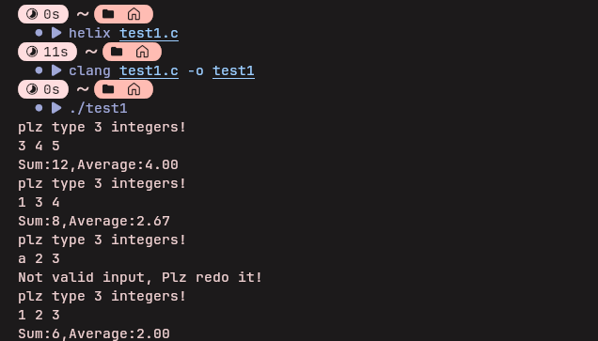

工程项目截图
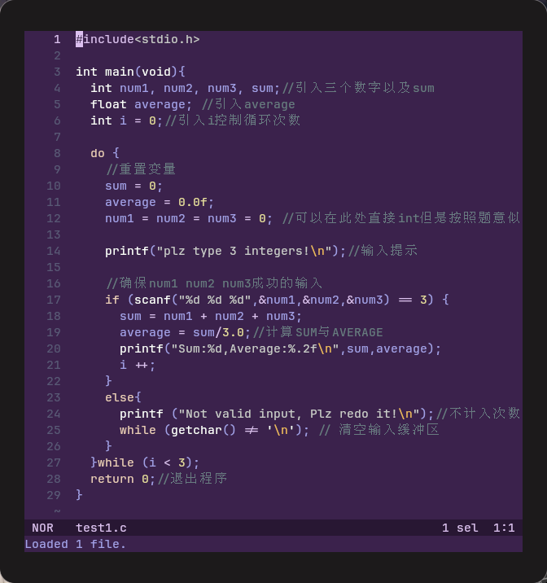

文件1.c
#include<stdio.h>

int main(void){
int num1, num2, num3, sum;//引入三个数字以及sum
float average; //引入average
int i = 0;//引入i控制循环次数

do {
//重置变量
sum = 0;
average = 0.0f;
num1 = num2 = num3 = 0; //可以在此处直接int但是按照题意似乎不可

printf("plz type 3 integers!\n");//输入提示

//确保num1 num2 num3成功的输入
if (scanf("%d %d %d",&num1,&num2,&num3) == 3) {
sum = num1 + num2 + num3;
average = sum/3.0;//计算SUM与AVERAGE
printf("Sum:%d,Average:%.2f\n",sum,average);
i ++;
}
else{
printf ("Not valid input, Plz redo it!\n");//不计入次数
while (getchar() != '\n'); // 清空输入缓冲区(参考AI)
}
}while (i < 3);
return 0;//退出程序
}

Quiz 2

输出结果截图
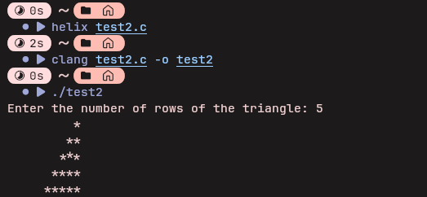

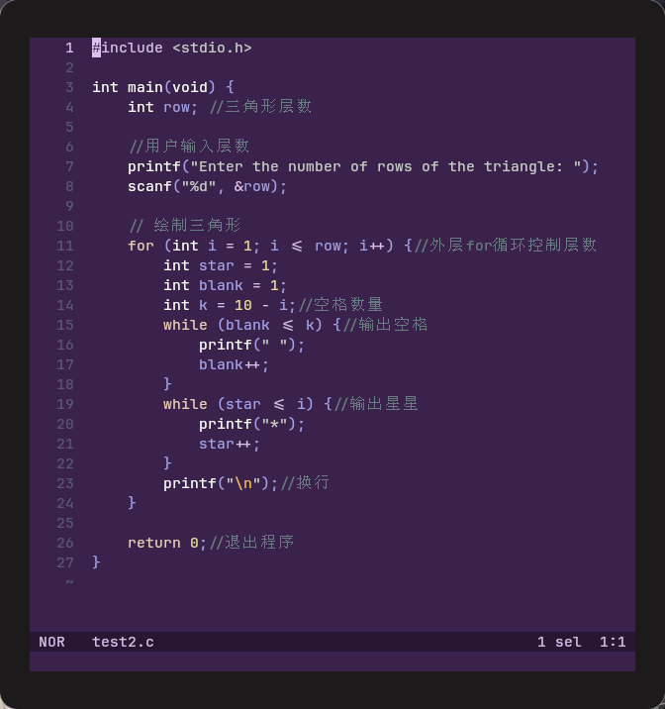
工程项目截图

文件2.c
#include <stdio.h>

int main(void) {
int row; //三角形层数

//用户输入层数
printf("Enter the number of rows of the triangle: ");
scanf("%d", &row);

// 绘制三角形
for (int i = 1; i <= row; i++) {//外层for循环控制层数
int star = 1;
int blank = 1;
int k = 10 - i;//空格数量
while (blank <= k) {//输出空格
printf(" ");
blank++;
}
while (star <= i) {//输出星星
printf("*");
star++;
}
printf("\n");//换行
}

return 0;//退出程序
}

Quiz 3

输出结果截图
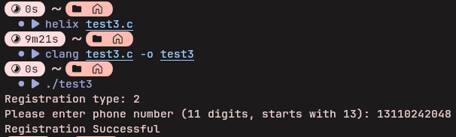

工程项目截图
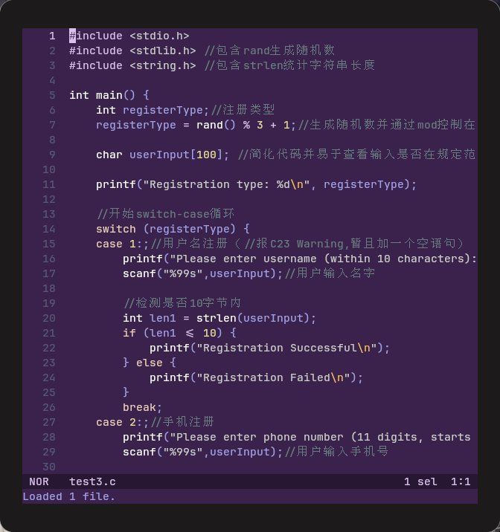

文件3.c (不敢用atoi怕被当AI，导致检查数字合理部分可能冗长，虽然rand不是完全意义随机但是似乎只能用rand了）
#include <stdio.h>
#include <stdlib.h> //包含rand生成随机数
#include <string.h> //包含strlen统计字符串长度

int main() {
int registerType;//注册类型
registerType = rand() % 3 + 1;//生成随机数并通过mod控制在1-3

char userInput[100]; //简化代码并易于查看输入是否在规定范围内

printf("Registration type: %d\n", registerType);

//开始switch-case循环
switch (registerType) {
case 1:;//用户名注册（//报C23 Warning,暂且加一个空语句）
printf("Please enter username (within 10 characters): ");
scanf("%99s",userInput);//用户输入名字

//检测是否10字节内
int len1 = strlen(userInput);
if (len1 <= 10) {
printf("Registration Successful\n");
} else {
printf("Registration Failed\n");
}
break;
case 2:;//手机注册
printf("Please enter phone number (11 digits, starts with 13): ");
scanf("%99s",userInput);//用户输入手机号

//检测是否全为数字
for(int i = 0; i <= 10; i++){
if(userInput[i] !='0' && userInput[i] != '1' && userInput[i] != '2' && userInput[i] != '3' && userInput[i] != '4' && userInput[i]!= '5' && userInput[i] != '6' && userInput[i] != '7' && userInput[i] != '8' && userInput[i] != '9'){
printf ("Registration Failed\n");
return 0;
}
}
int len2 = strlen(userInput);
if (len2 == 11 && userInput[0] == '1' && userInput[1] == '3') {
printf("Registration Successful\n");
} else {
printf("Registration Failed\n");
}
break;
case 3:;//激活码注册
printf("Please enter serial number (4-digit hexadecimal, starts with A): ");
scanf("%99s", userInput);

//检测是否输入为16进制数字
for(int i = 0; i <= 3; i++){
if(userInput[i] != '1' && userInput[i] != '2' && userInput[i] != '3' && userInput[i] != '4' && userInput[i] != '5' && userInput[i] != '6' && userInput[i] != '7' && userInput[i] != '8' && userInput[i] != '9' && userInput[i] != 'A' && userInput[i] != 'B' && userInput[i] != 'C' && userInput[i] != 'D' && userInput[i] != 'E' && userInput[i] != 'F' && userInput[i] != 'G'){
printf("Registration Failed\n");
return 0;
}
}

int len3 = strlen(userInput);//计算长度
if (len3 == 4 && (userInput[0] == 'A')) {
printf("Registration Successful\n");
} else {
printf("Registration Failed\n");
}
break;
}
return 0;
}

