BUPT SE ICP Quiz -- Unit 04 Decision making and Branching
If you are using LLM to help you in this quiz, you MUST write down 1) the name of the LLM and 2) the PROMPTS. Otherwise, you will get zero score if the instructor finds that you are using LLM.
You may use the following table as a template, putting the table down to the title of each question.

Name of LLM | Prompts

Please use conditional operator ?: to rewrite the codes.
if (x>num1&&x<num2)
myNum = num2-num1;
else
myNum = x;
myNum = (x>num1&&x<num2) ? num2-num1 : x ;

“break” can be used in both loop block and _switch_ block.

[ F ] T/F: The ternary operator in C returns a boolean value.

[ F ] T/F: Each case statement in a switch block must be followed by a break statement.

What does it mean to say that two control statements are nested? Give an example.
My Answer: Two control statements are nested means one statement is in the other one.
Example: //PART OF THE CODE MAINLY TO ILLUSTRATE THE NET STRUCTURE
int Week, Teacher;
scanf("%d %d", &Week, &Teacher);
switch(Week){
case 1:
printf("Learning C\n");
break;
case 2: {
if teacher == CYD{
printf("Learning C\n");
} else {
printf("Learning ML\n");
}
break;}
}

The two values of the data type bool are ___True___ and ___False___

Write a Boolean expression to test whether the value of the integer variable n was in the range 0 to 9, inclusive: __bool isInRange = (n >= 0 && n <= 9);__

Describe in English what the following conditional expression means: (x != 4) || (x != 17)
for what values of x is this condition TRUE?
This sentence means return 1 when x is not 4 or x is not 17.
This condition is TRUE all the time.

Using LLM to help you answer: what does the term short-circuit evaluation mean? Give an example.
Name of LLM | Prompts
LongCat AI | I'm a beginner in learning CS.  Please make a brief introduction of the term short-circuit evaluation.  And give an example in C programming language.

AI Answer: Short-circuit evaluation an optimization strategy used in boolean operations, where the second argument is only evaluated if the first argument does not suffice to determine the result.
Example(AI generate)
#include <stdio.h>
#include <stdbool.h>
bool true_func() {
printf(" true_func() called\n");
return true;
}
bool false_func() {
printf(" false_func() called\n");
return false;
}
int main() { // Example 1: Short-circuit with `&&`
printf("=== AND operator (a && b) ===\n");
printf("false && true_func():\n");
bool result1 = false && true_func(); // true_func() is NOT evaluated printf("Result: %d\n\n", result1);
printf("true && true_func():\n");
bool result2 = true && true_func(); // true_func() IS evaluated
printf("Result: %d\n\n", result2);
// Example 2: Short-circuit with `||`
printf("=== OR operator (a || b) ===\n");
printf("true || false_func():\n");
bool result3 = true || false_func(); // false_func() is NOT evaluated
printf("Result: %d\n\n", result3);
printf("false || false_func():\n");
bool result4 = false || false_func(); // false_func() IS evaluated
printf("Result: %d\n", result4);
return 0;
}

[ A ] Choose the correct answer: Suppose the body of a while loop contains a statement that, when executed, causes the condition for that while loop to become FALSE. A. The loop terminate immediately at that point; B. it complete the current cycle?

Using LLM to help you answer: What is the loop-and-a-half problem? What two strategies are presented in the text for solving it? Give an example.
Name of LLM | Prompts
LongCat AI | I'm a beginner in learning CS.  What is the loop-and-a-half problem? What two strategies are presented in the text for solving it?  Plz give a example in C language.

Based On AI Answer (Too long so I made an abstract): The loop-and-a-half prob is a challenge when I want to execute a loop at least once. However, the termination condition depends on processing done inside the loop body. To solve this, there’s two main solutions: 1. Break statement 2. Use flag variable.
Example:(Using break statement):
#include <stdio.h>
int main() {
int value;
while (1) { // Infinite loop
printf("Enter a positive number: ");
scanf("%d", &value);
if (value > 0) {
break; // Exit in the middle
} else {
printf("Error: Number must be positive. Try again.\n");
}
}
printf("You entered: %d\n", value);
return 0;
}

Write for loop control line for each of the following situations:
a) Counting form 1 to 100. _for (int i = 1; i <= 100; i++)_
b) Counting by sevens starting at 0 until the number has more than two digits. _for (int i = 0; i < 100; i += 7)_
c) Counting backward by twos form 100 to 0. __for (int i = 100; i >= 0; i -= 2)__

Using LLM to help you answer: Why is it best to avoid using a floating-point variable as the index variable in a for loop?
Name of LLM | Prompts
LongCat AI | Why is it best to avoid using a floating-point variable as the index variable in a for loop? // Given the former prompt, only asked this question.
1.Precision Errors in Floating-Point Arithmetic (Contains Binary Representation and Accumulate Errors) 2.Incorrect Loop Termination Conditions
3.Performance Overhead 4.Non-Uniform Step Sizes

Write a program that reads in two integers and prints out the larger number. Use if-else statements.
#include<stdio.h>
int main(void) {
int a, b;
printf("Enter two integers: ");
scanf("%d %d", &a, &b);
if (a > b) {
printf("%d\n", a);
} else {
printf("%d\n", b);
}
return 0;
}

Write a program that reads in three integers and prints the smallest number. Use nested if-else statements.
#include<stdio.h>
int main(void) {
int a, b, c;
printf("Enter three integers: ");
scanf("%d %d %d", &a, &b, &c);
if (a>b){
if (a>c){
if (b>c){
printf("%d\n", c);
} else {
printf("%d\n", b);
}
} else {
printf("%d\n", b);
}
} else {
if (b>c){
if (a>c){
printf("%d\n", c);
} else {
printf("%d\n", a);
}
} else {
printf("%d\n", a);
}
}
return 0;
}

Write a program that reads in a character and prints whether it is a vowel or consonant using a switch-case statement.
#include <stdio.h>
int main() {
char ch;
printf("Enter a character: ");
scanf(" %c", &ch);
switch(ch) {
case 'a': case 'A':
case 'e': case 'E':
case 'i': case 'I':
case 'o': case 'O':
case 'u': case 'U':
printf("%c is a vowel.\n", ch);
break;
default:
if ((ch >= 'a' && ch <= 'z') || (ch >= 'A' && ch <= 'Z'))
printf("%c is a consonant.\n", ch);
else
printf("%c is not a consonaunt.\n", ch);
}
return 0;
}

Write a program that reads in the month (1-12) and prints the number of days in that month using switch-case. Handle leap years properly.
#include<stdio.h>
int main(void){
int day, month, year;
printf("Enter a date mm/yyyy\b\b\b\b\b\b\b\a");
scanf("%d/%d/%d", &month, &day, &year);
if (year % 4 == 0 && year % 100 != 0 || year % 400 == 0){
switch(month){
case 1: case 3: case 5: case 7: case 8: case 10: case 12:
printf("The month has 31 days.\n");
break;
case 4: case 6: case 9: case 11:
printf("The month has 30 days.\n");
break;
case 2:
printf("The month has 29 days.\n");
}
} else {
switch(month){
case 1: case 3: case 5: case 7: case 8: case 10: case 12:
printf("The month has 31 days.\n");
break;
case 4: case 6: case 9: case 11:
printf("The month has 30 days.\n");
break;
case 2:
printf("The month has 28 days.\n");
}
}
return 0;
}

Write a program to display the following diagram on the screen. The number of rows in the figure should be a #define constant, which has the value 8 for this sample run. You should output the first 4 lines and then the following 8 lines.
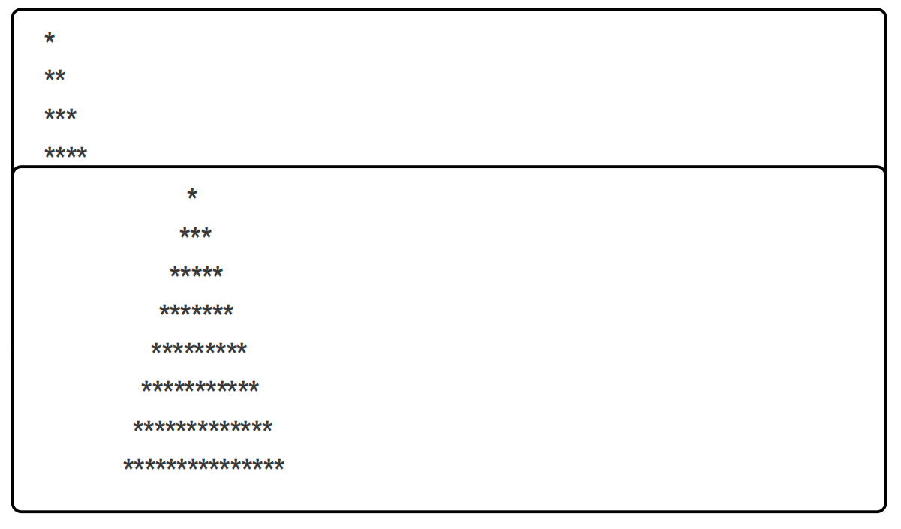
#include<stdio.h>
#define rowNumber 8
int main(void){
for (int i = 0; i < rowNumber/2; i++){
for (int j = 0; j <= i; j++){
printf("*");
}
printf("\n");
}
for (int i = 0; i < rowNumber; i++){
for (int j = 10; j >= i; j--) {
printf(" ");
}
for(int k = 0; k <= 2*i; k ++){
printf("*");
}
printf("\n");
}
return 0;
}

[本题选做] Xiao W lost his girlfriend on March 7th. Heartbroken, he began to hate the numbers 3 and 7 intensely. As a result, he created the W counting system. This system removes all numbers containing the digits 3 and 7 from a decimal base. For example, the next number after 2 is 4, and the next number after 29 is 40. Xiao W wants to know how many numbers are between X and Y in this counting system.
Input Format: A line with two integers X and Y, where 1 <= X <= Y <= 10^9, and neither X nor Y contains the digits 3 and 7.
Output Format: A line with an integer indicating the number of numbers between X and Y.
Sample Input
10 100k
Sample Output
57
#include <stdio.h>
int main() {
long long int a, b, removedNum = 0;
printf("Enter two integers:(a<=b) ");
scanf("%lld %lld", &a, &b);
int num[20];
for (int i = a; i <= b; i++) {
long long int tmp = i;
for (int j = 0; j < 20; j++) {
num[j] = tmp % 10;
tmp = tmp / 10;
}
for (int k = 0; k < 20; k++) {
if (num[k] == 3 || num[k] == 7) {
removedNum++;
break;
}
}
}
printf("%lld\n", b - a + 1 - removedNum);
return 0;
}

