**News letter:**

September:

# Pollution and climate change upsurge the risk of ‘climate penalty’

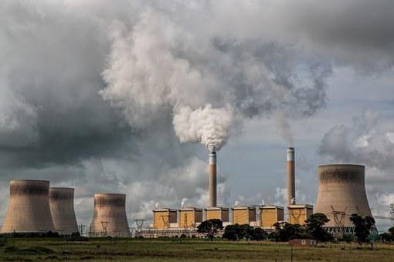

**September 2022 | Climate and Environment**

A rise in the frequency, intensity and duration of heatwaves will not only increase wildﬁres this century but also worsen air quality – harming human health and ecosystems, according to a new report from the World Meteorological Organization (WMO) launched on Wednesday, the International Day of Clean Air for Blue Skies.

## ‘Foretaste of the future’

The annual WMO Air Quality and Climate Bulletin warned that the interaction between pollution and climate change would impose a “climate penalty” for hundreds of millions of people.

In addition to reporting on the state of air quality and its close interlinkages with climate change, the Bulletin explores a range of possible air quality outcomes under high and low greenhouse gas emission scenarios.

The impact of last year’s wildﬁre smoke has served to augment this year’s heatwaves.

Mr. Taalas pointed to 2022 heatwaves in Europe and China, describing stable high atmospheric conditions, sunlight and low wind speeds as being “conducive to high pollution levels”.

“This is a foretaste of the future because we expect a further increase in the frequency, intensity and duration of heatwaves, which could lead to even worse air quality, a phenomenon known as the ‘climate penalty’”.

The “climate penalty” refers speciﬁcally to the increase in climate change as it impacts the air people breathe.

## Air pollutants

The region with the strongest projected climate penalty – mainly Asia – is home to roughly one-quarter of the world's population.

Climate change could exacerbate ozone pollution, which would lead to detrimental health impacts for hundreds of millions of people.

Because air quality and climate are interconnected, changes in one inevitably causes changes in the other.

The Bulletin explains that the combustion of fossils also emits nitrogen oxide, which can react with sunlight to form ozone and nitrate aerosols.

In turn, these air pollutants can negatively affect ecosystem health, including clean water, biodiversity, and carbon storage.

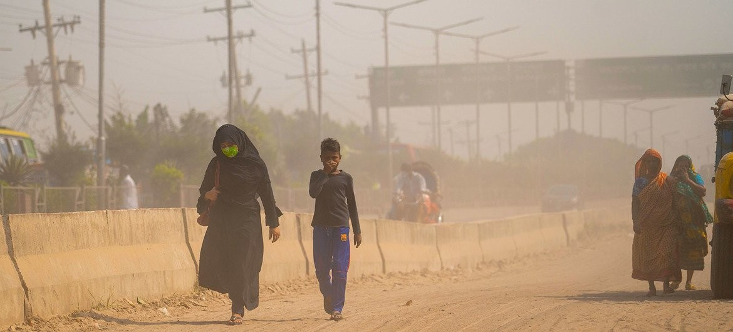

## Low-carbon scenario

To avoid this, the IPCC suggests a low-carbon emissions scenario, which would cause a small, short-term warming prior to temperature decreases.

A future world that follows this scenario would also beneﬁt from reduced nitrogen and sulfur compounds from the atmosphere to the Earth’s surface, where they can damage ecosystems.

WMO stations around the world would monitor the response of air quality and ecosystem health to proposed future emissions reductions.

This could quantify the eﬃcacy of the policies designed to limit climate change and improve air quality.

April:

**April 2022 | Breathing issues**

# Billions of people still breathe unhealthy air:

### Over 6000 cities now monitor air quality

Almost the entire global population (99%) breathes air that exceeds WHO air quality limits, and threatens their health. A record number of over 6000 cities in 117 countries are now monitoring air quality, but the people living in them are still breathing unhealthy levels of fine particulate matter and nitrogen dioxide, with people in low and

middle-income countries suffering the highest exposures.

The findings have prompted the World Health Organization to highlight the importance of curbing fossil fuel use and taking other tangible steps to reduce air pollution levels.

Released in the lead-up to World Health Day, which this year celebrates the theme Our planet, our health, the 2022 update of the World Health Organization’s air quality database introduces, for the first time, ground measurements of annual mean concentrations of nitrogen dioxide (NO2), a common urban pollutant and precursor of particulate matter and ozone. It also includes measurements of particulate matter with diameters equal or smaller than 10 μm (PM10) or 2.5 μm (PM2.5). Both groups of pollutants originate mainly from human activities related to fossil fuel combustion.

The new air quality database is the most extensive yet in its coverage of air pollution exposure on the ground. Some 2,000 more cities/human settlements are now recording ground monitoring data for particulate matter – PM10 and/or PM2.5 – than the last update. This marks an almost 6-fold rise in reporting since the database was launched in 2011.

Meanwhile, the evidence base for the damage air pollution does to the human body has been growing rapidly and points to significant harm caused by even low levels of many air pollutants.

Particulate matter, especially PM2.5, is capable of penetrating deep into the lungs and entering the bloodstream, causing cardiovascular, cerebrovascular (stroke) and respiratory impacts. There is emerging evidence that particulate matter impacts other organs and causes other diseases as well.

NO2 is associated with respiratory diseases, particularly asthma, leading to respiratory symptoms (such as coughing, wheezing or difficulty breathing), hospital admissions and visits to emergency rooms

WHO last year revised its Air Quality Guidelines, making them more stringent in an effort to help countries better evaluate the healthiness of their own air.

“Current energy concerns highlight the importance of speeding up the transition to cleaner, healthier energy systems,” said Dr Tedros Adhanom Ghebreyesus, WHO Director-General. “High fossil fuel prices, energy security, and the urgency of addressing the twin health challenges of air pollution and climate change, underscore the pressing need to move faster towards a world that is much less dependent on fossil fuels.”

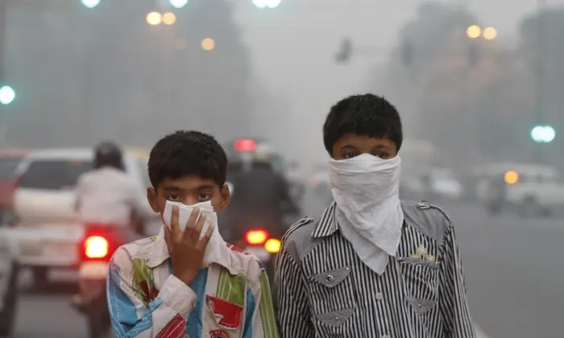

### Steps governments can take to improve air quality and health

A number of governments are taking steps to improve air quality, but WHO is calling for a rapid intensification of actions to:

* adopt or revise and implement national air quality standards according to the latest WHO Air Quality Guidelines;
* monitor air quality and identify sources of air pollution;
* support the transition to exclusive use of clean household energy for cooking, heating and lighting;
* build safe and affordable public transport systems and pedestrian- and cycle-friendly networks;
* implement stricter vehicle emissions and efficiency standards; and enforce mandatory inspection and maintenance for vehicles;
* invest in energy-efficient housing and power generation;
* improve industry and municipal waste management;
* reduce agricultural waste incineration, forest fires and certain agro-forestry activities (e.g. charcoal production); and
* include air pollution in curricula for health professionals and providing tools for the health sector to engage.

Almost the entire global population (99%) breathes air that exceeds WHO air quality limits, and threatens their health. A record number of over 6000 cities in 117 countries are now monitoring air quality, but the people living in them are still breathing unhealthy levels of fine particulate matter and nitrogen dioxide, with people in low and

middle-income countries suffering the highest exposures.

The findings have prompted the World Health Organization to highlight the importance of curbing fossil fuel use and taking other tangible steps to reduce air pollution levels.

Released in the lead-up to World Health Day, which this year celebrates the theme Our planet, our health, the 2022 update of the World Health Organization’s air quality database introduces, for the first time, ground measurements of annual mean concentrations of nitrogen dioxide (NO2), a common urban pollutant and precursor of particulate matter and ozone. It also includes measurements of particulate matter with diameters equal or smaller than 10 μm (PM10) or 2.5 μm (PM2.5). Both groups of pollutants originate mainly from human activities related to fossil fuel combustion.

The new air quality database is the most extensive yet in its coverage of air pollution exposure on the ground. Some 2,000 more cities/human settlements are now recording ground monitoring data for particulate matter – PM10 and/or PM2.5 – than the last update. This marks an almost 6-fold rise in reporting since the database was launched in 2011.

Meanwhile, the evidence base for the damage air pollution does to the human body has been growing rapidly and points to significant harm caused by even low levels of many air pollutants.

Particulate matter, especially PM2.5, is capable of penetrating deep into the lungs and entering the bloodstream, causing cardiovascular, cerebrovascular (stroke) and respiratory impacts. There is emerging evidence that particulate matter impacts other organs and causes other diseases as well.

NO2 is associated with respiratory diseases, particularly asthma, leading to respiratory symptoms (such as coughing, wheezing or difficulty breathing), hospital admissions and visits to emergency rooms

WHO last year revised its Air Quality Guidelines, making them more stringent in an effort to help countries better evaluate the healthiness of their own air.

“Current energy concerns highlight the importance of speeding up the transition to cleaner, healthier energy systems,” said Dr Tedros Adhanom Ghebreyesus, WHO Director-General. “High fossil fuel prices, energy security, and the urgency of addressing the twin health challenges of air pollution and climate change, underscore the pressing need to move faster towards a world that is much less dependent on fossil fuels.”

**Steps governments can take to improve air quality and health**

A number of governments are taking steps to improve air quality, but WHO is calling for a rapid intensification of actions to:

* adopt or revise and implement national air quality standards according to the latest WHO Air Quality Guidelines;
* monitor air quality and identify sources of air pollution;
* support the transition to exclusive use of clean household energy for cooking, heating and lighting;
* build safe and affordable public transport systems and pedestrian- and cycle-friendly networks;
* implement stricter vehicle emissions and efficiency standards; and enforce mandatory inspection and maintenance for vehicles;
* invest in energy-efficient housing and power generation;
* improve industry and municipal waste management;
* reduce agricultural waste incineration, forest fires and certain agro-forestry activities (e.g. charcoal production); and
* include air pollution in curricula for health professionals and providing tools for the health sector to engage.

### Improvement in monitoring needed

People living in lower and middle-income countries are the most exposed to air pollution. They are also the least covered in terms of air quality measurement – but the situation is improving.

Europe, and to some extent North America, remain the regions with the most comprehensive data on air quality. In many low- and middle-income countries, while PM2.5 measurements are still not available, they have seen large improvements for measurements between the last database update in 2018 and this one, with an additional 1500 human settlements in these countries monitoring air quality.

### WHO’s Air Quality Guidelines

The evidence base for the harm caused by air pollution has been growing rapidly and points to significant harm caused by even low levels of many air pollutants. Last year, the WHO responded by revising its Air Quality Guidelines to reflect the evidence, making them more stringent, especially for PM and NO2, a move strongly supported by the health community, medical associations and patient organizations.

The 2022 database aims to monitor the state of the world’s air and feeds into progress tracking of the Sustainable Development Goals.

### World Health Day 2022

World Health Day, marked on 7 April, will focus global attention on urgent actions needed to keep humans and the planet healthy and foster a movement to create societies focused on well-being. WHO estimates that more than 13 million deaths around the world each year are due to avoidable environmental causes.