FreeRTOS eZ80F91 Acclaim! Port - Copyright (C) 2016-2021 by NadiSoft All rights reserved

This file is part of the FreeRTOS port for ZiLOG's EZ80F91 Module.
Copyright (C) 2016 by Juergen Sievers <JSievers@NadiSoft.de>
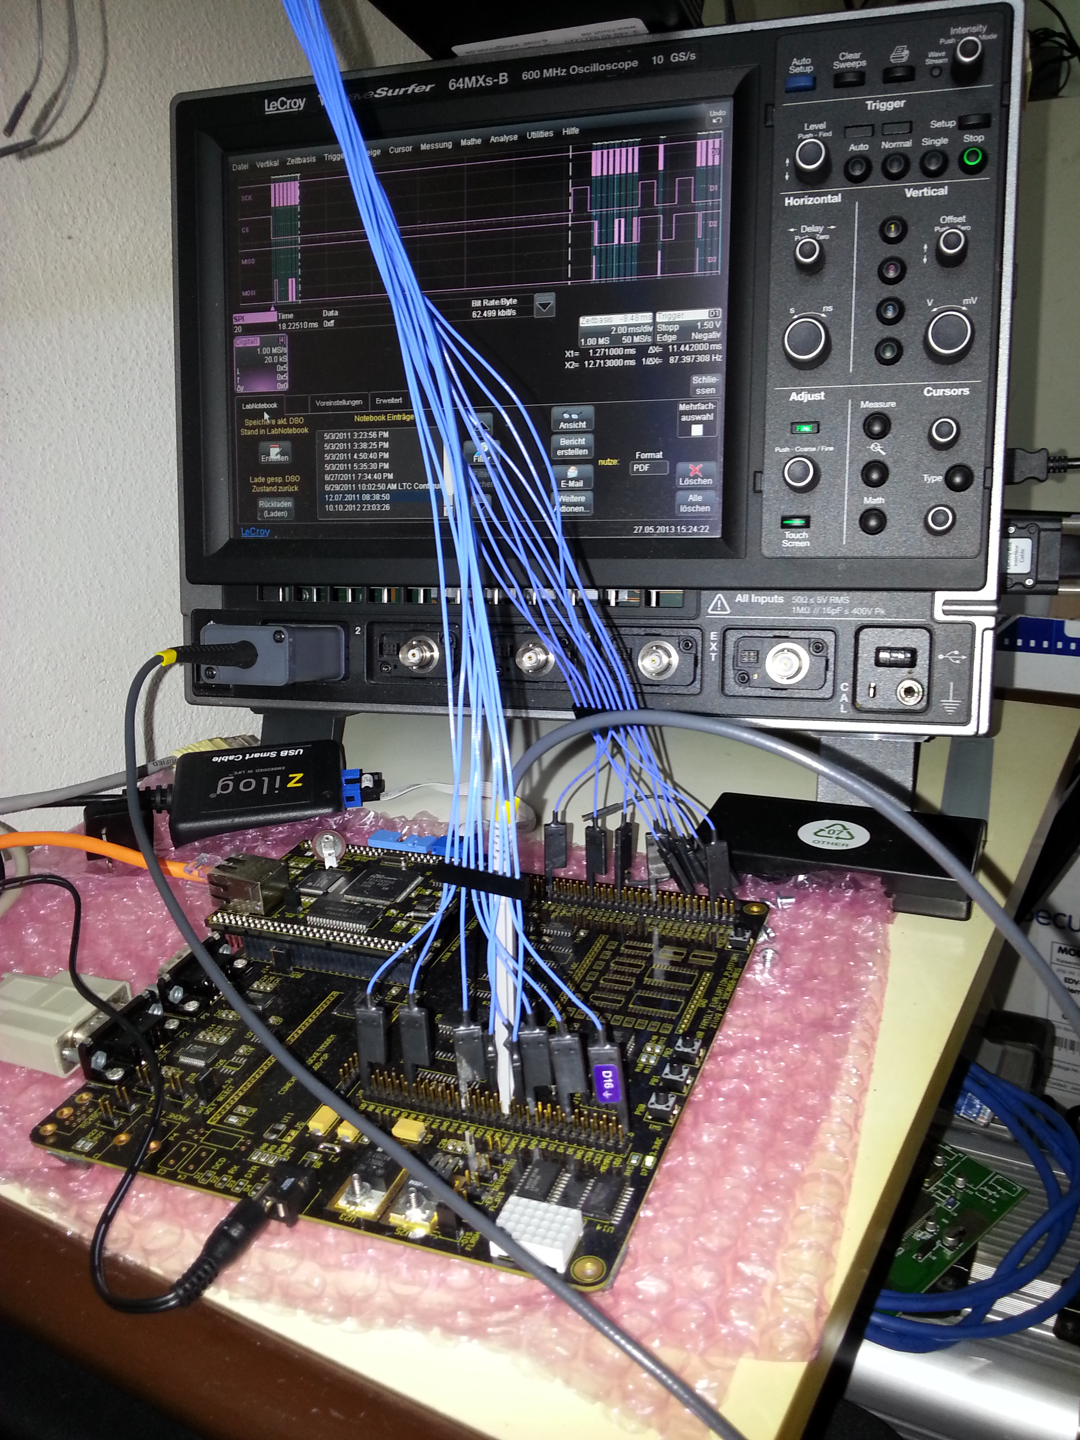
The Port was made and rudimentary tested on ZiLOG's EZ80F910300ZCOG Developer Kit using ZDSII Acclaim 5.3.4 Developer
Environment and comes WITHOUT ANY WARRANTY to you!
Developer:
SIE Juergen Sievers <JSievers@NadiSoft.de>
Repository directories:
- CPM CP/M 2.2 source and environment.
- doc some documantation.
- FreeRTOS the modified FreeRTOS real time kernel source code.
- FreeRTOSCLI the FreeRTOS-Plus-CLI command line interface source code.
- FreeRTOSTCP the modified FreeRTOS-Plus-TCP TCP/IP source code.
- Inc The Demo’s header files.
- monitor Z80 machine monitor. (not usable yet)
- src The Demo’s source files.
- uzlib The compress/un-compress library

See http://www.freertos.org.html for full details of the FreeRTOS directory structure and information on locating the files you require.

My Build- and Test-environment:
I use a Fedora Linux Workstation as host system. On this host a Windows 10 is running as guest under QEMU. On Windows I mount a samba share as drive Z: with at least the following directories.
- Z:\ZDSII_eZ80Acclaim!_5.3.4
ZiLOG Developer Studio II—eZ80Acclaim!® installation.
Free download from www.zilog.com.
- Z:\workspace
The Target is connected over its Serial and Ethernet port on the Linux-PC
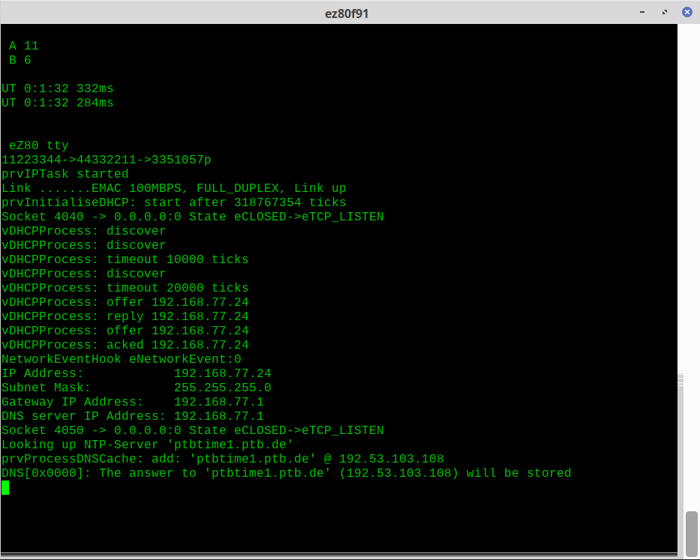
The Debug-output uses target’s serial-port 0 115200,8,1,n,RTS/CTS. I use PuTTY on the Linux-PC to display such information.
On the Linux-PC also runs a DHCP-Server with will answer to the target’s DHCP Requests.
At last the ZiLOG USBSmartCable is connect between the target and Lunux-PC. This USB -Device is routed to the Windows guest. It will be used by ZiLOG’s Developer Studio for download, flashing and debugging.
Changing to directory Z:\workspace (or on the linux to the shared) and clone the project https://github.com/notwendig/FreeRTOS-eZ80f91.git including submodules.
Apply the patch to zulib.
On the Windows-guest run the ZiLOG Developer Studio. Open the Project-file
Z:\workspace\FreeRTOS-eZ8091\uzib.zdsproj and build the uzlib[d].lib.
On a linux terminal change to directory uzlib and type make to build the packer/unpacker. Change to CPM directory and type make to build the CP/M 2.2 boot-tracks and the Disk-Image as packed C-Array.
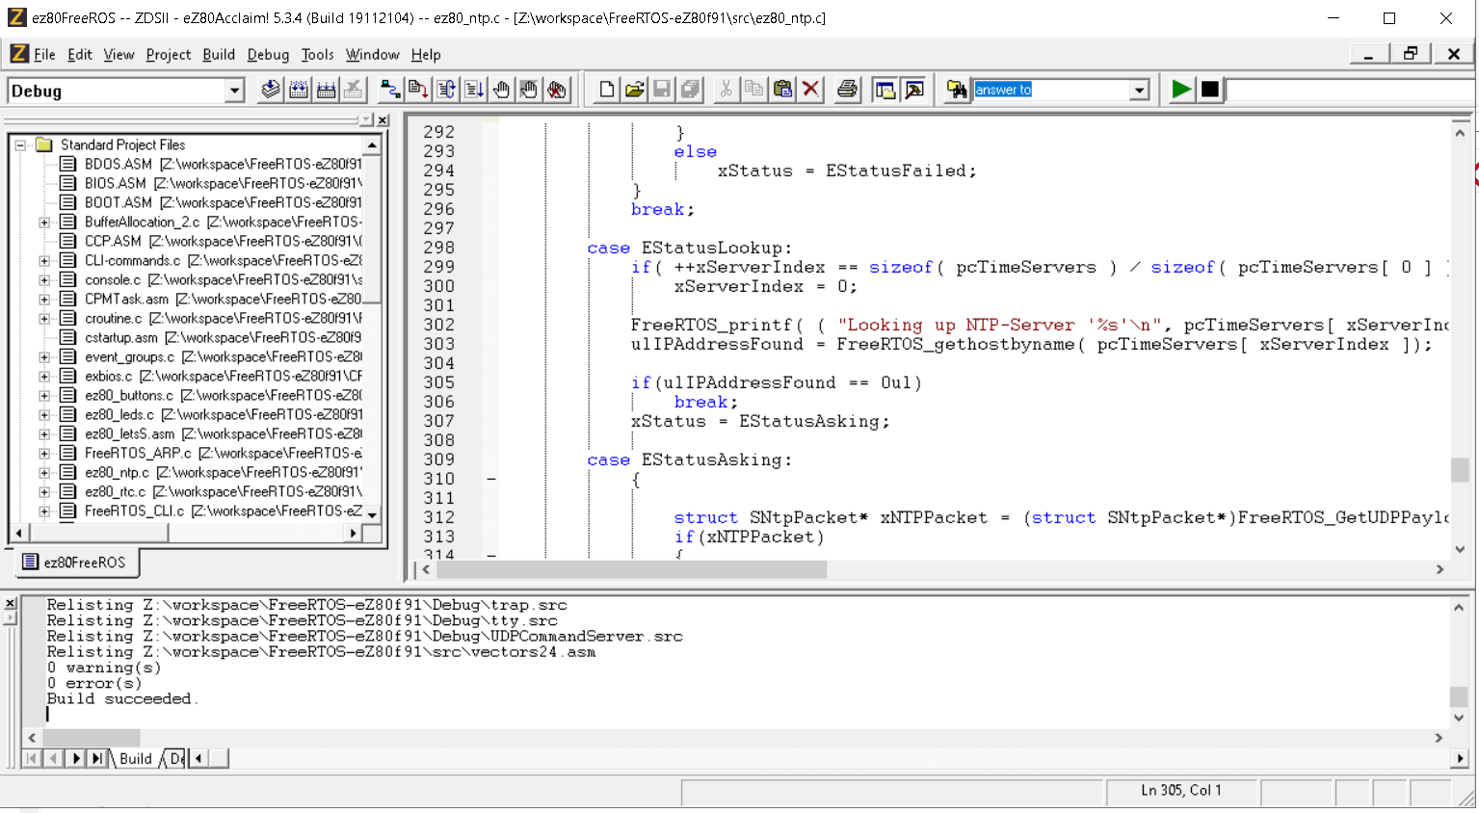
Now you are ready to open and build the z80FreeROS.zdsproj, and build it.

Before you download and run the Demo to the Target, a terminal (PuTTY) should be running on the target's serial-port connection.
After the target has gotten it’s IP you may start several other connection to the target.
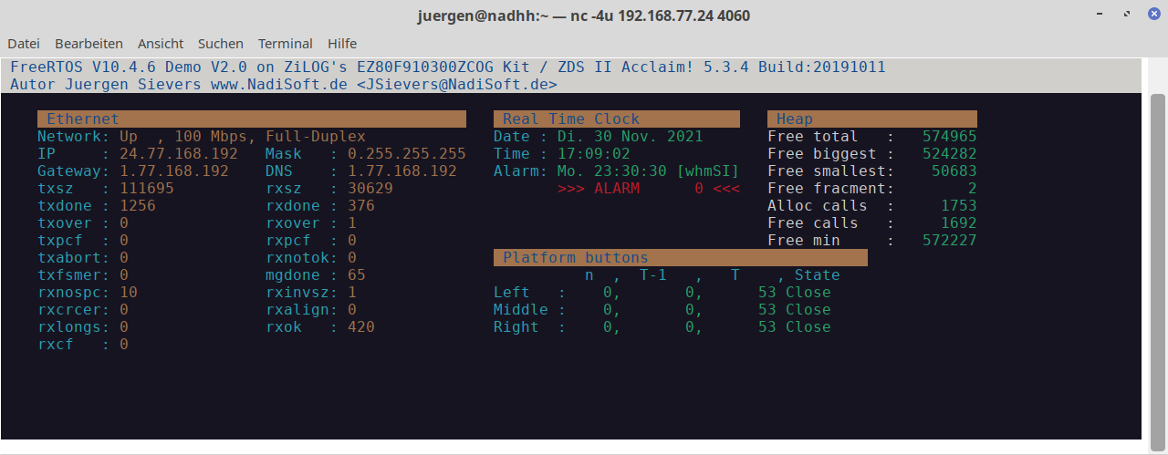
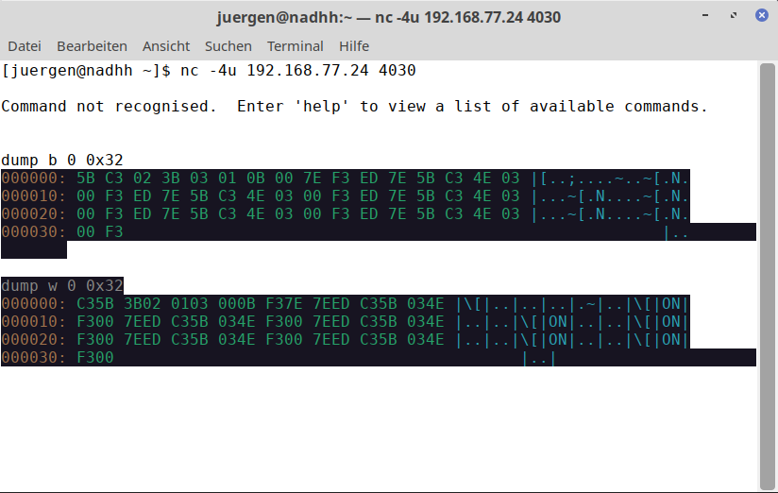
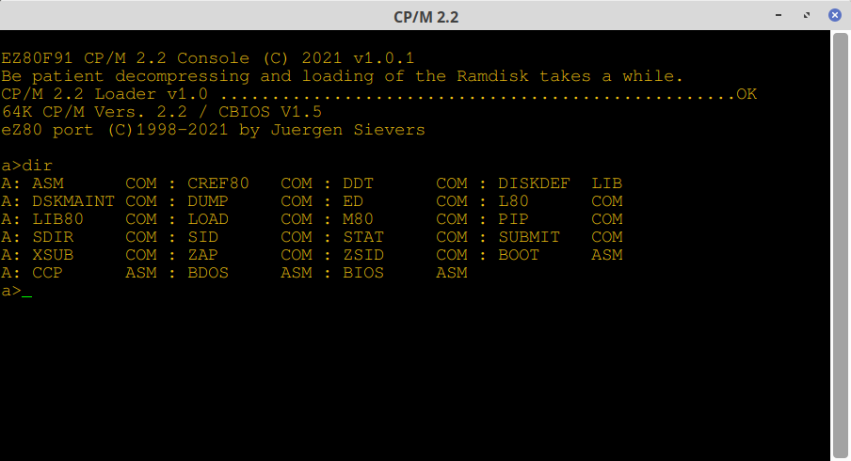

Regards
Jürgen

