# Lab Tasks:

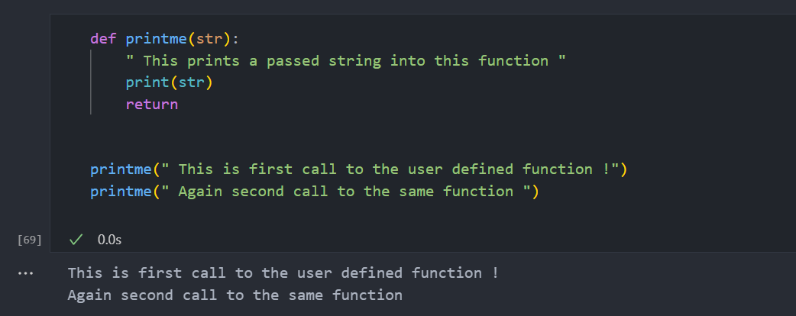

# Home Task:

