

**Usman Institute of Technology**

**Department of Computer Science Fall 2022**

Name: Muhammad Waleed

Roll no: 20B-115-SE

Course: DCCN (CS-222)

Course Instructor: Engr. Fauzan Saeed

Date: 14-Dec-2022

# Lab Task:

Implement following topology using packet tracer and configure static routes

## Arrangement:

Router Config:

Router0:

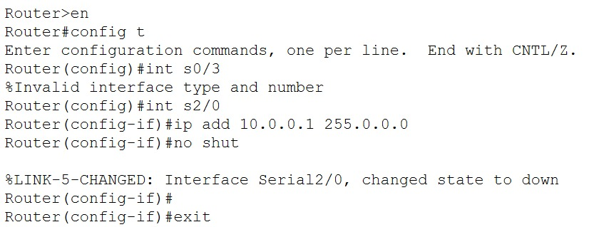



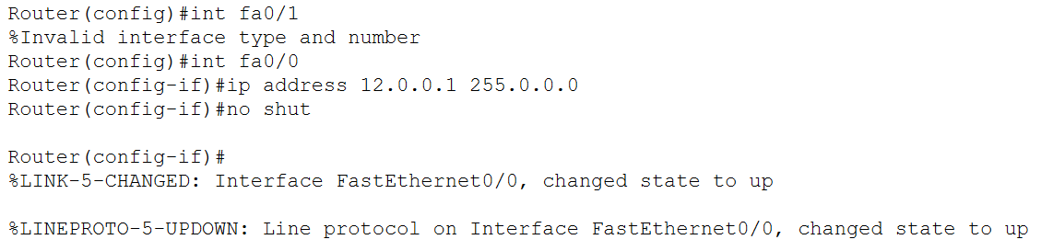

Router1:

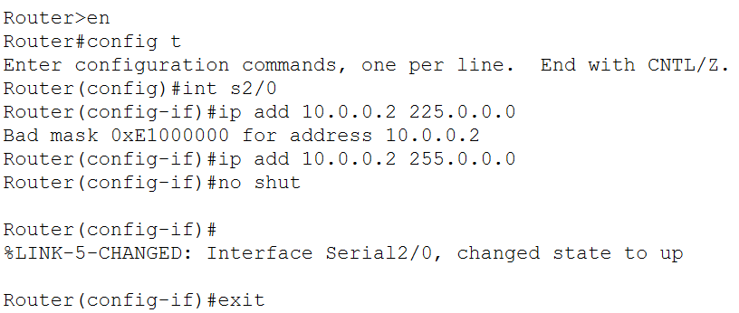

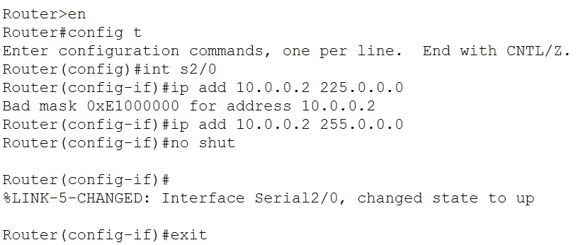



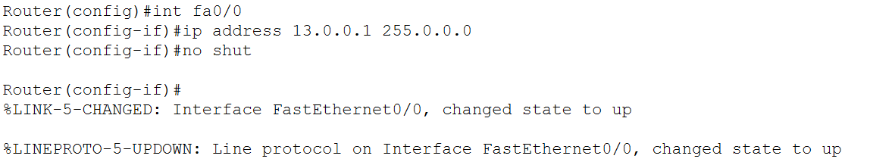

Router2:

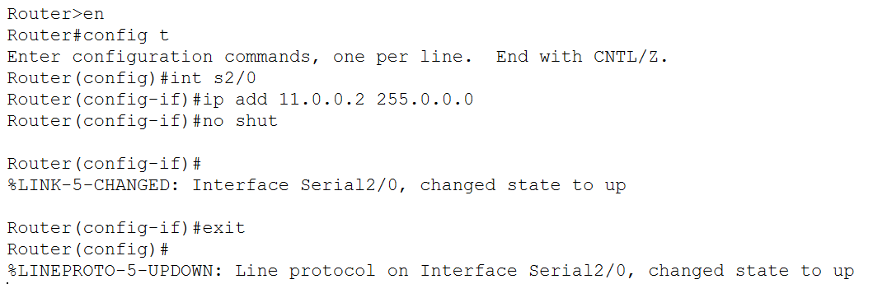

## Connectivity:

Router0:

Router1:

Router2:

PDU:

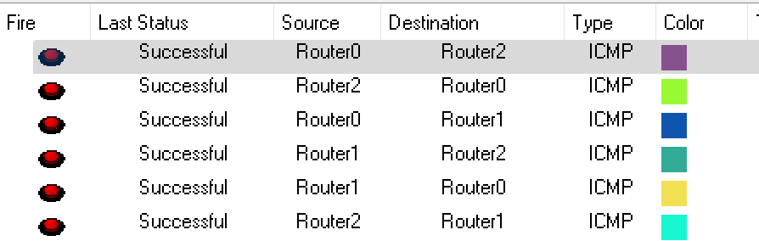

## Switch Configuration:

### Switch0:

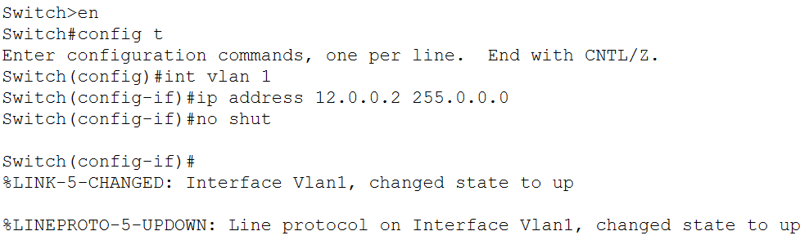

Server Config:

Using DHCP service to automatically assign IP to associated PCs.

PCs:

### Switch1:

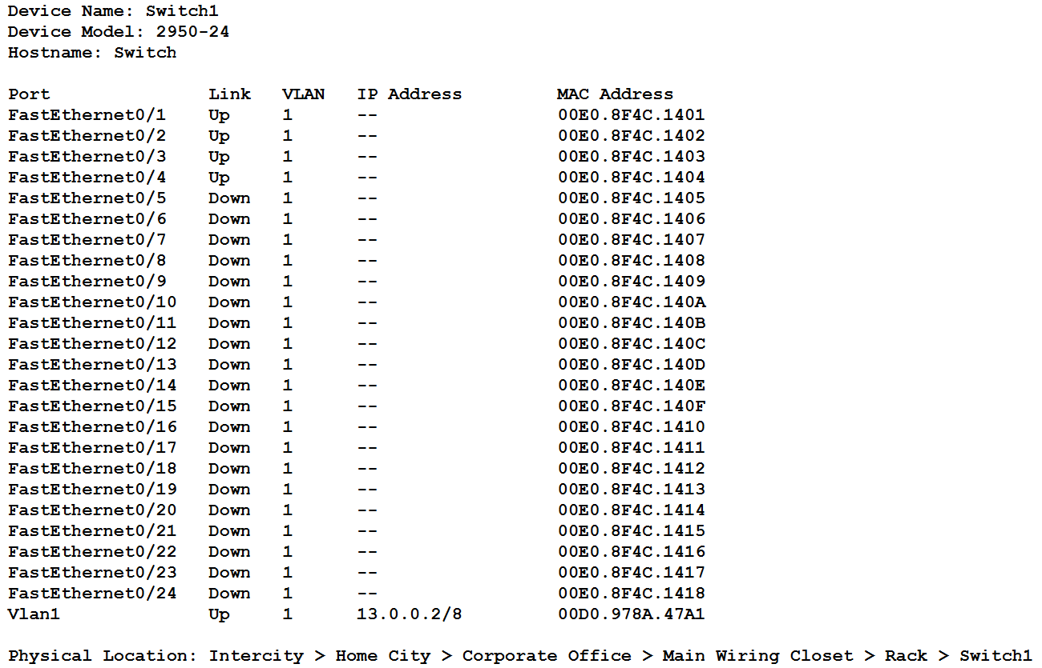

Server:

Using DHCP for auto assign IP,

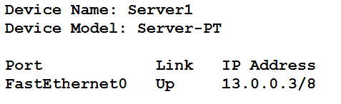

PCs:

### Switch2:

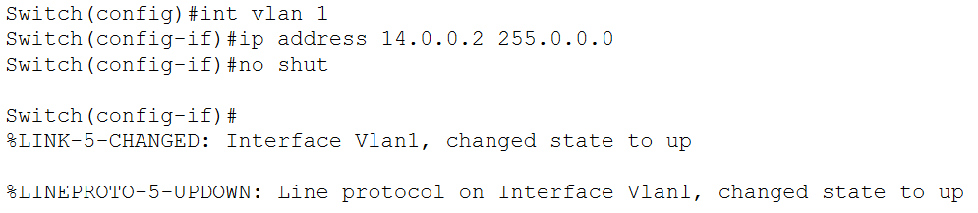

Server:

Using DHCP to auto assign IP

PCs:

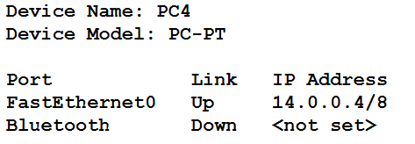

## Connectivity Test:

