

**Usman Institute of Technology**

**Department of Computer Science Fall 2022**

Name: Muhammad Waleed

Roll no: 20B-115-SE

Course: DCCN (CS-222)

Course Instructor: Engr. Fauzan Saeed

Date: 16-Oct-2022

# Lab Tasks:

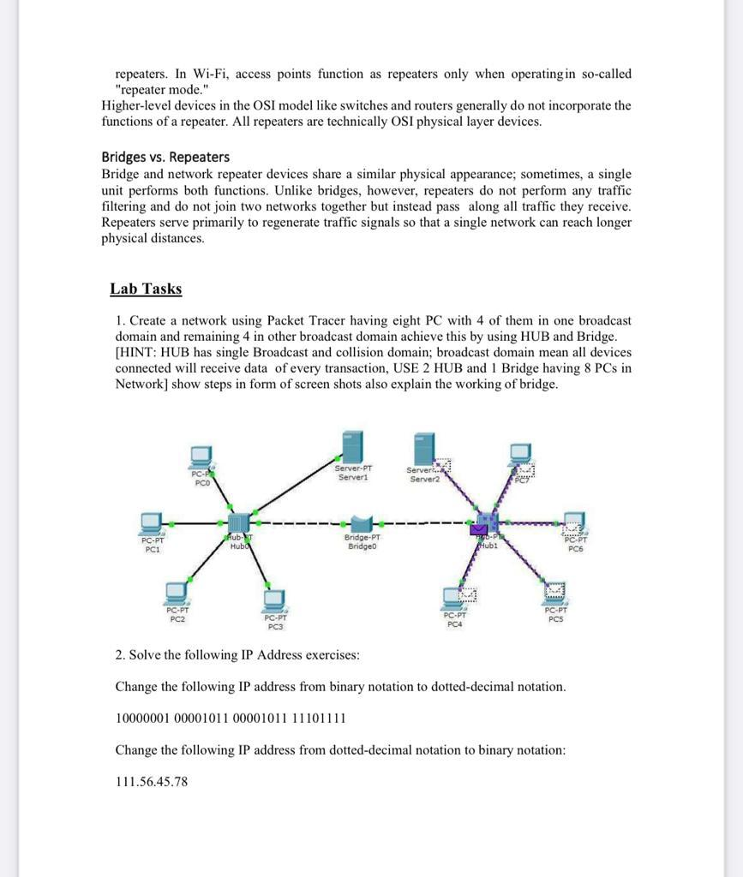TASK1:

## Arrangement of a Network:

## Configuration of Servers:

## PC Configuration of Server0:

PC0 PC1

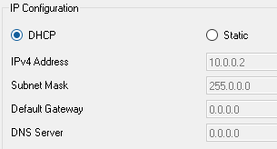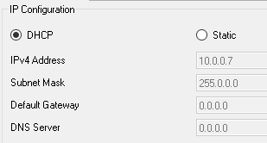

PC2

## PC Configuration of Server1:

PC3 PC6

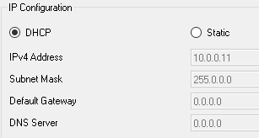

PC7

## Message Delivering:

### Within One Network:

#### From PC0 to PC2

### To Other Network:

#### From PC0 to PC6

### Collision:

## PDU:

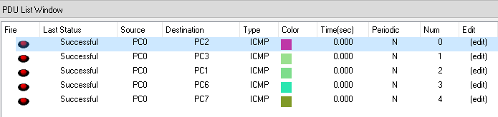

# Task2:



## Conversion of binary notation to dotted-decimal notation:

Step 1:

(10000001)₂ = (1 × 2⁷) + (0 × 2⁶) + (0 × 2⁵) + (0 × 2⁴) + (0 × 2³) + (0 × 2²) + (0 × 2¹) + (1 × 2⁰) = (129)₁₀

Step 2:

(00001011)₂ = (0 × 2⁷) + (0 × 2⁶) + (0 × 2⁵) + (0 × 2⁴) + (1 × 2³) + (0 × 2²) + (1 × 2¹) + (1 × 2⁰) = (11)₁₀

Step 3:

(00001011)₂ = (0 × 2⁷) + (0 × 2⁶) + (0 × 2⁵) + (0 × 2⁴) + (1 × 2³) + (0 × 2²) + (1 × 2¹) + (1 × 2⁰) = (11)₁₀

Step 4:

(11101111)₂ = (1 × 2⁷) + (1 × 2⁶) + (1 × 2⁵) + (0 × 2⁴) + (1 × 2³) + (1 × 2²) + (1 × 2¹) + (1 × 2⁰) = (239)₁₀

Step 5 (Net result):

129.11.11.23

## Conversion of dotted-decimal notation to binary notation:

111.56.45.78

Step 1:

|  |  |  |  |  |  |  |  |
| --- | --- | --- | --- | --- | --- | --- | --- |
| 0 | 1 | 1 | 0 | 1 | 1 | 1 | 1 |
|  | 111-64=47 | 47-32=15 |  | 15-8=7 | 7-4=3 | 3-2=1 | 1 |
| 128 | 64 | 32 | 16 | 8 | 4 | 2 | 1 |

01101111

Step 2:

|  |  |  |  |  |  |  |  |
| --- | --- | --- | --- | --- | --- | --- | --- |
| 0 | 0 | 1 | 1 | 1 | 0 | 0 | 0 |
|  |  | 56-32=24 | 24-16=8 | 8-8=0 |  |  |  |
| 128 | 64 | 32 | 16 | 8 | 4 | 2 | 1 |

00111000

Step 3:

|  |  |  |  |  |  |  |  |
| --- | --- | --- | --- | --- | --- | --- | --- |
| 0 | 0 | 1 | 0 | 1 | 1 | 0 | 1 |
|  |  | 45-32=13 |  | 13-8=5 | 5-4=1 |  | 1 |
| 128 | 64 | 32 | 16 | 8 | 4 | 2 | 1 |

00101101

Step 4:

|  |  |  |  |  |  |  |  |
| --- | --- | --- | --- | --- | --- | --- | --- |
| 0 | 1 | 0 | 0 | 1 | 1 | 1 | 0 |
|  | 78-64 |  |  | 14-8=6 | 6-4=2 | 2 |  |
| 128 | 64 | 32 | 16 | 8 | 4 | 2 | 1 |

01001110

Step 5(Net result):

01101111 00111000 00101101 01001110